**There are 2 parts to Class Exercise Part II, 50% each**

**Class Exercise #1**

Create a class and name it **Toppings** and write the code as shown below

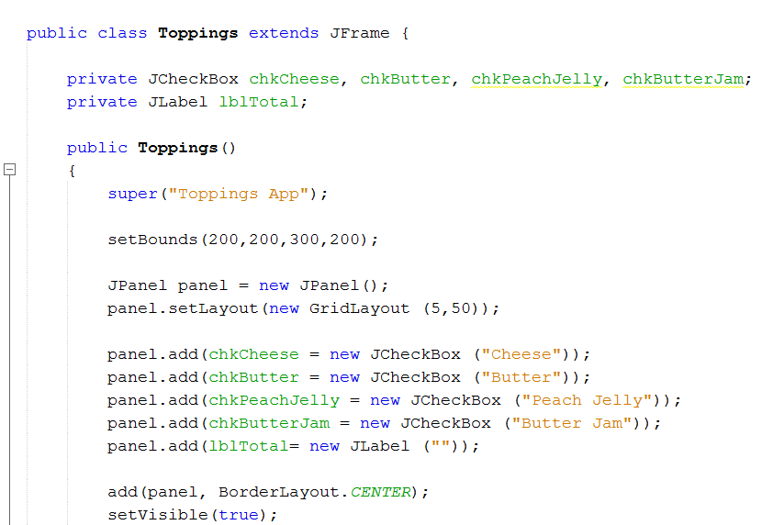

Code Continues to the next page…

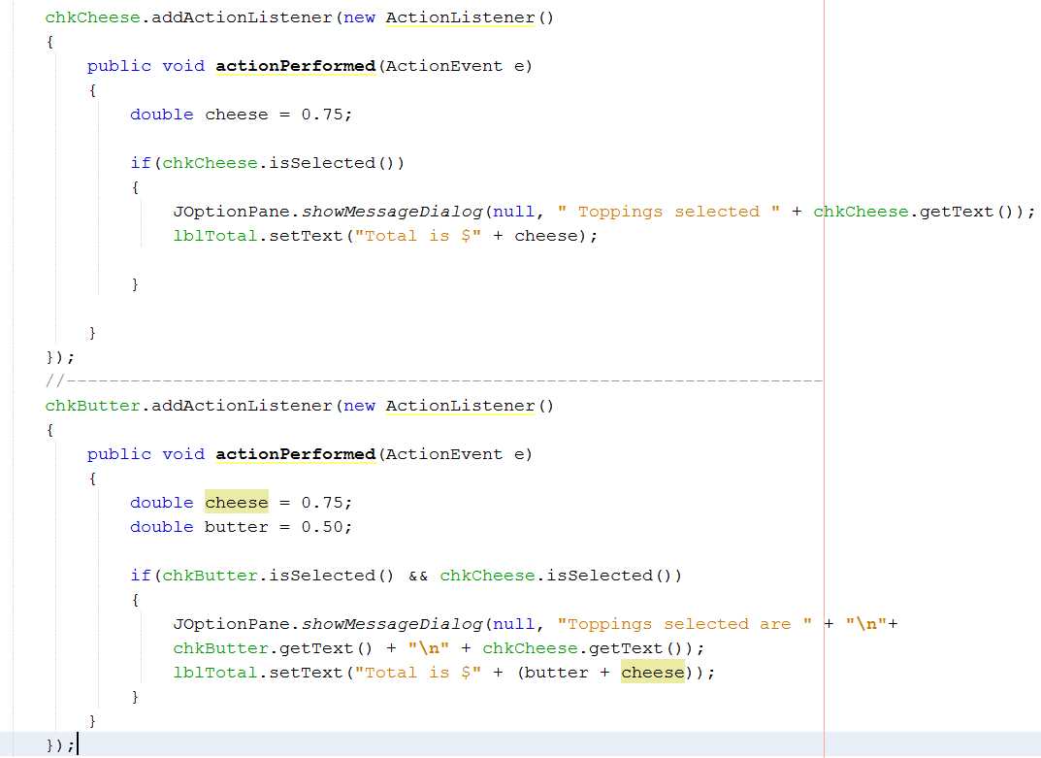

**Note**: Create a separate class and name it **CallToppings** and use this class for the main method, in which it will call the **Toppings** Class.

The separate or 2nd class will look something like the one below

public class CallToppings extends JFrame {

public static void main (String[]args)

{

JFrame frame = new Toppings(); //calling the Toppings class

frame.pack(); //packing the frame with no spaces left

frame.setVisible(true); //showing the frame

}

}

Print Screen the running application below here

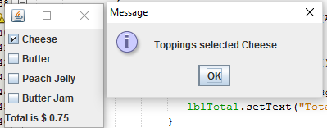

Copy and paste the code for the Toppings Class below here

package week15_part2;

import java.awt.BorderLayout;

import java.awt.GridLayout;

import java.awt.event.ActionEvent;

import java.awt.event.ActionListener;

import javax.swing.JCheckBox;

import javax.swing.JFrame;

import javax.swing.JLabel;

import javax.swing.JOptionPane;

import javax.swing.JPanel;

public class Toppings extends JFrame

{

private JCheckBox chkcheese, chkButter, chkPeachJelly, chkButterJam;

private JLabel lblTotal;

public Toppings ()

{

super("Toppings App");

setBounds(200,200,300,200);

JPanel panel = new JPanel();

panel.setLayout(new GridLayout(5,50));

panel.add(chkcheese = new JCheckBox("Cheese"));

panel.add(chkButter = new JCheckBox("Butter"));

panel.add(chkPeachJelly = new JCheckBox("Peach Jelly"));

panel.add(chkButterJam = new JCheckBox("Butter Jam"));

panel.add(lblTotal = new JLabel(""));

add(panel, BorderLayout.CENTER);

setVisible(true);

chkcheese.addActionListener(new ActionListener()

{

public void actionPerformed(ActionEvent e)

{

double cheese = 0.75;

if(chkcheese.isSelected())

{

JOptionPane.showMessageDialog(null, "Toppings selected " + chkcheese.getText());

lblTotal.setText("Total is $ " + cheese);

}

}

});

chkButter.addActionListener(new ActionListener()

{

public void actionPerformed(ActionEvent e)

{

double butter = 0.9;

double cheese = 0.75;

double total = cheese + butter;

if(chkButter.isSelected() && chkButter.isSelected())

{

JOptionPane.showMessageDialog(null, "Toppings selected " + chkButter.getText() + " " + chkcheese.getText());

lblTotal.setText("Total is $ " + total);

}

else if (chkButter.isSelected())

{

JOptionPane.showMessageDialog(null, "Toppings selected " + chkButter.getText());

lblTotal.setText("Total is $ " + butter);

}

else

{

JOptionPane.showMessageDialog(null, "Please choose Toppings!");

}

}

});

chkButterJam.addActionListener(new ActionListener()

{

public void actionPerformed(ActionEvent e)

{

double butterJam = 0.75;

if(chkButterJam.isSelected())

{

JOptionPane.showMessageDialog(null, "Toppings selected " + chkButterJam.getText());

lblTotal.setText("Total is $ " + butterJam);

}

}

});

chkPeachJelly.addActionListener(new ActionListener()

{

public void actionPerformed(ActionEvent e)

{

double peachJelly = 0.8;

if(chkPeachJelly.isSelected())

{

JOptionPane.showMessageDialog(null, "Toppings selected " + chkPeachJelly.getText());

lblTotal.setText("Total is $ " + peachJelly);

}

}

});

}

}

Copy and paste the code for the CallToppings Class below here

package week15_part2;

import javax.swing.JFrame;

public class CallTopping extends JFrame

{

public static void main(String[] args)

{

JFrame frame = new Toppings();

frame.pack();

frame.setVisible(true);

}

}

**Class Exercise #2**

Design the following JFrame using the Click and Drag Method, when the Results button is pressed retrieve the all fields chosen into a JOptionPane

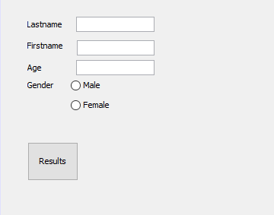

Print your running application below here

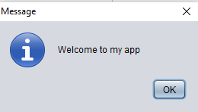

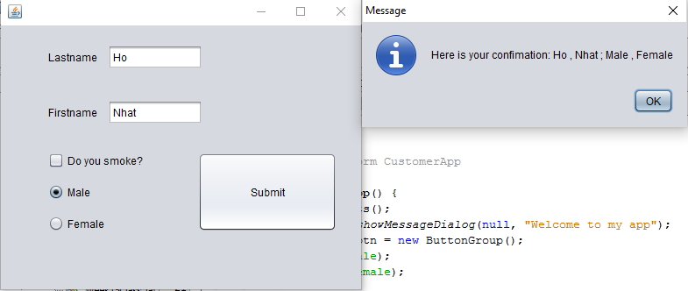

Copy and paste your code below here

package week15_part2;

import javax.swing.ButtonGroup;

import javax.swing.JOptionPane;

/**

*

* @author a208

*/

public class CustomerApp extends javax.swing.JFrame {

/**

* Creates new form CustomerApp

*/

public CustomerApp() {

initComponents();

JOptionPane.showMessageDialog(null, "Welcome to my app");

ButtonGroup btn = new ButtonGroup();

btn.add(rdoMale);

btn.add(rdoFemale);

Toppings frame = new Toppings();

frame.pack();

frame.setVisible(true);

}

/**

* This method is called from within the constructor to initialize the form.

* WARNING: Do NOT modify this code. The content of this method is always

* regenerated by the Form Editor.

*/

@SuppressWarnings("unchecked")

// <editor-fold defaultstate="collapsed" desc="Generated Code">

private void initComponents() {

jLabel1 = new javax.swing.JLabel();

jLabel2 = new javax.swing.JLabel();

chkSmokePreferences = new javax.swing.JCheckBox();

rdoMale = new javax.swing.JRadioButton();

rdoFemale = new javax.swing.JRadioButton();

btnSubmit = new javax.swing.JButton();

txtLastname = new javax.swing.JTextField();

txtFirstname = new javax.swing.JTextField();

setDefaultCloseOperation(javax.swing.WindowConstants.EXIT_ON_CLOSE);

jLabel1.setText("Lastname");

jLabel2.setText("Firstname");

chkSmokePreferences.setText("Do you smoke?");

rdoMale.setText("Male");

rdoFemale.setText("Female");

btnSubmit.setText("Submit");

btnSubmit.addActionListener(new java.awt.event.ActionListener() {

public void actionPerformed(java.awt.event.ActionEvent evt) {

btnSubmitActionPerformed(evt);

}

});

javax.swing.GroupLayout layout = new javax.swing.GroupLayout(getContentPane());

getContentPane().setLayout(layout);

layout.setHorizontalGroup(

layout.createParallelGroup(javax.swing.GroupLayout.Alignment.LEADING)

.addGroup(layout.createSequentialGroup()

.addGap(54, 54, 54)

.addGroup(layout.createParallelGroup(javax.swing.GroupLayout.Alignment.LEADING)

.addGroup(layout.createSequentialGroup()

.addGroup(layout.createParallelGroup(javax.swing.GroupLayout.Alignment.LEADING)

.addComponent(chkSmokePreferences)

.addComponent(rdoFemale)

.addComponent(rdoMale))

.addPreferredGap(javax.swing.LayoutStyle.ComponentPlacement.RELATED, 63, Short.MAX_VALUE)

.addComponent(btnSubmit, javax.swing.GroupLayout.PREFERRED_SIZE, 158, javax.swing.GroupLayout.PREFERRED_SIZE)

.addGap(28, 28, 28))

.addGroup(layout.createSequentialGroup()

.addGroup(layout.createParallelGroup(javax.swing.GroupLayout.Alignment.TRAILING)

.addGroup(layout.createSequentialGroup()

.addComponent(jLabel2)

.addPreferredGap(javax.swing.LayoutStyle.ComponentPlacement.UNRELATED)

.addComponent(txtFirstname, javax.swing.GroupLayout.PREFERRED_SIZE, 108, javax.swing.GroupLayout.PREFERRED_SIZE))

.addGroup(layout.createSequentialGroup()

.addComponent(jLabel1)

.addPreferredGap(javax.swing.LayoutStyle.ComponentPlacement.UNRELATED)

.addComponent(txtLastname, javax.swing.GroupLayout.PREFERRED_SIZE, 108, javax.swing.GroupLayout.PREFERRED_SIZE)))

.addContainerGap(javax.swing.GroupLayout.DEFAULT_SIZE, Short.MAX_VALUE))))

);

layout.setVerticalGroup(

layout.createParallelGroup(javax.swing.GroupLayout.Alignment.LEADING)

.addGroup(layout.createSequentialGroup()

.addGap(22, 22, 22)

.addGroup(layout.createParallelGroup(javax.swing.GroupLayout.Alignment.BASELINE)

.addComponent(jLabel1)

.addComponent(txtLastname, javax.swing.GroupLayout.PREFERRED_SIZE, javax.swing.GroupLayout.DEFAULT_SIZE, javax.swing.GroupLayout.PREFERRED_SIZE))

.addGap(35, 35, 35)

.addGroup(layout.createParallelGroup(javax.swing.GroupLayout.Alignment.BASELINE)

.addComponent(jLabel2)

.addComponent(txtFirstname, javax.swing.GroupLayout.PREFERRED_SIZE, javax.swing.GroupLayout.DEFAULT_SIZE, javax.swing.GroupLayout.PREFERRED_SIZE))

.addGap(32, 32, 32)

.addGroup(layout.createParallelGroup(javax.swing.GroupLayout.Alignment.LEADING, false)

.addGroup(layout.createSequentialGroup()

.addComponent(chkSmokePreferences)

.addGap(18, 18, 18)

.addComponent(rdoMale)

.addGap(18, 18, 18)

.addComponent(rdoFemale))

.addComponent(btnSubmit, javax.swing.GroupLayout.DEFAULT_SIZE, javax.swing.GroupLayout.DEFAULT_SIZE, Short.MAX_VALUE))

.addContainerGap(66, Short.MAX_VALUE))

);

pack();

}// </editor-fold>

private void btnSubmitActionPerformed(java.awt.event.ActionEvent evt) {

// TODO add your handling code here:

JOptionPane.showMessageDialog(null, "Here is your confimation: " + txtLastname.getText() + " , " + txtFirstname.getText() + " ; " +

rdoMale.getText() + " , " + rdoFemale.getText());

}

/**

* @param args the command line arguments

*/

public static void main(String args[]) {

/* Set the Nimbus look and feel */

//<editor-fold defaultstate="collapsed" desc=" Look and feel setting code (optional) ">

/* If Nimbus (introduced in Java SE 6) is not available, stay with the default look and feel.

* For details see http://download.oracle.com/javase/tutorial/uiswing/lookandfeel/plaf.html

*/

try {

for (javax.swing.UIManager.LookAndFeelInfo info : javax.swing.UIManager.getInstalledLookAndFeels()) {

if ("Nimbus".equals(info.getName())) {

javax.swing.UIManager.setLookAndFeel(info.getClassName());

break;

}

}

} catch (ClassNotFoundException ex) {

java.util.logging.Logger.getLogger(CustomerApp.class.getName()).log(java.util.logging.Level.SEVERE, null, ex);

} catch (InstantiationException ex) {

java.util.logging.Logger.getLogger(CustomerApp.class.getName()).log(java.util.logging.Level.SEVERE, null, ex);

} catch (IllegalAccessException ex) {

java.util.logging.Logger.getLogger(CustomerApp.class.getName()).log(java.util.logging.Level.SEVERE, null, ex);

} catch (javax.swing.UnsupportedLookAndFeelException ex) {

java.util.logging.Logger.getLogger(CustomerApp.class.getName()).log(java.util.logging.Level.SEVERE, null, ex);

}

//</editor-fold>

/* Create and display the form */

java.awt.EventQueue.invokeLater(new Runnable() {

public void run() {

new CustomerApp().setVisible(true);

}

});

}

// Variables declaration - do not modify

private javax.swing.JButton btnSubmit;

private javax.swing.JCheckBox chkSmokePreferences;

private javax.swing.JLabel jLabel1;

private javax.swing.JLabel jLabel2;

private javax.swing.JRadioButton rdoFemale;

private javax.swing.JRadioButton rdoMale;

private javax.swing.JTextField txtFirstname;

private javax.swing.JTextField txtLastname;

// End of variables declaration

}

Submit this document to Week 15 Class Exercise it will NOT overwrite your 1st one