There are 2 Tasks each worth 50%

Task #1

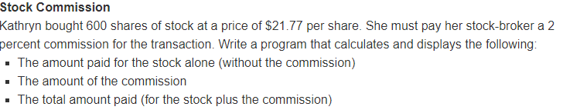

Print screen your results below here

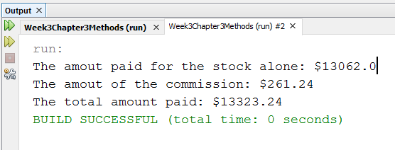

Copy and paste your code below here

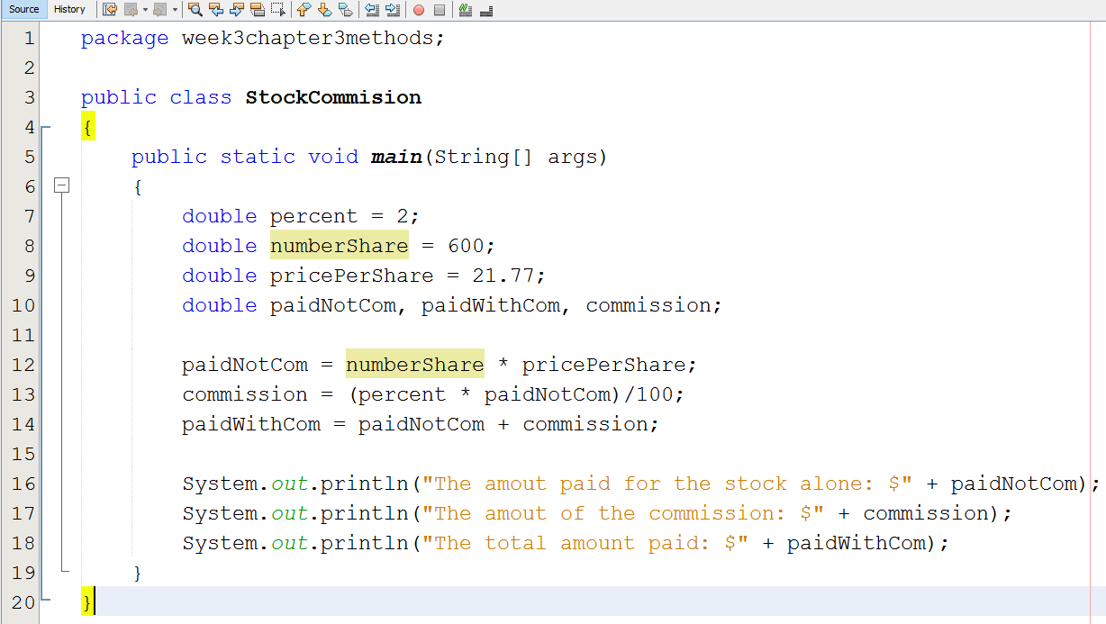

Task #2

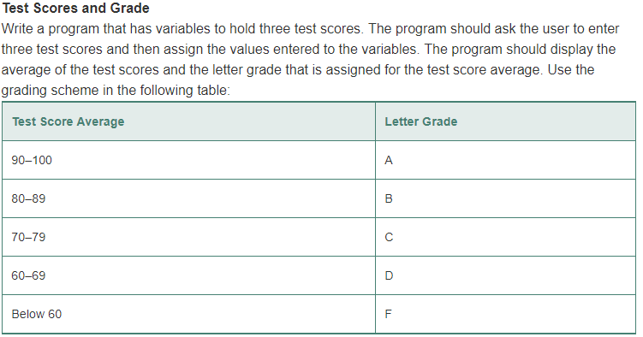

Print screen your results below here

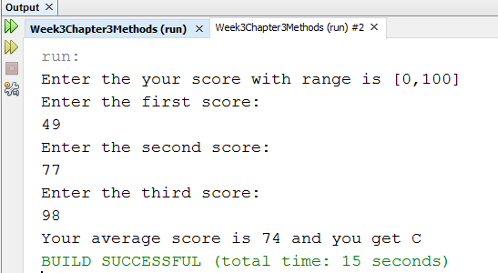

Copy and paste your code below here

package week3chapter3methods;

import java.util.\*;

public class TestScoreAndGrade

{

public static void main(String[] args)

{

Scanner scan = new Scanner(System.in);

int firstScore, secondScore, thirdScore;

int average;

String grade="";

System.out.println("Enter the your score with range is [0,100] ");

System.out.println("Enter the first score: ");

firstScore = scan.nextInt();

scan.nextLine();

System.out.println("Enter the second score: ");

secondScore = scan.nextInt();

scan.nextLine();

System.out.println("Enter the third score: ");

thirdScore = scan.nextInt();

scan.nextLine();

average = (firstScore + secondScore + thirdScore)/3;

if(average > 100 )

System.out.println("Your score can not greater than 100!");

else

{

if (average >= 90 && average <= 100)

grade = "A";

else if (average >= 80 && average <= 89)

grade = "B";

else if (average >= 70 && average <= 79)

grade = "C";

else if (average >= 60 && average <= 69)

grade = "D";

else if (average< 60)

grade = "F";

System.out.println("Your average score is " + average + " and you get " + grade);

}

}

}

Submit this document to Week 3 Class Exercise