There are 3 project each worth 33.3%

1. Turn to page 305 and complete Q13

Print screen the running application below here

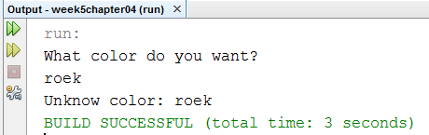

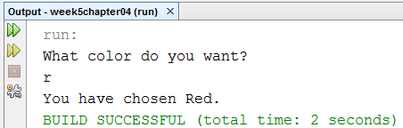

Copy and paste your code below here

package week5chapter04;

import java.util.Scanner;

public class question1

{

public static void main(String [] args)

{

Scanner scan = new Scanner(System.in);

String letter;

System.out.println("What color do you want? ");

letter = scan.nextLine();

switch(letter)

{

case "B": case "b":

System.out.println("You have chosen Blue.");

break;

case "G": case "g":

System.out.println("You have chosen Green.");

break;

case "R": case "r":

System.out.println("You have chosen Red.");

break;

default:

System.out.println("Unknow color: " + letter);

break;

}

}

}

1. Write a program that completes the requirements below:

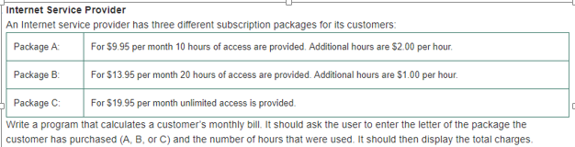

**Note: if the hours are greater than 10 or 20 for Package A or B than addition $2.00 or $1.00 charge per hour**

Print screen the running application below here

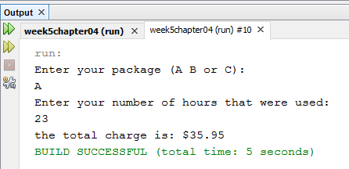

Copy and paste your code below here

package week5chapter04;

import java.util.Scanner;

public class question2

{

public static void main(String [] args)

{

Scanner scan = new Scanner(System.in);

char letter;

int hours, extra;

double totalCharge = 0;

do

{

System.out.println("Enter your package (A B or C): ");

letter = scan.next().charAt(0);

System.out.println("Enter your number of hours that were used: ");

hours = scan.nextInt();

switch (letter)

{

case 'A':

if(hours > 10)

{

extra = hours - 10;

totalCharge = 9.95 + extra*2;

}

else

{

totalCharge = 9.95;

}

break;

case 'B':

if(hours > 20)

{

extra = hours - 20;

totalCharge = 13.95 + extra;

}

else

{

totalCharge = 13.95;

}

break;

case 'C':

totalCharge = 19.95;

break;

default:

System.out.println("You are not enter (A B or C)! Try again!");

break;

}

}while((letter != 'A')&&(letter != 'B')&&(letter != 'C'));

System.out.println("the total charge is: $" + totalCharge);

}

}

1. Write a program that completes the requirements below:

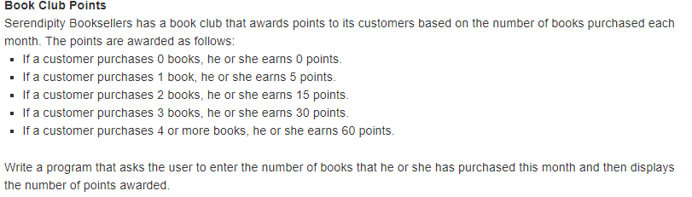

Print screen the running application below here

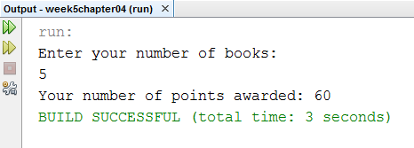

Copy and paste your code below here

package week5chapter04;

import java.util.Scanner;

public class question3

{

public static void main(String [] args)

{

Scanner scan = new Scanner(System.in);

int books, points = 0;

System.out.println("Enter your number of books: ");

books = scan.nextInt();

switch (books)

{

case 0:

points = 0;

break;

case 1:

points = 5;

break;

case 2:

points = 15;

break;

case 3:

points = 30;

break;

default:

if(books >= 4)

points = 60;

break;

}

System.out.println("Your number of points awarded: " + points);

}

}

Submit this document to week 5 class exercise