There are 2 tasks each worth 50%

Turn to page 386 and complete Q4

Print screen your running app below here

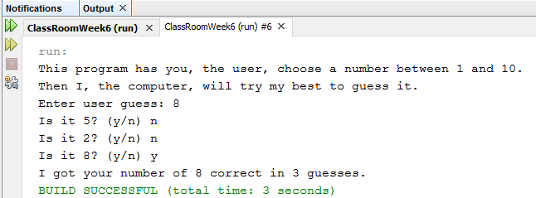

Copy and paste your code below here

package classroomweek6;

import java.util.Random;

import java.util.Scanner;

public class ClassRoomWeek6

{

public static void main(String[] args)

{

Scanner scan = new Scanner(System.in);

Random rand = new Random();

int userGuess, computerGuess, count=1;

System.out.println("This program has you, the user, choose a number between 1 and 10.\n"

+ "Then I, the computer, will try my best to guess it.");

System.out.print("Enter user guess: ");

userGuess = scan.nextInt();

if(userGuess > 10 || userGuess < 1)

{

System.out.println("Cannot go over 10");

System.exit(0);

}

scan.nextLine();

computerGuess = rand.nextInt(10) + 1;

while(userGuess != computerGuess)

{

System.out.println("Is it " + computerGuess + "? (y/n) n");

computerGuess = rand.nextInt(10) + 1;

count++;

}

System.out.println("Is it " + computerGuess + "? (y/n) y");

System.out.println("I got your number of " + userGuess + " correct in " + count + " guesses.");

}

}

Turn to page 386 and complete Q5

Print screen your running app below here

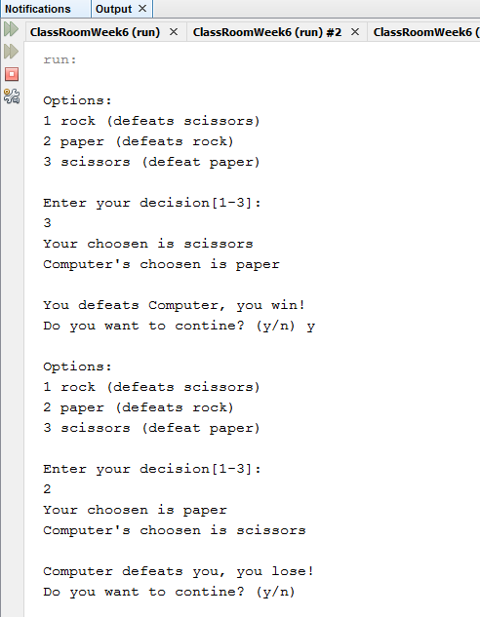

Copy and paste your code below here

package classroomweek6;

import java.util.Random;

import java.util.Scanner;

public class question5

{

public static void main(String[] args)

{

Scanner scan = new Scanner(System.in);

Random rand = new Random();

int user, computer;

String ans;

String win = "You defeats Computer, you win!";

String lose = "Computer defeats you, you lose!";

do

{

System.out.print("\nOptions:");

System.out.print("\n1 rock (defeats scissors) \n2 paper (defeats rock) \n3 scissors (defeat paper)\n\n");

System.out.print("Enter your decision[1-3]: \n");

user = scan.nextInt();

if(user < 1 || user > 3)

{

System.out.println("You have to choose one of these above selection!");

System.exit(0);

}

printDecision(user, 1);

computer = rand.nextInt(3) + 1;

printDecision(computer, 0);

if(user == computer)

{

System.out.println("The game is tie");

}

else

{

if(user == 1)

{

if(computer == 2)

System.out.println(lose);

else if (computer == 3)

System.out.println(win);

}

else if(user == 2)

{

if(computer == 1)

System.out.println(win);

else if (computer == 3)

System.out.println(lose);

}

else if (user == 3)

{

if(computer == 2)

System.out.println(win);

else if (computer == 1) {

} else {

System.out.println(lose);

}

}

}

scan.nextLine();

System.out.print("Do you want to contine? (y/n) ");

ans = scan.nextLine();

}while(ans.equals("y") || ans.equals("Y"));

}

public static void printDecision(int decision, int type)

{

switch(decision)

{

case 1:

if(type == 1)

System.out.println("Your choosen is rock");

else

System.out.println("Computer's choosen is rock\n");

break;

case 2:

if(type == 1)

System.out.println("Your choosen is paper");

else

System.out.println("Computer's choosen is paper\n");

break;

case 3:

if(type == 1)

System.out.println("Your choosen is scissors");

else

System.out.println("Computer's choosen is scissors\n");

break;

}

}

}

Submit this document to Week 6 classroom exercise