1. Turn to page 434 and complete Q#20

Print screen your running app below here

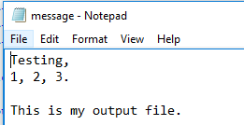

Copy and paste your code below here

package week7chapter6;

import java.io.BufferedWriter;

import java.io.File;

import java.io.FileWriter;

public class question1

{

public static void main(String[] args)

{

try

{

File f = new File("D:\\message.txt");

FileWriter fw = new FileWriter(f, true);

BufferedWriter bw = new BufferedWriter(fw);

if(f.exists())

{

bw.write("Testing,");

bw.write("\r\n");

bw.write("1, 2, 3.");

bw.write("\r\n\r\n");

bw.write("This is my output file.");

bw.close();

System.out.println("Written into the message.txt file");

}

}

catch(Exception ex)

{

System.out.println(ex);

}

}

}

1. Turn to page 435 and complete Q#21

Print screen your running app below here

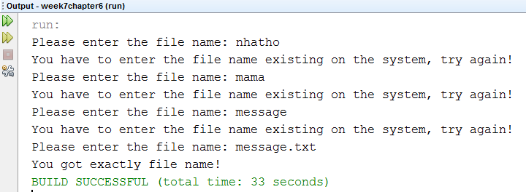

Copy and paste your code below here

package week7chapter6;

import java.io.File;

import java.util.Scanner;

public class question2

{

public static void main(String[] args)

{

String fileName;

Scanner scan = new Scanner(System.in);

do

{

System.out.print("Please enter the file name: ");

fileName = scan.nextLine();

File f = new File(fileName);

if(!f.exists())

{

System.out.println("You have to enter the file name existing on the system, try again!");

continue;

}

System.out.println("You got exactly file name!");

break;

}while(true);

}

}

1. Continuing with The JFrame project include an Address, City, State, and Zipcode and write the input Starting with Lastname to Zipcode into a .txt file



Print screen your running app below here

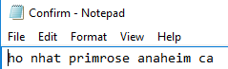

Copy and paste your code below here

package week7chapter6;

import java.awt.BorderLayout;

import java.awt.event.ActionEvent;

import java.awt.event.ActionListener;

import java.io.BufferedReader;

import java.io.BufferedWriter;

import java.io.File;

import java.io.FileReader;

import java.io.FileWriter;

import javax.swing.JButton;

import javax.swing.JFrame;

import javax.swing.JLabel;

import javax.swing.JOptionPane;

import javax.swing.JPanel;

import javax.swing.JTextField;

public class JFrameClass extends JFrame{

public static void main(String[] args)

{

//JFrame class allows the program to build something GUI

JFrame frame = new JFrameClass();

//allow the frime to utilize spaces

frame.pack();

frame.setTitle("IO Processing");

frame.setVisible(true);

}

//construct our projects

private JTextField txtLastname, txtFirstname, txtAddress, txtCity, txtState;

private JLabel lblLastname, lblFirstname, lblAddress, lblCity, lblState;

private JButton btnSubmit;

private JButton btnClear;

// intialize the objects by placing them on the frame

public JFrameClass()

{

JPanel p = new JPanel();

p.add(lblLastname = new JLabel("Lastname"));

// 20 = width

p.add(txtLastname = new JTextField(10));

p.add(lblFirstname = new JLabel("Firstname"));

// 20 = width

p.add(txtFirstname = new JTextField(10));

p.add(lblAddress = new JLabel("Address"));

p.add(txtAddress = new JTextField(10));

p.add(lblCity = new JLabel("Clty"));

p.add(txtCity = new JTextField(10));

p.add(lblState = new JLabel("State"));

p.add(txtState = new JTextField(2));

p.add(btnSubmit = new JButton ("Submit"));

p.add(btnClear = new JButton ("Clear"));

//position the frame

add(p,BorderLayout.EAST);

//places the ears

//to the button control

btnSubmit.addActionListener(new ActionListener()

{

public void actionPerformed(ActionEvent e)

{

//what is the action?

try

{

File f = new File("D:\\Confirm.txt");

FileWriter fw = new FileWriter(f,true);

BufferedWriter bw = new BufferedWriter(fw);

bw.write(txtLastname.getText() + " " + txtFirstname.getText() + " " + txtAddress.getText() + " " + txtCity.getText() + " " + txtState.getText());

bw.newLine();

bw.close();

JOptionPane.showMessageDialog(null,"Confirm");

}

catch(Exception ex)

{

JOptionPane.showMessageDialog(null,"Error " + ex);

}

}

});

btnClear.addActionListener(new ActionListener()

{

public void actionPerformed(ActionEvent e)

{

txtLastname.setText("");

txtFirstname.setText("");

txtCity.setText("");

txtState.setText("");

}

});

}

}

1. Continuing with the JFrame project include a third JButton named **Read** and when pressed will read from the .txt file

Print screen your running app below here



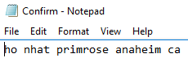

Copy and paste your code below here

package week7chapter6;

import java.awt.BorderLayout;

import java.awt.event.ActionEvent;

import java.awt.event.ActionListener;

import java.io.BufferedReader;

import java.io.BufferedWriter;

import java.io.File;

import java.io.FileReader;

import java.io.FileWriter;

import javax.swing.JButton;

import javax.swing.JFrame;

import javax.swing.JLabel;

import javax.swing.JOptionPane;

import javax.swing.JPanel;

import javax.swing.JTextField;

public class JFrameClass extends JFrame{

public static void main(String[] args)

{

//JFrame class allows the program to build something GUI

JFrame frame = new JFrameClass();

//allow the frime to utilize spaces

frame.pack();

frame.setTitle("IO Processing");

frame.setVisible(true);

}

//construct our projects

private JTextField txtLastname, txtFirstname, txtAddress, txtCity, txtState;

private JLabel lblLastname, lblFirstname, lblAddress, lblCity, lblState;

private JButton btnSubmit;

private JButton btnClear, btnRead;

// intialize the objects by placing them on the frame

public JFrameClass()

{

JPanel p = new JPanel();

p.add(lblLastname = new JLabel("Lastname"));

// 20 = width

p.add(txtLastname = new JTextField(10));

p.add(lblFirstname = new JLabel("Firstname"));

// 20 = width

p.add(txtFirstname = new JTextField(10));

p.add(lblAddress = new JLabel("Address"));

p.add(txtAddress = new JTextField(10));

p.add(lblCity = new JLabel("Clty"));

p.add(txtCity = new JTextField(10));

p.add(lblState = new JLabel("State"));

p.add(txtState = new JTextField(2));

p.add(btnSubmit = new JButton ("Submit"));

p.add(btnClear = new JButton ("Clear"));

p.add(btnRead = new JButton ("Read"));

//position the frame

add(p,BorderLayout.EAST);

//places the ears

//to the button control

btnSubmit.addActionListener(new ActionListener()

{

public void actionPerformed(ActionEvent e)

{

//what is the action?

try

{

File f = new File("D:\\Confirm.txt");

FileWriter fw = new FileWriter(f,true);

BufferedWriter bw = new BufferedWriter(fw);

bw.write(txtLastname.getText() + " " + txtFirstname.getText() + " " + txtAddress.getText() + " " + txtCity.getText() + " " + txtState.getText());

bw.newLine();

bw.close();

JOptionPane.showMessageDialog(null,"Confirm");

}

catch(Exception ex)

{

JOptionPane.showMessageDialog(null,"Error " + ex);

}

}

});

btnRead.addActionListener(new ActionListener()

{

public void actionPerformed(ActionEvent e)

{

try{

File f = new File("D:\\Confirm.txt");

FileReader fr = new FileReader(f);

BufferedReader br = new BufferedReader(fr);

String read;

while((read=br.readLine()) !=null)

{

JOptionPane.showMessageDialog(null, read);

}

JOptionPane.showMessageDialog(null, br);

}

catch(Exception ex)

{

JOptionPane.showMessageDialog(null, ex);

}

}

});

btnClear.addActionListener(new ActionListener()

{

public void actionPerformed(ActionEvent e)

{

txtLastname.setText("");

txtFirstname.setText("");

txtCity.setText("");

txtState.setText("");

}

});

}

}

Submit this document to Week 6 classroom exercise