Objectives:

* Arrays + 3 Classroom Exercises (Save this document somewhere safe, it will be uploaded on our 2nd meeting with the REST of classroom Exercises) each worth 16.6 points

1. Here is an example

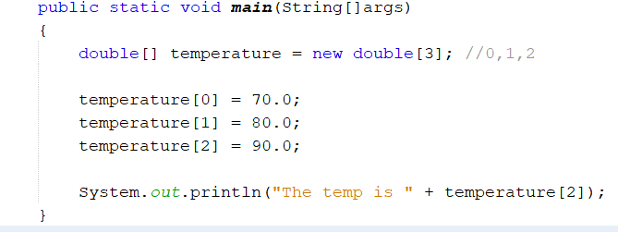

1. An example of an index out of bounds

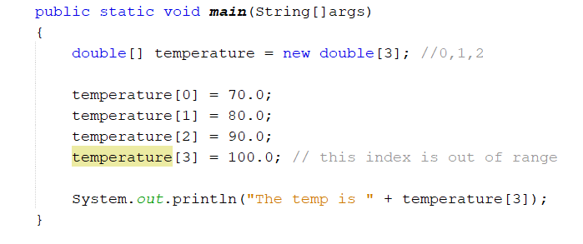

1. Now, change the [3] to [4]

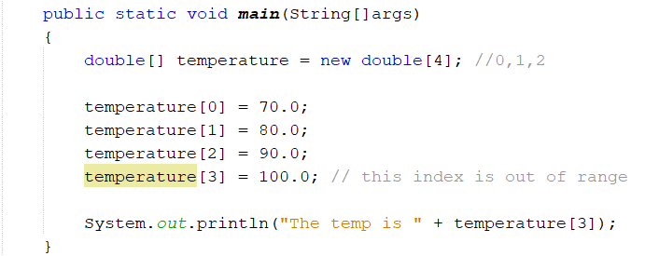

1. You can go over the index, change the [4] to [10] and write a for loop

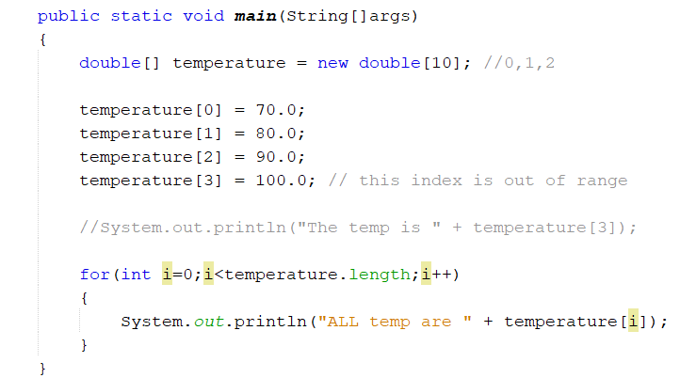

1. Looping through String Arrays

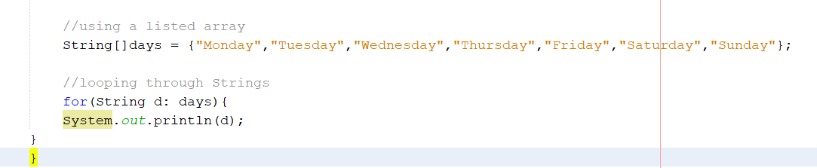

Passing days array variable to the String d variable

1. A complete program based on the temp

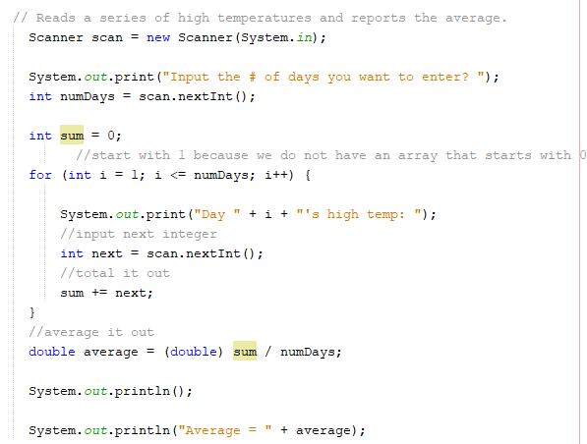

1. **Class Exercise #1:** Implement an array to question #6 with 3 inputs

Print screen your results below here

Copy and paste your code below here

1. 2-D Arrays

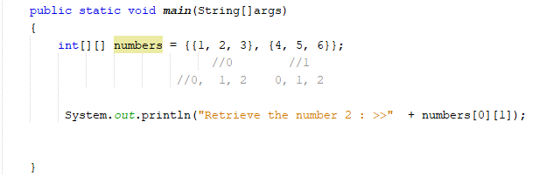

1. **Class Exercise #2:** Use a nested for loop to retrieve all numbers from both arrays for question #8, here is an example below

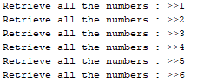

Print screen your results below here

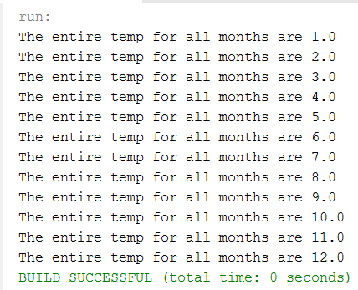

Copy and paste your code below here

1. Summing the arrays in a for loop

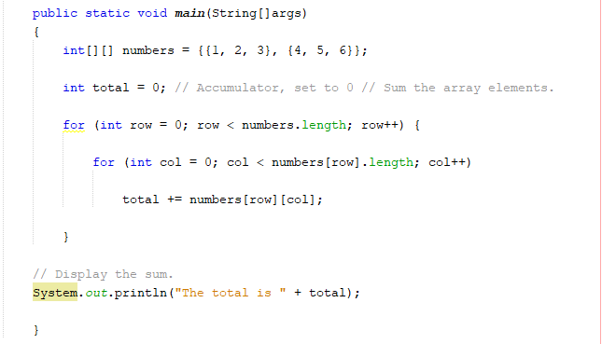

1. Example of a 3-D array

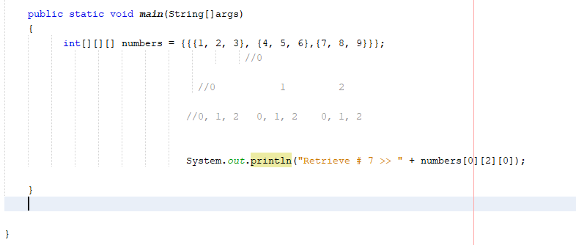

1. For loop on a 3-D array

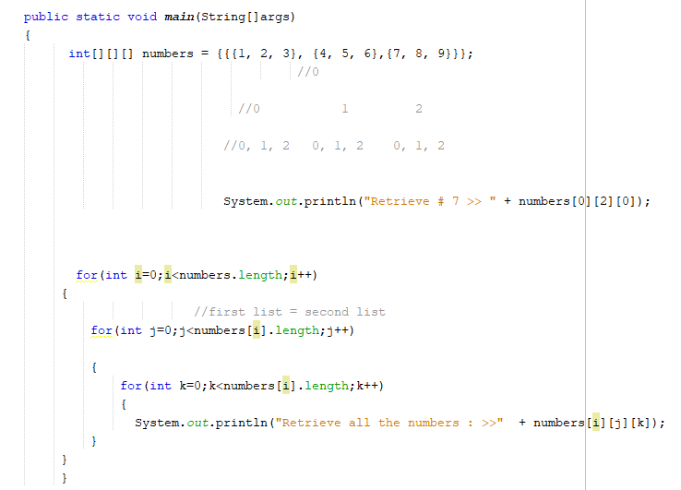

1. **Class Exercise #3:** Sum all 3 arrays for question # 12

Below is an example:



Print screen your results below here

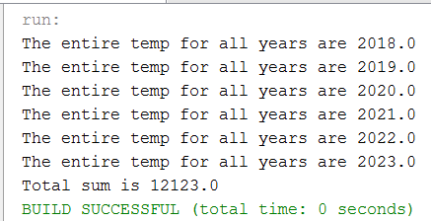

Copy and paste your code below here

package week9chapter7;

public class Week9chapter7

{

public static void main(String[] args)

{

double [] temp = new double[3];

temp[0] = 70.0;

temp[1] = 80.0;

temp[2] = 90.0;

System.out.println("Todays temp is " + temp[1]);

for(int i=0; i<temp.length; i++)

{

System.out.println("The entire temp for all days are " + temp[i]);

}

double [] days = {1,2,3};

double months [][] = { {1,2,3,4,5,6} , {7,8,9,10,11,12} };

for(int i =0; i < months.length; i++)

{

for(int j = 0; j < months[i].length; j++)

{

System.out.println("The entire temp for all months are " + months[i][j]);

}

}

double years [][][] = {{{2018,2019}, {2020,2021}, {2022,2023}}};

//////////////////////////////////////////////////////0

/////////////////////////0/////////1///////2///////////

double total = 0;

for(int i =0; i < years.length; i++)

{

for(int j = 0; j < years[i].length; j++)

{

for(int k = 0; k < years[i][j].length; k++)

{

System.out.println("The entire temp for all years are " + years[i][j][k]);

total += years[i][j][k];

}

}

}

System.out.println("Total sum is " + total);

}

}

Important: save this document somewhere safe, it will be submitted on the 2nd meeting with the rest of the classroom exercises (DO NOT SUBMIT THIS DOCUMENT NOW)