There are 8 exercises each worth 12.5 points

1. Complete the following:



Note: use numbers 1-20 for elements

#1 Print screen your results below here

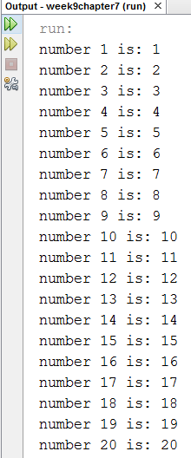

Copy and paste your code below here

package week9chapter7;

public class Week9chapter7

{

public static void main(String[] args)

{

int [] names = new int[20];

// Initial the value for array

for(int i = 0; i < 20; i++)

names[i] = i+1;

// Print out the elements of the array

for(int i = 0; i < 20; i++)

System.out.println("number " + (i+1) + " is: " + names[i]);

}

}

1. For Question #1, Sum the 20 elements.

#2 print screen your results below here

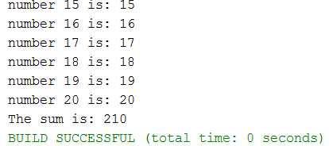

Copy and paste your code below here

package week9chapter7;

public class Week9chapter7

{

public static void main(String[] args)

{

int sum = 0;

int [] names = new int[20];

// Initial the value for array

for(int i = 0; i < 20; i++)

names[i] = i+1;

// Print out the elements of the array

for(int i = 0; i < 20; i++)

{

System.out.println("number " + (i+1) + " is: " + names[i]);

sum += names[i];

}

System.out.println("The sum is: " + sum);

}

}

1. Complete the following:



Then be sure to loop through each name and print it.

#3 print screen your results below here

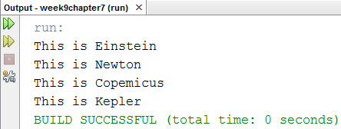

Copy and paste your code below here

package week9chapter7;

public class question3

{

public static void main(String[] args)

{

String [] master = {"Einstein", "Newton", "Copemicus", "Kepler"};

for(int i = 0; i < master.length; i++)

System.out.println("This is " + master[i]);

}

}

1. Copy and paste the code below and average the array

int[] numbers = new int[]{20, 30, 25, 35, -16, 60, -100};

//calculate sum of all array elements

int sum = 0;

for(int i=0; i < numbers.length ; i++)

sum = sum + numbers[i];

//calculate average value

System.out.println("Average value of the array elements is : " + average);

}

}

#4 print screen your results below here

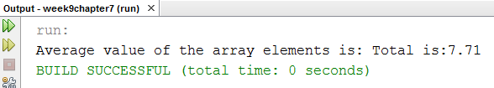

Copy and paste your code below here

package week9chapter7;

public class question4

{

public static void main(String[] args)

{

int[] numbers = new int[]{20, 30, 25, 35, -16, 60, -100};

//calculate sum of all array elements

int sum = 0;

double average = 0;

for(int i=0; i < numbers.length ; i++)

sum = sum + numbers[i];

//calculate average value

average = sum/(numbers.length \* 1.0); // convert to double number

System.out.print("Average value of the array elements is: ");

System.out.printf("Total is:%.2f\n", average);

}

}

1. Create a 3-D array for the numbers 10,20,30,40,50,60,70,80,90 and retrieve the number 50

#5 print screen your results below here

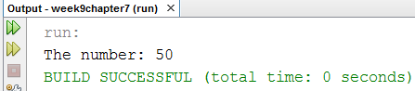

Copy and paste your code below here

package week9chapter7;

public class question5

{

public static void main(String[] args)

{

int numbers[][][] = {{ {10,20,30}, {40,50,60}, {70,80,90} }};

System.out.println("The number: " + numbers[0][1][1]);

}

}

1. For question #5, retrieve all numbers for the 3-D array

#6 print screen your results below here

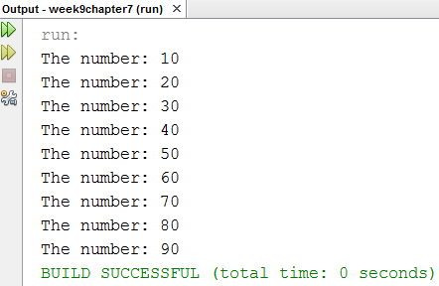

Copy and paste your code below here

package week9chapter7;

public class question5

{

public static void main(String[] args)

{

int numbers[][][] = {{ {10,20,30}, {40,50,60}, {70,80,90} }};

for(int a = 0; a < numbers.length; a++)

{

for(int b = 0; b < numbers[a].length; b++)

{

for(int c = 0; c < numbers[a][b].length; c++)

System.out.println("The number: " + numbers[a][b][c]);

}

}

}

}

1. Create a 2-D array for the numbers 100,200,300,400 and retrieve the number 300

#7 print screen your results below here

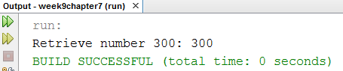

Copy and paste your code below here

package week9chapter7;

public class question7

{

public static void main(String[] args)

{

int numbers[][] = { {100, 200},{300, 400} };

System.out.println("Retrieve number 300: " + numbers[1][0]);

}

}

1. For question #7, retrieve all numbers for the 2-D array

#8 print screen your results below here

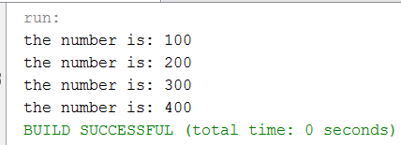

Copy and paste your code below here

package week9chapter7;

public class question7

{

public static void main(String[] args)

{

int numbers[][] = { {100, 200},{300, 400} };

for (int[] number : numbers) {

for (int b = 0; b < number.length; b++) {

System.out.println("the number is: " + number[b]);

}

}

}

}

Submit this document + the (Week 9 Chapter 07 Arrays (Student Copy) + Classroom Exercise Part I) we did together in-class (you can download this from Week 09 Module Lecture and Labs) if you have not completed the Exercise Part I