Complete the following tasks below

There are 3 tasks each worth 33.3%

Task #1



Print screen your results below here

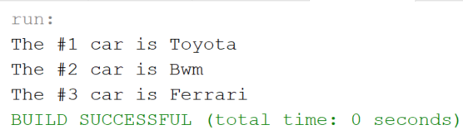

Copy and paste your code below here

import java.util.ArrayList;

public class week12Hw

{

public static void main(String[] args)

{

ArrayList<String> arr = new ArrayList<String>();

arr.add("Toyota");

arr.add("Bwm");

arr.add("Ferrari");

for(int i = 0; i < arr.size(); i++)

{

System.out.println("The #" + (i+1) + " car is " + arr.get(i));

}

}

}

Task #2

Using the example from Example #1, Write code that creates an ArrayList that can hold String objects with a Scanner that will ask for the last middle and first names and age. Ensure that you use Integer ArrayList for the age.

Print screen your results below here

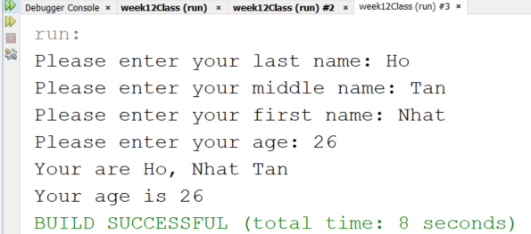

Copy and paste your code below here

import java.util.ArrayList;

import java.util.Scanner;

public class number2

{

public static void main(String[] args)

{

ArrayList arr = new ArrayList();

Scanner scan = new Scanner(System.in);

String lastName, middleName, firstName;

int age;

System.out.print("Please enter your last name: ");

lastName = scan.nextLine();

System.out.print("Please enter your middle name: ");

middleName = scan.nextLine();

System.out.print("Please enter your first name: ");

firstName = scan.nextLine();

System.out.print("Please enter your age: ");

age = scan.nextInt();

arr.add(lastName);

arr.add(middleName);

arr.add(firstName);

arr.add(age);

String output;

System.out.println("Your are " + arr.get(0) + ", " + arr.get(2) + " " + arr.get(1));

System.out.println("Your age is " + arr.get(3));

}

}

Task #3

Using the example from Example #2, cont... With the code so it will output to a text file using the FileWriter and BufferedWriter classes.

Print screen your results below here

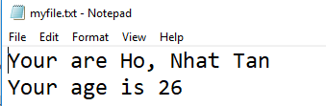

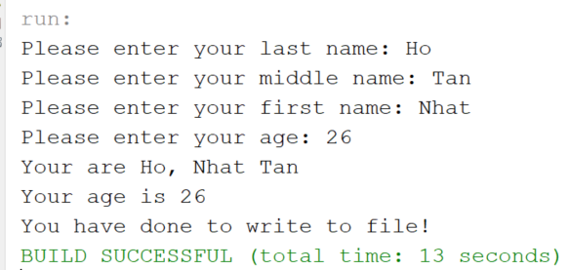

Copy and paste your code below here

import java.io.BufferedWriter;

import java.io.File;

import java.io.FileWriter;

import java.io.IOException;

import java.util.ArrayList;

import java.util.Scanner;

public class number3

{

public static void main(String[] args)

{

ArrayList arr = new ArrayList();

Scanner scan = new Scanner(System.in);

String lastName, middleName, firstName;

int age;

System.out.print("Please enter your last name: ");

lastName = scan.nextLine();

System.out.print("Please enter your middle name: ");

middleName = scan.nextLine();

System.out.print("Please enter your first name: ");

firstName = scan.nextLine();

System.out.print("Please enter your age: ");

age = scan.nextInt();

arr.add(lastName);

arr.add(middleName);

arr.add(firstName);

arr.add(age);

String output = "Your are " + arr.get(0) + ", " + arr.get(2) + " " + arr.get(1) +

"\r\nYour age is " + arr.get(3);

System.out.println(output);

try

{

File file = new File("./myfile.txt");

if (!file.exists())

{

file.createNewFile();

}

FileWriter fw = new FileWriter(file);

BufferedWriter bw = new BufferedWriter(fw);

bw.write(output);

bw.close();

System.out.println("You have done to write to file!");

}

catch(IOException ex)

{

System.out.println("Error in closing the BufferedWriter "+ex);

}

}

}