Complete the following tasks below, there are 2 tasks each worth 50 points

1. Complete the following ArrayLists below with an output for each list, the output can be anything

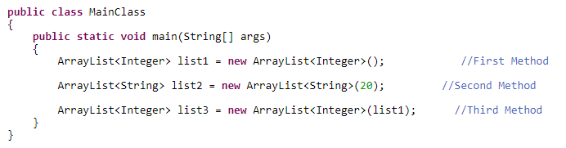

#1 Print screen the results below here

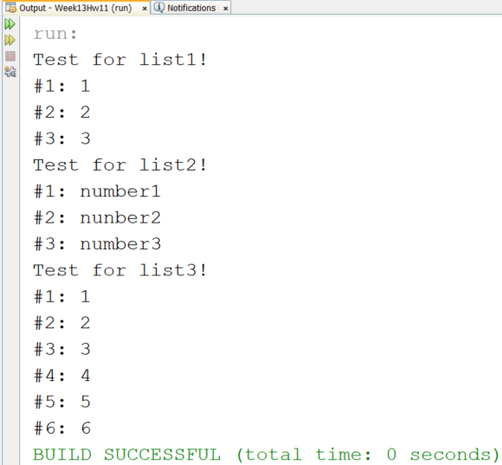

Copy and paste the code below here

import java.util.ArrayList;

public class MainClass

{

public static void main(String[] args)

{

System.out.println("Test for list1!");

ArrayList<Integer> list1 = new ArrayList<Integer>();

list1.add(1);

list1.add(2);

list1.add(3);

for(int i = 0; i < list1.size(); i++)

System.out.println("#" + (i+1) + ": " + list1.get(i));

System.out.println("Test for list2!");

ArrayList<String> list2 = new ArrayList<String>(20);

list2.add("number1");

list2.add("nunber2");

list2.add("number3");

for(int i = 0; i < list2.size(); i++)

System.out.println("#" + (i+1) + ": " + list2.get(i));

System.out.println("Test for list3!");

ArrayList<Integer> list3 = new ArrayList<Integer>(list1);

list3.add(4);

list3.add(5);

list3.add(6);

for(int i = 0; i < list3.size(); i++)

System.out.println("#" + (i+1) + ": " + list3.get(i));

}

}

1. Complete the following in an ArrayList

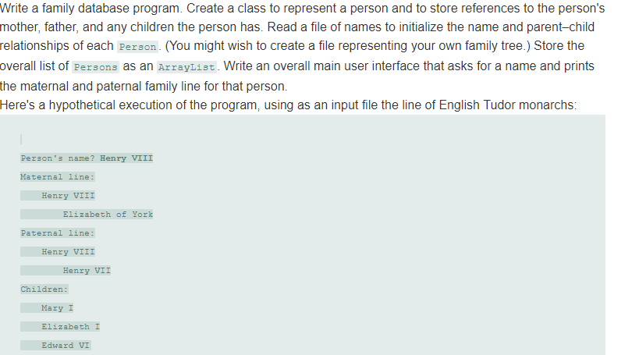

#2 print screen the results below here

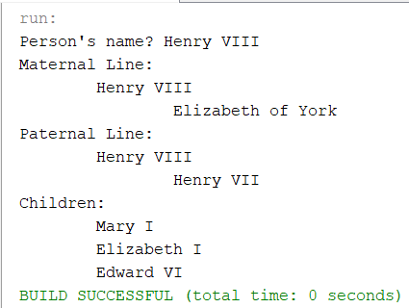

Copy and paste the code below here

package week9homework7;

import java.util.ArrayList;

public class Person

{

ArrayList<String> children = new ArrayList<String>();

public String personTest()

{

return "Henry VIII";

}

public String getFather()

{

return "Henry VII";

}

public String getMother()

{

return "Elizabeth of York";

}

public void showMaternal()

{

System.out.println("Person's name? " + personTest());

System.out.println("Maternal Line:");

System.out.println("\t" + personTest());

System.out.println("\t\t" + getMother());

}

public void showPaternal()

{

System.out.println("Paternal Line:");

System.out.println("\t" + personTest());

System.out.println("\t\t" + getFather());

}

public void getChildren()

{

children.add("Mary I");

children.add("Elizabeth I");

children.add("Edward VI");

}

public void showChildren()

{

System.out.println("Children:");

System.out.println("\t" + children.get(0));

System.out.println("\t" + children.get(1));

System.out.println("\t" + children.get(2));

}

}

package week9homework7;

public class Main

{

public static void main(String[] args)

{

Person p = new Person();

p.showMaternal();

p.showPaternal();

p.getChildren();

p.showChildren();

}

}

Submit this document to Week 13 Homework