There are 4 projects each worth 25%

Turn to page 182 and complete question #2

Print screen the running application below here

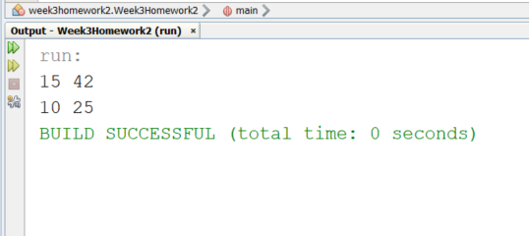

Copy and paste your code below here

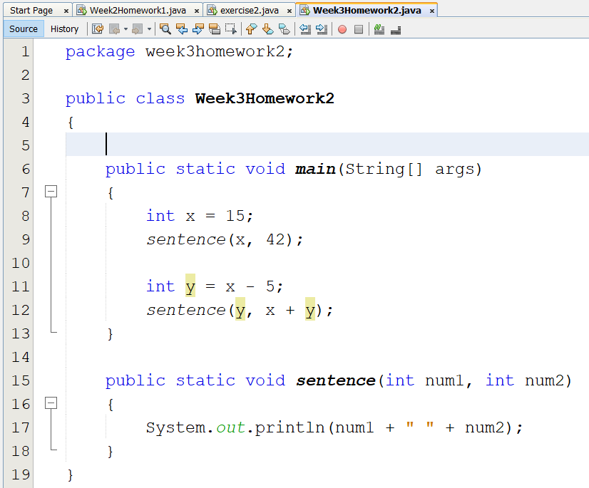

Turn to page 182-183 and complete question #3

Print screen the running application below here

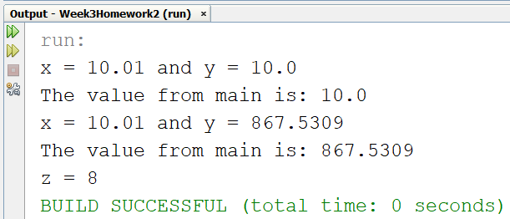

Copy and paste your code below here

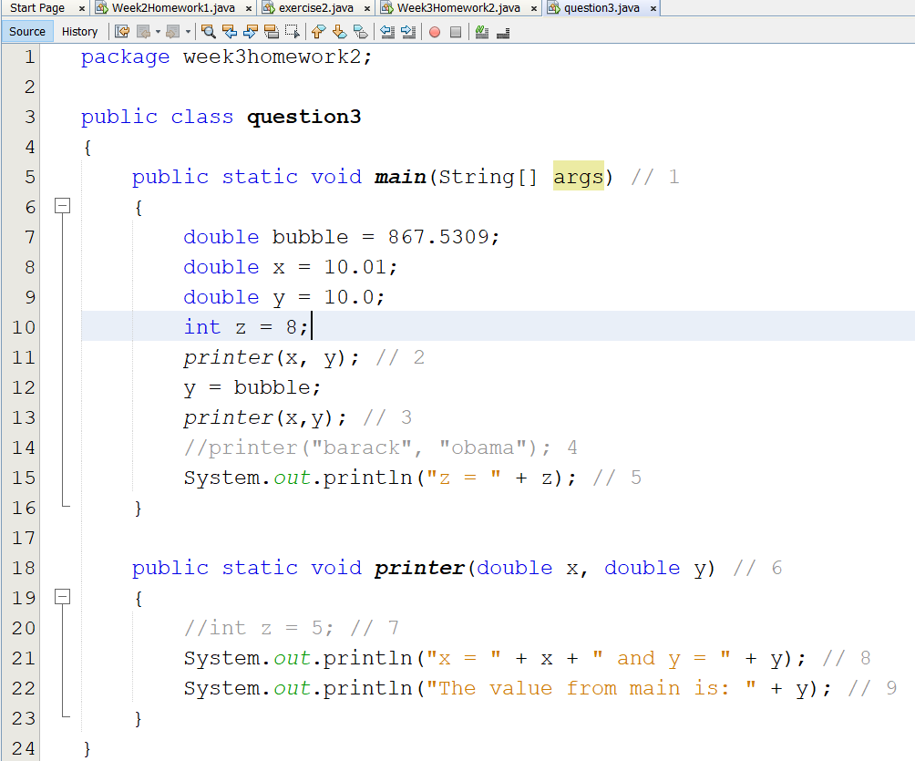

Turn to page 189 and complete question #22

Print screen the running application below here

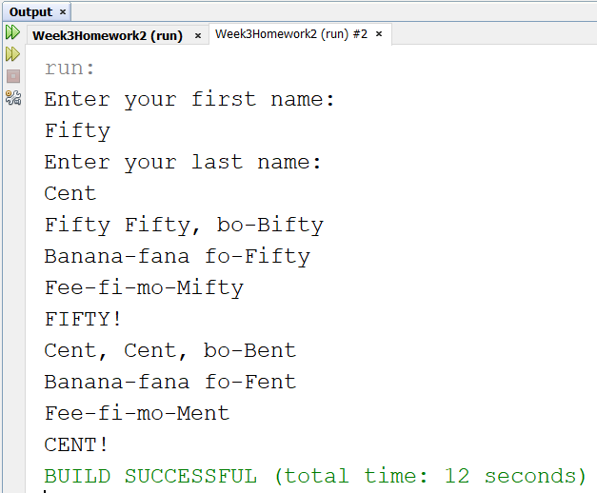

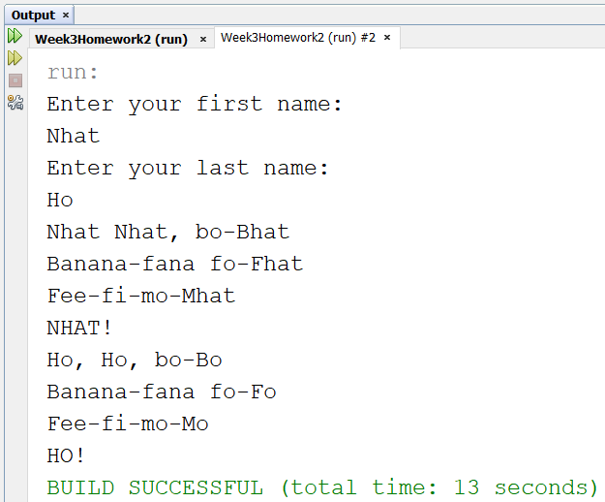



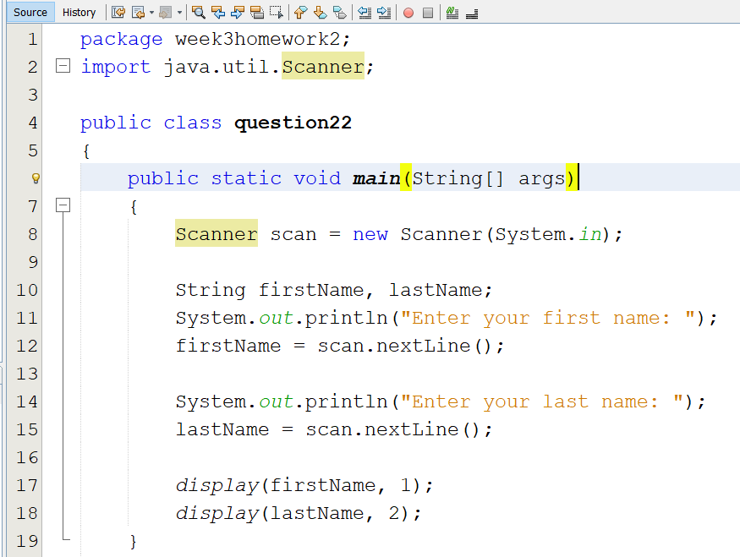

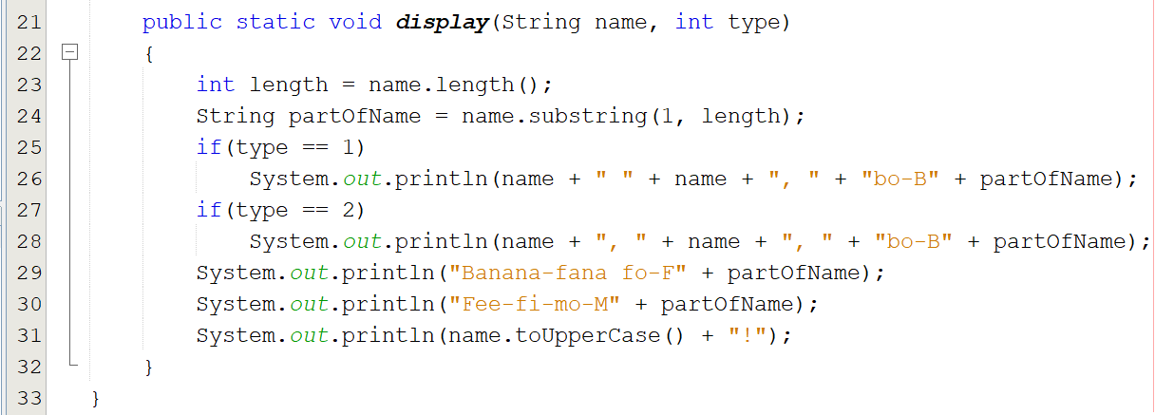

Turn to page 189 and complete question #25

Print screen the running application below here

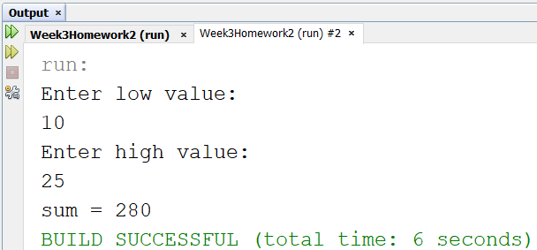

Copy and paste your code below here

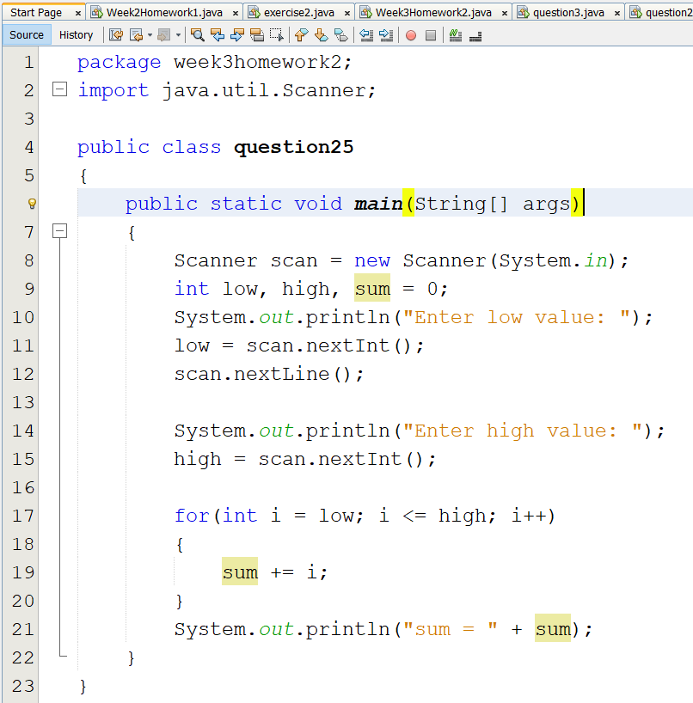

Submit this document to week 3 homework in Canvas