Complete the following below:

1. Turn to page 51 #23 and write a Java Program that completes the requirement(s).

Print screen the running app with results below here

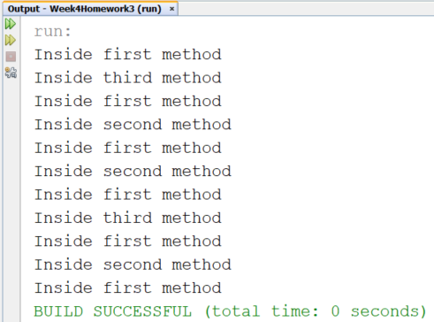

Copy and Paste your code below here

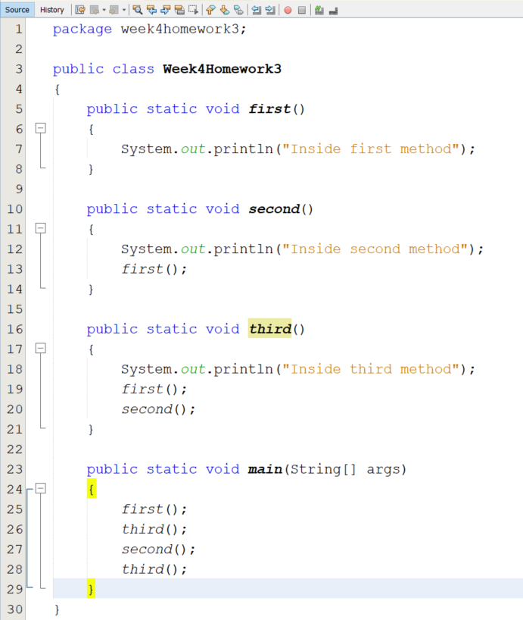

1. Turn to page 55 #5 and write a Java Program that completes the requirement(s).

Print screen the running app with results below here

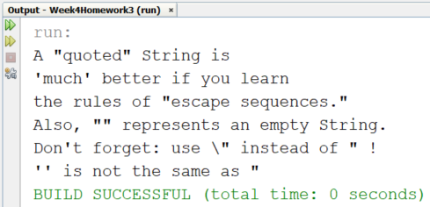

Copy and Paste your code below here

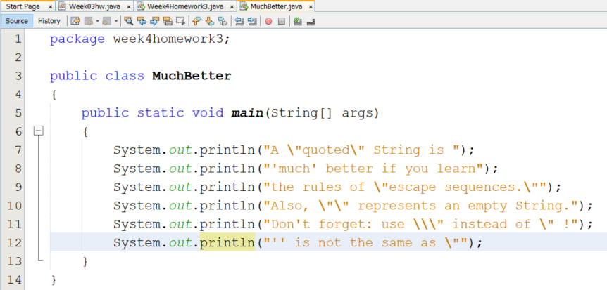

1. Turn to page 125 #27 and write a Java Program that completes the requirements(s).

Print screen the running app with results below here

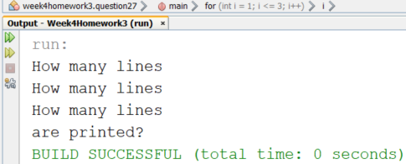

Copy and Paste your code below here

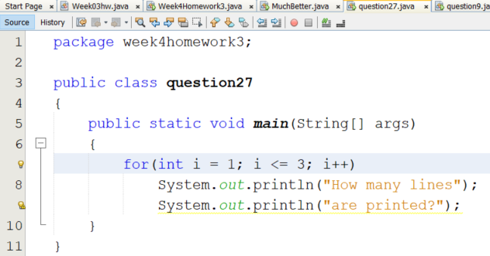

1. Turn to page 185 #9 and write a Java Program that completes the requirement(s).

Print screen the running app with results below here

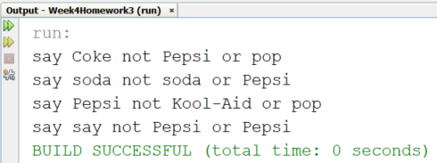

Copy and Paste your code below here

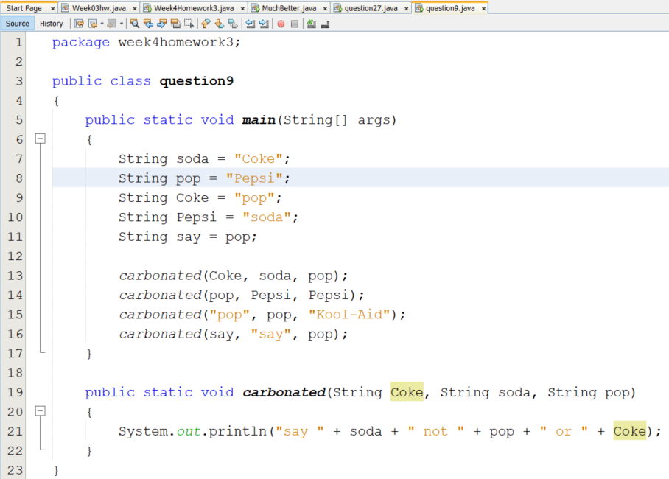

Submit this document to Week 4 Canvas