There are 4 tasks each worth 25 points

Task #1

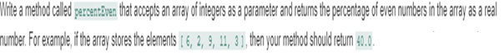

#1 Print screen your results below here

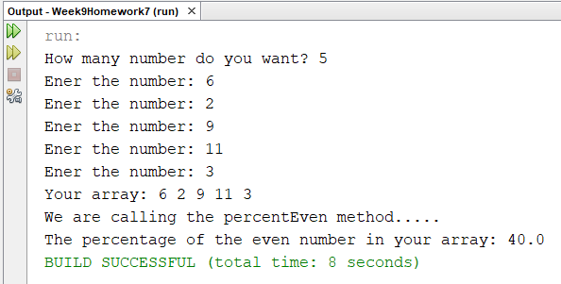

Copy and paste your code below here

package week9homework7;

import java.util.Scanner;

public class Week9Homework7

{

public static void main(String[] args)

{

Scanner scan = new Scanner(System.in);

int numbers = 0;

int[] array;

double percent = 0;

System.out.print("How many number do you want? ");

numbers = scan.nextInt();

array = new int[numbers];

for(int c = 0; c < numbers; c++)

{

System.out.print("Ener the number: ");

array[c] = scan.nextInt();

}

showArray(array);

System.out.print("\nWe are calling the percentEven method.....");

percent = percentEven(array);

System.out.println("\nThe percentage of the even number in your array: " + percent);

}

public static void showArray(int array[])

{

System.out.print("Your array: ");

for(int c = 0; c < array.length; c++)

{

System.out.print(array[c] + " ");

}

}

public static double percentEven(int array[])

{

double count = 0, percent = 0;

for(int i = 0; i< array.length; i++)

{

if(array[i]%2 == 0)

count++;

}

percent = (count / array.length)\*100;

return percent;

}

}

Task #2

Retrieve all numbers as shown below for the 2 separate arrays

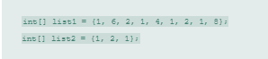

#2 print screen your results below here

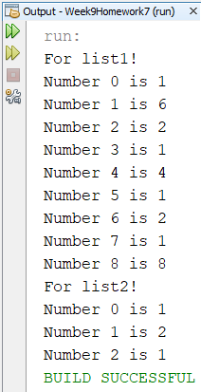

Copy and paste your code below here

package week9homework7;

public class question2

{

public static void main(String[] args)

{

int[] list1 = {1, 6, 2, 1, 4, 1, 2, 1, 8};

int[] list2 = {1, 2, 1};

System.out.println("For list1!");

for(int i = 0; i < list1.length; i++)

System.out.println("Number " + i + " is " + list1[i]);

System.out.println("For list2!");

for(int i = 0; i < list2.length; i++)

System.out.println("Number " + i + " is " + list2[i]);

}

}

Task #3

Based on the following 3-d array retrieve the numbers 3 6 and 9



#3 print screen your results below here

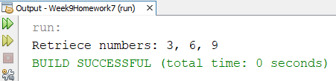

Copy and paste your code below here

package week9homework7;

public class question3

{

public static void main(String[] args)

{

int [][][] threeD = {{ {1, 2, 3}, {4, 5, 6}, {7, 8, 9} }};

System.out.print("Retriece numbers: ");

System.out.println(threeD[0][0][2] + ", " + threeD[0][1][2]

+ ", " + threeD[0][2][2]);

}

}

Task #4

Loop through each array and retrieve all numbers in each array for Task #3

#4 print screen your results below here

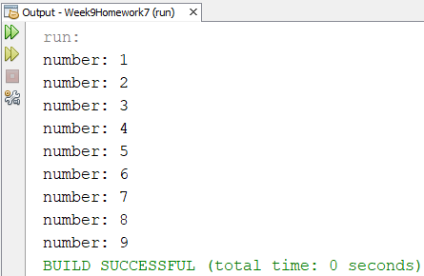

Copy and paste your code below here

package week9homework7;

public class question3

{

public static void main(String[] args)

{

int [][][] threeD = {{ {1, 2, 3}, {4, 5, 6}, {7, 8, 9} }};

for (int[][] threeD1 : threeD)

{

for (int[] item : threeD1)

{

for (int c = 0; c < item.length; c++)

System.out.println("number: " + item[c]);

}

}

}

}

Submit this document to week 09 Homework