There are 4 tasks each worth 25%

**Task #1**



Print screen the running app below here with the result(s)

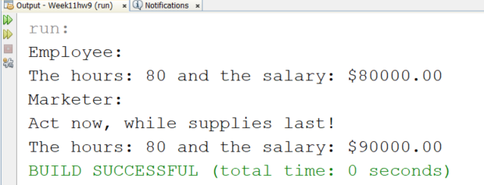

Copy and paste your code below here

package week11hw9;

**public class Employee**

{

public int getHours()

{

return 80;

}

public double getSalary(){

return 80000.0;

}

public int getVacationDays(){

return 20;

}

public String getVacationForm(){

return "red";

}

}

package week11hw9;

**public class Marketer extends Employee**

{

public void advertise()

{

System.out.println("Act now, while supplies last!");

}

@Override

public double getSalary()

{

return super.getSalary() + 10000;

}

}

package week11hw9;

**public class Week11hw9**

**{**

**public static void main(String[] args)**

{

System.out.println("Employee:");

Employee edna = new Employee();

System.out.print("The hours: " + edna.getHours() + " and the salary: ");

System.out.printf("$%.2f\n", edna.getSalary());

System.out.println("Marketer:");

Marketer stan = new Marketer();

stan.advertise();

System.out.print("The hours: " + stan.getHours() + " and the salary: ");

System.out.printf("$%.2f\n", stan.getSalary());

}

}

**Task #2**



Print screen the running app below here with the result(s)

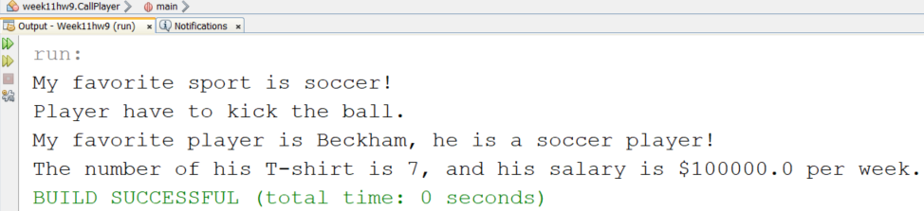

Copy and paste your code below here

package week11hw9;

**public class Player**

{

String sport, name;

int number;

double salary;

public void setSport(String whatSport)

{

sport = whatSport;

}

public void setName(String newName)

{

name = newName;

}

public void setNumber(int newNumber)

{

number = newNumber;

}

public void setSalary(double newSalary)

{

salary = newSalary;

}

public String getSport()

{

return sport;

}

public String getName()

{

return name;

}

public int getNumber()

{

return number;

}

public double getSalary()

{

return salary;

}

}

package week11hw9;

**public class Soccer extends Player**

{

public void showFavorite()

{

System.out.println("My favorite sport is soccer!");

}

public void showInfor()

{

System.out.println("Player have to kick the ball.");

}

}

package week11hw9;

**public class CallPlayer**

**{**

**public static void main(String[] args)**

**{**

Soccer davis = new Soccer();

davis.setName("Beckham");

davis.setSport("soccer");

davis.setNumber(7);

davis.setSalary(100000);

davis.showFavorite();

davis.showInfor();

System.out.print("My favorite player is " + davis.getName());

System.out.println(", he is a " + davis.getSport() + " player!");

System.out.print("The number of his T-shirt is " + davis.getNumber());

System.out.println(", and his salary is $" + davis.getSalary() + " per week.");

}

}

**Task #3**

Get the output of this code, you will have to separate the code into different classes

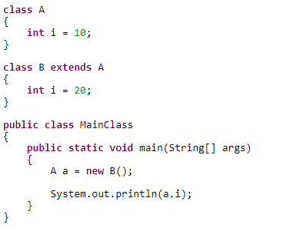

Print screen the running app below here with the result(s)

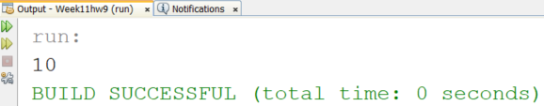

Copy and paste your code below here

package week11hw9;

**public class A**

{

int i = 10;

}

package week11hw9;

public class B extends A

{

int i = 20;

}

package week11hw9;

**public class MainClass**

{

public static void main(String[] args)

{

A a = new B();

System.out.println(a.i);

}

}

**Task #4**

Get the output of this code, you will have to separate the code into different classes

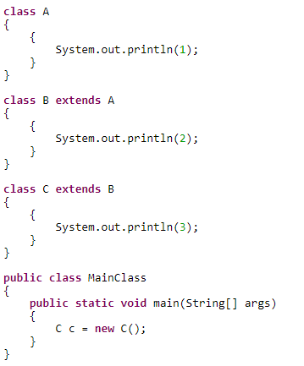

Print screen the running app below here with the result(s)

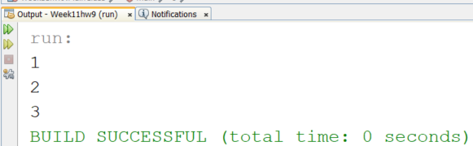

Copy and paste your code below here

package week11hw9;

**public class A**

{

{

System.out.println(1);

}

}

package week11hw9;

**public class B extends A**

{

{

System.out.println(2);

}

}

package week11hw9;

**public class C extends B**

{

{

System.out.println(3);

}

}

package week11hw9;

**public class MainClass**

{

**public static void main(String[] args)**

{

C c = new C();

}

}

Submit this document to Week 11 Homework