Instructions:

* Please NO talking during exam
* Open Book
* Instructor cannot assist with the exam
* The exam must be submitted by end of class

There are 4 tasks each worth 25 points

Based on Chapter 04 (Conditional Executions)

Complete the following below:

Task #1

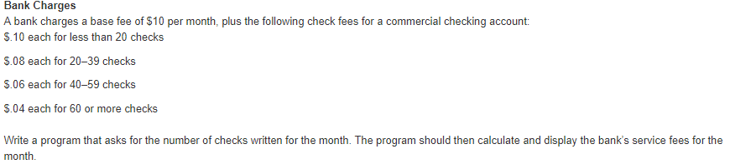

Print screen your running app below here

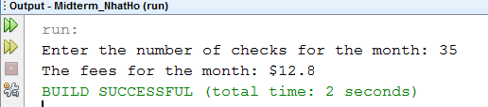

Copy and paste your code below here

package midterm_nhatho;

import java.util.Scanner;

public class Midterm_NhatHo

{

public static void main(String[] args)

{

Scanner scan = new Scanner(System.in);

int numberChecks;

double fees = 10;

double rate = 0;

System.out.print("Enter the number of checks for the month: ");

numberChecks = scan.nextInt();

if(numberChecks < 20)

rate = 0.1;

else if(numberChecks >=20 && numberChecks <= 39)

rate = 0.08;

else if(numberChecks >= 40 && numberChecks <= 59)

rate = 0.06;

else if(numberChecks >= 60)

rate = 0.04;

fees += rate * numberChecks;

System.out.println("The fees for the month: $" + fees);

}

}

Task #2

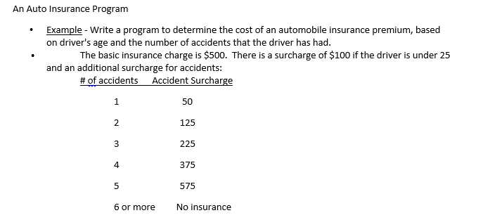

Print screen your running app below here

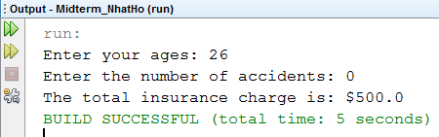

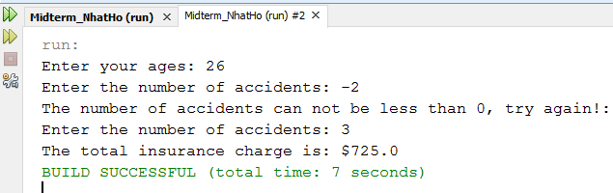

Copy and paste your code below here

package midterm_nhatho;

import java.util.Scanner;

public class task2

{

public static void main(String[] args)

{

Scanner scan = new Scanner(System.in);

int ages, numAccidents;

double charges = 500, surcharge = 0;

System.out.print("Enter your ages: ");

ages = scan.nextInt();

while(true)

{

System.out.print("Enter the number of accidents: ");

numAccidents = scan.nextInt();

if(numAccidents < 0)

{

System.out.println("The number of accidents can not be less than 0, try again!: ");

continue;

}

else

{

switch(numAccidents)

{

case 0:

surcharge = 0;

break;

case 1:

surcharge = 50;

break;

case 2:

surcharge = 125;

break;

case 3:

surcharge = 225;

break;

case 4:

surcharge = 375;

break;

case 5:

surcharge = 575;

break;

default:

surcharge = 0;

break;

}

}

break;

}

if(ages < 25)

surcharge += 100;

charges += surcharge;

System.out.println("The total insurance charge is: $" + charges);

}

}

Task #3

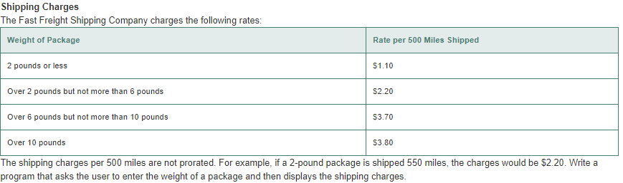

Print screen your running app below here

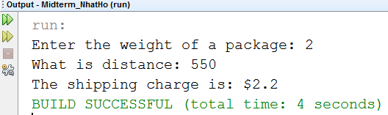

Copy and paste your code below here

package midterm_nhatho;

import java.util.Scanner;

public class task3

{

public static void main(String[] args)

{

int distanceMultiple;

double weight = 0, charge = 0, distance = 0;

Scanner scan = new Scanner(System.in);

System.out.print("Enter the weight of a package: ");

weight = scan.nextDouble();

System.out.print("What is distance: ");

distance = scan.nextDouble();

distanceMultiple = (int)distance / 500;

if((distance % 500)!=0)

distanceMultiple++;

if(weight <= 2)

charge = distanceMultiple * 1.1;

else if(weight > 2 && weight <= 6)

charge = distanceMultiple * 2.2;

else if(weight > 6 && weight <= 10)

charge = distanceMultiple * 3.7;

else if(weight > 10)

charge = distanceMultiple * 3.8;

System.out.println("The shipping charge is: $" + charge);

}

}

Task #4

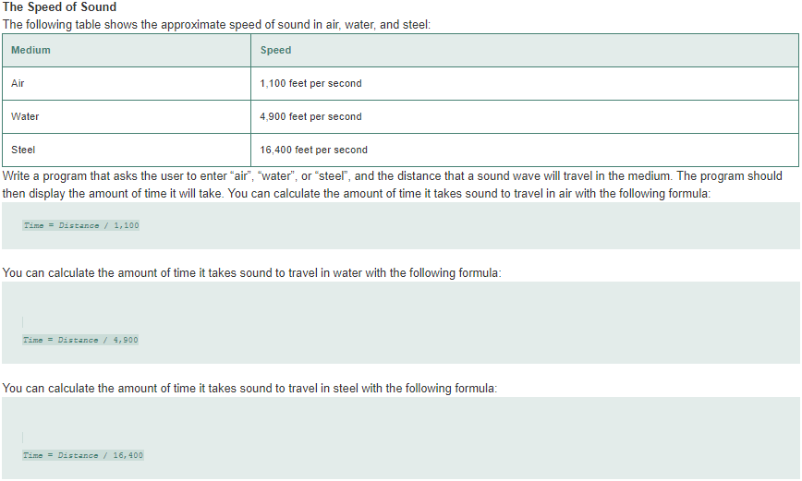

Print screen your running app below here

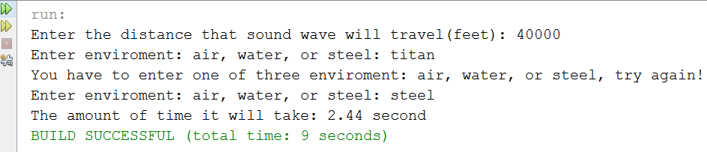

Copy and paste your code below here

package midterm_nhatho;

import java.util.Scanner;

public class task4

{

public static void main(String[] args)

{

Scanner scan = new Scanner(System.in);

String type;

double distance, time;

int speedAir = 1100, speedWater = 4900, speedSteel = 16400;

System.out.print("Enter the distance that sound wave will travel(feet): ");

distance = scan.nextDouble();

scan.nextLine();

while(true)

{

System.out.print("Enter enviroment: air, water, or steel: ");

type = scan.nextLine();

if(type.equalsIgnoreCase("air"))

time = distance / speedAir;

else if(type.equalsIgnoreCase("water"))

time = distance / speedWater;

else if(type.equalsIgnoreCase("steel"))

time = distance / speedSteel;

else

{

System.out.print("You have to enter one of three enviroment: air, water, or steel,");

System.out.println(" try again!");

continue;

}

break;

}

System.out.print("The amount of time it will take: ");

System.out.printf("%.2f second\n", time);

}

}

Submit this document to Canvas Week 8