Please read Instructions:

1. This is an **open** **book** final
2. Please no **talking**
3. The **instructor** cannot assist on the final

Good Luck!

Please print screen clearly… There are **6** questions with **6** print screens each worth 16.6%

Based on Chapters 6-8

Chapter 06 File Processing

1. Use a Scanner that asks the user to input the last name, first name and age and output the following in the exact format as shown below:

The full name of the student is last and first name input and the age is age input

Example if the user enters John Doe with the age 18 then the output would be *>> the full name of the student is Doe and John and the age is 18 input*

#1 Print screen the output below here

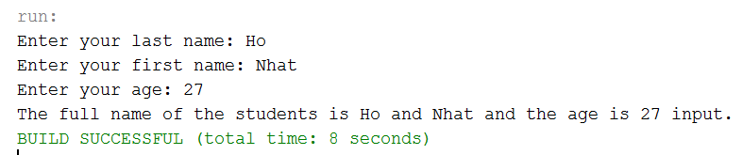

#1 print screen your code below here

package final_part2;

import java.util.Scanner;

public class Final_part2 {

public static void main(String[] args)

{

Scanner scan = new Scanner(System.in);

System.out.print("Enter your last name: ");

String lastName = scan.nextLine();

System.out.print("Enter your first name: ");

String firstName = scan.nextLine();

System.out.print("Enter your age: ");

int age = scan.nextInt();

System.out.println("The full name of the students is " + lastName + " and " + firstName + " and the age is " + age + " input.");

}

}

1. Using #1’s code, transfer or output the data into a text file and name the file **confirmation** some place on the computer.

#2 run the program and open the text file and print screen the java program with the open text file side-by-side below here

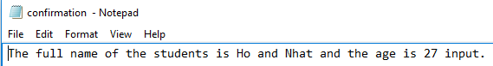

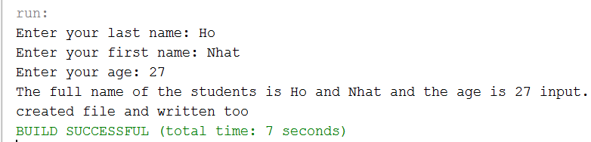

#2 print screen the code for the output to a text file below here

package final_part2;

import java.io.BufferedWriter;

import java.io.File;

import java.io.FileWriter;

import java.util.Scanner;

public class Final_part2

{

public static void main(String[] args)

{

Scanner scan = new Scanner(System.in);

System.out.print("Enter your last name: ");

String lastName = scan.nextLine();

System.out.print("Enter your first name: ");

String firstName = scan.nextLine();

System.out.print("Enter your age: ");

int age = scan.nextInt();

String information = "The full name of the students is " + lastName + " and " + firstName + " and the age is " + age + " input.";

System.out.println(information);

try

{

File f = new File("confirmation .txt");

FileWriter fw = new FileWriter(f, true);

BufferedWriter bw = new BufferedWriter (fw);

//conditional

if(f.exists())

{

bw.write(information);

bw.close();

System.out.println("created file and written too");

}

}

catch(Exception ex)

{

System.out.println(ex);

}

}

}

1. Create ONLY an output that will transfer the text below into a text file with the headers (Please see below) name the text file **employees** so where on the computer. DISREGARD the GRIDLINES only the data has to be transferred.

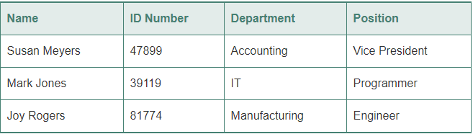

#3 run the program and open the text file and print screen the java program with the open text file side-by-side below here

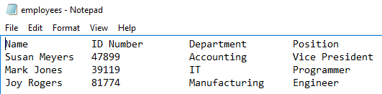

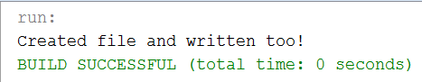

#3 print screen the code for the output to a text file below here

package final_part2;

import java.io.BufferedWriter;

import java.io.File;

import java.io.FileWriter;

public class finalPart2_ex3

{

public static void main(String[] args)

{

String header = "Name ID Number Department Position";

String one = "Susan Meyers 47899 Accounting Vice President";

String two = "Mark Jones 39119 IT Programmer";

String three = "Joy Rogers 81774 Manufacturing Engineer";

try

{

File f = new File("employees.txt");

FileWriter fw = new FileWriter(f, true);

BufferedWriter bw = new BufferedWriter (fw);

//conditional

if(f.exists())

{

bw.write(header);

bw.write("\r\n");

bw.write(one);

bw.write("\r\n");

bw.write(two);

bw.write("\r\n");

bw.write(three);

bw.write("\r\n");

bw.close();

System.out.println("Created file and written too!");

}

}

catch(Exception ex)

{

System.out.println(ex);

}

}

}

Chapter 07 Arrays

1. Create a 1-D array for the numbers 1-10 and retrieve all numbers using a for loop and also retrieve the lucky number 7 in a separate System.out.println

#4 print screen your results below here

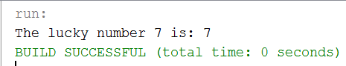

package final_part2;

public class finalpart2_ex4

{

public static void main(String[] args)

{

int [] array = new int[10];

for(int i = 0; i < array.length; i++)

{

array[i] = (i+1);

}

System.out.println("The lucky number 7 is: " + array[6]);

}

}

1. Create a 2-D array for the numbers 1-20, separate the numbers 1-10 into the 1-D and the rest into the 2-D. Retrieve all numbers 1-20 using a nested for loop. Retrieve the number 12 in a separate System.out.println

#5 print screen your results below here

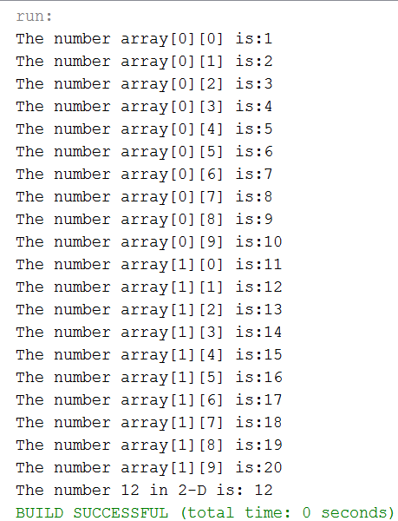

package final_part2;

public class finalpart2_ex5

{

public static void main(String[] args)

{

// Initialize the 2-D

int[][] array = new int[2][10];

for(int row = 0; row < array.length; row++)

{

for(int column = 0; column < array[row].length; column++)

{

array[row][column] = 10*row + 1 + column;

}

}

// Retrieve all number

for(int row = 0; row < array.length; row++)

{

for(int column = 0; column < array[row].length; column++)

{

System.out.println("The number array[" + row + "][" + column + "] is:" + array[row][column]);

}

}

// Retrieve the number 12

System.out.println("The number 12 in 2-D is: " + array[1][1]);

}

}

Chapter 08 Classes

1. Using #1’s code, separate the class and create a main class that will call the sub-class with the same outputs as shown for question #1.

#6 print screen your results below here

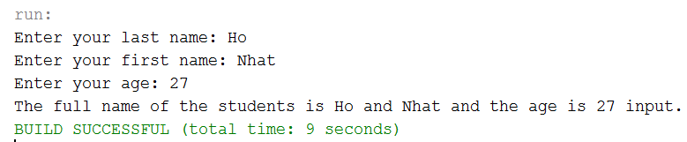

#6 print screen your sub-class (the class without the main method) below here

package final_part2;

import java.util.Scanner;

public class finalpart2_ex6

{

String lastName;

String firstName;

String information;

int age;

void getInformation()

{

Scanner scan = new Scanner(System.in);

System.out.print("Enter your last name: ");

lastName = scan.nextLine();

System.out.print("Enter your first name: ");

firstName = scan.nextLine();

System.out.print("Enter your age: ");

age = scan.nextInt();

}

void showInformation()

{

information = "The full name of the students is " + lastName + " and " + firstName + " and the age is " + age + " input.";

System.out.println(information);

}

}

#6 print screen the main method below here

package final_part2;

public class finalMain_ex6

{

public static void main(String[] args)

{

finalpart2_ex6 info = new finalpart2_ex6();

info.getInformation();

info.showInformation();

}

}

Submit this document to Week 16 final exam, it will not overwrite the 1st submission.

Thank you everyone and Have a GREAT holiday and new year! All the best!