Instructions:

* Please NO talking during exam
* Open Book
* Instructor cannot assist with the exam
* The exam must be submitted by end of class

There are 6 tasks each worth 16.6 points

Based on Chapter 05 (Program Logic and Indefinite Loops)

Task #1

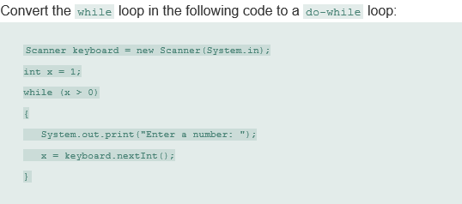

Print screen your running app below here

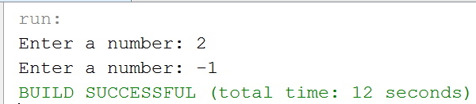

Copy and paste your code below here

package midterm_part2;

import java.util.Scanner;

public class Midterm_part2

{

public static void main(String[] args)

{

Scanner keyboard = new Scanner(System.in);

int x;

do

{

System.out.print("Enter a number: ");

x = keyboard.nextInt();

}

while(x > 0);

}

}

Task #2

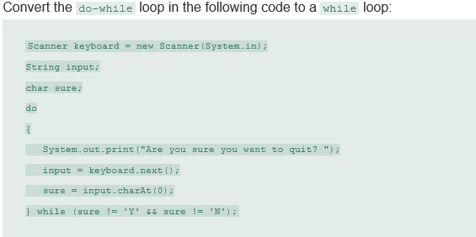

Print screen your running app below here

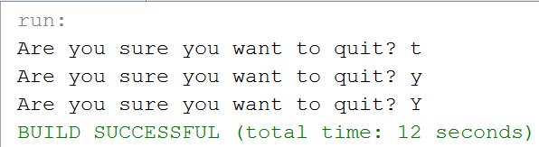

Copy and paste your code below here

package midterm_part2;

import java.util.Scanner;

public class question2

{

public static void main(String[] args)

{

Scanner keyboard = new Scanner(System.in);

String input;

char sure = 't';

while(sure != 'Y' && sure != 'N')

{

System.out.print("Are you sure you want to quit? ");

input = keyboard.next();

sure = input.charAt(0);

}

}

}

Task #3



Print screen your running app below here

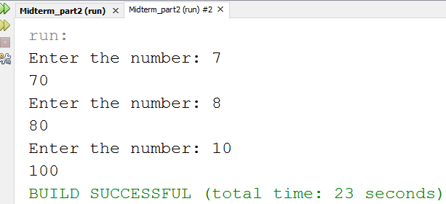

Copy and paste your code below here

package midterm_part2;

import java.util.Scanner;

public class question3

{

public static void main(String[] args)

{

Scanner scan = new Scanner(System.in);

int product = 0;

while(product < 100)

{

System.out.print("Enter the number: ");

product = scan.nextInt();

product *= 10;

System.out.println(product);

}

}

}

Task #4



Print screen your running app below here

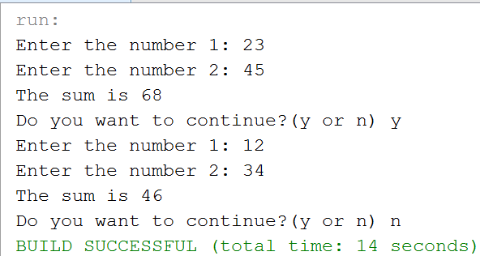

Copy and paste your code below here

package midterm_part2;

import java.util.Scanner;

public class question4

{

public static void main(String[] args)

{

Scanner scan = new Scanner(System.in);

int number1, number2, sum;

String input;

char ans;

do

{

System.out.print("Enter the number 1: ");

number1 = scan.nextInt();

System.out.print("Enter the number 2: ");

number2 = scan.nextInt();

sum = number1 + number2;

System.out.println("The sum is " + sum);

scan.nextLine();

System.out.print("Do you want to continue?(y or n) ");

input = scan.next();

ans = input.charAt(0);

}while(ans == 'Y' || ans == 'y' );

}

}

Based on Chapter 06 (File Processing)

Task #5

Write a program that will output the following text into a text file in the exact format as shown below, do not ask the user to input data, just write the following below to a FileWriter Class

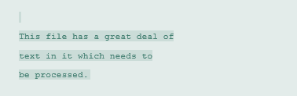

Print screen your running app below here

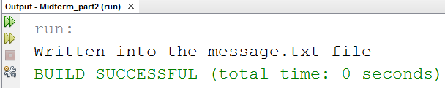

Open your text file and print screen it below here

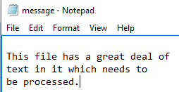

Copy and paste your code below here

package midterm_part2;

import java.io.File;

import java.io.FileWriter;

public class question5

{

public static void main(String[] args)

{

try

{

File f = new File("D:\\message.txt");

FileWriter fw = new FileWriter(f, true);

if(f.exists())

{

fw.write("\r\n");

fw.write("This file has a great deal of");

fw.write("\r\n");

fw.write("text in it which needs to");

fw.write("\r\n");

fw.write("be processed.");

fw.close();

System.out.println("Written into the message.txt file");

}

}

catch(Exception ex)

{

System.out.println(ex);

}

}

}

Task #6 (make sure you output the results into a text file)

Using a Scanner Class ask the user to input the following:

1. Lastname
2. Firstname
3. Address
4. City
5. State
6. Zipcode

Afterwards, pass the information into a text file using the FileWriter Class. Format the output so the each input is on top of each other. Example output:

Last name: Doe

First name: Mike

Address 111 St

City: Santa Ana

State: CA

Zipcode: 11111

Print screen your running app below here

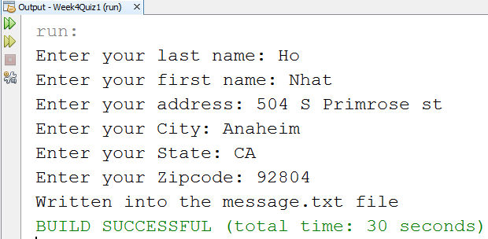

Open your text file and print screen it below here

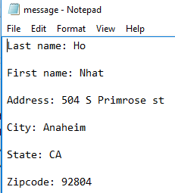

Copy and paste your code below here

package week4quiz1;

import java.util.Scanner;

import java.io.File;

import java.io.FileWriter;

public class question6

{

public static void main(String[] args)

{

Scanner scan = new Scanner(System.in);

String lastName, firstName, address, city, state, zipCode;

System.out.print("Enter your last name: ");

lastName = scan.nextLine();

System.out.print("Enter your first name: ");

firstName = scan.nextLine();

System.out.print("Enter your address: ");

address = scan.nextLine();

System.out.print("Enter your City: ");

city = scan.nextLine();

System.out.print("Enter your State: ");

state = scan.nextLine();

System.out.print("Enter your Zipcode: ");

zipCode = scan.nextLine();

try

{

File f = new File("D:\\message.txt");

FileWriter fw = new FileWriter(f, true);

if(f.exists())

{

fw.write("Last name: " + lastName + "\r\n");

fw.write("\r\n");

fw.write("First name: " + firstName + "\r\n");

fw.write("\r\n");

fw.write("Address: " + address + "\r\n");

fw.write("\r\n");

fw.write("City: " + city + "\r\n");

fw.write("\r\n");

fw.write("State: " + state + "\r\n");

fw.write("\r\n");

fw.write("Zipcode: " + zipCode + "\r\n");

fw.close();

System.out.println("Written into the message.txt file");

}

}

catch(Exception ex)

{

System.out.println(ex);

}

}

}

Submit this document & ***resubmit*** your Midterm Part I to Canvas Week 8

Note: for some reason, if you do not have the Midterm Part I, only submit this document.