Instructions:

* Please NO talking during exam
* Open Book
* Instructor cannot assist with the exam
* The exam must be submitted by end of class

There are 5 Questions each worth 20 points

1. Turn to page 193 and complete question #20, be sure to write a **method**

Print screen the running app with the results below here

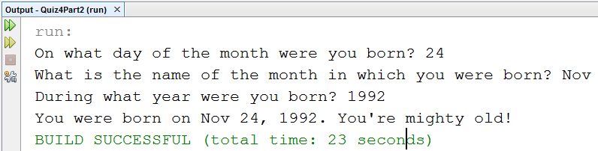

Copy and paste your code below here

package quiz4part2;

import java.util.Scanner;

public class Quiz4Part2

{

public static void main(String[] args)

{

inputBirthday();

}

public static void inputBirthday()

{

Scanner scan = new Scanner(System.in);

int day, year;

String nameOfMonth;

System.out.print("On what day of the month were you born? ");

day = scan.nextInt();

scan.nextLine();

System.out.print("What is the name of the month in which you were born? ");

nameOfMonth = scan.nextLine();

System.out.print("During what year were you born? ");

year = scan.nextInt();

System.out.print("You were born on " + nameOfMonth + " " + day + ", " + year + ". ");

System.out.println("You're mighty old!");

}

}

1. Write a Java Program that meets the below requirements and **write a separate method** for the speed and time variables by **passing** **two** **parameters** one for the *speed* and the other for the *time*.

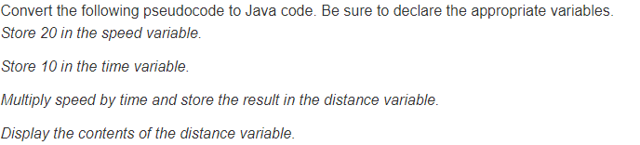

Print screen the running app with the results below here

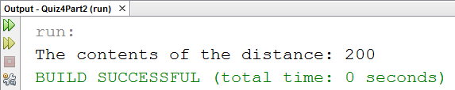

Copy and paste your code below here

package quiz4part2;

public class Question2

{

public static void main(String[] args)

{

int speed = 20;

int time = 10;

canculateDistance(speed, time);

}

public static void canculateDistance(int speed, int time)

{

int distance = speed * time;

System.out.println("The contents of the distance: " + distance);

}

}

1. Write a program using the class, where the program will ask the user to input 3 numbers in an input dialog box and output in a Message Dialog Box **(Add the sum of three numbers)**

Print screen the running app with the results below here

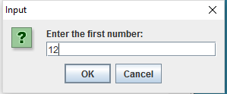

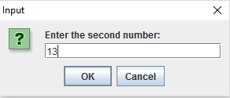

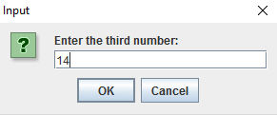

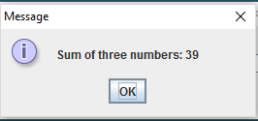

Copy and paste your code below here

package quiz4part2;

import javax.swing.JOptionPane;

public class question3

{

public static void main(String[] args)

{

JOptionPane();

}

public static void JOptionPane()

{

String input;

int first, second, third, sum;

input = JOptionPane.showInputDialog("Enter the first number: ");

first = Integer.parseInt(input);

input = JOptionPane.showInputDialog("Enter the second number: ");

second = Integer.parseInt(input);

input = JOptionPane.showInputDialog("Enter the third number: ");

third = Integer.parseInt(input);

sum = first + second + third;

JOptionPane.showMessageDialog(null, "Sum of three numbers: " + sum);

}

}

1. Write a **while** loop that will loop through numbers 1-10

Print screen the running app with the results below here

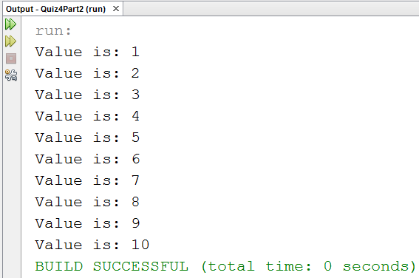

Copy and paste your code below here

package quiz4part2;

public class question4

{

public static void main(String[] args)

{

int i =0;

while(i++ < 10)

{

System.out.println("Value is: " + i);

}

}

}

1. Write a Java Program that meets the below requirements.

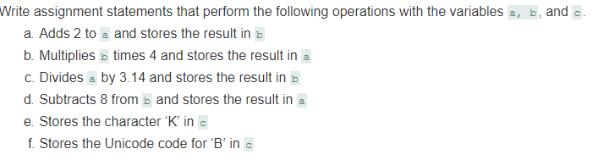

Print screen the running app with the results below here

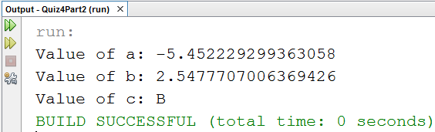

Copy and paste your code below here

package quiz4part2;

public class question5

{

public static void main(String[] args)

{

double a = 2;

double b = a;

a = b*4;

b = a / 3.14;

a = b - 8;

char c = 'K';

c = 66; //Unicode of B equal 66

System.out.println("Value of a: " + a);

System.out.println("Value of b: " + b);

System.out.println("Value of c: " + c);

}

}

Submit this document to Canvas