Instructions:

* Please NO talking during exam
* Open Book
* Instructor cannot assist with the exam
* The exam must be submitted by end of class

There are 4 tasks each worth 25 points

**Based on Chapter 9 Inheritance**

**Task #1**

1. Create 3 classes and name them >> a, b & >> class (c) will be the main method
2. Class (a) will extend class (b)
3. Created a Scanner for classes (a) and (b) that will instruct the user to input a number for each class
4. From class (c) inherit class (a) and output the two numbers, sum or add the numbers, and average the numbers

Print screen your output below here

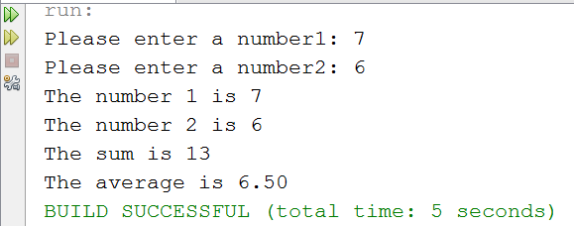

Copy and paste your code below here

package quiz2week13;

import java.util.Scanner;

public class a extends b

{

public int getNumber1()

{

Scanner scan = new Scanner(System.in);

System.out.print("Please enter a number1: ");

return scan.nextInt();

}

}

package quiz2week13;

import java.util.Scanner;

public class b

{

public int getNumber2()

{

Scanner scan = new Scanner(System.in);

System.out.print("Please enter a number2: ");

return scan.nextInt();

}

}

package quiz2week13;

public class c extends a

{

public static void main(String[] args)

{

a test = new a();

int number1 = test.getNumber1();

int number2 = test.getNumber2();

System.out.println("The number 1 is " + number1);

System.out.println("The number 2 is " + number2);

System.out.println("The sum is " + (number1+number2));

System.out.print("The average is ");

double average = (number1+number2)/2.0;

System.out.printf("%.2f\n",average);

}

}

**Task #2**

1. Create 3 classes and name them >> d, e & >> class (f) will be the main method
2. Class (d) will extend class (e)
3. Created a Scanner for classes (d) and (e) that will instruct the user to input a last name from class (d) and a first name from class (e)
4. From class (f) output the first and last name

Print screen your output below here

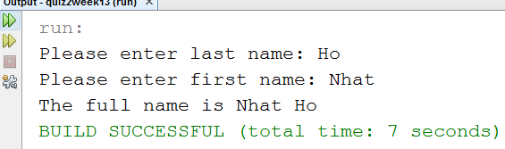

Copy and paste your code below here

package quiz2week13;

import java.util.Scanner;

public class d extends e

{

public String getLast()

{

Scanner scan = new Scanner(System.in);

System.out.print("Please enter last name: ");

return scan.nextLine();

}

}

package quiz2week13;

import java.util.Scanner;

public class e

{

public String getFirst()

{

Scanner scan = new Scanner(System.in);

System.out.print("Please enter first name: ");

return scan.nextLine();

}

}

package quiz2week13;

public class f

{

public static void main(String[] args)

{

d name = new d();

String last = name.getLast();

String first = name.getFirst();

String fullName = first + " " + last;

System.out.println("The full name is " + fullName);

}

}

**Based on Chapter 10 Array Lists**

**Task #3**

1. Create an Array List that will add 3 random ages and get the initial size of the list

Print screen your output below here

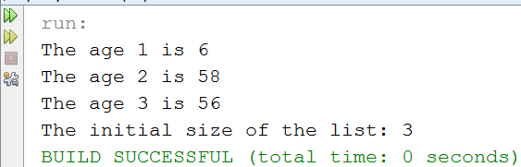

Copy and paste your code below here

import java.util.ArrayList;

import java.util.Random;

import java.util.Scanner;

public class number3

{

public static void main (String[] args)

{

Scanner scan = new Scanner(System.in);

Random rand = new Random();

ArrayList<Integer> ages = new ArrayList<Integer>();

for(int i = 0; i < 3; i++)

{

// Age should be from 1 - 100

ages.add(rand.nextInt(100) + 1);

}

for(int i = 0; i < 3; i++)

{

System.out.println("The age " + (i+1) + " is " + ages.get(i));

}

System.out.println("The initial size of the list: " + ages.size());

}

}

**Task #4**

1. Create an Array List that will add 3 random names and loop through the Array List

Print screen your output below here

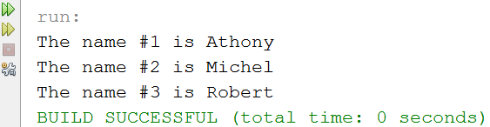

Copy and paste your code below here

import java.util.ArrayList;

public class number4

{

public static void main (String[] args)

{

Random rand = new Random();

ArrayList<String> names = new ArrayList<String>();

names.add("Athony");

names.add("Michel");

names.add("Robert");

for(int i = 0; i < names.size(); i++)

{

System.out.println("The name #" + (i+1) + " is " + names.get(i));

}

}

}

Submit this document & ***resubmit*** your ***Week 13 Q2 Part I*** to Canvas Week 13