Instructions:

* Please NO talking during exam
* Open Book
* Instructor cannot assist with the exam
* The exam must be submitted by end of class

There are 5 tasks each worth 20 points

1. Write a Java Program that meets the below requirements.

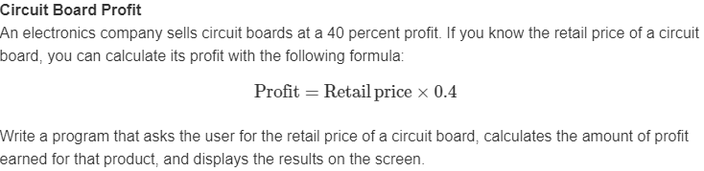

Print screen the running app with the results below here

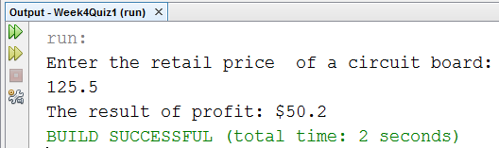

Copy and paste your code below here

package week4quiz1;

import java.util.Scanner;

public class Week4Quiz1

{

public static void main(String[] args)

{

Scanner scan = new Scanner(System.in);

double retailPrice, profit;

System.out.println("Enter the retail price of a circuit board: ");

retailPrice = scan.nextDouble();

profit = retailPrice * 0.4;

System.out.println("The result of profit: $" + profit);

}

}

1. Write a Java Program that meets the below requirements.

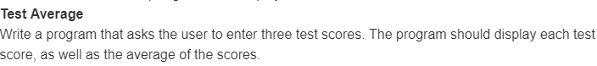

Print screen the running app with the results below here

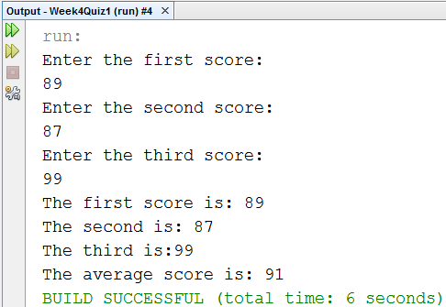

Copy and paste your code below here

package week4quiz1;

import java.util.Scanner;

public class TestAverage

{

public static void main(String[] args)

{

Scanner scan = new Scanner(System.in);

int firstScore, secondScore, thirdScore, averageScore;

System.out.println("Enter the first score: ");

firstScore = scan.nextInt();

System.out.println("Enter the second score: ");

secondScore = scan.nextInt();

System.out.println("Enter the third score: ");

thirdScore = scan.nextInt();

averageScore = (firstScore + secondScore + thirdScore)/3;

System.out.println("The first score is: " + firstScore);

System.out.println("The second is: " + secondScore);

System.out.println("The third is:" + thirdScore);

System.out.println("The average score is: " + averageScore);

}

}

1. Write a Java Program that meets the below requirements.

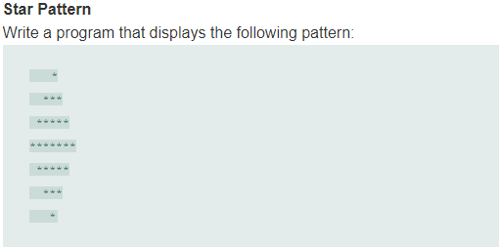

Print screen the running app with the results below here

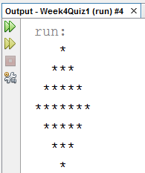

Copy and paste your code below here

package week4quiz1;

public class StarPattern

{

public static void main(String[] args)

{

System.out.println(" *");

System.out.println(" ***");

System.out.println(" *****");

System.out.println("*******");

System.out.println(" *****");

System.out.println(" ***");

System.out.println(" *");

}

}

1. Write a Java Program that meets the below requirements.

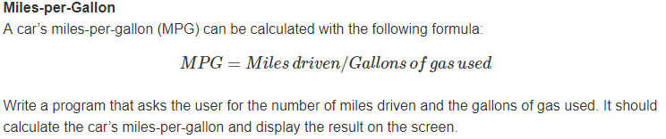

Print screen the running app with the results below here

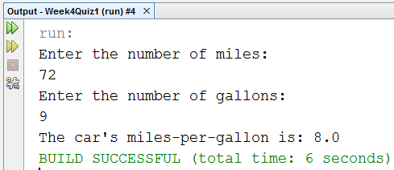

Copy and paste your code below here

package week4quiz1;

import java.util.Scanner;

public class MilesperGallon

{

public static void main(String[] args)

{

Scanner scan = new Scanner(System.in);

double miles, gallons, milesPerGallon;

System.out.println("Enter the number of miles: ");

miles = scan.nextDouble();

System.out.println("Enter the number of gallons: ");

gallons = scan.nextDouble();

milesPerGallon = miles/gallons;

System.out.println("The car's miles-per-gallon is: " + milesPerGallon);

}

}

1. Continue with step #4, and use the File Writer and Buffered Writer classes to write to a text file

When you open the file, it should say as shown below, substitute the**??** marks with your input and output

**The number of miles driven is?? And gallons used is?? And your result is??**

Print screen the running app with the results below here

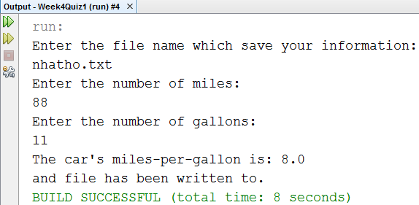

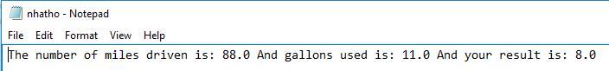

Copy and paste your code below here

package week4quiz1;

import java.util.Scanner;

import java.io.PrintWriter;

import java.io.FileNotFoundException;

public class MilesperGallon

{

public static void main(String[] args)

{

Scanner scan = new Scanner(System.in);

double miles, gallons, milesPerGallon;

String fileName;

System.out.println("Enter the file name which save your information: ");

fileName = scan.nextLine();

try

{

// Print class

PrintWriter p = new PrintWriter(fileName);

System.out.println("Enter the number of miles: ");

miles = scan.nextDouble();

p.print("The number of miles driven is: " + miles);

System.out.println("Enter the number of gallons: ");

gallons = scan.nextDouble();

p.print(" And gallons used is: " + gallons);

milesPerGallon = miles/gallons;

p.println(" And your result is: " + milesPerGallon);

p.close();

System.out.println("The car's miles-per-gallon is: " + milesPerGallon);

System.out.println("and file has been written to.");

}

catch(FileNotFoundException ex)

{

System.out.println("The error is " + ex);

}

}

}

Submit this document to Canvas