Instructions:

* Please NO talking during exam
* Open Book
* Instructor cannot assist with the exam
* The exam must be submitted by end of class

There are 6 print screens each worth 16.6 points

**Based on Chapter 7 Arrays**

1. Write a 1-D Array that will loop through numbers 1-10 and sum/average the numbers

#1 Print screen the running below here

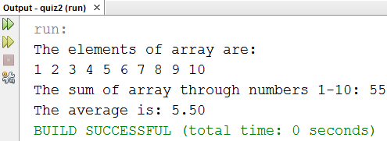

Copy and paste your code below here

package quiz2;

public class Quiz2

{

public static void main(String[] args)

{

int arr[] = new int[10];

int sum = 0;

double average;

// Initialize the array

for(int i = 0; i< 10; i++)

{

arr[i] = i+1;

}

// Calculate the sum

System.out.println("The elements of array are: ");

for(int i = 0; i< 10; i++)

{

System.out.print(arr[i] + " ");

sum += arr[i];

}

average = (sum*1.0)/arr.length;

System.out.println("\nThe sum of array through numbers 1-10: " + sum);

System.out.print("The average is: ");

System.out.printf("%.2f\n", average);

}

}

1. Write a 2-D Array for the numbers 1-10 and output the numbers 1 and 10 only

#2 print screen the running below here

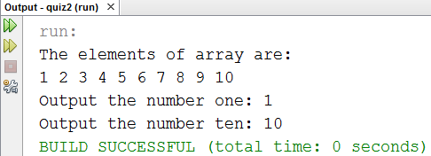

Copy and paste your code below here

package quiz2;

public class number2

{

public static void main(String[] args)

{

int arr[][] = new int[2][5];

// Initialize the 2-D array from 1-10

for(int i = 0; i < arr.length; i++)

{

for(int j = 0; j < arr[i].length; j++)

{

if (i == 1)

arr[i][j] = j + 1 + arr[i].length;

else

arr[i][j] = j+1;

}

}

// List the array

System.out.println("The elements of array are: ");

for(int i = 0; i < arr.length; i++)

{

for(int j = 0; j < arr[i].length; j++)

{

System.out.print(arr[i][j] + " ");

}

}

System.out.println("\nOutput the number one: " + arr[0][0]);

System.out.println("Output the number ten: " + arr[1][4]);

}

}

1. Write a 1-D array that will loop through the alphabet letters from A-J

#3 print screen the running below here

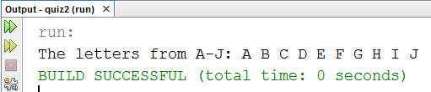

Copy and paste your code below here

package quiz2;

public class number3

{

public static void main(String[] args)

{

int nums = 'J' -'A';

char arr[] = new char[nums+1];

for (char c = 'A'; c <= 'J'; c++)

{

arr[c - 'A'] = c;

}

System.out.print("The letters from A-J: ");

for(int i = 0; i < arr.length; i++)

{

System.out.print(arr[i] + " ");

}

System.out.println();

}

}

1. Write a 2-D array that will loop through the alphabet letters from A-T

#4 print screen the running below here

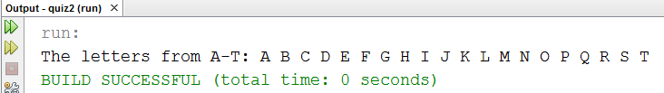

Copy and paste your code below here

package quiz2;

public class number3

{

public static void main(String[] args)

{

int nums = 'T' - 'A';

char arr[][] = new char[2][nums/2 +1];

char first = 'A';

// Initialize the 2-D array

for (int i = 0; i < arr.length; i++)

{

for(int j = 0; j < arr[i].length; j++)

{

arr[i][j] = first;

first++;

}

}

System.out.print("The letters from A-T: ");

for (int i = 0; i < arr.length; i++)

{

for(int j = 0; j < arr[i].length; j++)

{

System.out.print(arr[i][j] + " ");

}

}

System.out.println();

}

}

**Based on Chapter 8 Classes**

1. Start and complete the following class below

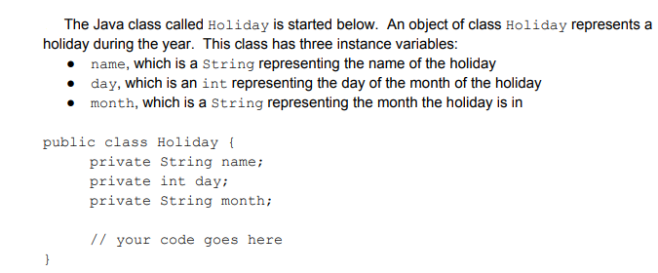

Choose the Holiday**.** Be sure to call it from a main method and name the main method >> **getHoliday**

#5 print screen the running below here

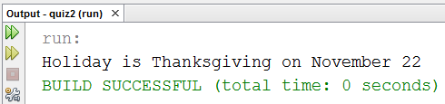

Copy and paste your code below here

package quiz2;

public class Holiday

{

private String name;

private int day;

private String month;

public void setName(String newName)

{

name = newName;

}

public void setDay(int newDay)

{

day = newDay;

}

public void setMonth(String newMonth)

{

month = newMonth;

}

public void showInfo()

{

System.out.println("Holiday is " + name + " on " + month + " " + day);

}

}

package quiz2;

public class getHoliday

{

public static void main(String[] args)

{

Holiday Thanksgiving = new Holiday();

Thanksgiving.setName("Thanksgiving");

Thanksgiving.setDay(22);

Thanksgiving.setMonth("November");

Thanksgiving.showInfo();

}

}

1. Start and complete the following class below

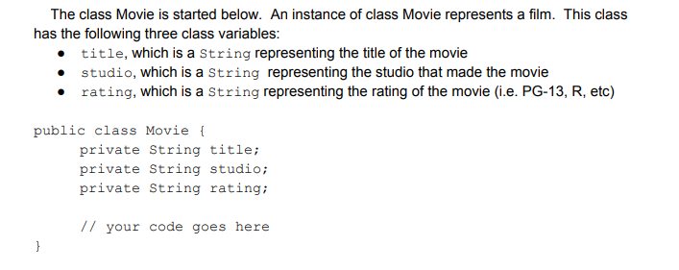

Choose the any movie**.** Be sure to call it from a main method and name the main method >> **getMovie**

#6 print screen the running below here

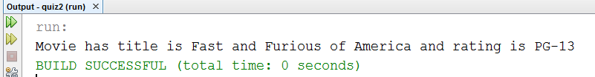

Copy and paste your code below here

package quiz2;

public class Movie

{

private String title;

private String studio;

private String rating;

public void setTitle(String newTitle)

{

title = newTitle;

}

public void setStudio(String newStudio)

{

studio = newStudio;

}

public void setRating(String newRating)

{

rating = newRating;

}

public void showInfo()

{

System.out.println("Movie has title is " + title + " of " + studio + " and rating is " + rating);

}

}

package quiz2;

public class getMovie

{

public static void main(String[] args)

{

Movie movie = new Movie();

movie.setTitle("Fast and Furious");

movie.setStudio("America");

movie.setRating("PG-13");

movie.showInfo();

}

}

Submit this document to Week 13 Q2 Canvas