MICROPROCESSOR – MICROCONTROLLER

LAB 1

TRAN NHAT TAN – 1852732

1. EX1

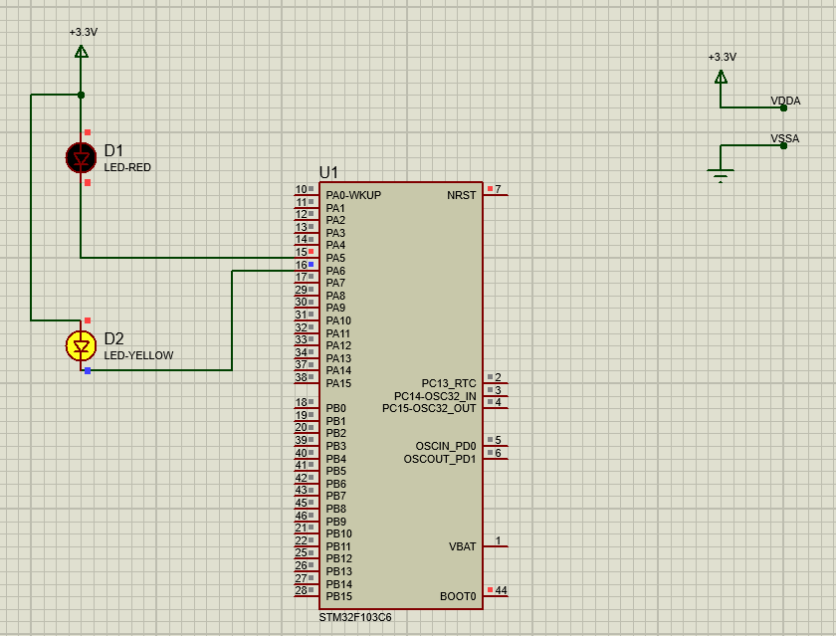

Source code:



1. EX2

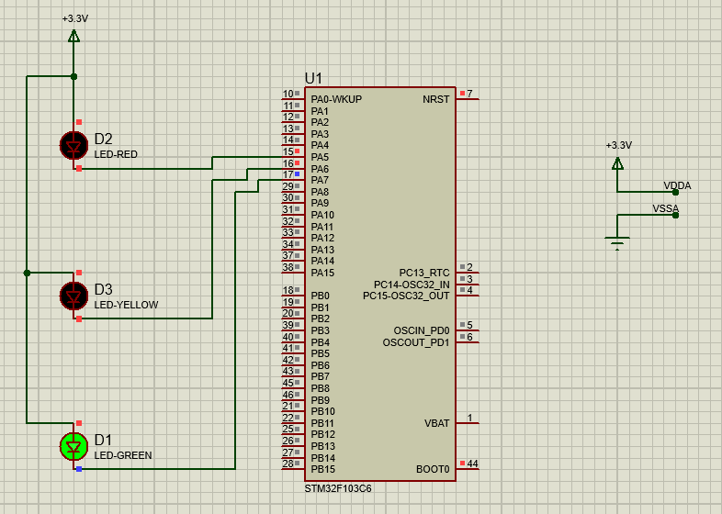

Source code:



1. EX3

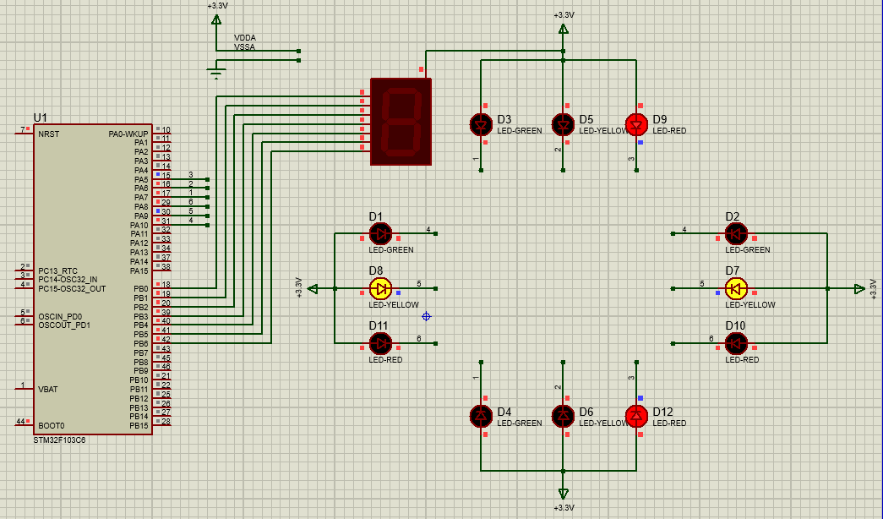

Source code:



1. EX4



1. EX5



1. EX6
2. EX7