***Christopher Guy***

***Bergen***

***Design: Archirivolto***

**PRODUCT DES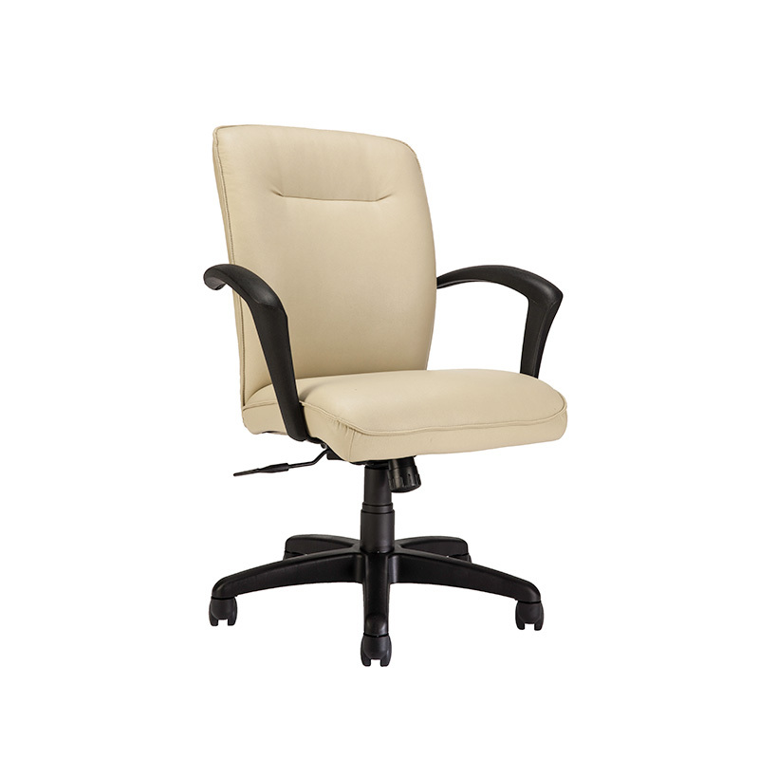CRIPTION**

Soft polyurethane armchair with different bases. Fix or swiveling base in transparent (OP0), titanium

(GFM11), graphite (GFM69), white (GFM71) or black (GFM73) embossed lacquered steel or in natural

beech (F1), Canaletto walnut (FNC) or burned oak (RB) stained beech, or with 5 spokes in polished

aluminum, or with wheels in black painted aluminum. Seat and back in monochrome polyurethane

available in white (P01), lino (P02), fango (P03), petrolio (P04) or antracite (P05) colors, or two-tone

polyurethane back petrolio (P04) and front fango (P03). For supplies of more than 50 pieces other colors

are available. New 4 spokes base in graphite, white or black nylon available in swiveling version (401-T)

and on wheels (401-C). Fireproof seat 1 IM – CRIB5.

**GENERAL TERMS AND MAINTENANCE**

The SOFT LEATHER is a natural material. A non uniformity in the wrinkle's drawing and small defects must be considered a feature that certifies the quality of leather. The leather undergo

over time a slight discoloration, either with exposure to direct sunlight or to sources of heat. Be careful with straps, studs, buttons or other sharp metal objects that could scar the surfaces.

MAINTENANCE: It is a good practice to remove the dust, which often clogs the pores, not allowing the natural perspiration. Always use a soft, dry cloth. Avoid using brushes that can damage

the surface. The removal of stain is extremely difficult as in the case of grease spots, ink and alcohol. Good results can be obtained by acting promptly with soapy water or mild detergent,

rinse and wipe dry immediately with a soft cloth. Avoid alcohol, acetone, trichlorethylene, detergents or abrasives.

Christopher Guy LEATHERS are produced with selected cow leathers, tanned and dyed with products that do not contain substances harmful to human health, in full compliance with the

current regulations.

MAINTENANCE: see the instructions for the soft leather.

The SYNTHETIC LEATHER (or false leather or vin-leather) is a special ecological fabric similar to leather or hide even if not realized with animal material. Has excellent physiological and

hygienic qualities and is harmless from the toxicological point of view. It does not cause dust allergies. High resilience is finally a good guarantee of durability. It is also self-extinguishing, and

reliable with regards to the safety. It's a product Made in Italy. MAINTENANCE: requires no special care. In case of stains wipe with a damp cloth. Use neutral specific products. Do not use

brushes, grease, petrol or acetone which will damage the surfaces.

FABRICS / SYNTHETIC NABUK: With regard to the fiber content, technical specifications and maintenance instructions, please refer to the information available by the authorized dealer.

PAINT, LACQUER AND EMBOSSED PAINT: the main features are light and corrosion resistant. The embossed painting also makes the surface more resistant to scratches, thanks to its grainy

film.

MAINTENANCE: For normal cleaning, use a slightly damp soft cloth. Do not use abrasive cleaners, solvents, ammonia, acetone. In case of stains, remove them with a solution of mild soap

and water, taking care to dry the wet surfaces.

The WOOD that is used for all Christopher Guy products is sourced only from the finest ecologically sustainable forest plantations and each piece has been treated using the least invasive

processes as not to affect its natural beauty, but importantly guarantees the longevity and durability over the years of use. Wood is a natural material and as such, it will continue to change

in appearance which will further enhance its natural look. Minor variations of tone, the presence of knots, veins and burn marks are all testament to the uniqueness and authenticity that

each piece of wood will possess. MAINTENANCE: Please read the care instructions for lacquer.

LAMINATE is a material highly resistant to shocks, water, steam, heat, stains, light, and chemical agents.

MAINTENANCE: To remove stubborn stains use a damp cloth with water and liquid detergent.

MARBLE AND NATURAL STONES are protected by a layer of water-oil repellent that protects surfaces. The lead polishing gives to the slab's surface gloss and resistance to light and hard

weather conditions, which gives a guarantee of excellent durability.

MAINTENANCE: For proper cleaning and surface protection of natural stone or granite use specific products according to their use.Do not use harsh detergents that can dull the surface and

affect the water-oil repellent treatment. It is advisable to clean, protect and polish only with specific products for natural stone or granite for a long term durability.

The making of the CERAMIC used for all Christopher Guy ceramic tables is an innovative process. It begins with the wet grinding of natural materials such as clay, granite and ceramic

particles that are in powder form, which then are all compacted down together in a process known as 'firing'. MAINTENANCE: Ceramic tops should be cleaned with a wet sponge and a mild

detergent. Do not use abrasive cleaning products. Do not use a steam cleaner. For best results, it is recommended that you use a limestone cleaning gel. It is best to remove fresh stains as

quickly as possible as there is the potential risk that over time the stain can penetrate the pores of the ceramic. In the event that a stain has been present on the ceramic for some time, use a

solution mixed from bicarbonate soda and water. Rub the surface, allowing the solution to penetrate the stain, and then wipe it off with a wet sponge. GLASS and MIRRORS, all glass,

tempered or not, have safety features such as to match the requirements.

MAINTENANCE: Avoid using abrasive materials that can damage the surface permanently. For the mirrors, it is recommended to use only a soft cloth dampened with alcohol.

POLYURETHANE belongs to a large class of compounds called polymers. Polyurethane is made through a process known as 'condensation' which allows the polyurethane to be moulded into

any shape. Once the process of condensation is complete and the desired shape has been formed, the end result is that the shaped cannot be unchanged. As a result and by using the right

elements, the desired requirement of softness and comfort can be met. MAINTENANCE: For normal cleaning, use a damp cloth. Do not use abrasive cleaning products such as ammonia or

solvents. To remove spots, use a solution mixed from water and mild soap and ensure that you dry the affected area immediately after wiping it.

INSTRUCTIONS

If you must assemble components, follow all instructions included in the packaging. Screws, bolts and other fastening parts should preferably be tightened by hand. Do not use power tools.

In case of difficulty, please contact your dealer for any assistance. Do not use the product for uses other than those related to the category it belong.

DISPOSAL

After use do not dispose of the furniture in the environment. Entrust to specialized companies for the recovery and / or disposal.

WARRANTY

This Certificate of Guarantee apply to all Christopher Guy products, and is valid only in cases where the item purchased is defective or fails to fulfill compliance to the objective descriptions

and aspects of quality and performance made by the seller or the producer. The warranty applies to the product up to 2 years after delivery. The warranty is supplied at the moment of the

sale, and is valid only in the presence of data and stamp of the dealer, the bill of lading or receipt. The warranty is valid only for defects of conformity existing at the delivery thereof and

excludes any other type of defect source later if not objectively recognized. Are also excluded from application of the Warranty Certificate the following aspects: transport damage, damage or

breakdown products as a result of improper handling and / or storage at the warehouse store or distributor, faults and deterioration from use, scratches and abrasions, stains, exposure to

water, direct sunlight, excessive heat or cold, vandalism, misuse, misapplication and / or incorrect use of the product, improper handling of materials. Are also excluded from the guarantee

products made from materials supplied by the customer and tampering or attempted repair of the goods without written permission by Christopher Guy.

These information are based on data published in our latest pricelist. Christopher Guy reserves the right to change or improve any product without any notice.