Project Code (Acronym) -
Customer Management

Software Configuration Management Plan

Version: 1.0

Date: 2/4/2021

Product Development Lead: Trần Duy Bảo

PLAN UPDATE HISTORY
Version | Date | Brief Description and Reason for Change | Affected Pages | Author
1.0 | 2/4/2021 | Initial release | - | Nhật Tiến

TABLE of CONTENTS
Guidance
Be sure to update page numbers in this table when changes are made

1.0 INTRODUCTION 1
1.1 Purpose 1
1.2 Scope 1
1.3 References 1
2.0 ROLES AND RESPONSIBILITIES 3
2.1 Project Organization 3
2.2 Project Stakeholders (Roles) and Responsibilities 3
2.3 Boards 4
3.0 RESOURCES AND ENVIRONMENTS 7
3.1 Personnel 7
3.2 Plans, Schedule, and Resources 7
3.3 Repository 7
3.4 Support Tools 8
4.0 ACTIVITIES AND APPROACH 10
4.1 CM Phasing and Milestones 10
4.2 Configuration Identification 12
4.3 Configuration Control 12
4.4 Configuration Status Accounting 13
4.5 Configuration Audits 14
4.6 Data Management 15
GLOSSARY / ACRONYMS 18
Attachment #1 Data Management List 19

ROLES AND RESPONSIBILITIES

Project Organization
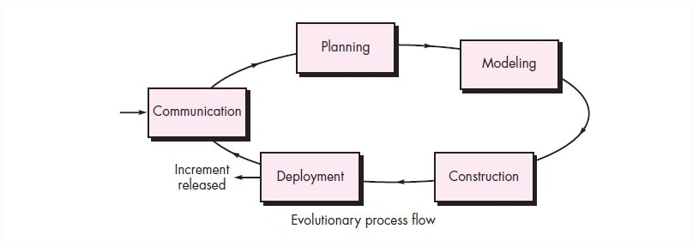
Stage | Brief Description
Communication | Project intiation  Requirement gathering
Planning | Estimating  Scheduling  Tracking
Modeling | Analysis  Design
Construction | Code  Test
Deloyment | Delivery  Support  Feedback

Project Stakeholders (Roles) and Responsibilities
Stakeholders (Roles) | Responsibility
Scrum Master | Responsible for the implementation of the CM and DM process for their project areas and performs CM/DM activities in accordance with standard processes and procedures as defined for Customer Management in this CM Plan. May submit Change Requests (CRs).
Scrum Member (Dev, Tester, Product Owner) | Responsible for ensuring that the CM processes and work products are performed according to this CM Plan and the documented CM processes and procedures.
DevOps | Responsible for coordinating and implementing CM for the Customer Management project, identifying and controlling configuration items (CIs), establishing baselines upon which a CI is placed under CM control, providing reports as defined in this CM Plan, and providing adequate resources, including tools to support CM activities for the Customer Management project.  Ensures the establishment of the baselines for the CIs and approves changes to these CIs.

Boards

Configuration Control Board
A CCB has been established to authorize changes to baselined documentation, hardware and software and for in-development products. The CCB is chaired by the PDL and the membership consists of the CMO and senior team members who provide broad interdisciplinary representation. CCB members are:Trần Duy Bảo, Bùi Lâm Nhật Tiến, Trần Phúc Khang, Trương Thanh Trúc, Võ Hồ Thái Sơn, Nguyễn Hữu Tín, Hồ Tâm Như. The PDL requests the participation of additional personnel as necessary depending on the CR under consideration.
The CCB supports the PDL and includes technical and administrative representatives who recommend approval or disapproval of proposed engineering changes to a CI's current approved configuration and its documentation. The board also recommends approval or disapproval of proposed deviations from a CI's current approved configuration and its documentation.
Guidance
If the CCB meets regularly, state how often (this may vary according to the phase of the project). If it does not meet regularly, use the text below.
CCB meetings are called as necessary by the Chair depending on the quantity of Open CRs. The CCB will meet at least quarterly.
The Configuration Management Officer (CMO) serves as coordinator and scribe to the board and provides status accounting reports to the CCB and updates the status accounting information to reflect CCB decisions.
Guidance
Modify the figure below with to highlight your projects CCB, and any subsidiary team CCB(s) under your project’s control. Use appropriate nomenclature and indicate the Chair’s name(s).

Trần Duy Bảo
Võ Hồ Thái Sơn
Hồ Tâm Như
Trương Thanh Trúc
Trần Phúc Khang

Nguyễn Hữu Tín
Bùi Lâm Nhật Tiến

Figure 2-1. Mission Customer Management Configuration Boards

CCB Responsibilities
The CCB has authority for managing the project's product through the performance of the functions listed below:
- Authorize establishment of configuration baselines and identification of CIs.
- Represent interests of project management and all groups who may be affected by changes to the baselines.
- Assign, review, and provide for disposition of action items.
- Serve as a source for the coordination of technical expertise for the project.
- Determine or review the availability of resources required to complete the proposed change or modification, assess the impact of the proposed change upon the system, examine cost considerations, and determine the impact of the change on development and test schedules.
- Analyze change request impact, benefit and necessity.
- Approve changes – or disapprove – as appropriate.
- Monitor the status of open change requests

RESOURCES AND ENVIRONMENTS

Personnel
The CM effort for this project is
Trần Duy Bảo: 90%-95%
Bùi Lâm Nhật Tiến: 90%-95%
Võ Hồ Thái Sơn: 90%-95%
Nguyễn Hữu Tín: 90%-95%
Hồ Tâm Như: 90%-95%
Trần Phúc Khang: 90%-95%
Trương Thanh Trúc: 90%-95%
Personnel involved in CM activities will be familiar with and apply the standards and guidelines referenced in Section 1, are familiar with the CM Process, and the chosen CM tools. Required training is listed in the training matrix in the SMP/PP.

Guidance:

For Classes of Software other than A, B, and C the required training for the CM personnel should be listed here.

Plans, Schedule, and Resources
The CM schedule is closely coordinated with the product schedule. CM audits will be performed at the conclusion of each new phase of development to verify that the CM procedures are correctly implemented as defined in this document. CM audits are scheduled in the project schedule.
The estimated CM budget for this project is documented in the annual budget identified in the SMP/PP. The PDL will periodically review actual budget expenditures against planned expenditures and resolve any issues.
The CMO coordinates with the PM to ensure that CM activities are conducted in concert with the appropriate project activities and maintained in the project schedule.

Repository
The Customer Management Repository structure is shown in Figure 3-1 with each of its main sub-folder elements described.

Guidance:

An example of a directory structure is provided in this template. If this example is followed it should be placed on a shared server. If a tool, or web-based solution is chosen, describe it and provide a screen-shot of its organization and/or layout.

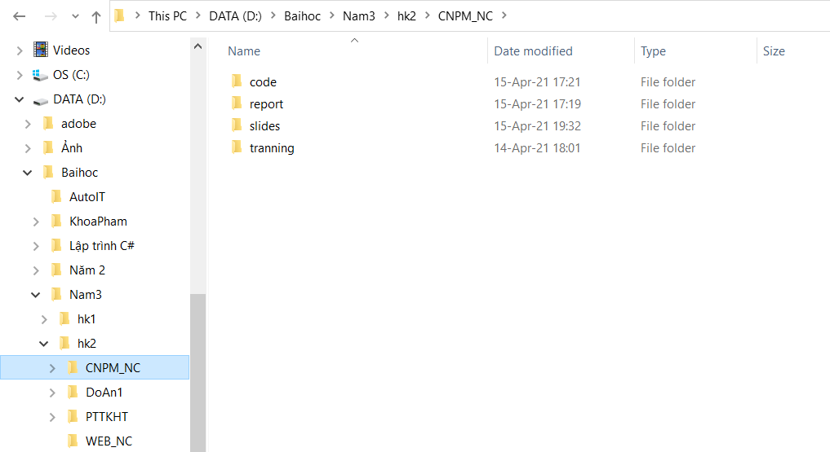
Figure 3-1. Customer Management repository structure

Software baselines are maintained in the CM support tool described in the next section.

Support Tools

Guidance
The tools may be manual (consisting of controlled ledgers, notebooks, spreadsheets, or similar items) or automated (comprising a computerized database or similar set of tools and capabilities) or be a combination of the two.
Multiple tools may be used to manage code, requirements, design, code, change requests, documentation, etc. List all that are need for CM and change control (for both documents and software).
The detailed description of how to use the CM system may be separately documented as individual CM procedures and should be referenced (e.g., procedures for storage and retrieval of CIs, archiving and retrieving CM records, creating CM reports).

The configuration management support tool used on the Customer Management project is Visual Studio Code for code and [GitHub, Git Bash & SourcTree] for CCB controlled documents
The data management support tool for the project is Sql Server 2008 R2, Mongodb.

ACTIVITIES AND APPROACH

CM Phasing and Milestones
Guidance
The author may choose to describe this section of the document using a combination of text and graphics, text only, or graphics only. This section should be tailored to describe CM activities within the system development life cycle phases covered by this version of the plan. The sample text in this section describes typical activities.
The purpose of this section is to ensure that CM activity is appropriate to the scope and timing of the Customer Management project activity.
Non software items will be version controlled by the author until the item is ready for signature and then will be placed under more formal control (if appropriate as identified in Attachment 1).
Software elements will be version controlled by the developer until the item’s unit test is completed and then placed under version control within the CM tool. Upon the completion of the development phase the item is placed under CCB control.
Table 4-1 identifies the planned baselined items, when they will be baselined, and when they will be considered for revision by milestone in relation to project activity for [[project name]]. Items marked with a “P” for the controlling organization are expected to be controlled by the Mission Projects CCB, otherwise it is controlled by the local CCB.
Guidance
This list contains elements found through initial development and all phases of a project. For a project already in operations and maintenance, the phases may be the same for the incremental changes, and the baselines may be fewer.
Create your list of planned baselined Items, see below for example. A list of actual baselined items is maintained on a regular basis in the DML. Actual baselines are defined in Version Description Documents and revision histories (for documents).
Table 4-1. Planned CM Baselines
Guidance
All the baselined items and versions shown by phase are for example purposes only -- the contents of this table may look quite different.
Baselined Items |  | New Versions Planned by Phase
Baselined Items | Org. | Concept | Requirements | Design | Implementation | System Testing | Acceptance Testing | Operations
Database Design | P | • | • | • | • | •
Traning |  |  |  |  | •
Configuration Management Plan | P | • | • |  |  | •
Test Plan | P | • | • |  |  | •
Github Responsitory | P | • |  | • | •
UI Design | P | • |  | • | • | • | • | •
Interation | P |  |  | • | • | • | • | •

Configuration Identification

Identifying configuration items
For a complete list of all configuration items and data items for the Customer Management project, see Customer Management Data Management List (DML) (initial version Attachment 1). The updated Customer Management project DML will be maintained in the “database” repository folder. CNPM_NC

Naming configuration items
The Naming Convention to be used on the Customer Management project is: Base.ss.uu, where:
Base – Not more than 40 alphanumeric characters that define the software or system media and its content, document, or other work product
Suffix - ss.uu -- a period followed by 2 alphanumeric characters, another period and another 2 alphanumeric characters, which provide the revision / version of the software or system work product, for example:

- First two characters (ss) of the suffix define a major release or revision as defined by the project;
- Second two characters (uu) of the suffix define a minor release, update or revision as defined by the project.
Guidance
Tailor this section with your project’s naming conventions.

Baseline Documentation
Version Description Documents (VDD’s or release documentation) document the contents of delivery baselines. These document the specific contents of baselines including versions of software elements and documentation.

GLOSSARY / ACRONYMS

Guidance
Tailor the list appropriately

CCB – Configuration Control Board
CI – Configuration Item
CM – Configuration Management
CMO – Configuration Management Officer
COTS - Commercial Off-The Shelf
CR – Change Request
CRB – Change Review Board
DM – Data Management
DML – Data Management List
FCA – Functional Configuration Audit
IRB – Internal Review Board
PCA – Physical Configuration Audit
PAL – Process Asset Library
PDL – Product Development Lead
QA – Quality Assurance
QER - Quality Evaluation Report
RTM - Requirements Traceability Matrix
SPR – System Problem Report
VDD – Version Description Document

Attachment #1 Data Management List

Guidance
Sample work products are included herein, update with a list of your project’s work products in the DML spreadsheet too.
The below is a snapshot from the latest excel version of the DML. Update the Sample DML in excel with your project’s work products and paste here (Paste Special, HTML Format seems to work best).

Title | Description / Notes | Created by/ Responsible for updates | Level of Control | Location  http://github.com/nhattien69/OKA1-KH.git | Primary Process Area | Frequency of update/creation | Current Version Number | Current Version Date | ITAR Sensitive? |  | PPQA Evaluation Required?
Data Management List (DML) (this list) | This is important to Planning, Monitoring and Control and CM | PDL | Version | 02 Project Management | PP | As needed |  |  | N
CM/DM Plan | See Product Plan section 1.0  (or this could be a separate plan) | CM Lead | CCB | 05 CM Materials | PP | Annual |  |  | Y | Yes
Project Plan |  | PDL | CCB | 02 Project Management | PP | Annual |  |  | Y | Yes
Acquisition Management Plan | See Product Plan section 1.0  (or this could be a separate plan) | PDL | CCB | 02 Project Management | PP | Annual |  |  | Y | Yes
Schedule | Schedule, notes and inputs to schedule in the form of redlines/emails | PDL | Version | 02 Project Management | PP | Monthly |  |  | N
Estimates with Basis of Estimates | Includes software and work product size estimates, effort estimates, staffing, schedule estimates and basis for all | PDL | Version | 02 Project Management | PP | As needed |  |  | N
Processes | Includes process for both mgmt and technical work. See Product Plan section 1.0 for references. | ISD Division CCB | CCB | Goddard Process Asset Library: software.gsfc.nasa.gov | PP | As needed |  |  | N
Metrics Processes | Project specific procedures for metrics collection, storage and analysis | PDL | CCB | 02 Project Management | PP | Annual |  |  | N
Project Training Plan and Log | The log is updated as needed and the plan is reviewed for updated annually | PDL | Stored | 02 Project Management | PP | Annual |  |  | N
Monthly Cost Actuals | Includes dollars and FTEs | PDL | Stored | 02 Project Management | PMC | Monthly |  |  | N
Meeting Minutes | Includes all team meetings.  Includes all status meetings with participants outside the project team. | Project Personnel | Stored | 05 Meeting Minutes | PMC | As needed |  |  | N
Meeting Log | Includes agenda, attendees, and action items. | PDL | Stored | 02 Project Management | PMC | As needed |  |  | N
Project Training Material | Project specific or project developed training only. | Project Personnel | Stored | EPG | PMC | Quarterly |  |  | N
Senior Staff Presentations |  | Project Personnel | Stored | 02 Project Management | PMC | Quarterly |  |  | N
Status Information | Includes any status information received from team members or other sources via email or other mechanism not otherwise described | PDL | Stored | 02 Project Management | PMC | As Provided |  |  | N
Senior Management Material (for Reviews) |  | PDL | Stored | 02 Project Management | PMC | Monthly |  |  | N
Milestone Review Materials | Presentation materials and any other support materials prepared for these milestone reviews: SRR, PDR, CDR, TRR, ATTR | PDL | Version | 02 Project Management | PMC | As generated |  |  | Y | Yes
Action Item List |  | Project Personnel/ PDL | Stored | 02 Project Management | PMC | Monthly |  |  | N
Significant Correspondence | Could include any emails or other information that might be of future use. | Project Personnel/ PDL | Stored | PDL and Team Member email account | PMC | As needed |  |  | N
Project Metrics Plan | See Product Plan section 1.0 for description and specification of measurement objectives, particular measures to support these objectives and methods of analysis  (or this could be a separate plan) | 110 | CCB | 02 Project Management | MA | Annual |  |  | N | Yes
Metrics Data |  | Project Personnel | Stored | 03 Technical Work Products | MA | Monthly |  |  | N
Risks |  | PDL | Version | 02 Project Management | RSKM | Monthly |  |  | Y
Risk Management Plan | See Product Plan section 1.0  (or this could be a separate plan) | PDL | Version | 02 Project Management | RSKM | As needed |  |  | Y | Yes
Change Request (CR) | Includes impact analysis. Analysis may take the form of a white paper if necessary | CM lead | Version | 08 Change Requests | CM | Annual |  |  | N
CCB Meeting Minutes |  | CM Lead | Stored | 02 Project Management | CM | Monthly |  |  | N
Change Request Log |  | CM Lead | Stored | 02 Project Management | CM | Monthly |  |  | N
Baselined Documents (List each separately) |  | CM Lead | Version | CM Tool | CM | When baselined |  |  | Y | Yes
Baselined Software (List each CSCI separately) | Add a line for each subsystem/box -- e.g. GNC and CDH. Don't add a line for each new build. | CM Lead | Version | CM Tool | CM | When baselined |  |  | Y | Yes
CM Evaluation Reports/Audit Reports |  | CM Lead | Stored | 05 CM Materials | CM | Monthly |  |  | N
Quality Assurance Plan | See Product Plan section 1.0  (or this could be a separate plan) | QA Lead | CCB | 07 QA Items | PPQA | Annual |  |  | N | Yes
QA Evaluation Reports | Work product assessments and process assessments in the form of completed checklists, reports, and distribution emails | QA Lead | Stored | 07 QA Items | PPQA | Quarterly |  |  | N
QA Evaluation Corrective Action Log |  | QA Lead | Stored | 07 QA Items | PPQA | Quarterly |  |  | N
Requirements Traceability Matrix |  | Project Personnel | CCB | 02 Project Management | REQ | As needed |  |  | N | Yes
Requirements |  | Project Personnel | Version | 01 Requirements | REQ | As needed |  |  | Y | Yes
Developed Software with Release Notes | Includes source code files, command files, make files, link files. | Project Personnel | CCB | Baseline Snapshots-- 03 Technical Work Products  Version controlled through CM tool | D&I | As needed |  |  | N | Yes
System Problem Report (SPR) |  | CM lead | Version | 08 Change Requests | D&I | Monthly |  |  | N
Migration Plan |  | Project Personnel | Version | 03 Technical Work Products | D&I | As needed |  |  | N | Yes
System Design Documentation via PDR and CDR Packages |  | Project Personnel | Version | 03 Technical Work Products | D&I | As needed |  |  | N | Yes
Architecture Diagram and definitions | Includes trade studies | PDL | Version | 03 Technical Work Products | D&I | As needed |  |  | N
Real-time O/S |  | DTL | Version | 03 Technical Work Products | D&I | As needed |  |  | N
Simulators | Includes models, designs and software | DTL | Version | 03 Technical Work Products | D&I | As needed |  |  | N
System Documentation |  | Project Personnel | Version | 03 Technical Work Products | D&I | As needed |  |  | N | Yes
Lab Records | Includes lab configuration drawing, inventories, and calibration records | Lab Manager | Stored | 03 Technical Work Products | D&I | As needed |  |  | Y | Yes
Version Description Documents |  | CM Lead | Version | 03 Technical Work Products | D&I | As needed |  |  | Y | Yes
Inspection Artifacts | Announcements, materials and actions | DTL | Version | 03 Technical Work Products | V&V | As needed |  |  | N
Use Cases |  | Project Personnel | CCB | 03 Technical Work Products | V&V | As needed |  |  | N
Test Cases / Test Scripts |  | Project Personnel | Version | 03 Technical Work Products | V&V | As needed |  |  | Y
Test Plan |  | Project Personnel | Version | 03 Technical Work Products | V&V | Annual |  |  | Y | Yes
Test Reports | Includes detailed test results | Project Personnel | Version | 03 Technical Work Products | V&V | As needed |  |  | Y
Purchase Requests | emails, requests for purchases, status of purchases and approvals if needed. | PDL | CCB | 02 Project Management | ACQ | As needed |  |  | Y
Task Descriptions/ SOWs |  | PDL | Version | NASA TOMS System | ACQ | Annual |  |  | N | Yes
Purchase receipt and acceptance records | Hardcopy documents | Lab Manager | Stored | Lab Manager Files | ACQ | Upon receipt and acceptance |  |  | N
M533 and Q533 |  | PDL | Stored | Management | ACQ | Monthly |  |  | N
Work Order Authorization Form (WOA) |  | PDL | Version | Control by Accounting | ACQ | Annual |  |  | N
Make/Buy Decisions |  | PDL | Stored | 02 Project Management | ACQ | As needed |  |  | N

