Evaluation Only. Created with Aspose.Words. Copyright 2003-2022 Aspose Pty Ltd.
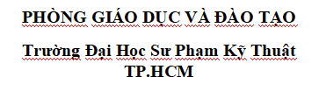
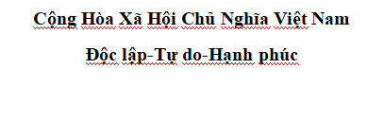
Danh Sách Môn Học

STT | Môn Học | Số Tiết | Ghi Chú
1 | Machine_Learning | 100 | Machine learning
2 | AI | 100 | AI
3 | OOP | 90 | oop with C# and Java
4 | Graph_Theory | 80 | Graph and Algorthms
5 | Web Design | 80 | Design Web And Web Concept
6 | Data Structure | 80 | Structure and Concept
7 | NetWork | 80 | NetWord and Concept , appication
8 | Math | 80 | Basic Math for Information
9 | Physics | 80 | Basic Physics for infomation
10 | Database | 80 | Sql and Database

