**Task 1**

* How did you use connection pooling?

Connection pooling is used by defining database connections in a context.xml file. These connections get cached on first use so that they can be reference on subsequent calls.

* File name, line numbers as in Github

File name: context.xml

Path: [cs122b-winter18-team-54](https://github.com/UCI-Chenli-teaching/cs122b-winter18-team-54/tree/z-have-both)/[Project](https://github.com/UCI-Chenli-teaching/cs122b-winter18-team-54/tree/z-have-both/Project)/[WebContent](https://github.com/UCI-Chenli-teaching/cs122b-winter18-team-54/tree/z-have-both/Project/WebContent)/[META-INF](https://github.com/UCI-Chenli-teaching/cs122b-winter18-team-54/tree/z-have-both/Project/WebContent/META-INF)/context.xml

* Snapshots

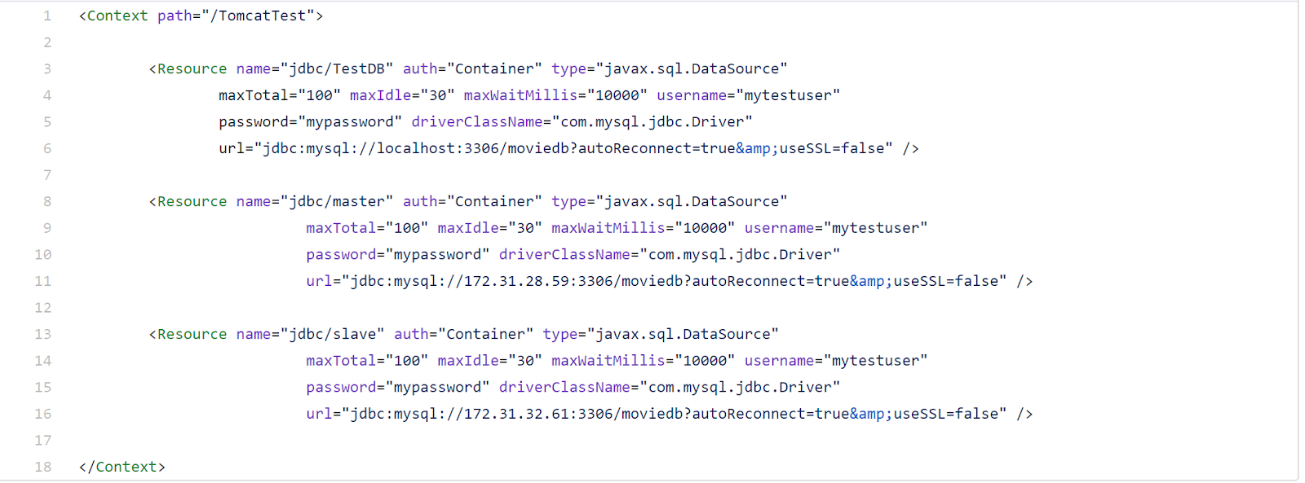

* How did you use Prepared Statements?

Instead of using Statement, I use PreparedStatement with my query. I replace the “?” in query by using setString() or setInt() function. Then I use executeQuery() function

* File name, line numbers as in Github

File: MovieServlet.java - line 610-629, line 661.

* Snapshots

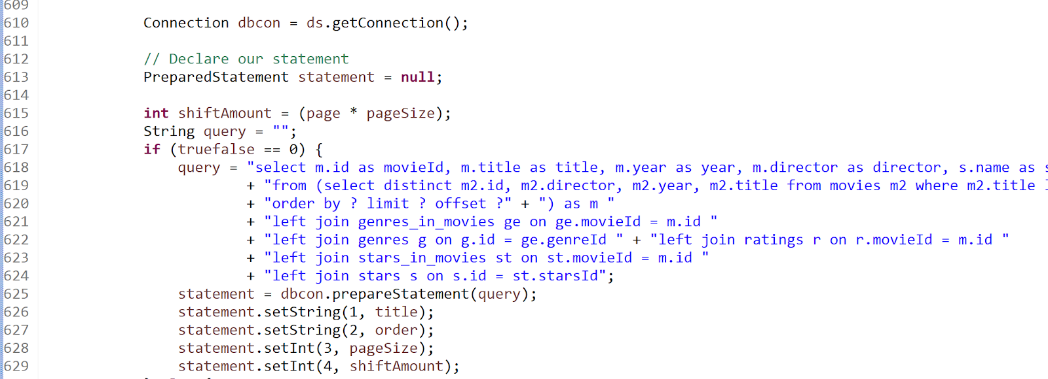

**Task 2**

* Address of AWS and Google instances

//Instance 1 (load balancer, Google)

<http://35.231.20.131/Project/servlet/Login>

//Instance 1 (load balancer, AWS)

http://18.218.216.139/Project/servlet/Login

//Instance 2 (master, AWS)

http://18.218.147.79:8080/Project/servlet/Login

//Instance 3 (slave, AWS)

http://18.188.111.204:8080/Project/servlet/Login

* Have you verified that they are accessible? Does Fablix site get opened both on Google’s 80 port and AWS’ 8080 port?

Yes

* How connection pooling works with two backend SQL?

With two backend instances we define a Reference for each SQL database. In our case we have defined a Master and a Slave reference. The Master is used for all POST and GET methods whereas the Slave is used only for GET methods.

* + File name, line numbers as in Github

File name: context.xml

Path: [cs122b-winter18-team-54](https://github.com/UCI-Chenli-teaching/cs122b-winter18-team-54/tree/z-have-both)/[Project](https://github.com/UCI-Chenli-teaching/cs122b-winter18-team-54/tree/z-have-both/Project)/[WebContent](https://github.com/UCI-Chenli-teaching/cs122b-winter18-team-54/tree/z-have-both/Project/WebContent)/[META-INF](https://github.com/UCI-Chenli-teaching/cs122b-winter18-team-54/tree/z-have-both/Project/WebContent/META-INF)/context.xml

Line numbers: All line numbers in this file

File name: MovieServlet.java

Path: [cs122b-winter18-team-54](https://github.com/UCI-Chenli-teaching/cs122b-winter18-team-54/tree/z-have-both)/[Project](https://github.com/UCI-Chenli-teaching/cs122b-winter18-team-54/tree/z-have-both/Project)/[src](https://github.com/UCI-Chenli-teaching/cs122b-winter18-team-54/tree/z-have-both/Project/src)/[API](https://github.com/UCI-Chenli-teaching/cs122b-winter18-team-54/tree/z-have-both/Project/src/API)/MovieServlet.java

Line numbers: [226,239], [315,329], [408,421], [524, 538], [891,904]

File name: AddMovieServlet

Path: [cs122b-winter18-team-54](https://github.com/UCI-Chenli-teaching/cs122b-winter18-team-54/tree/z-have-both)/[Project](https://github.com/UCI-Chenli-teaching/cs122b-winter18-team-54/tree/z-have-both/Project)/[src](https://github.com/UCI-Chenli-teaching/cs122b-winter18-team-54/tree/z-have-both/Project/src)/[API](https://github.com/UCI-Chenli-teaching/cs122b-winter18-team-54/tree/z-have-both/Project/src/API)/AddMovieServlet.java

Line numbers: [62,75]

File name: StarServlet

Path: cs122b-winter18-team-54/Project/src/API/StarServlet.java

Line numbers: [52, 65]

File name: CustomerService

Path: [cs122b-winter18-team-54](https://github.com/UCI-Chenli-teaching/cs122b-winter18-team-54/tree/z-have-both)/[Project](https://github.com/UCI-Chenli-teaching/cs122b-winter18-team-54/tree/z-have-both/Project)/[src](https://github.com/UCI-Chenli-teaching/cs122b-winter18-team-54/tree/z-have-both/Project/src)/[Controllers](https://github.com/UCI-Chenli-teaching/cs122b-winter18-team-54/tree/z-have-both/Project/src/Controllers)/CustomerService.java

Line numbers: [38, 51]

File name: EmployeeService

Path: [cs122b-winter18-team-54](https://github.com/UCI-Chenli-teaching/cs122b-winter18-team-54/tree/z-have-both)/[Project](https://github.com/UCI-Chenli-teaching/cs122b-winter18-team-54/tree/z-have-both/Project)/[src](https://github.com/UCI-Chenli-teaching/cs122b-winter18-team-54/tree/z-have-both/Project/src)/[Controllers](https://github.com/UCI-Chenli-teaching/cs122b-winter18-team-54/tree/z-have-both/Project/src/Controllers)/EmployeeService.java

Line numbers: [38,51]

* + Snapshots

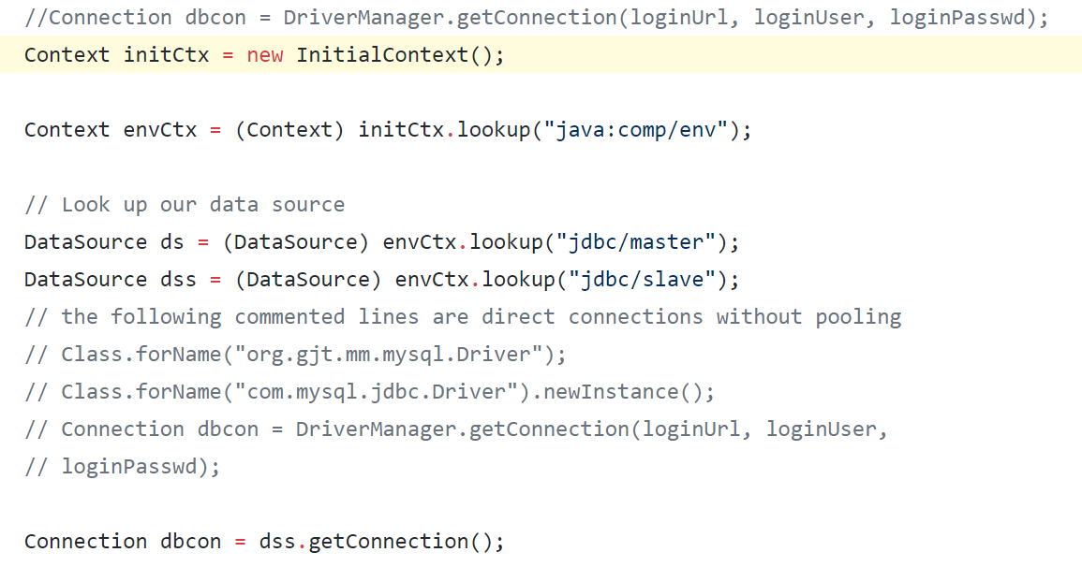

* How read/write requests were routed?

All POST requests GET routed to master while all read requests get routed to either master or slave.

* + File name, line numbers as in Github

File name: MovieServlet.java

GET :  [222,239]

File name: AddMovieServlet.java

POST:

* Snapshots

First picture is GET request

Second picture is POST request

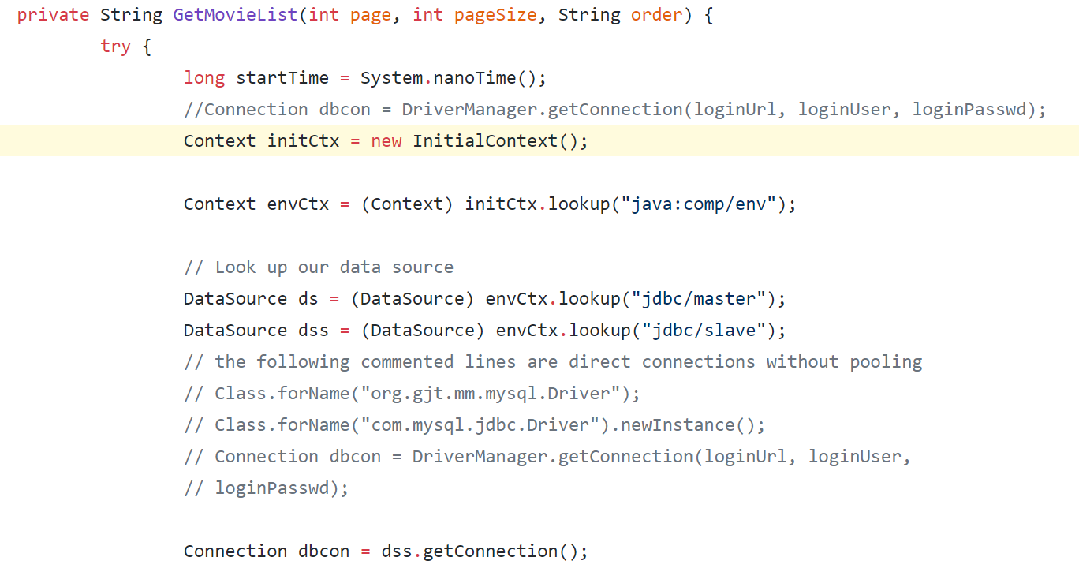

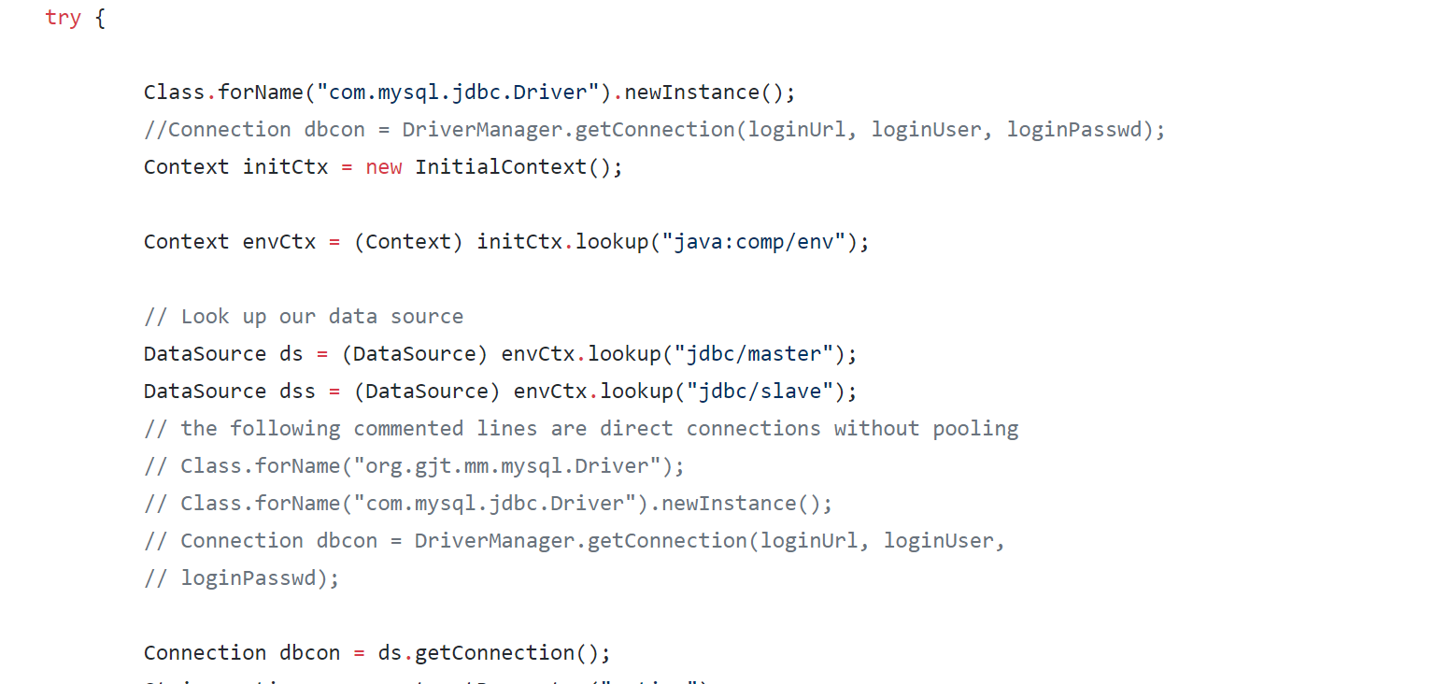

**Task 3**

* Have you uploaded the log file to Github? Where is it located?

All .txt files in this directory

[cs122b-winter18-team-54](https://github.com/UCI-Chenli-teaching/cs122b-winter18-team-54/tree/z-have-both)/[Project_5_Report](https://github.com/UCI-Chenli-teaching/cs122b-winter18-team-54/tree/z-have-both/Project_5_Report)/jmeter_report/

* Have you uploaded the HTML file to Github? Where is it located?

[cs122b-winter18-team-54](https://github.com/UCI-Chenli-teaching/cs122b-winter18-team-54/tree/z-have-both)/[Project_5_Report](https://github.com/UCI-Chenli-teaching/cs122b-winter18-team-54/tree/z-have-both/Project_5_Report)/[jmeter_report](https://github.com/UCI-Chenli-teaching/cs122b-winter18-team-54/tree/z-have-both/Project_5_Report/jmeter_report)/jmeter_report.html

* Have you uploaded the script  to Github? Where is it located?

[cs122b-winter18-team-54](https://github.com/UCI-Chenli-teaching/cs122b-winter18-team-54)/[Project_5_Report](https://github.com/UCI-Chenli-teaching/cs122b-winter18-team-54/tree/master/Project_5_Report)/[jmeter_report](https://github.com/UCI-Chenli-teaching/cs122b-winter18-team-54/tree/master/Project_5_Report/jmeter_report)/average_parser.ipynb

* Have you uploaded the WAR file and README  to Github? Where is it located?

[cs122b-winter18-team-54](https://github.com/UCI-Chenli-teaching/cs122b-winter18-team-54)/[Project_5_Report](https://github.com/UCI-Chenli-teaching/cs122b-winter18-team-54/tree/master/Project_5_Report)/WAR_file/