Group Project Documentation   
Advanced Cross-Platform Application Programming with .NET

Bird Meal Order System

**Prepared by HHTM**

Đỗ Thành Huy, Phạm Hoàng Hà, Dương Minh Thành, Phạm Minh Nhật

**Ho Chi Minh City, 2023**

**Table of Contents**

**Table of Contents ii**

**Revision History ii**

**1.** **Project Introduction 1**

1.1 Product Perspective 1

1.2 User Classes and Characteristics 1

**2.** **Database Design 1**

**3.** **System Architecture 1**

**4.** **Implementation 2**

4.1. Deployment Considerations 2

4.2. Screenshots and explanations 2

**5.** **References 2**

**Revision History**

|  |  |  |  |
| --- | --- | --- | --- |
| **Name** | **Date** | **Reason For Changes** | **Version** |
| *Van Vo* | *21 May 2023* | *Initial draft* | *1.0 draft 1* |
|  |  |  |  |
|  |  |  |  |
|  |  |  |  |

# Project Introduction

## Product Perspective

Our product is an online shopping platform on the website designed to give customers a shopping experience for their pet bird food. It will allow customers to find and choose the right food for each type of bird, with a certain origin, and we provide a variety of feeding routes for a variety of improvement purposes. Thereby helping bird owners to care about the quality of meals for their pets.

The platform will be used in a consumer setting, accessed through a web browser. Customers will require an internet connection to use the platform. The platform will depend on third-party services, such as PayPal payment gateways and shipping providers, to function properly.

## User Classes and Characteristics

*Functional requirement:*

- Public feature:

1. Feature: Search Product

- Function trigger: When User clicks the button with name "Search".

- Function description: This function helps users to search related products based on the keywords entered by the user in the search bar.

- Function details: Users click on the search bar on the screen and type keywords related to the product to be searched. Then, click on the "Search" button, a list of products related to the keyword that the user entered will be rendered on the screen. If the searched product is not suitable, the user can repeat the operation to search for the product.

2. Feature: Update

a. Change Password

- Function trigger: Customer clicks on “Change password” in the User Profile page.

- Function description: User can change set password to new password.

- Function details: In the User Profile page, the user clicks on "Change password", the system will appear a form asking the user to enter a new password, then the system will send an authentication form asking the user to enter the username and the password you are using to confirm. If the authentication is successful, the new password will be changed. If the authentication fails or the user closes the authentication form, the current password will be preserved and will not be changed.

b. Edit Profile

- Function trigger: This function triggers when a customer clicks the "Edit" button in the "Profile Management" section of the User Profile page.

- Function description: User can edit his/her registered information.

- Function details: display a below screen, similar user profile page but with editable data.

3. Feature: Cart

a. Add product to cart

- Function trigger: When a customer clicks “Add to cart” in product detail.

- Function description: This function allows users to add the products they want to buy to the cart so they can proceed to check out later.

- Function details: When the user clicks on the “Add to cart” button, the product will be added to the cart and the product's information will be stored in the user's cart. Users can continue to add other products or view their shopping cart to check and edit before checkout.

b. Edit product in cart

- Function trigger: User click on “icon cart” in the header and redirect to cart detail.

- Function description: Users can edit the quantity of product or remove them out of cart.

- Function details: To be able to edit the products added to the cart, the user can click on the cart icon on the header, the "Product detail" page will appear on the screen. At this page, users can increase or decrease the quantity of previously added products or users can click the "Remove to cart" button to remove the products added to the cart.

4. Feature: Authentication

a. Login

- Function trigger: User click the button with name “Login” in screen

- Function description: This function allows users with an activated account or an administrator to log in to the system. When filling in the login information completely and correctly, the system will verify and redirect the page to the homepage if it is a customer account or to the admin page if it is an admin account.

- Function details: The login function starts when the user has an account but has not logged into the system. Here users can login using the login form by filling in the username and password information on the displayed form, then pressing the login button. The system will check the login information, if it is wrong, the system will display the login page and error message again, if successful, the system will save the login data to the session and redirect to the homepage if logged in with the user account or admin page if the user fills in the login information as an admin account.

b. Logout

- Function trigger: When the user clicks the button with name “Log out” on screen.

- Function description: The function allows users to log out of the system and return to the home page.

- Function details: The logout function starts when the user is logged in in the system and wants to log out the account from the system. On the homepage the user will press the logout button, the system will display the user message "Do you want to exit?" with "Yes" and "No" buttons. Here if the

user selects "Yes", the system will cancel the session, exit the login screen and reload the homepage. If the user selects "No", the system will not perform the logout and return to the current screen.

c. Register

- Function trigger: When the user clicks on the “Sign up” button. The registration form will occur for users to fill out required information.

- Function description: When users need to create an account for shopping. After registration, the account will be updated to the database, provide security, notification, authentication...

- Function details: The function will receive the information of the user, such as their username, email address, password and some personal information by input. System shall validate the user's input on the registration form to ensure all required fields are filled out and that the email address is in a valid format. The system shall require users to authenticate themselves with their email address and password when logging into their account. The system shall ensure that user passwords are stored securely using encryption or other industry-standard security measures. The system shall create a user profile for the user upon successful account creation, which may include personal information, preferences, or other optional details. The system shall ensure that the registration form and login functionality are accessible to users with disabilities and comply with relevant accessibility standards.

5. Feature: View

View product/meal routing list

- Function trigger: When a user visits the Home page.

- Function description: Render product list and meal routing in system.

- Function details: Render a screen below, for customers to choose the product and meal which they are looking for.

6. Feature: Feedback

a. View feedback

- Function trigger: When a user clicks on a product item to see product detail.

- Function description: Feedback of other users will render in the feedback content.

- Function details: Render a screen below, where to show feedback of this product.

b. Send feedback

- Function trigger: In product detail users can type their feedback on this product.

- Function description: have an input text in the below of product detail for users to type their feedback.

- Function details: Render a screen below, for users to type their feedback.

7. Feature: Checkout

- Function trigger: When the user clicks on “checkout button” in cart detail.

- Function description: redirect them to the checkout page.

- Function details: Display a screen below, for customers to fill in the info such as their phone and their location to receive the product.

- Manage feature:

1. View Dashboard

- Function trigger: When login with an Admin account and choose “View Dashboard” in the sidebar.

- Function description: This function helps admin to see details of revenue and reports of products that were sold.

- Function details: Render a screen below to show the report and revenue of the system.

2. Account management by Admin

- Function trigger: When admin clicks on “Account management” in the sidebar of the management page.

- Function description: Show the list of accounts in the system so the admin can manage them.

- Function details: Admin can view account profile details and disable them.

3. Search account

- Function trigger: Admin click search button in account management page.

- Function description: Will return the account with information mapping with the keyword in search input.

- Function details: When an admin types their account name in search input and clicks the “Search” button the function will render the list of accounts suitable with this keyword.

4. View profile account detail

- Function trigger: Admin click on “Detail” of account in account management page.

- Function description: Pop up a screen profile detail of which account admin wants to see.

- Function details: Render screen profile detail to show name, password, and have important option is “disable” account for which account admin have reason to avoid them in our system.

5. Product Management

- Function trigger: When staff click on “Product Management” in sidebar of Management Page.

- Function description: Staff can manage the product system through a list of products in the product management screen.

- Function details: Render a screen below, allow staff to edit product lists and update them or add a new product by clicking on the add button.

6. Order Management

- Function trigger: When staff click on “Order Management” in the Management Page.

- Function description: Show the list of order in the system.

- Function details: Show the screen below, for staff can view all orders and can view order details of each account. Therefore, staff can report revenue for the manager.

a. View Order Detail

- Function trigger: When staff click on the “Detail” button in the Management Page.

- Function description: Pop up the order detail of each order.

- Function details: Show the screen below, for staff to view order details. Therefore, can use tool for scan which products is hot selling well.

7. Feedback management

- Function trigger: When staff click on “Feedback Management” in the sidebar of the Management Page.

- Function description: Show the list of feedback of each product.

- Function details: Render the screen below, have name product, start, and feedback content for staff can accept them push in product details to avoid feedback unstable such as spam or danger url.

# Database Design

Entity Relationship Diagram:

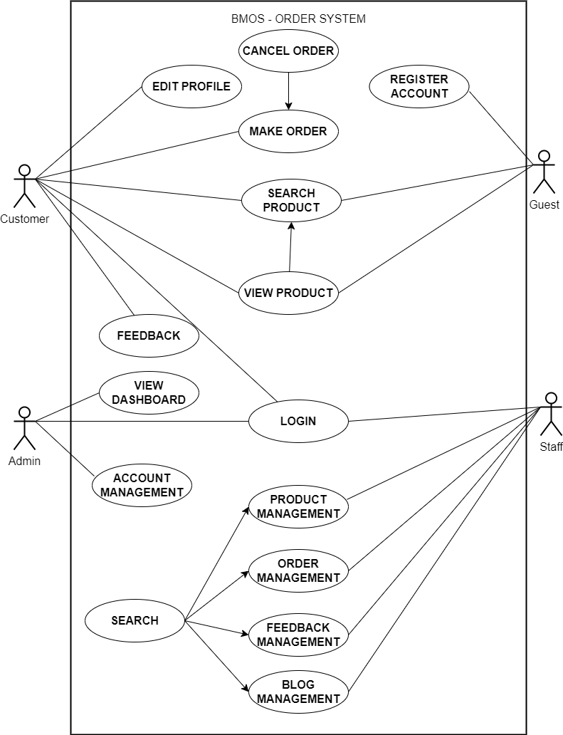

Workflow:

* Workflow 1: Guest 🡪 (1) Register 🡪 Become a new member 🡪 (2) Login 🡪 (3) Update profile
* Workflow 2: Member 🡪 (1) Login 🡪 (2) Search product 🡪 (3) View Product Detail 🡪 (4) Order
* Workflow 3: Staff 🡪 (1) Login 🡪 (2) Manage product 🡪 (3) Manage orders
* Workflow 4: Admin 🡪 (1) Login 🡪 (2) View dashboard 🡪 (3) Manage users

Data diagram:

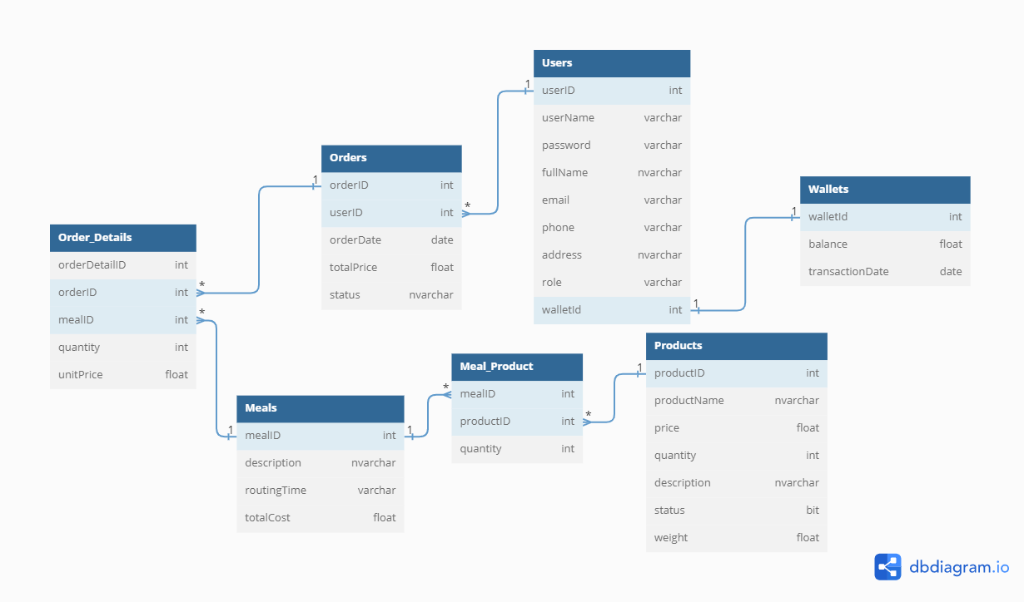

# System Architecture

*<Describe the environment in which the project will operate, including the hardware platform; operating systems and versions; geographical locations of users, servers, and databases; and organizations that host the related databases, servers, and websites.>*

*<A detailed description of how you design the system. You should provide your understanding of your architecture and how your application implemented. The diagrams (eg UML: deployment diagram, class diagrams) should be provided if necessary.>*

*<A detailed description of any new technologies you find out (not in school) to develop applications.>*

# Implementation

## Deployment Considerations

*<Summarize the information and activities that are needed to ensure an effective deployment of the solution into its operating environment.>*

*<Describe the access that users will require to be able to use the system, such as whether the users are distributed over multiple time zones or located close to each other. State when the users in various locations need to access the system. If infrastructure changes are needed to support the software’s need for capacity, network access, data storage, or data migration, describe those changes.>*

*<Record any information that will be needed by people who will be preparing training or modifying business processes in conjunction with deployment of the new solution.>*

## Screenshots and explanations

*<Screen flow | Dialog Map>*

*<The screenshots and explanations>*

# References

1. *Beatty, Joy. Process Impact Intranet Development Standard, Version 1.3, www.processimpact.com/corporate/standards/PI Intranet Development Standard.pdf*
2. *Rath, Andrew. Process Impact Internet Application User Interface Standard, Version 2.0, www.processimpact.com/corporate/standards/PI Internet UI Standard.pdf*