**RMIT UNIVERSITY VIETNAM **

School of Science, Engineering and Technology

Department of Information Technology

**EEET2578 Engineering Quality Assurance**

**ISYS2092 Software Testing**

**GROUP PROJECT – SEMESTER 2, 2024**

**Component 3: BDD Testing with Java, Katalon and Cucumber**



Team number: 2

Team members:

* Tran Minh Nhat – s3926629
* Tran Tan Phat – s3836612
* Dang Vinh Luan – s3927222
* Pham Nguyen Minh Dang – s3922418

*We declare that in submitting all work for this assessment we have read, understood and agree to the content and expectations of the Assessment declaration.*

**Ho Chi Minh City, Vietnam**

**September 2024**

TABLE OF CONTENTS

Introduction 3

Test Cases 4

Test Results 6

**INTRODUCTION**

As software developers, it is ubiquitous and essential for us to know how our software works [1]. And when comes to that, we always have a lot of questions to answer:

* How does the software actually work?
* What kind of behaviour it demonstrates?
* What kind of algorithm did it used to perform those tasks?
* How can we optimize its performance?
* How can we improve the software’s behaviour?
* …

There’s a lot to considered to answer this question. And to do that, a specific kind of software testing is needed. We maybe think that it is JUnit or TestNG testing to the rescue, but actually, both of those kinds of test only worked at a surface-level. It is not deep enough to answer the above questions.

So what kind of testing do we need now? It is BDD - Behaviour-Driven Development! BDD is a special type of testing that allows developers to write the tests using natural languages (in fact, their mother tongue) to check the software. It’s like we verbally asked the software to do their work but without converting them to machine code by ourselves.

There are a lot of tools that we can used to do the BDD for a software. One of them is the Cucumber tool, operated using the Gherkin language. When we heard about “Cucumber”, we usually think of a vegetable, but actually this is a name of a separate software! First established in 2005 as RSpec Stories, it changed into Cucumber at the request of the founder’s wife, and now it is one of the most popular BDD software on the world nowadays, with over 10.6% of shares among 70 software and tools!

In this part of the group project, we are going to explore the beauty of the Cucumber and its accompanied Gherkin language through the process of testing a simple calculator application, Build from a Java base, combined with the user-story skills possessed by us, our team will optimize them to create the “yummiest” Cucumber “tests” for the Calculator Application to eat, but whether it is delicious or tasted like poisonous food is another story.

As software developers, we understand a report like this will be very useful to demonstrate the process of our testing journey. We hope that you will enjoy the report, accompanied by insights from both the Cucumber and Katalon.

**Sincerely**

**The Authors**

**TEST CASES**

Jira/QAlity Page:

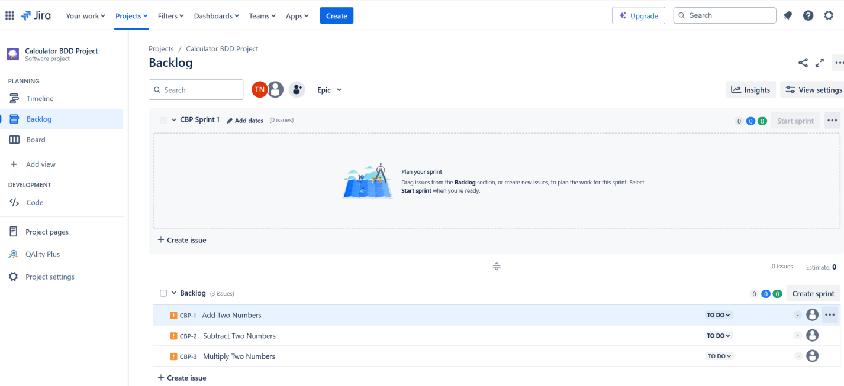

1. Add Two Numbers

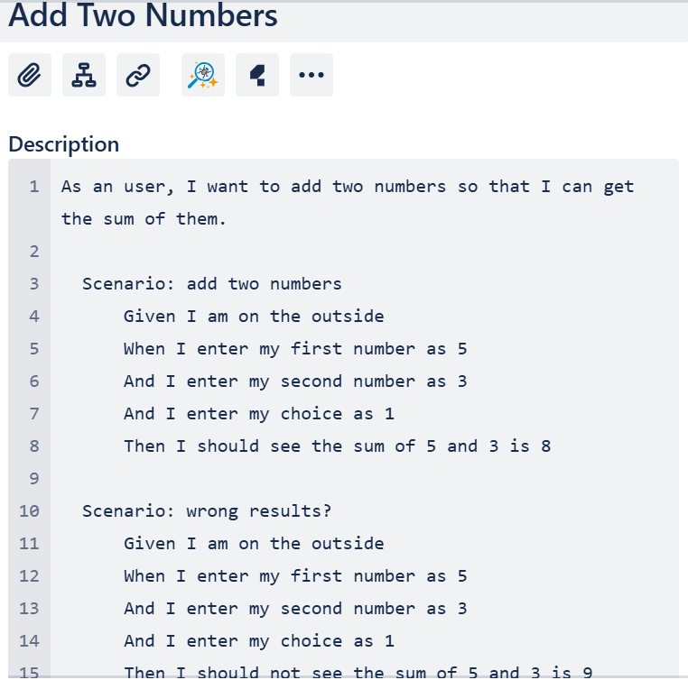

1. Subtract Two Numbers

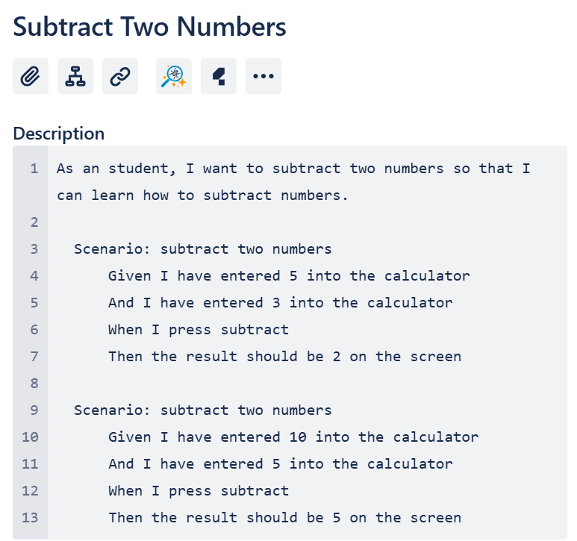

1. Multiply Two Numbers

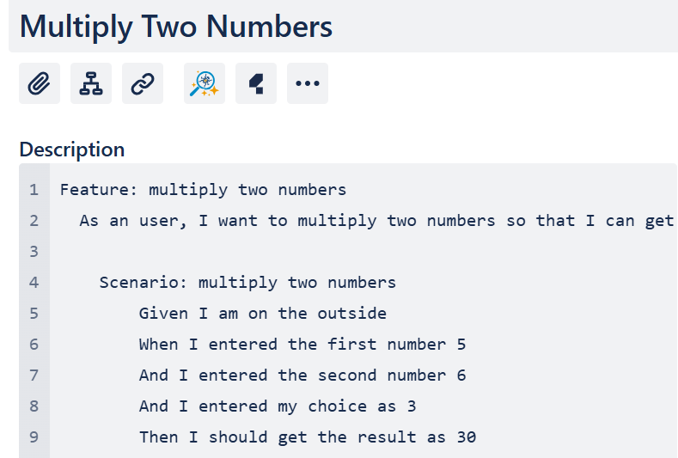

1. Divide Two Numbers

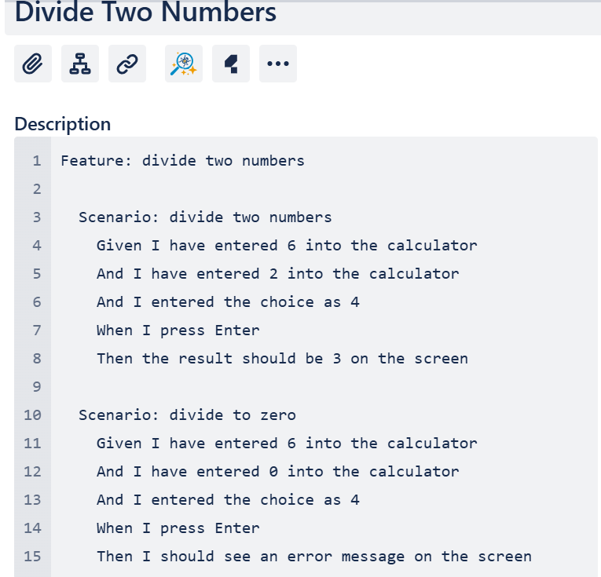

1. Modulus Functions

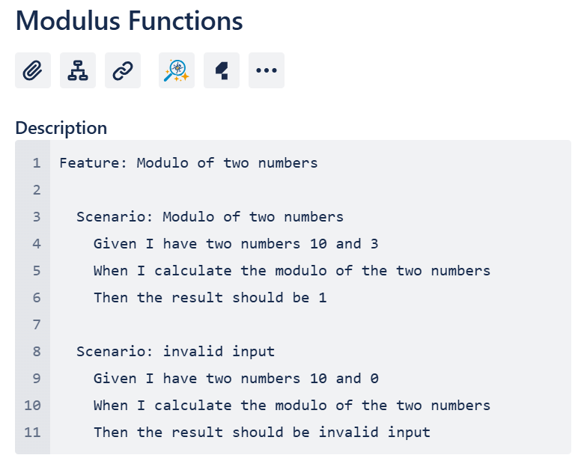

1. Power Functions

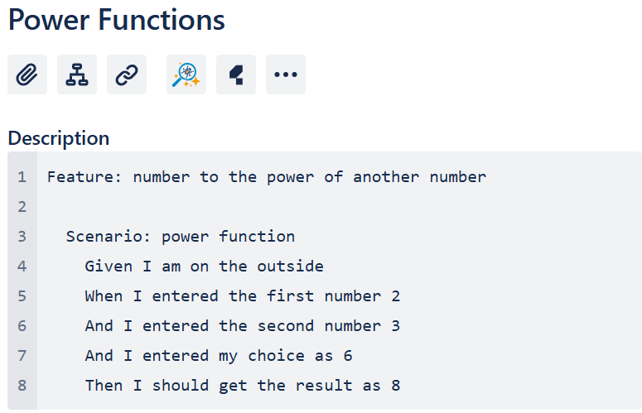

**REFERENCES**

[1] “The hardest part of building software is not coding, it’s requirements - Stack Overflow,” stackoverflow.blog, Dec. 29, 2023. https://stackoverflow.blog/2023/12/29/the-hardest-part-of-building-software-is-not-coding-its-requirements/