Load Balancer Page

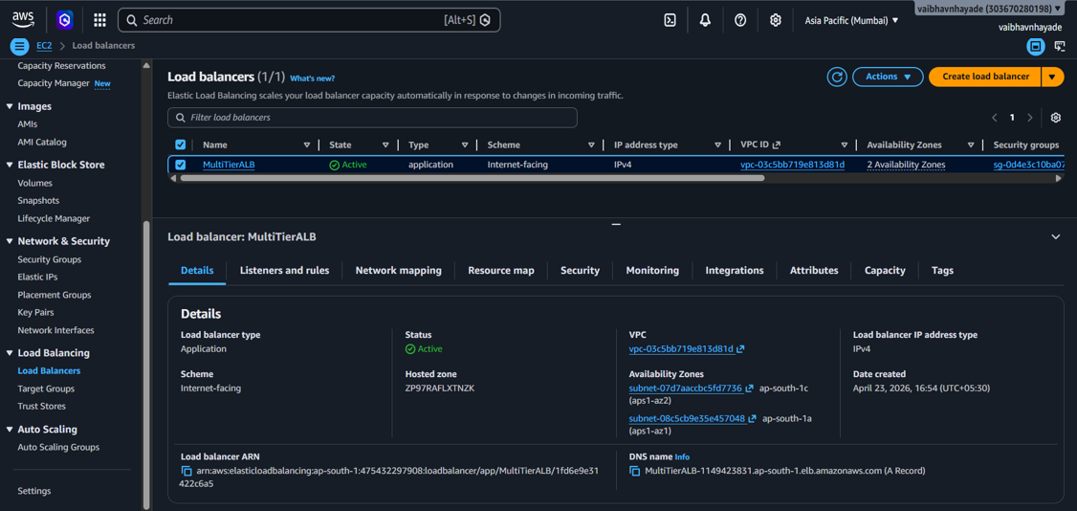
Listener Page

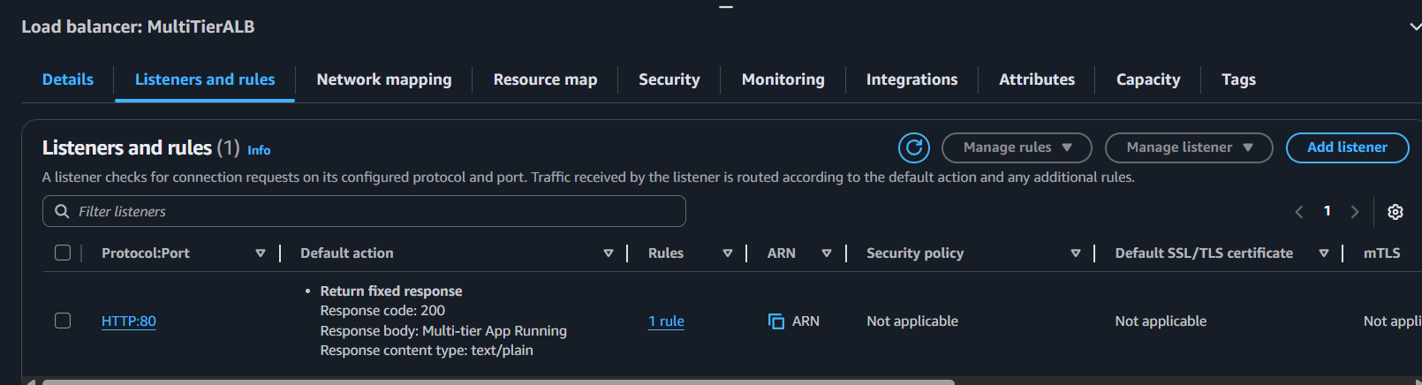
EC2 Instances Page
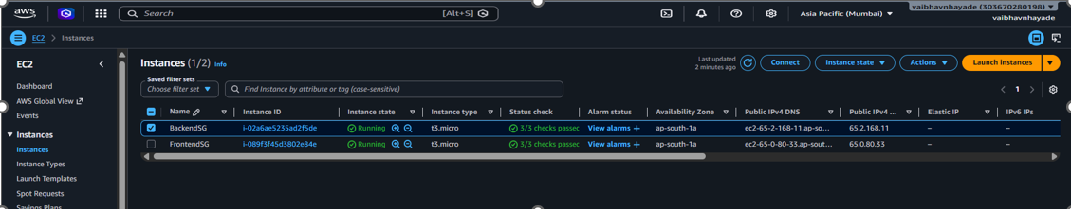

RDS Database Page
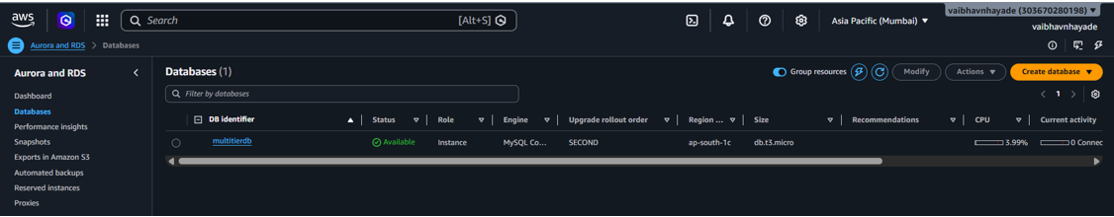

Security Groups Page
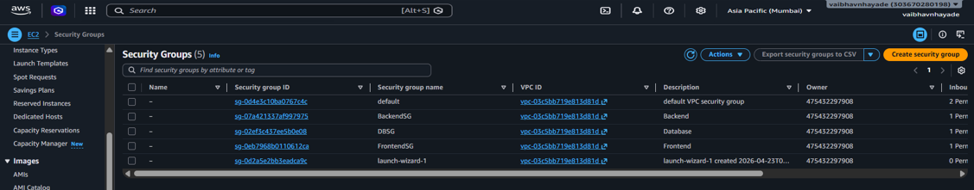

Project Output Page
