Computer Simulation using Object-oriented design in C

Henry X. Lawerence, Nicholas A. Hays, Benjamin J. Pasero

University of Washington – Tacoma

February 21, 2016

Table of Contents

Abstract 2

ISA 4

Instruction Set 4

R-Type (add, nand) 4

I-Type (addi, lw, sw, beq) 5

J-Type (jalr) 5

O-Type (halt) 5

DataPath Design 5

CPU 5

ALU 5

Memory 6

Register File 6

Assembler 6

Parser 6

View 6

Signals 7

Simulator 7

Model 7

View 7

Signals 8

Appendix A 9

# Abstract

Fdaskjl;;;;;;;;;;;;;;;;;;;;;;;;;;;;;;;fdassssssssssssssssssssdsafasdfasfjalksdfjlak;sdjf;alsdkjf;dsalkjf; Fdaskjl;;;;;;;;;;;;;;;;;;;;;;;;;;;;;;;fdassssssssssssssssssssdsafasdfasfjalksdfjlak;sdjf;alsdkjf;dsalkjf;

Fdaskjl;;;;;;;;;;;;;;;;;;;;;;;;;;;;;;;fdassssssssssssssssssssdsafasdfasfjalksdfjlak;sdjf;alsdkjf;dsalkjf;

Fdaskjl;;;;;;;;;;;;;;;;;;;;;;;;;;;;;;;fdassssssssssssssssssssdsafasdfasfjalksdfjlak;sdjf;alsdkjf;dsalkjf;

Fdaskjl;;;;;;;;;;;;;;;;;;;;;;;;;;;;;;;fdassssssssssssssssssssdsafasdfasfjalksdfjlak;sdjf;alsdkjf;dsalkjf;

Fdaskjl;;;;;;;;;;;;;;;;;;;;;;;;;;;;;;;fdassssssssssssssssssssdsafasdfasfjalksdfjlak;sdjf;alsdkjf;dsalkjf;

Fdaskjl;;;;;;;;;;;;;;;;;;;;;;;;;;;;;;;fdassssssssssssssssssssdsafasdfasfjalksdfjlak;sdjf;alsdkjf;dsalkjf;

Fdaskjl;;;;;;;;;;;;;;;;;;;;;;;;;;;;;;;fdassssssssssssssssssssdsafasdfasfjalksdfjlak;sdjf;alsdkjf;dsalkjf;

Fdaskjl;;;;;;;;;;;;;;;;;;;;;;;;;;;;;;;fdassssssssssssssssssssdsafasdfasfjalksdfjlak;sdjf;alsdkjf;dsalkjf;

Fdaskjl;;;;;;;;;;;;;;;;;;;;;;;;;;;;;;;fdassssssssssssssssssssdsafasdfasfjalksdfjlak;sdjf;alsdkjf;dsalkjf;

Fdaskjl;;;;;;;;;;;;;;;;;;;;;;;;;;;;;;;fdassssssssssssssssssssdsafasdfasfjalksdfjlak;sdjf;alsdkjf;dsalkjf;

*Keywords:* klasdjflsakfjdaslkfjdasljsa

PC Simulation using Object-oriented design in C

Introduction

Brief intro to project

(2-3 paragraphs)

# ISA

(Heading 1 centered and bolded)

-describe our ISA. i.e 32bit, fixed length, refer to our assignment 1 papers for content.

-what instructions do we have? Addressing modes?

How have we incorporated OOD into our ISA?

Example in text figure..

Our model is similar to the LC-2200 datapath design. (see Figure 1 below)

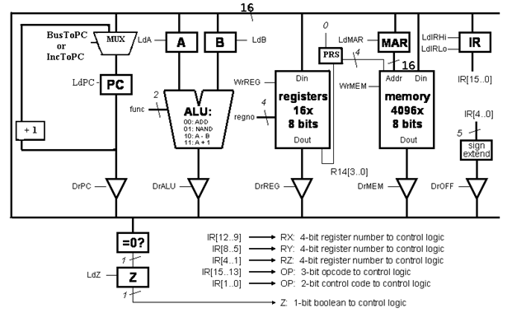

Figure 1: LC-2200 Data Path Design.

## Instruction Set

What is an instruction set? What purpose does it serve?

Describe what instructions we support

### R-Type (add, nand)

Describe mode

Give graphic outline of format..i.e 31-28 opcode, 27-24 Reg X…

### I-Type (addi, lw, sw, beq)

Describe mode

Give graphic outline of format..i.e 31-28 opcode, 27-24 Reg X…

### J-Type (jalr)

Describe mode

Give graphic outline of format..i.e 31-28 opcode, 27-24 Reg X…

### O-Type (halt)

Describe mode

Give graphic outline of format..i.e 31-28 opcode…

-

# DataPath Design

-describe the data path design

-how does the data path design influence out project?

How have we incorporated OOP principles into the design?

Grab information from c docs or gtk docs and pull directly and cite in text apa

## CPU

-What is the CPU?

-What does the CPU do in our application?

-How have we implemented the CPU?

FSM

Screen shot of ROM put in text

Screen shot of source code, put in appendix apa format, reference appropriately in text

Describe all main functions purpose.

## ALU

-what is the ALU?

-what type of operations does the ALU perform in our application?

- Screen shot of source code, put in appendix apa format, reference appropriately in text

## Memory

-what functions does it have? How does it do them?

Refer to source code in appendix using correct apa in text reference

Screen shot of source code, put in appendix apa format, reference appropriately in text

## Register File

how many?

Describe function.

Screen shot from lc2200 online and put in text with caption

Screen shot of source code, put in appendix apa format, reference appropriately in text

# Assembler

Discuss purpose

What its used for.

Grab information from c docs or gtk docs and pull directly and cite in text apa

## Parser

How it works

Objectives

Describe bit shifts, bin to string, anything you did during process

Screen shot of source code, put in appendix apa format, reference appropriately in text

## View

describe the object hierarchy (i.e high level container (type), layout container(s), menu bar in first sub container, …)

You might also want to be sure you describe what the image is.

Refer to image in text with caption at the bottom of image as shown above in ISA

Screen shot of source code for view, put in appendix apa format, reference appropriately in text

## Signals

If any? Maybe to parser?

Screen shot of source code, put in appendix apa format, reference appropriately in text

# Simulator

Describe purpose of simulator

Describe its function

How it relates to this project

## Model

How the tree model works

What information it stores, how it retrieves its information, how it updates the view

Screen shot of source code, put in appendix apa format, reference appropriately in text

## View

Describe view layout

Describe view object hierarchy

Include screen shot in text

## Signals

What do the signals do?

Gtk signals

What signals are there (how many)?

How do they interact with control unit

How do they allow user to update register values

Open file chooser

# Appendix

GtkWindow

GtkBox -> Container1

MenuBar

FileMenu

FileLoadMenuItem

GtkBox->Container2

TreeView1

TreeModel

ScrollableContainer

TreeView2

TreeModel

TreeListStore

TreeList