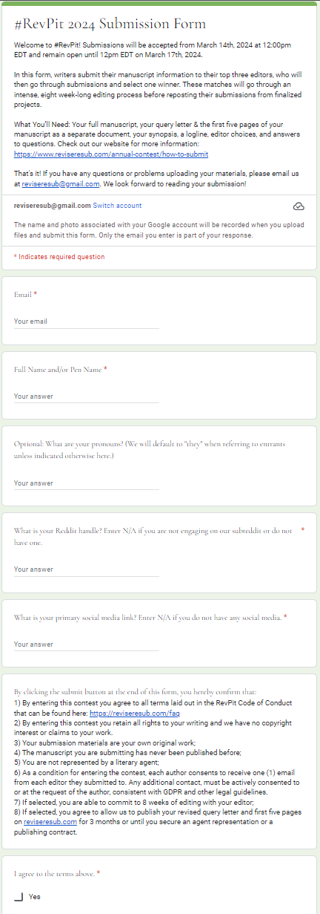Section 1



Your Editors
This is where you'll indicate your editor picks.
Editor Choices: Pick any THREE editors. If you select more, your entry may be disqualified. *
[checkbox] Editor Option 1
[checkbox] Editor Option 2
[checkbox] Editor Option 3Section 2

Your Answers

These questions will help us get to know you and your entry better!

Why did you choose these editors as the best match for you and your manuscript? *

Why is working with an editor helpful for you at this point, and what are your concerns about your manuscript? *

Have you queried or entered this manuscript in other mentorship or similar contests (please include if you are currently querying or being considered for other programs)? If so, what were the results (including any feedback you received)? *

What other feedback have you received, and have you applied that feedback or not? If not, why? *

Why do you love your main character? *

Is there anything you are completely unwilling to change about your manuscript? *Section 3

Your Manuscript Information

If you aren't sure which age category or genre to choose, pick the one that's the best match.

Manuscript Title *

Age Category *
[checkbox] Middle Grade
[checkbox] Young Adult
[checkbox] Adult

Genre *
[checkbox] Romance
[checkbox] Mystery/Thriller
[checkbox] Fantasy
[checkbox] Science fiction/speculative
[checkbox] Horror
[checkbox] Historical fiction
[checkbox] Contemporary/general fiction
[checkbox] Book club/women's fictionSection 4

Optional: Subgenre

Word Count *

Logline *

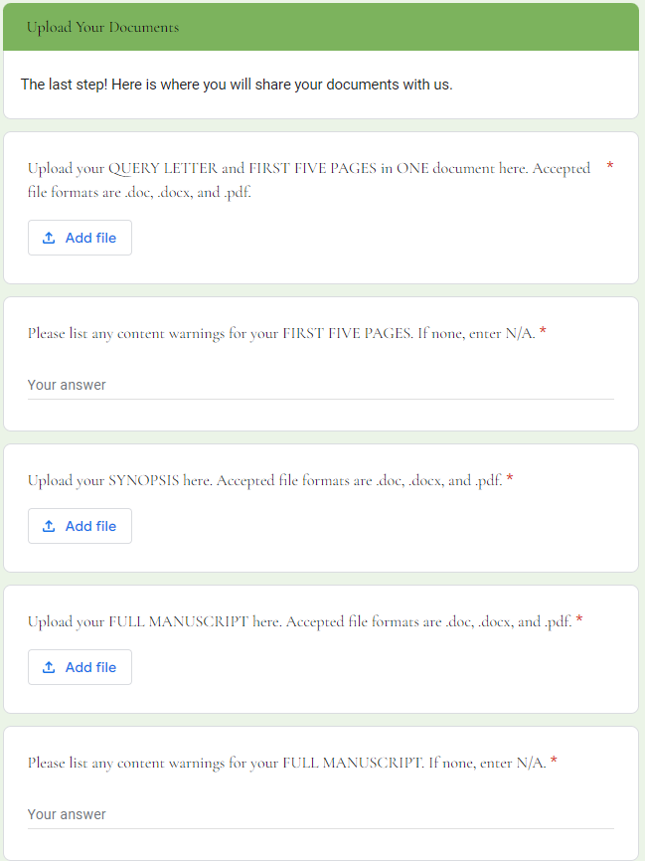Section 5