Block Ciphers, AES and Integrity
CSC 3114: Cryptology and Coding Theory | Take-Home Assignment (Test 2) | Group 4
# | Name | Registration No. | Student No.
1 | NANSEREKO HOUSNAH | 24/U/09631/EVE | 2400709631
2 | SUUNA RAYMOND | 24/U/11403/EVE | 2400711403
3 | NABUKEERA SUMAYAH KASWA | 24/U/07899/EVE | 2400707899
Video presentation: https://drive.google.com/file/d/1TARreFrYcpibNIpK1Uo6iej6iJCPtoCY/view?usp=sharing
Tools: Python 3 with PyCryptodome, PyCA cryptography and the standard library hashlib/hmac.

Task 1: Theory and Cipher Design
a) Confusion, diffusion and the avalanche effect
Confusion hides the relationship between the key and the ciphertext so the key cannot be worked out from the output. In AES it comes from SubBytes, a non-linear S-box substitution. Diffusion spreads each plaintext bit across many ciphertext bits so patterns disappear. AES achieves it with ShiftRows and MixColumns. Together, over repeated rounds, they produce the avalanche effect: changing one input bit should change about half of the output bits.
b) DES vs AES
Property | DES | AES
Block size | 64 bits | 128 bits
Key size | 56 effective bits | 128, 192 or 256 bits
Rounds | 16 | 10, 12 or 14
Structure | Feistel network | Substitution-permutation network
Security today | Insecure: key small enough to brute-force | Secure with a proper key size and mode
c) ECB vs CBC vs CTR
ECB encrypts each block independently, so identical blocks give identical ciphertext and patterns leak. CBC XORs each block with the previous ciphertext block and needs padding. CTR XORs the plaintext with an encrypted counter, so it needs no padding. An IV/nonce gives each encryption a fresh start so the same plaintext never encrypts the same way twice. Misuse to avoid: never reuse a CTR nonce with the same key. It repeats the keystream and exposes the XOR of the plaintexts.

Task 2: Python Avalanche Experiment
AES-128 with key 1234567890abcdef encrypted the block Sixteen byte txt. We flipped one plaintext bit at a time (bits 0 to 9) and counted how many of the 128 ciphertext bits changed:
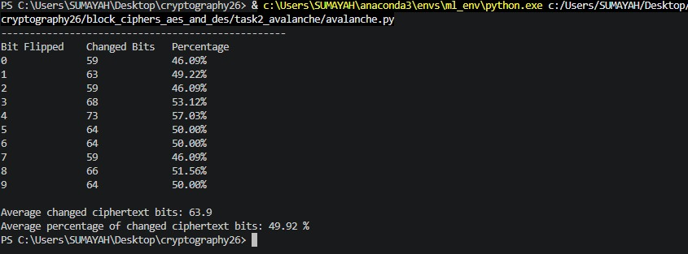

Interpretation: one flipped bit changed 49.92% of the ciphertext on average, almost exactly the ideal 50%, and every trial fell between 46% and 57%. So the ciphertexts of near-identical plaintexts look unrelated. An attacker learns nothing about how similar two inputs are and cannot recover the key by making small changes and watching the output.

Task 3: AESModes in Practice
Message: The quick brown fox jumps over the lazy dog!! (45 bytes), with a fresh random AES-256 key. CBC used a fresh random IV with PKCS7 padding. CTR used a fresh random nonce/counter.
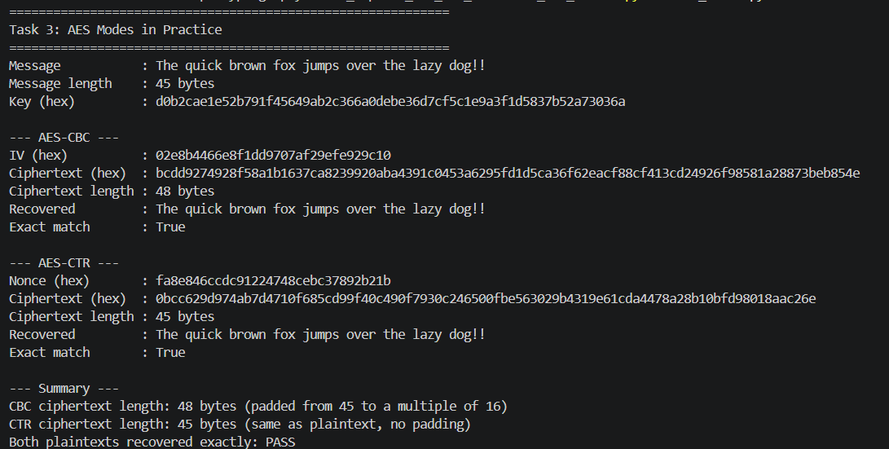
Observations
- Padding and length: CBC works on whole 16-byte blocks, so the 45-byte message grew to 48 bytes. CTR acts as a stream cipher, so the ciphertext is exactly 45 bytes. Neither mode hides the message length.
- Parallelism: CBC encryption is sequential because each block depends on the previous one. CTR blocks are independent, so CTR encrypts and decrypts in parallel and allows random access.
- No integrity: flipping one ciphertext bit in CTR flips exactly that plaintext bit, and decryption still succeeds. Neither mode detects tampering, which motivates Task 4.

Task 4: Integrity and Tampering
We hashed the message and computed an HMAC-SHA256 tag with a random 32-byte key, then changed one character and recomputed both:
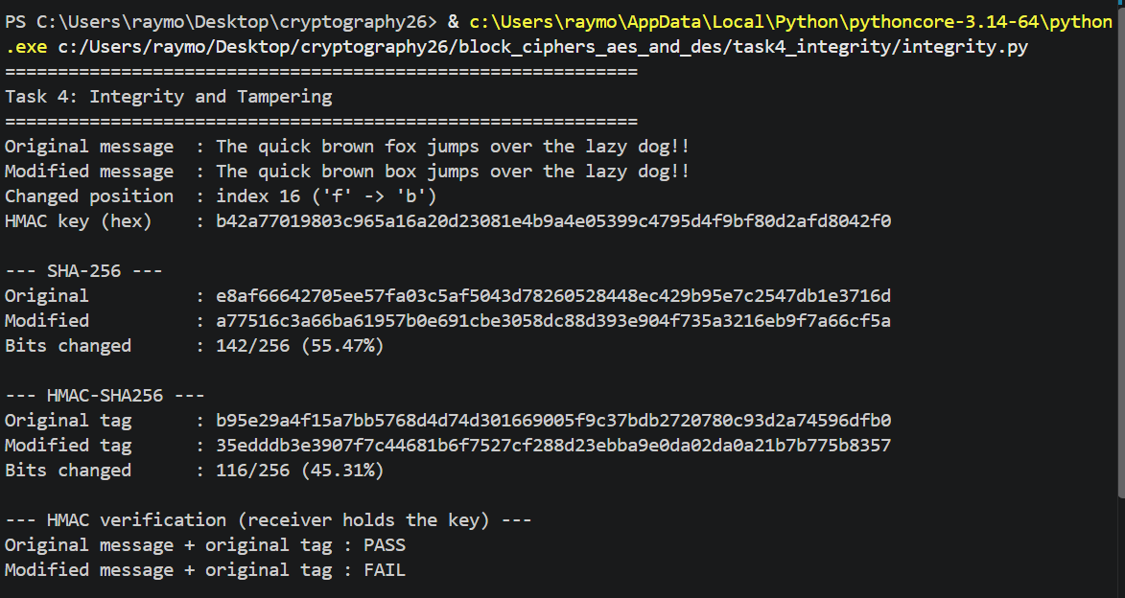
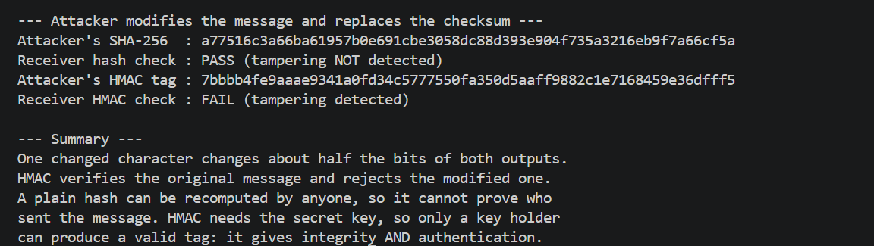
What changed: one character flipped 142/256 bits of the hash and 116/256 bits of the tag, roughly half (the avalanche effect again). HMAC verification passed for the original message and failed for the modified one.
Why a hash is not enough: SHA-256 has no secret, so an attacker can change the message, recompute its hash and replace it. Our run shows the receiver accepting this forgery. HMAC mixes in a secret key, so without the key the attacker cannot produce a valid tag, and our run shows the forgery rejected. A valid tag proves integrity (the message is unchanged) and authentication. It does not give non-repudiation, since both sides share the key.

Task 5: Reflection
The most important lesson we learned is that a strong cipher does not make a system secure on its own. How it is used matters just as much.
Our avalanche experiment showed that AES itself is very strong. Flipping a single plaintext bit changed 49.9% of the ciphertext bits on average, almost exactly the ideal 50%. But Task 3 showed that this strength depends on correct use. AES-CBC and AES-CTR both recovered our message exactly, and each encryption used a fresh random IV or nonce, so the same message never produced the same ciphertext. Reusing a CTR nonce with the same key would reveal the XOR of two plaintexts without anyone breaking AES. We also saw that encryption only hides content. Neither mode detects a modified ciphertext, and CTR even lets an attacker flip chosen plaintext bits.
Task 4 completed the picture. An attacker defeated a plain SHA-256 hash simply by recomputing it, but HMAC-SHA256 rejected the tampered message because the attacker did not have the secret key.
Secure communication therefore needs confidentiality and integrity together, plus careful handling of keys, IVs and nonces. This is why authenticated encryption such as AES-GCM is preferred in practice.

