ODD of Tiger Territory Dynamics model implemented in NetLogo

The model description follows the ODD protocol for describing individual-based models (Grimm et al. 2006, 2010).

**PURPOSE**

The purpose of this model is to simulate the territorial dynamics of tigers in Chitwan National Park, Nepal and thereby predict the demographic parameters of the tiger population in response to habitat quality and tiger density. Tiger population dynamics is deduced from merging territory dynamics with observed demographic rates.

**ENTITIES, STATE VARIABLES AND SCALES**

Model entities are the square spatial units or habitat cells comprising the landscape, male and female tigers, and tiger territories. Model landscape (157 x 345 cells; each cell is 250m x 250m) represents Chitwan National Park, Nepal and adjoining area (3385 km2). The boundaries in the model landscape are impermeable (i.e., the tigers and their territories cannot extend beyond the boundaries).

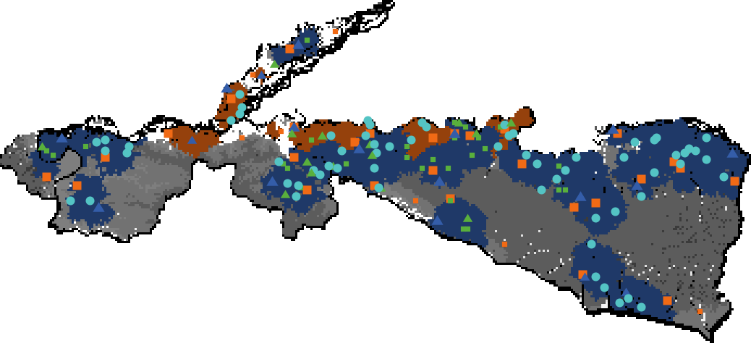

**Figure 1**: Model landscape with 35 adult female tiger and 18 adult male tiger territories. Female tigers are indicated with orange squares, female territories are orange. Male tigers are indicated with blue triangles, male territories are blue; and male territories overlap the territories of multiple females. Cubs (male and female) are indicated with cyan circles, transient females are indicated by green squares and transient males by green triangles.

All state variables characterizing these entities are listed in Table 1.

**Table 1** State variables for male and female tigers, and the habitat cells.

|  |  |  |  |  |
| --- | --- | --- | --- | --- |
| Entity | Variable name | Description | Possible values | Units |
| Male, Female | Age | Age in months | 1-180 | Months |
|  | My-mom | Identity of mom | Identity of female tiger | - |
|  | Natal-origin | Cell where male/female was initialized or the centroid of mother’s territory | 0 – max X, 0 – max Y | Cell units |
|  | Age-class | Indicates development stage of male/female | Cub, Juvenile, Transient, or Breeder | - |
|  | Territory | Set of cells belonging to territory | Set of cell coordinates | - |
| Female | Fertile? | Whether the female is fertile | True/false | - |
|  | Gestating? | Whether the female is gestating | True/false | - |
|  | Males-in-my-territory | Identities of males overlapping female territory | Set of male identities | - |
|  | My-offspring | Number of offspring in current litter | 1-5 | Individual cubs |
|  | Num-litters | Total number of litters the female has had up until current time | 0 – max number of litters over lifetime | - |
|  | terr-orig | Cell that female was initialized at or first cell of territory | 0 – max X, 0 – max Y | Cell units |
|  | t-gestation | Indicates how long female has gestated | 0-3 or 4 | Months |
|  | t-parenting | Indicates how long female has been a parent of current litter | 0-24 | Months |
| Male | Dominant-males | Identities of males that have beaten male in challenges | Set of male identities | - |
|  | Females-in-my-territory | Identities of females overlapping male territory | Set of female identities | - |
|  | Initial-male? | Indicates whether male was created at beginning of simulation | True/false | - |
|  | Lost-territory? | Indicates if male lost a territory to a challenger | True/false | - |
|  | Male-land-tenure | Total time male held onto territory | 0 – entire breeding phase until death | Months |
| Cell | Owner-fem | Identity of female with cell in her territory | Identity of female tiger | - |
|  | Owner-male | Identity of male with cell in his territory | Identity of male tiger | - |
|  | Prey | Prey produced at cell | 0 – max prey production | kg/month |
|  | Is-churia? | Indicates whether cell falls within churia hill boundary | True/false | - |
|  | Is-park? | Indicates whether cell falls within national park boundary | True/false | - |

**PROCESS OVERVIEW AND SCHEDULING**

The following sequence of processes is performed at each time step (1 month) (Fig. 2). Model entities are processed in a randomized order, unless stated otherwise, and changes in state variables are updated immediately. Note that in the program there are mutual links between tigers and territory cells, and males and females, which implies that these links have to be updated every time a tiger dies, or a territory is changed or lost; these technical updates are not described in the following.

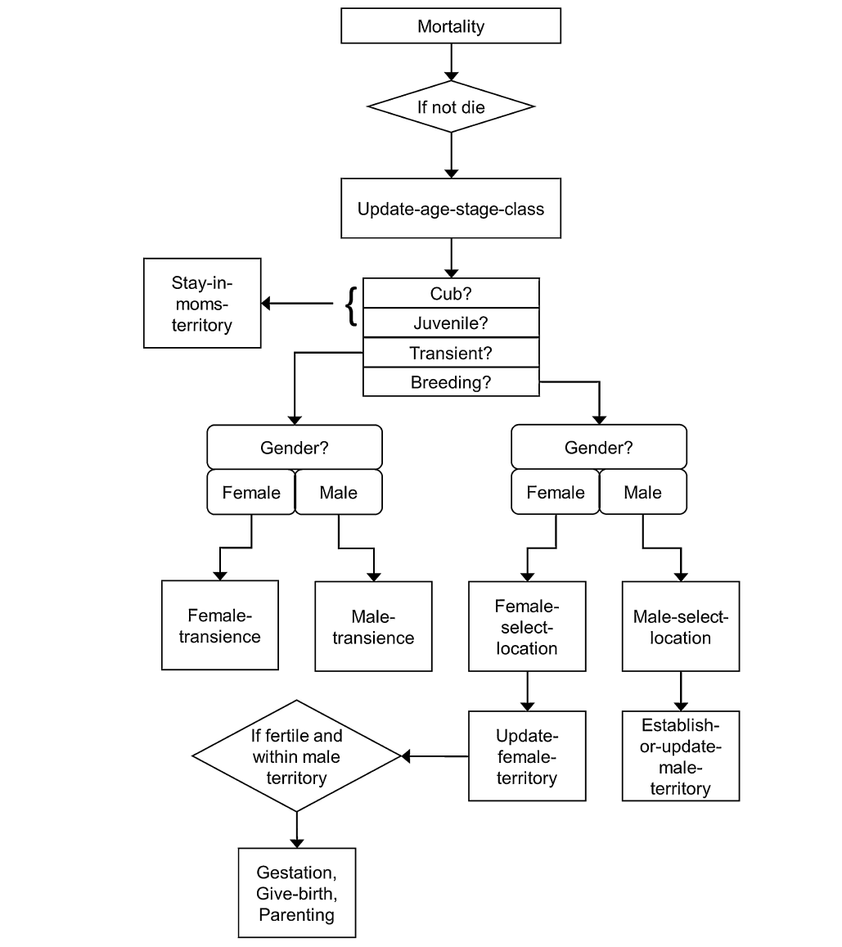

**Figure 2.** Overview of model processes.

1. *Mortality*: Depends on sex, age, and on whether the tiger is a territory holder or disperser.

2. *Update-age-stage-class*: Tigers age and develop and may proceed to the next age class, i.e., cub, juvenile, transient, or breeder (Karanth and Stith, 1999).

3. *Female-select-location*: Upon reaching breeding stage, females select a location to begin establishing a territory.

4. *Male-select-location*: Upon reaching breeding stage, males select a location to begin looking for available females.

5. *Update-female-territory*: Females try to add habitat cells to their territory until the total amount of prey available reaches a certain threshold. They select new cells based on their prey availability and presence and rank, which are correlated to age, of other females. Within a time step, females can try up to 48 times to add a new cell. If the resulting set of habitat cells consists of two or more non-contiguous clusters of cells, all but the largest cluster are removed from the territory (*find-clusters*, *remove-clusters*).

6. *Female-starvation*: Females die if the total prey production within their territory is below 76 kg/month (derived from Miller et al., 2014) and the food within their territory has not increased.

7. *Calculate-fem-centroid*: Calculates the centroid of female territory, i.e., the cell which has the average X and Y coordinates of cells of the female’s territory. These centroids are used to assign female to male territories.

8. *Establish-or-update-male-territory*: A model territory is established or updated. The selection of female territories to be added to a male’s territory is based on the proximity of female territories (their centroids) and the rank of nearby males. Males with less than six female territories may add territories; males with six female territories may replace, if possible, the female whose centroid is farthest away from the male’s territory centroid by a closer female. This is done to prevent male territories from overlapping substantially.

9. *Calculate-male-centroid*: Calculates the centroids of male territories.

10. *Parenting*: (female only) Updates the time since a female gave birth; this determines when the female becomes fertile again and her cubs leave her.

11. *Gestation*: (female only) Updates gestation time and initiates reproduction (give-birth) when gestation time of a female is over.

12. *Prob-mating*: Determines whether fertile females mate with males and begins gestation period.

13. *Plotting*: Model output is plotted or written to files.

**DESIGN CONCEPTS**

**Basic principles**

Acquisition and maintenance of territories reflect fundamental ecological relationships between organisms and their environment. How male and female territorial animals, like tigers, establish, defend, and modify territories, can be related to basic principles such as resource requirements and dominance relationships (Adams, 2001; Brown and Orians, 1970; Burt, 1943; Jacobs et al., 2008; Moorcroft et al., 2006).

**Emergence**

Tiger population size and age distribution over time emerge from demographic processes and territory dynamics. Female territory dynamics emerge from prey biomass distribution and competition with other females. Male territory dynamics emerge from female territory locations and competition with other males.

**Adaptation**

Female tigers adapt their territories to changes in prey biomass and the presence of adjacent female territories, while males adapt their territories to the number and location of nearby female territories and the presence of adjacent male territories.

**Fitness**

Individual tiger fitness is indirectly modeled as access to prey and mates through the formation and adaptation of territories.

**Interaction**

Competition for habitat cells is a direct interaction for both females and males. Males also interact directly as they can expel other males from their territory to gain access to females. In such cases, to trigger estrous in females, infanticide can occur.

**Sensing**

Females can sense total prey available to them within their territory and the prey abundance of cells neighboring their territories. Males know the number of females within their territory and nearby as well as the location of the corresponding female territories. Females sense whether or not a habitat cell adjacent to their territory is owned by another female, and males sense whether or not other males are nearby.

**Stochasticity**

Stochasticity was incorporated into many processes to account for natural variation. The initial locations and ages of tigers, mortality, challenges between males, females taking habitat cells from adjacent females, male selection of females to move toward, litter size, gender of cubs, and mating all include elements of stochasticity.

**Observation**

Individual and population-level processes were observed. These included reproduction (i.e., litter size and lifetime reproductive success for females), mortality (i.e., infanticide and mortality rates for different age classes), dispersal (i.e., distance from natal range to post-natal territory), resource selection (i.e., prey biomass for females and females for males), male and female land tenure (i.e., time that breeding animal held onto territory before dying or dispersing), territory size and spatial distribution, and tiger population size and age structure.

**INITIALIZATION**

The model is initialized with 28 adult female tigers and 14 adult male tigers (based on observations by Karki et al., 2013). Individuals are distributed randomly in the landscape, with 80% of each sex in the lowlands and 20% in Churia hills. The minimum distance between two females is 12 cells (~3 km), and between two males is 20 cells (5km). The ages are randomly selected from a range of adult breeding ages (≥ 3 and <11 years).

**INPUT**

Following files are imported:

1. GIS data Chitwan National Park polygon: CNP_45_UTM.shp
2. GIS data Churia hill range: Churia_CNP.shp
3. Raster GIS file with prey production values: prey_prod_v6.asc

Furthermore, the parameter values used are listed in Table 2.

**Table 2.** Parameter values used in the Tiger Territorial Dynamics model

|  |  |  |  |
| --- | --- | --- | --- |
| Parameters | Values | Reference | Notes |
| Age-classes |  | Karanth and Stith, 1999 | Based on long-term field data of tigers across sites. |
| Breeding | 3+ years |  |  |
| Transient | 2 - 3 years |  |  |
| Juvenile | 1 - 2 years |  |  |
| Cub | 0 – 1 year |  |  |
| Litter size distribution |  | Kenney et al., 2014 | Based on long-term field data of tigers in Chitwan. |
| 1 | 0 |  |  |
| 2 | 0.23 |  |  |
| 3 | 0.58 |  |  |
| 4 | 0.17 |  |  |
| 5 | 0.02 |  |  |
| Maximum number of cells female can add to territory per time step | 48 (3 km2) | derived from Sunquist, 1981 |  |
| Annual survival |  | Karanth and Stith, 1999 | Parameterized from field data on tigers, leopards and cougars. |
| Breeding male | 0.8 |  |  |
| Breeding female | 0.9 |  |  |
| Dispersing male | 0.65 |  |  |
| Transient male | 0.65 |  |  |
| Transient female | 0.7 |  |  |
| Juvenile | 0.9 |  |  |
| Cub | 0.6 |  |  |
| Annual fecundity |  | Kenney et al., 2014 | Based on long-term field data of tigers in Chitwan. |
| Probability that 3-year old resident female breeds if fertile | 0.9 |  |  |
| Probability that 4+ year old resident female breeds if fertile | 1 |  |  |
| Maximum possible dispersal distance from natal range |  | Smith,1993 | Based on long-term field data of tigers in Chitwan. |
| Transient male | 66 km |  |  |
| Transient female | 33 km |  |  |
| Prey thresholds |  |  |  |
| Minimum within territory | 76 kg/month | Miller et al., 2014 | Model estimates 2.5 kg per day to maintain basal metabolic rate of female Bengal tiger in Bangladesh. Hence, 2.5 kg x 365 days / 12 months. |
|  |  |  |  |
| Maximum within territory | 167.3 kg/month | Sunquist, 1981 | Estimated from empirical data: female tiger consumes 5 – 6 kg per day. Hence 5.5 kg x 365 days / 12 months. |

**Table 2.** Parameter values used in the Tiger Territorial Dynamics model (continued)

|  |  |  |  |
| --- | --- | --- | --- |
| Parameters | Values | Reference | Notes |
| Probability that dominant female will take territory cell from subordinate female if cell has highest prey | 0.25 | Carter et al., 2015 | Based on expert opinion. |
| Proportion of within territory prey utilized by female tiger | 0.1 | Karanth et al., 2004 | Based on field data of large carnivore guilds across different sites in Asia and Africa. |
| Radius in which breeding males will search for nearby breeding females | 3 km | Ahearn et al., 2001 | Based on long-term field data of tigers in Chitwan. |
| Max number of female territories a male can overlap | 6 | Kenney et al., 2014 | Based on long-term field data of tigers in Chitwan. |
| Litter sex ratio at birth | 50:50 | Karanth and Stith, 1999 | Based on long-term field data of tigers across sites. |
| Gestation period | 3 or 4 months with equal probability | Sunquist et al., 1999 | Gestation is 103 days (between 3 and 4 months). Model randomly selects either 3 or 4 months. |
| Search criteria for dispersing females to determine location of territory origin |  |  | Based on expert opinion |
| Ideal area in which no other female territory occurs | 12.57 km2 (2 km radius) | Carter et al., 2015 |  |
| Less-optimal area in which no other female territory occurs | 3.14 km2 (1 km radius) | Carter et al., 2015 |  |
| Probability that the dispersing male dies after losing challenge | 0.25 | Kenney et al., 2014 | Based on long-term field data of tigers in Chitwan. |
| Probability that the resident male dies after losing challenge | 0.6 | Kenney et al., 2014 | Based on long-term field data of tigers in Chitwan. |
| Probability offspring die due to infanticide following successful challenge |  | derived from Pusey and Packer, 1994 | Based on long-term field data on African lions in Tanzania;s Serengeti National Park. |
| Juvenile | 0.24 | Karanth and Stith, 1999 | Parameterized from field data on tigers, leopards and cougars. |
| Cub | 0.79 |  |  |

**SUBMODELS**

1. *Mortality*: Monthly background mortality rates are derived from the observed age-specific annual survival rates (from Karanth and Stith, 1999). When a female with dependent offspring (i.e., cubs and juveniles) dies, then her offspring die as well. Tigers die when they reach 15 years old, considered their maximum age in the wild (Smith and McDougal, 1991).

2. *Update-age-stage-class*: The age of each tiger increases by 1 month at each time step. Age-classes are based on those used in Karanth and Stith (1999). Tigers are considered “cubs” from birth to 12 months old, “juveniles” from 12 to 24 months old, “transient females” or “transient males” from 24 to 36 months, and “breeding males” or “breeding females” after 36 months of age. Male breeders who have lost their territory become “floater” males with a mortality rate equal to transient males. Females become fertile at 36 months.

3. *Female-select-location*: When females reach 3 years they move to a location where they establish the origin point of their territory. The following describes the steps involved in selecting that location.

* 1. The female identifies all cells within 33 km of her natal origin. We chose 33 km as the search radius because this is the maximum observed distance females traveled from their natal range to establish their home range in Chitwan (Smith, 1993).
  2. Of those cells, she identifies cells that have no other female territory within 2 km and have no other transient female present.
  3. Of those cells meeting that criteria, she selects and moves to the cell that has the highest mean prey within 2 km.
  4. If no cells meet that criteria, then she identifies cells within 33 km of her natal range that have no other female territory within 1 km and that have no other transient female present.
  5. Of those cells meeting that criteria, she selects and moves to the cell that has the highest mean prey within 1 km.
  6. If no cells meet the above mentioned criteria, then she dies. This is analogous to her dying from no food because she is unable to establish a territory in any suitable areas.

4. *Male-select-location*: When males reach 3 years old they move to a location from which they will try and establish a territory. The following describes the steps involved in selecting that location.

* 1. The male identifies the centroids of all female territories that “belong” to a male and those that do not belong to a male.
  2. If the male has previously lost a challenge to a resident male, then he distinguishes those females belonging to unchallenged and challenged males.
  3. The first choice for the male is to move to the closest cell within 66 km of his natal range that is the territory centroid of a female not belonging to a male. The male cannot move to that location if another dispersing male has already moved to it. This ensures that young males from the same cohort do not all clump on the same female. The natal range is defined as the centroid of the dispersing male’s mother’s territory at birth. We chose 66 km as the search radius because this is the maximum observed distance males traveled from their natal range to establish their home range in Chitwan (Smith, 1993).
  4. If no “unoccupied” female exists within 66 km, then the male will select a female closest to his natal range and that belongs to an unchallenged male. This ensures that the male will not continually challenge the same resident male, and instead keeps looking for females across the landscape. Also, no other dispersing male must be present at that centroid. If a male without a territory moves to a female’s centroid that is occupied by a resident male, it might challenge that resident male in the next time step.

5. *Update-female-territory*: Adult breeding females update the size and shape of their territories based on the location of prey resources and adjacent female territories. The following steps are involved in updating territories for female tigers.

* 1. Cells neighboring an existing female territory are categorized as being vacant (i.e., not belonging to another female’s territory) or owned by another female. Neighbors are defined as the four cells sharing a border (not a vertex) with the territory cells. This allowed territories to be more concentrated in space.
  2. If the cell is owned, then the female determines if the owner female is “subordinate” to her. This is based on age, with middle-aged females being the most dominant, young adult females moderately dominant, and older females the least dominant; the dominance relationships are listed in Table S1, which is implemented in the NetLogo procedure *subord?*.
  3. If there are neighboring cells not owned by other females, then she will add a vacant neighboring cell with the highest prey biomass production.
  4. If there are both vacant and subordinate cells and if a vacant neighboring cell has an equal or higher prey biomass production than a neighboring cell owned by a subordinate female, then she adds the vacant cell to her territory.
  5. If, instead, the highest prey biomass production of a neighbor cell belonging to a subordinate female is greater than the highest prey biomass production of a vacant neighboring cell, then she has a 25% probability of adding the cell from the subordinate female to her own territory. Otherwise, she adds the vacant cell even though it has a lower prey biomass production than the cell from the subordinate female.
  6. If there are no vacant neighbor cells, then she adds the cell belonging to a subordinate female with the highest prey biomass production. Although females are highly territorial and sometimes demonstrate aggression toward each other along the edges of their respective territories, doing so incurs a cost (Smith et al., 1987). In other words, a female does not attempt to co-opt a portion of another female’s territory unless it is necessary and beneficial to her.
  7. Addition of new cells to her territory ceases when 10% of all available prey biomass production (i.e., prey biomass cropped by tigers, Karanth et al., 2004) in her territory within one time steps equals 167.3 kg/month (Table 2).
  8. Females can also shift their territories in space if nearby prey resources are higher than those currently obtained within the female’s territory. A female achieves basal metabolic energy demands when she has access to 76 kg/month of prey within her territory (Table 2). This number is based on estimates of energetic requirements (2.5 kg/day) applied to female tigers in Bangladesh (Miller et al., 2014). A female will replace a cell from the edge of her territory with the lowest prey biomass production with a neighboring cell of higher prey biomass production once she has met her energetic minimum of 76 kg/month within her territory. The edge of her territory consists of all the cells in her territory that share exactly one border with another territory cell.
  9. The territory must be contiguous, with all cells sharing at least one border with each other. If gaps occur between cells, then the female moves to the largest group of cells, and all smaller, isolated groups of cells (or single cells) are removed from the territory (procedures *find-clusters*, *remove clusters*).

6. *Female-starvation*: Females die if the total prey within their territory is <76 kg/month (i.e., basal metabolic requirement) and the food available to them within their territory did not increase from the previous time step. Non-increasing access to food in her territory indicates that she is hemmed in by other dominant females and is unlikely to ascertain more food. If the starving female has offspring, then they die as well.

7. *Calculate-fem-centroid*: The centroids of all female territories are determined and assigned to their respective female. The centroid is determined by the arithmetic means of the X and Y coordinates of all cells belonging to the female’s territory. The state variable “owner-fem-centroid” of the cell at the centroid’s location is assigned to the female territory holder.

8. *Establish-or-update-male-territory*: Adult males establish or update the size and shape of their territories based on the location of nearby adult females and other adult males. Essentially, a male territory represents all the territories of females that he has exclusive access to. Male territories contract or expand when they lose or gain access to female territories. A male territory can overlap a maximum of six female territories (Sunquist, 1981). The “establish-or-update-male-territory” sub-model requires information about the territory centroids of females and males. Territory centroids are calculated in the “calculate-fem-centroid” and “calculate-male-centroid” processes. The following describes the steps involved in establishing and updating a male’s territory.

* 1. If male already has a territory comprising one or more female territories (i.e., he is a resident male), then his territory size and shape is updated based on changes in territories of the females he already overlaps.
  2. If a male does not have access to any females (i.e., dispersing male), then he identifies all of the females that have territory centroids within 3 km of himself.
  3. If a male is a resident breeder (i.e., already overlaps female territories), then he identifies all females that have territory centroids within 3 km of the territory centroids of the females he overlaps. This allows the male to expand his territory based on the location of female territories already within his territory.
  4. In some cases, a female territory centroid is beyond 3 km but her territory shares a border with the resident male’s territory (i.e., the combined territories of the females he overlaps). We assume that a male would be aware of this neighboring female based on territorial markings (Smith et al., 1987). Thus, the resident male also identifies those neighboring females.
  5. Of the nearby females (i.e., within 3 km or sharing a territorial border), the male identifies which of them do not “belong” to another male. He then adds the territories of the closest available females to his own. If the male already has access to six females, then he cannot add any more even if they are available.
  6. However, if the centroid of an available female’s territory is closer than the farthest territory centroid of a female belonging to a male with six females, then he will replace the farthest female with the closer female’s territory. This reflects the idea that it is energetically more efficient to defend a territory with females that are closer to each other.
  7. If no available females are nearby, a dispersing male identifies all nearby females belonging to other males. The following behaviors (8–10) do not apply to “floater” males, as they previously lost their territory and do not initiate challenges with resident males any longer.
  8. The dispersing male (excluding floaters) randomly chooses one of the males overlapping those nearby female territories to challenge for access to his female(s). The dispersing male cannot challenge a resident male that he has lost to in the past. The probability of various outcomes of the challenge is listed in Table 3 (NetLogo procedure *prob-winning*).
  9. If the dispersing male wins the challenge, he adds the territory of the female(s) previously belonging to the resident male to his own territory. If the females had offspring, then there is a certain probability that they die due to infanticide, a commonly observed phenomenon in the wild among territorial animals. Probabilities that a cub and juvenile die due to infanticide are in Table 2. These probabilities are based on the empirical data from African lions (Pusey and Packer, 1994).
  10. If the dispersing male loses the challenge, but survives, then he continues dispersing. He remembers the male he lost to and cannot challenge him again in the future.

9. *Calculate-male-centroid*: See calculate-female-centroid.

10. *Parenting*: After giving birth to a litter, a female’s offspring are dependent on her for 2 years. During that time she is not fertile and hence incapable of giving birth to another litter. In this submodel, parenting time starts at zero when litter is born and parenting time increases by one each time step. If parenting time is 24 (i.e., 2 years), unless induced by infanticide, the female becomes “fertile” again and is capable of giving birth to another litter if she is within an adult male’s territory. At that time, the cubs turn 2 years and become transients.

11. *Gestation and give-birth*: Once pregnant the female gestates for 3 or 4 months. She is no longer fertile during that period. Since gestation is about 103 days in the wild, the model randomly selects 3 or 4 months as the gestation period so that the average gestation period for all females is approximately 3.5 months. In this submodel, gestation time is reduced by one each time step. If gestation time is zero, the female proceeds to reproduce (see NetLogo procedure give-birth). She gives birth to a litter of size and male:female ratio according to probabilities in Table 2. Each offspring stays within the territory of its mother until it becomes a transient adult.

12. *Prob-mating*: Once females reach the age of 36 months or 3 years, they become fertile and are capable of giving birth to litters. They have a 90% annual probability of successfully mating within their first reproductive year. That probability increases to 100% after they turn 4 years of age.

13. *Plotting*: Plots of total population size, age structure, and territory sizes of males and females are updated each time step.

**References**

Grimm, Volker, Uta Berger, Finn Bastiansen, Sigrunn Eliassen, Vincent Ginot, Jarl Giske, John Goss-Custard, Tamara Grand, Simone K Heinz, and Geir Huse. 2006. “A Standard Protocol for Describing Individual-Based and Agent-Based Models.” *Ecological Modelling* 198 (1): 115–26.

Grimm, Volker, Uta Berger, Donald L. DeAngelis, J. Gary Polhill, Jarl Giske, and Steven F. Railsback. 2010. “The ODD Protocol: A Review and First Update.” *Ecological Modelling* 221 (23): 2760–68. doi:10.1016/j.ecolmodel.2010.08.019.