## Running the Code: Python Environment Instructions

Download the following software:

* Download the latest X-Code from the Apple app store.
* Install the Anaconda package handler: <https://docs.conda.io/projects/conda/en/latest/user-guide/install/macos.html>
* Install the latest version of pyCharm:

<https://www.jetbrains.com/pycharm/>

The code is in the zipped folder “NicMergeFiles” under the subfolder Code. There are 5 python files:

* map_details.py: edit this file to control the output of the mapping functions and histogram production.
* merged_census_gazetter.py: run to merge the census and gazetter data. Not necessary unless changes to the algorithm are made.
* map_production_functions: contains functions required to produce the maps.
* missing_analysis: contains functions for the statistical analysis of the mapped/unmapped data.
* master_file.py: calls functions from other files to ultimately run the code.
* Github found at: <https://github.com/nhcha6/prussianString>

Now open a terminal window:

* type the command ‘conda info –envs’  
  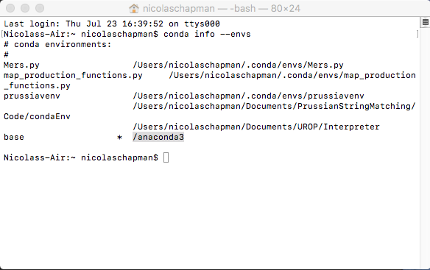
* This location with the * next to it is the base location for conda, and where we will install files to. Select the file path and copy it.

Now, to set up the environment with required packages, first open PyCharm:

* In the menu bar select File -> Open and navigate the folder containing the code (PrussianCensusCode). Once selected the files should appear in side bar:  
  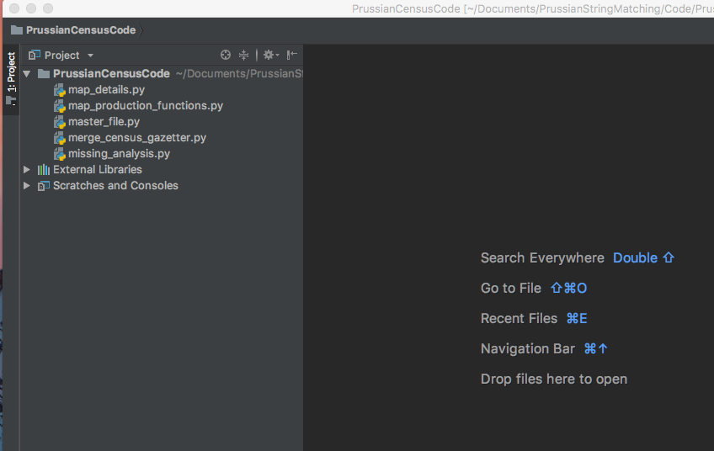
* In the menu bar select PyCharm -> Preferences. Navigate to ‘Project Interpreter” and click “Show All”.  
  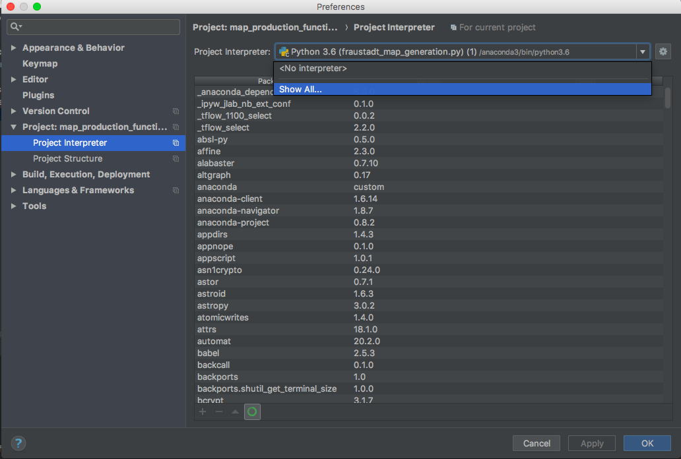
* Click the ‘+’ in the window that appears:  
  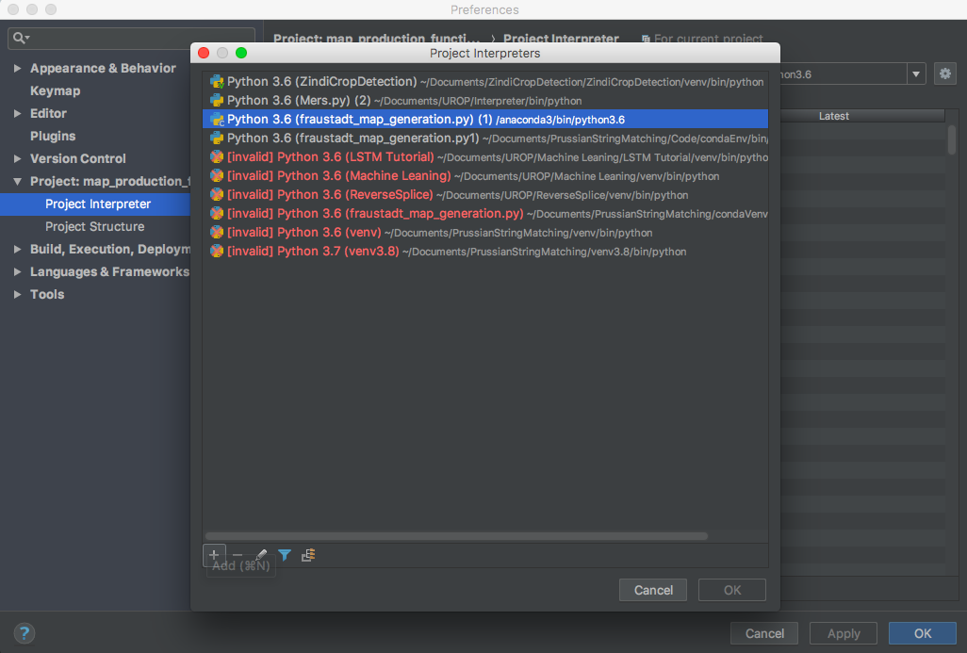
* Select “Conda Enviornment”, check “Existing environment” and click the three dots next to the drop town box.  
  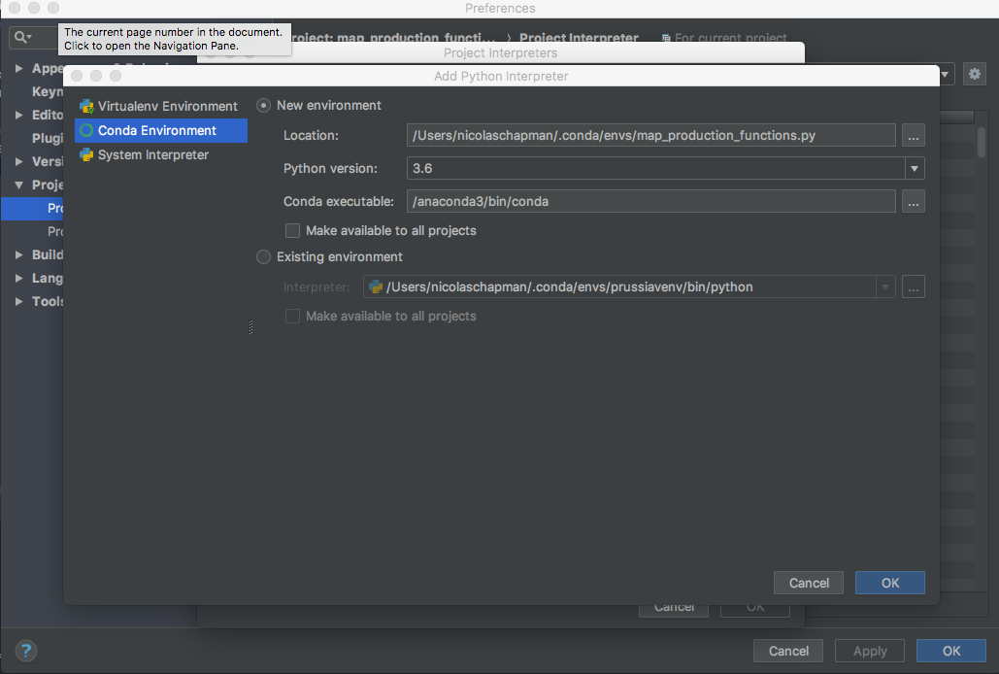
* Paste the file path you copied, then open the folder ‘bin’ and select the version of python you desire:  
  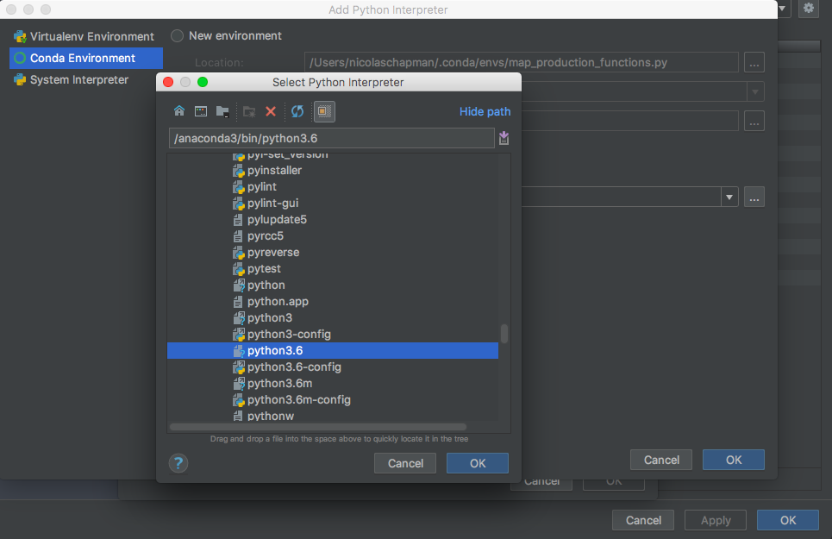
* Click ‘Ok’ on all the windows you have open until you are back on the main python window.

Now that the interpreter is set-up, we need to install the required packages:

* Return to the terminal window you previously had open and type the command ‘source activate’. (base) should appear next to the command line.  
  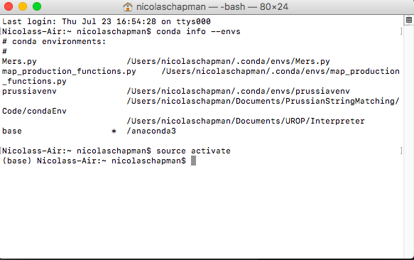
* Now tyoe the command ‘conda install pandas’  
  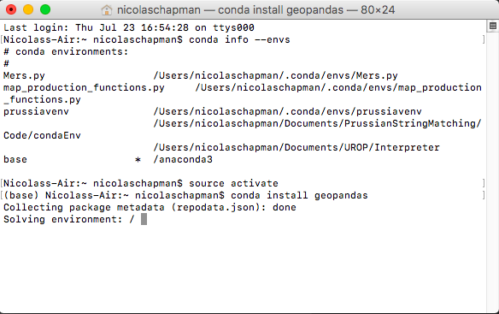
* This may take a while, and if prompted with any questions about updating other packages etc. say yes.
* Repeat this command once complete (conda install xxxxxxx) with the following packages:
  + geopandas
  + geoplot
  + json
  + numpy
  + tabulate
  + re
  + math
  + matplotlib
* Some of these packages may already have been installed, and if so don’t worry!

With all these packages installed, return to the PyCharm to prepare to run the code.

* Go through missing_analysis.py, merge_census_gazetter.py and map_production_functions.py and change the path under WORKING_DIRECTORY at the top of the script to the location of the folder ‘NicMergeData’ on your system.
* run master_file.py by clicking the little play button in the top right corner.
* If everything has worked, it should run and produce some maps and histograms!