LIXI REST API
DOCUMENT

chonnh@gmail.com

Basic Authentication:
url: http://lixi.global/services/Rest/*
username: baokim_lixi
password: baokim1234

- bkUpdateStatus
  - URL: http://lixi.global/services/Rest/bkUpdateStatus
  - Method: POST
  - Parameters:
# | Name | Type | Required | Value
1 | orderId | Long | Yes
2 | status | String | YES
3 | message | String | NO
4 | receiveMethod | String | NO
5 | UpdatedOn | String | YES
  - Return data: JSON
{“error”: “[0 | 1]”, “message”: “[message]”}

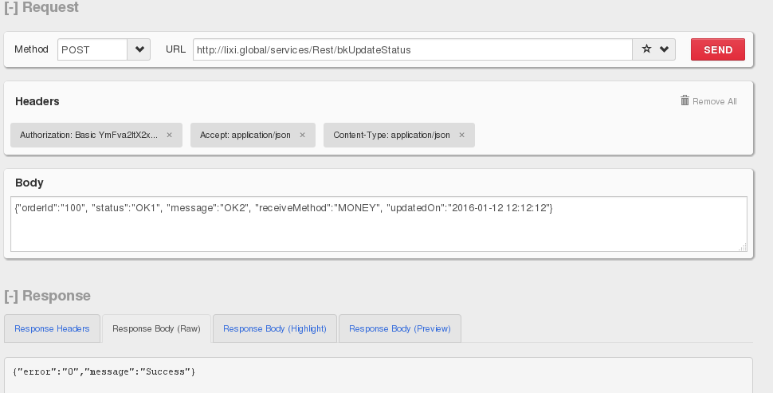
  - Example:

