Website BaoKim.VN
PARTNER INTERGRATION API

Hà nội, 06 – 2015

Categories List

Description
- URI: /promotion/categories/list
- Method: GET

Parameter
Name | Data Type | Required | Detail
(No parameter)

Result
- HTTP Status Code = 200
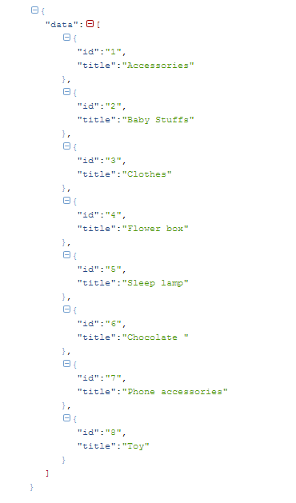

Products List

Description
- URI: /promotion/products/list
- Method: GET

Parameter
Name | Data Type | Required | Detail
category_id | Int | N | Categories ID
price | Int | N | Amount products

Result
- HTTP Status Code = 200
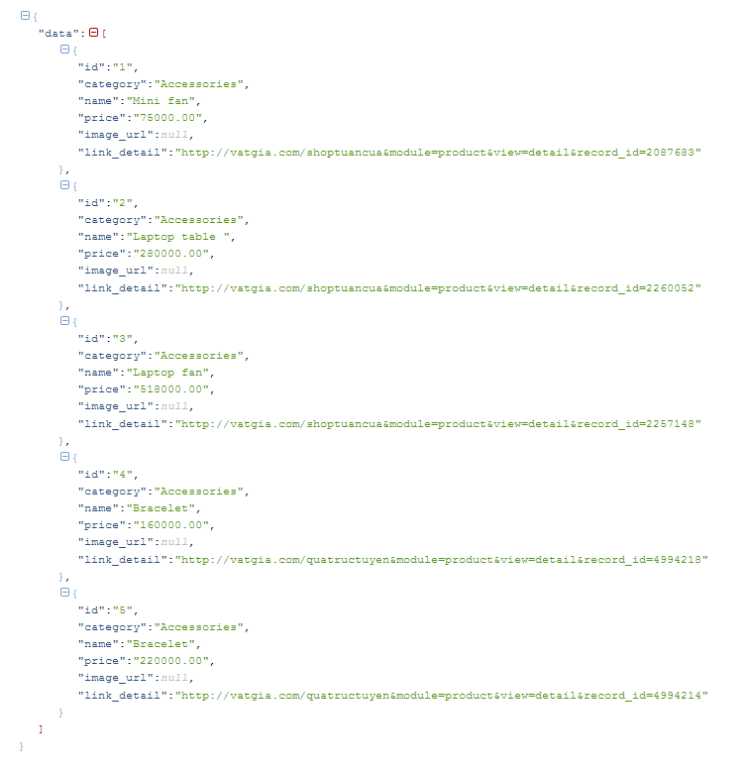

Submit Orders

Description
- URI: /promotion/order/submit
- Method: POST

Parameter
Name | Data Type | Required | Detail
order_id | String | Y | Order ID of Merchant (Order id is UNIQUE)
sender_name | String | N | Name of Sender
sender_email | String | Y | Email of Sender
sender_phone | String | Y | Phone number of Sender
product_id | Int | Y | Product ID
price | Int | Y | Price of Product
receiver_name | String | Y | Name of Receiver
receiver_email | String | Y | Email of Receiver
receiver_phone | String | Y | Phone number of Receiver
receiver_address | String | Y | Address of Receiver
message | String | N | Message detail

Result
- HTTP Status Code = 200
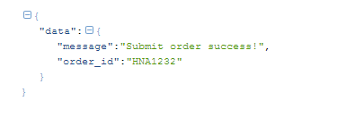

Check status orders

Description
- URI: /promotion/order/checkStatus
- Method: POST

Parameter
Name | Data Type | Required | Detail
order_id | String | Y | Order ID of Merchant

Result
- HTTP Status Code = 200
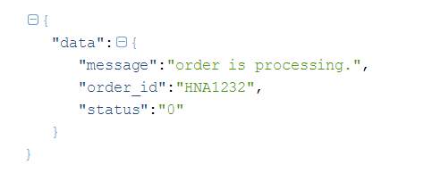
- List Order Status Code:
Status | Detail
0 | Order is Processing
1 | Order is Complete
2 | Order is Cancel

