**Specification Document**

**Project: File Management System (Lockers Pvt. Ltd.)**

**Developer: Narges Goshayeshisafa**

**January 2021**

**Product’s Capabilities:**

This product is a file management system which can do the following:

* Retrieves the file names in an ascending order.
* Business-level operations:
  + Adds a user specified file to the application.
  + Deletes a user specified file from the application.
  + Searches a user specified file from the application.
  + Closes the current execution context and return to the main context.
* Option to close the application.

**Appearance:**

**File Management System**

**Lockers Pvt. Ltd.**

**Click on What you would like to do**

**Page 1**

**File Management System**

**Retrieve Files**

Possible errors appear here

**Page 1.1**

**File Management System**

**Click on What you would like to do**

**Page 2**

**File Management System**

**Add a File**

Possible errors appear here

**Page 2.1**

**File Management System**

**Delete a File**

Possible errors appear here

**Page 2.2**

**File Management System**

**Search for a File**

Possible errors appear here

**Page 2.3**

**User Interactions:**

In this application, users can choose between some options to manage the file system. The application’s design is simple and tries to avoid any confusion for the user. There are buttons that the user can push based on what she/he wants to do. The design of the application is simple and focuses on the options mostly. The option to go back is always given to the user. If the user enters a file name wrong the option to correct it will be given to her/him.

**Sprints:**

Duration: 3 weeks

Type: Scrum

Sprint Duration: 1 week

Sprint 1:

-Build welcome screen

-Add app name and developer details

-Show main menu

-Show options in main menu

-Add option 1 in main menu (Show files in ascending order)

-Support closing the application

Sprint 2:

-Show option 2 (file operations)

-Show file operations menu

-Add option 1 in file operations. Add a file

-Add option 2 in file operations. Delete a file

Sprint 3: (Keeping it light to account for unknowns)

-Search a file

-Back to main menu

-Unknowns

**Flowchart:**

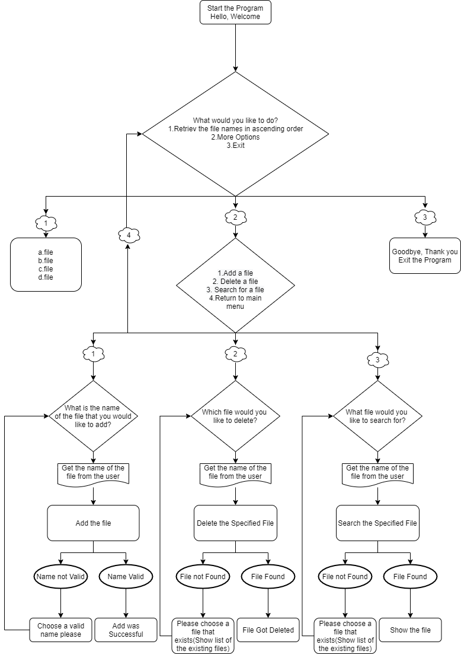

**Algorithms and Core Concepts Used:**

The methods that are used in this project are: ShowWelcomeScreen(), ShowMainMeny(), collectMainMenueOption(), showFileInAscendingOrder(), showFileOperations(), collectFileOperation(), addAFile() throws InvalidPathException, deleteAFile(), searchFile(), in addition to a lot of different methods in File class and Path class to use the path and do operations on different files. A lot of built in functions such as sort was used in this program to make sure that the operations are time and space efficient.

**Link to the GitHub Repository:**

https://github.com/nhcl/LockedMe.com

**Screenshots:**

* **Welcome Page:**

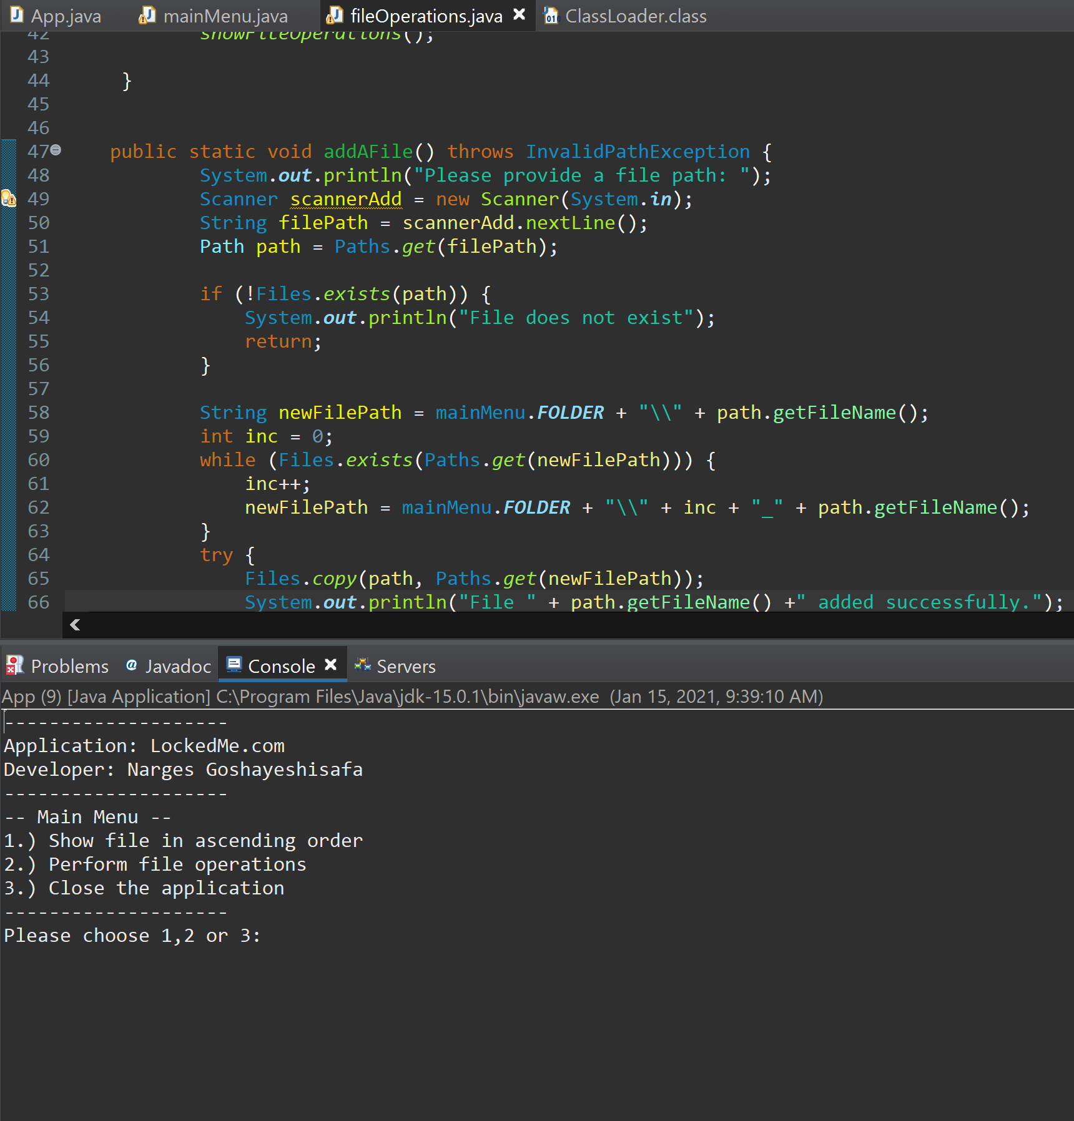

* **Show Files in Ascending Order:**

[ASCII order chart starts with the special characters, goes to numbers, then some other special characters, then upper case, and then lower case alphabet.]

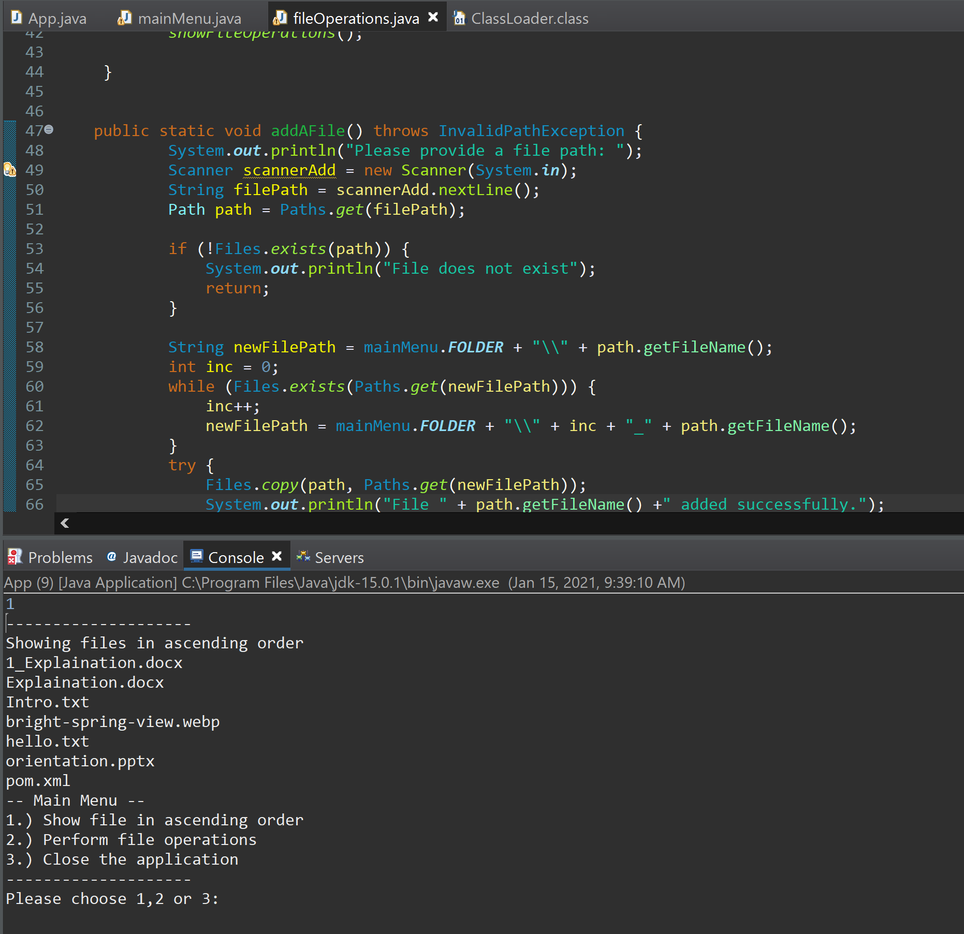

* **Perform file operations:**

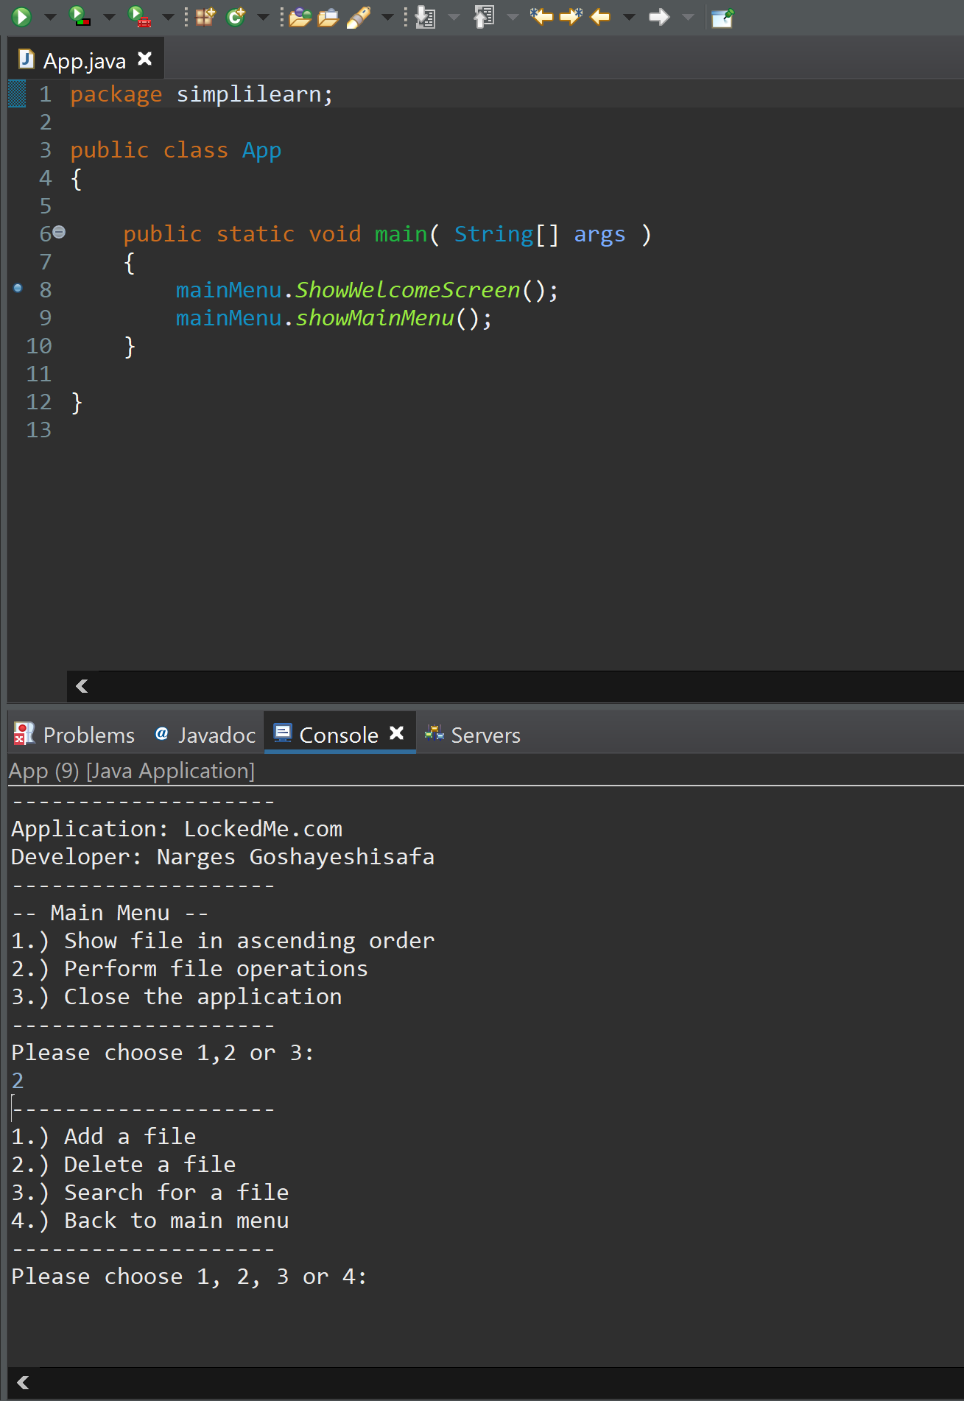

* **Closing the application:**

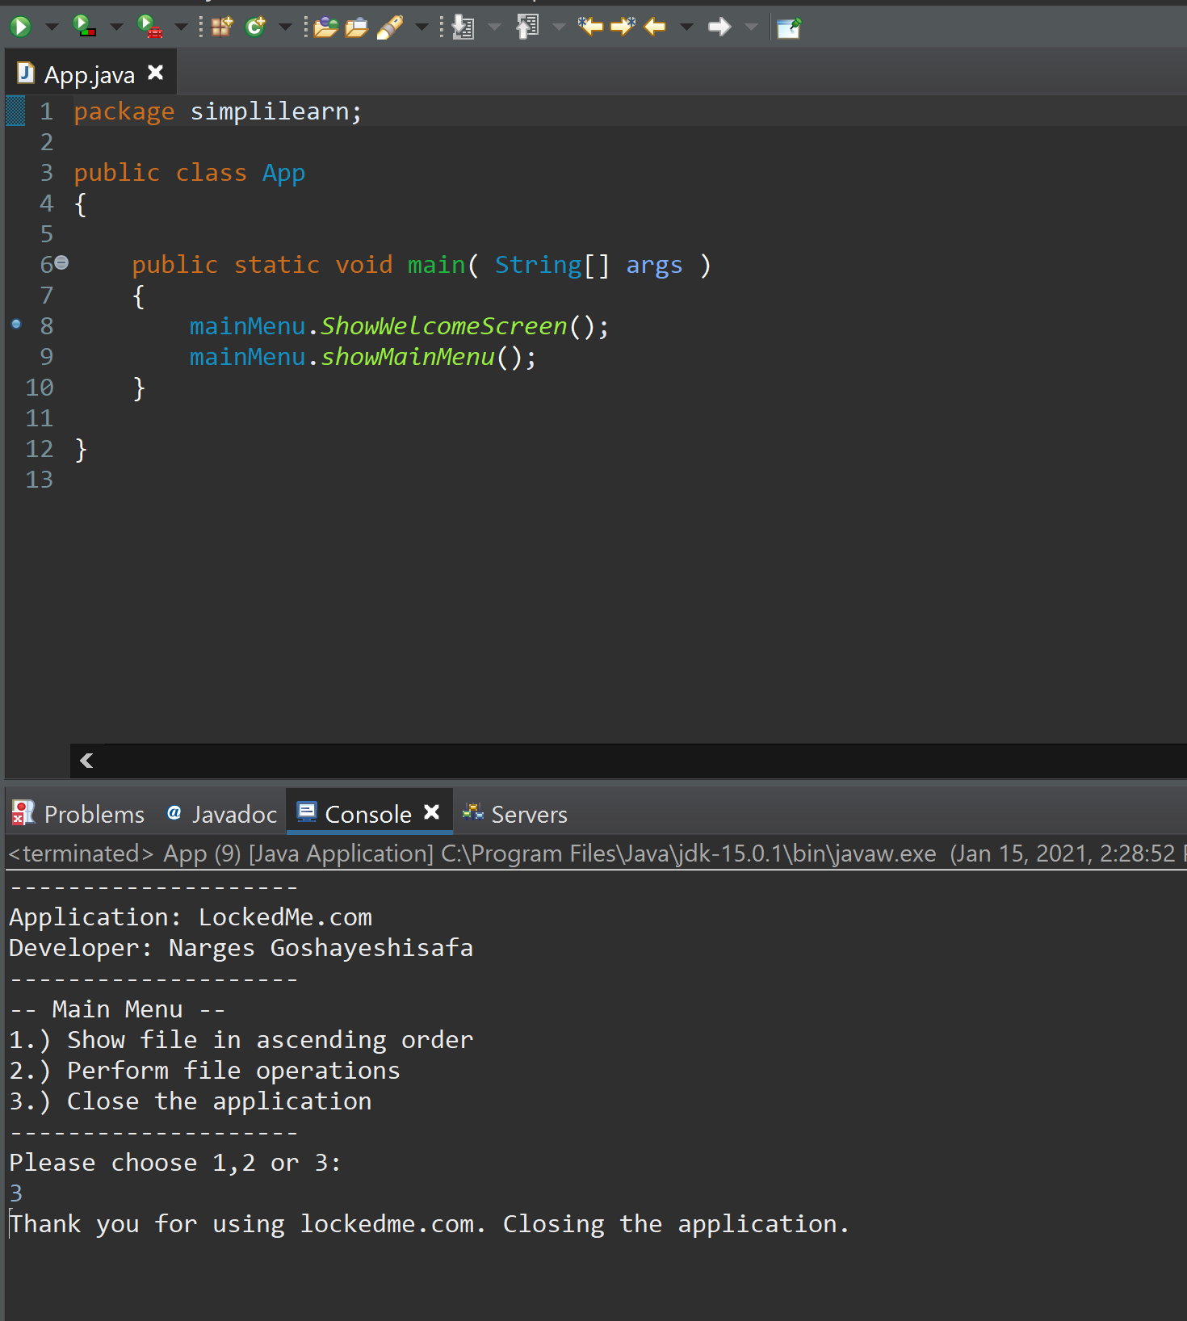

* **Adding a file:**

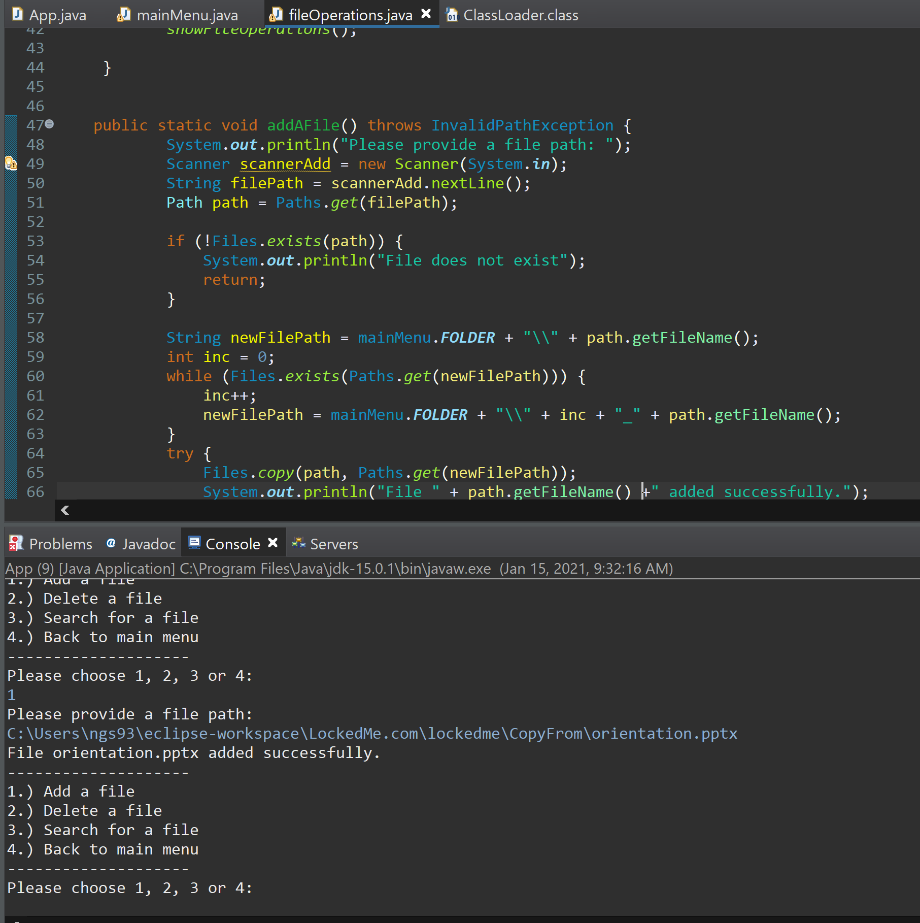

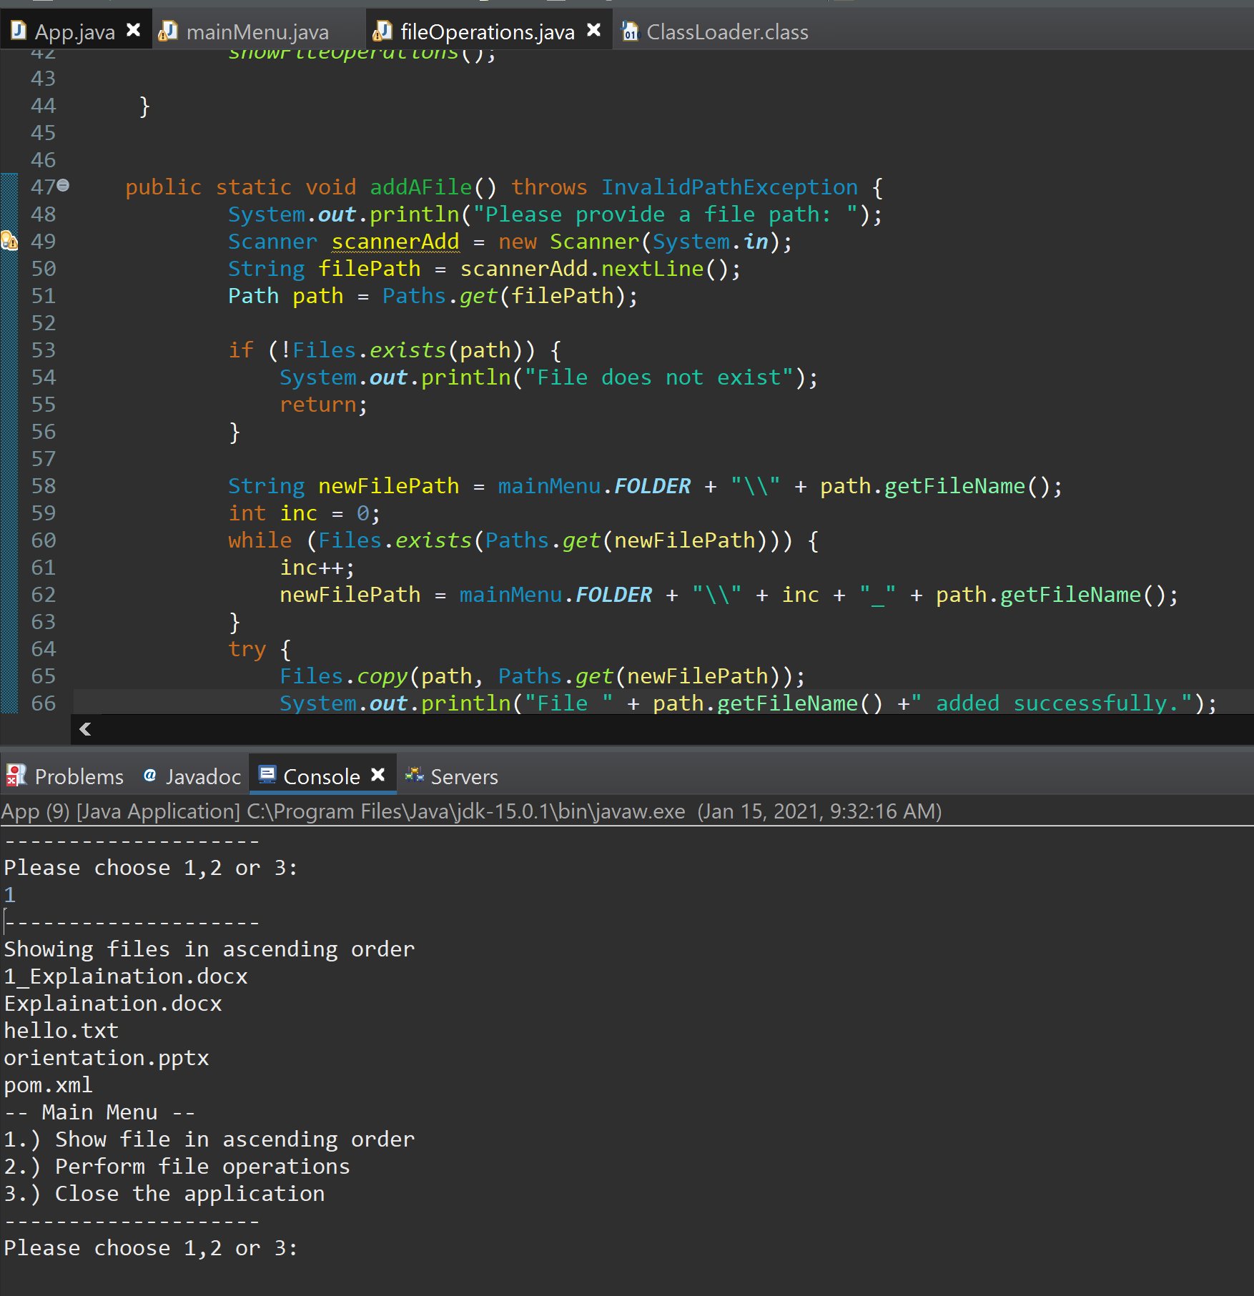

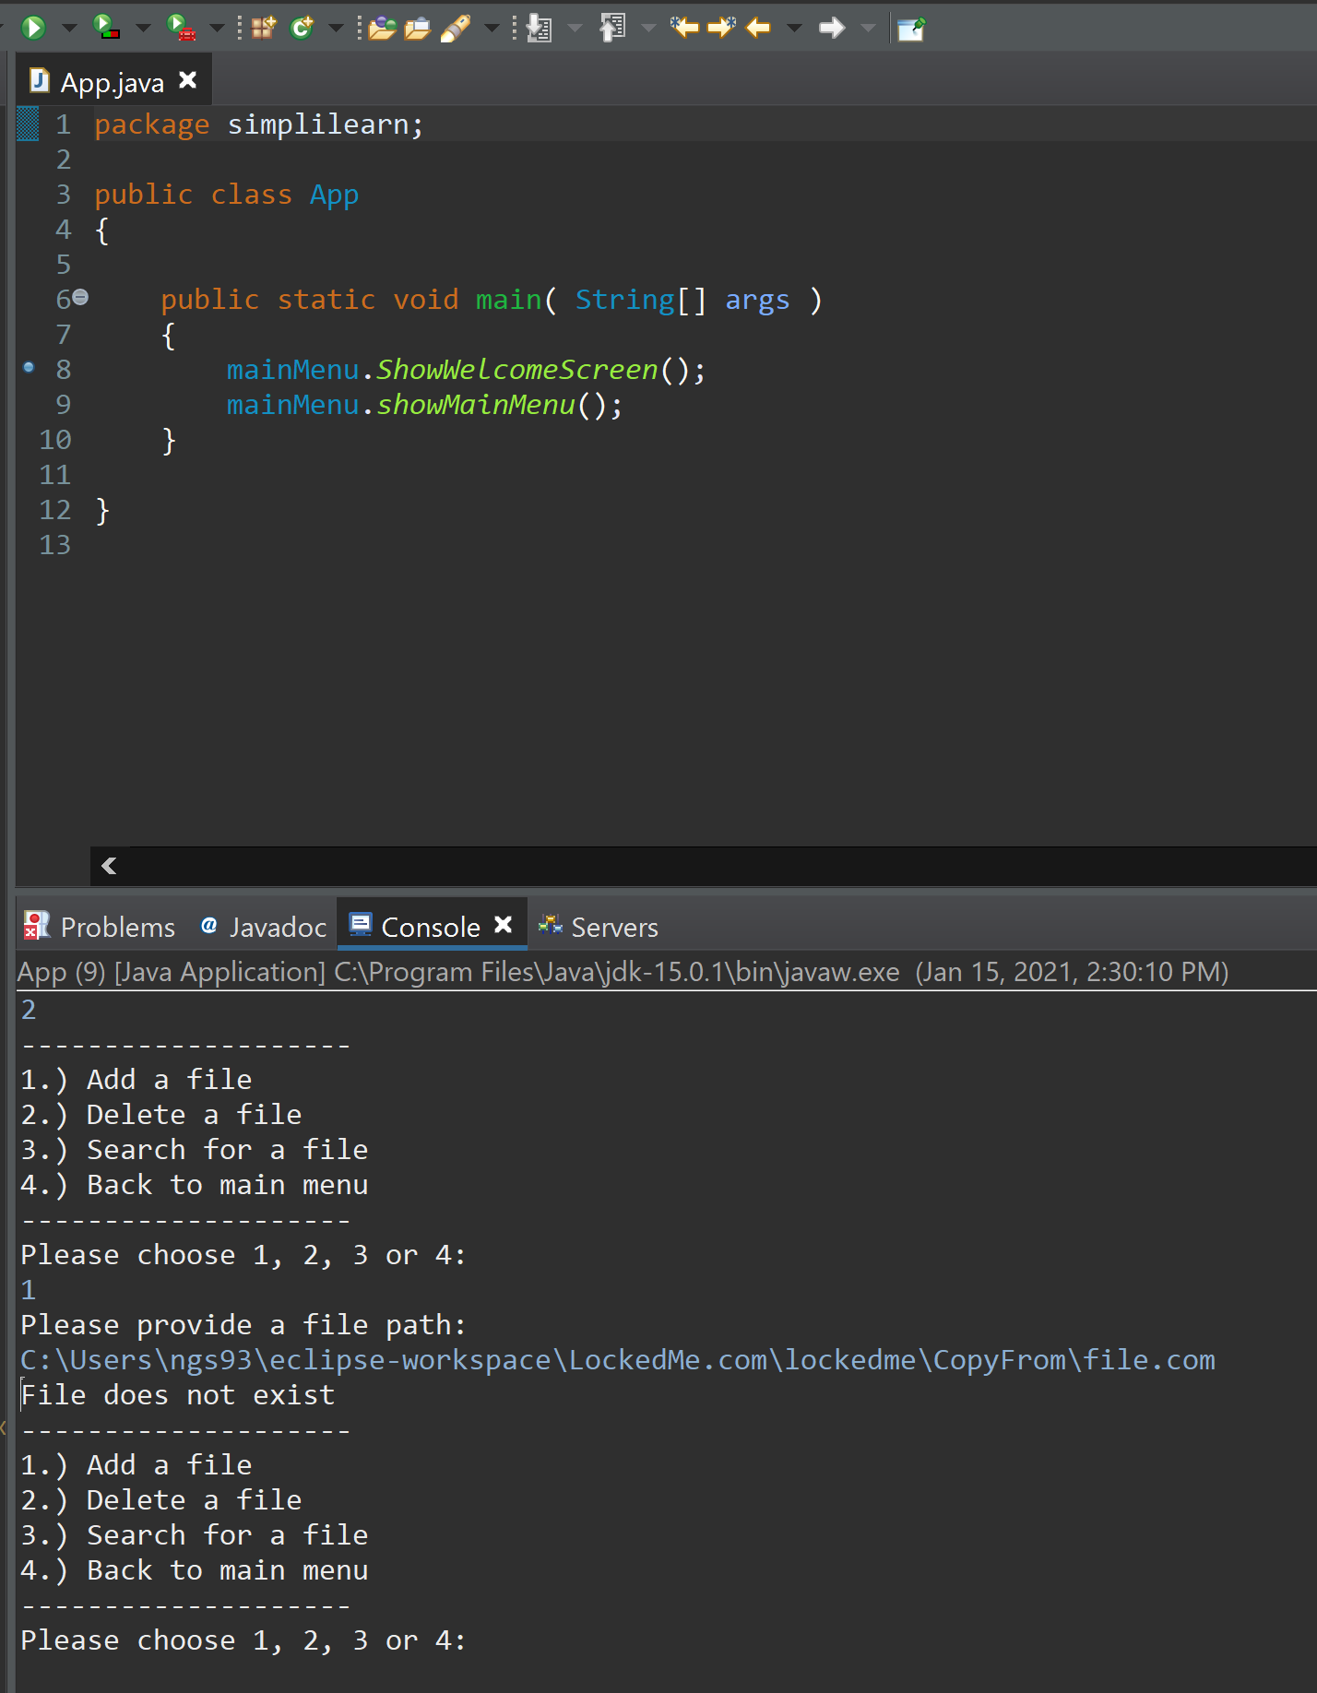

* **Deleting a file:**

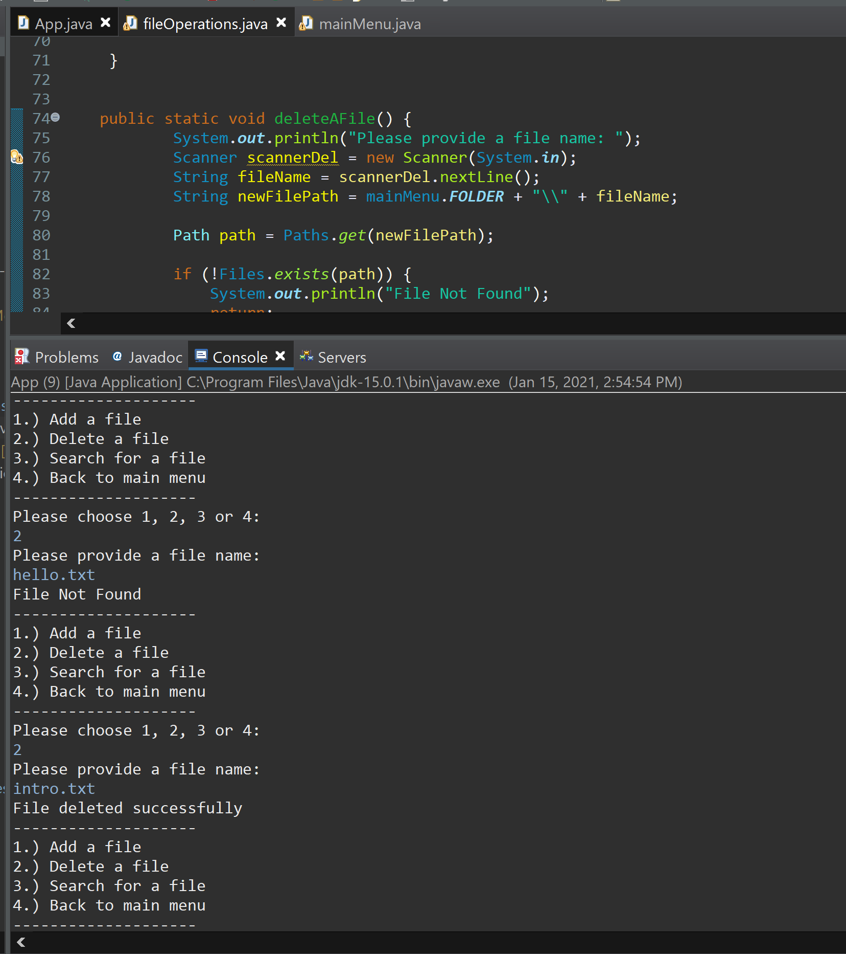

* **Searching for a file:**

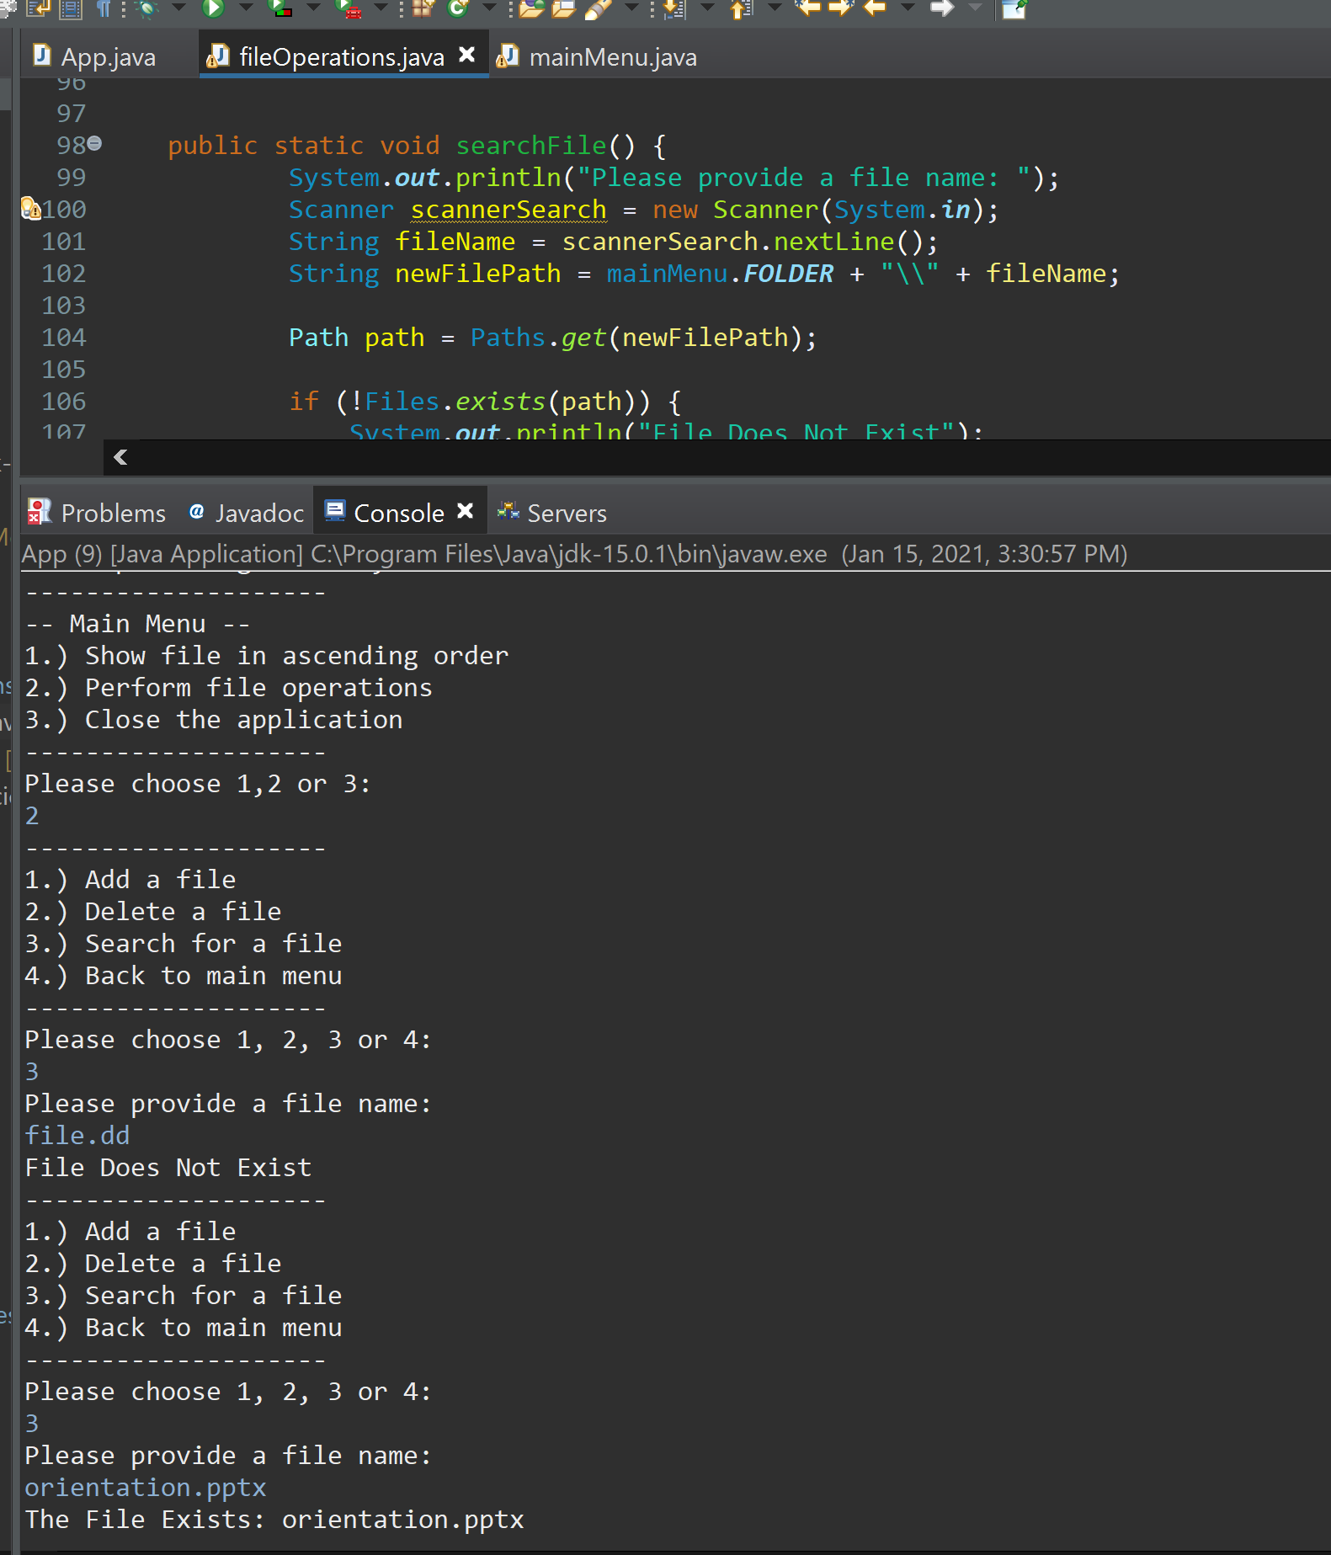

* **Back to main menu:**

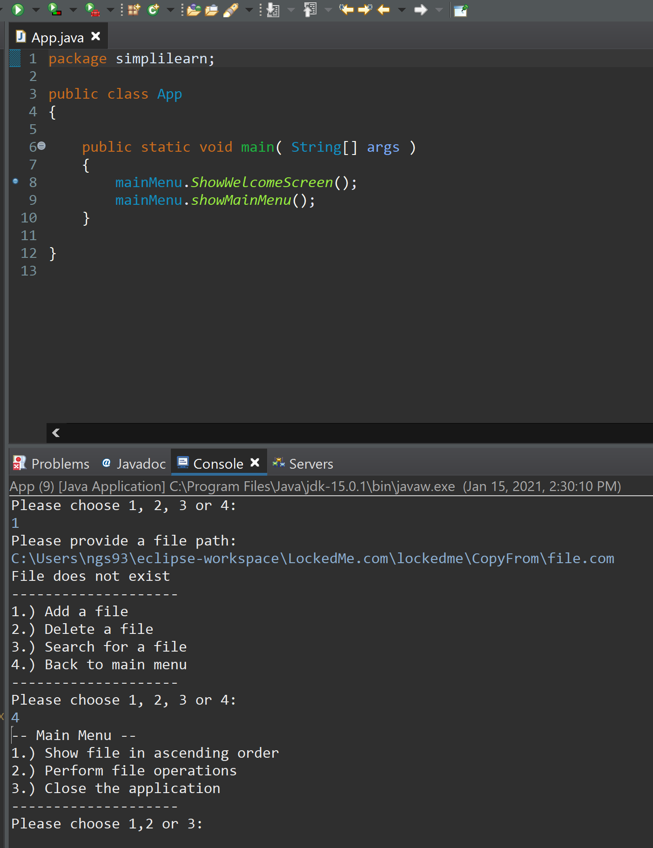

* **Invalid Input:**

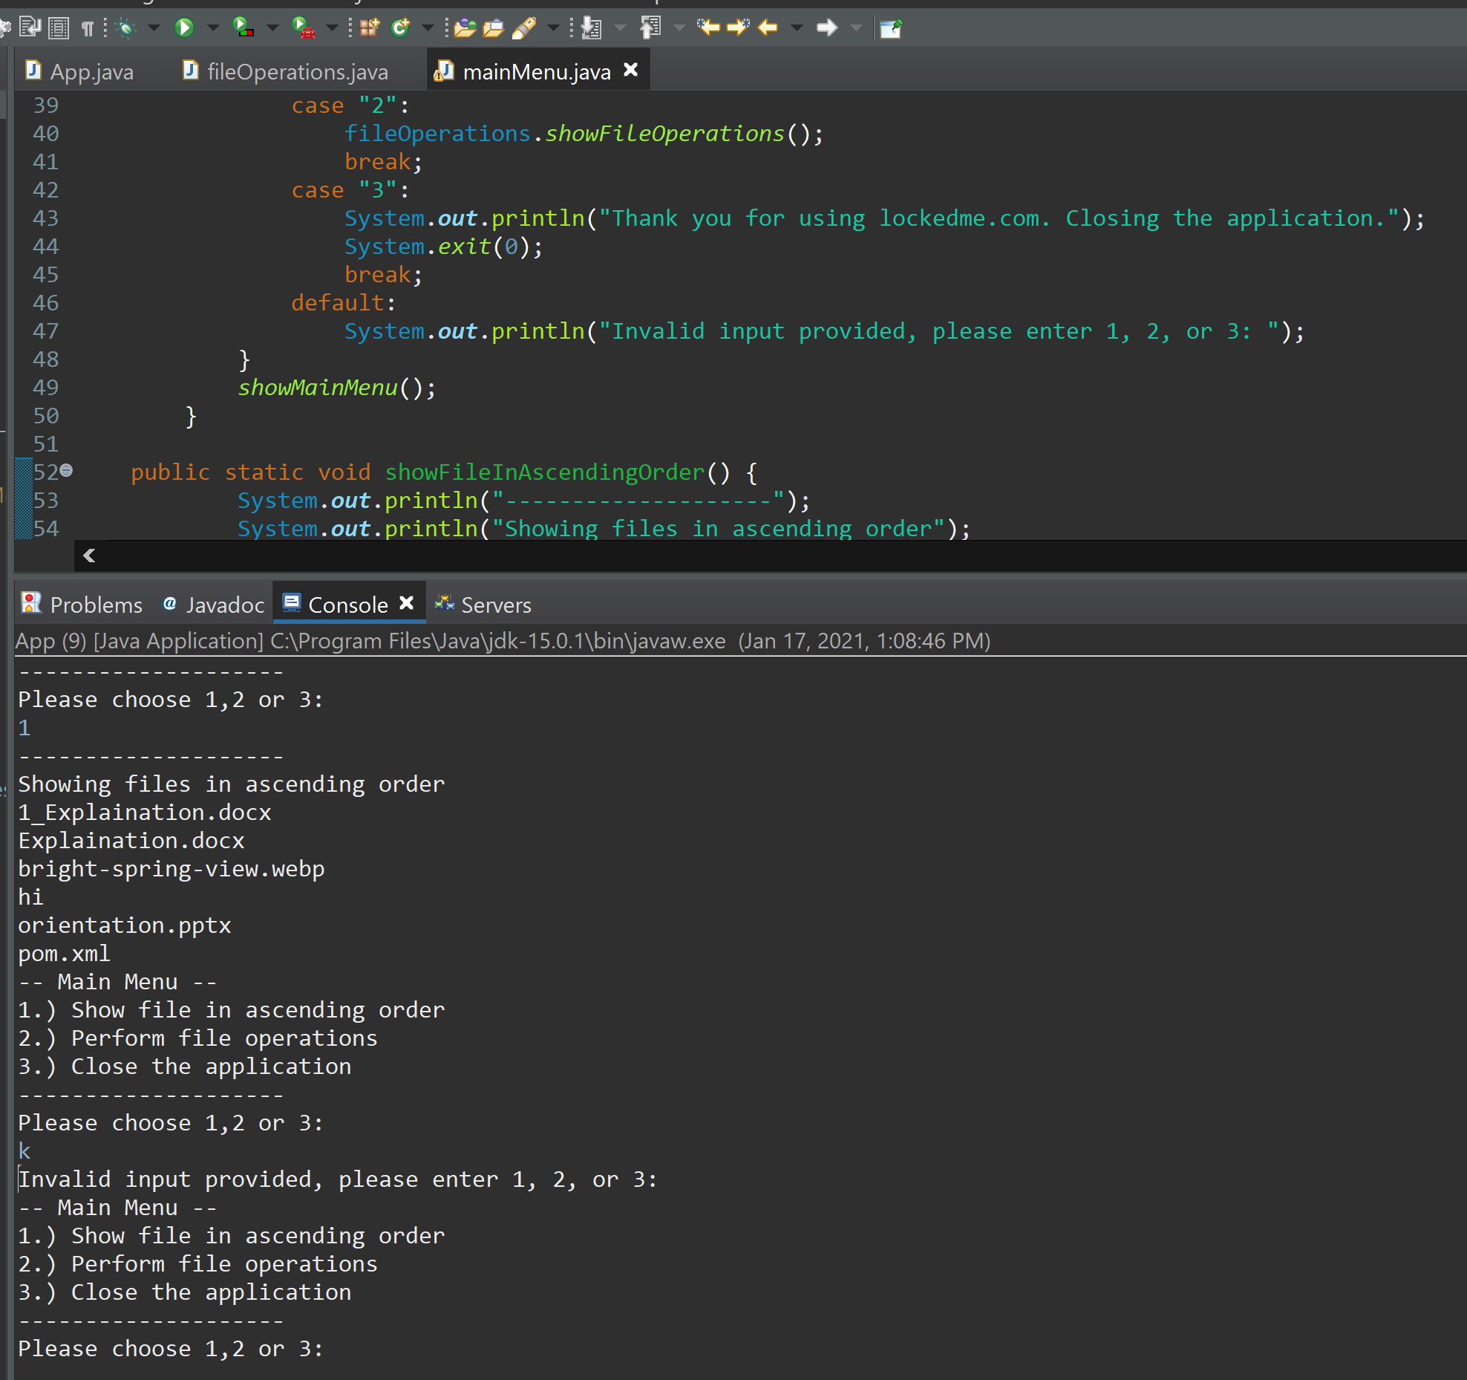

**Conclusion:**

The first version of this application is up and running. This has been planned in 3 sprints. There are several improvements that can be made. One thing that was assumed is that the folder consists of files only and the search and delete operations are done on a flat folder. This can be improved in this program by allowing the user to add directories inside the source directory and search or delete all the files that are in different layers.