Introduction
A fundamental problem in all fields of science is the ability to understand meaning and relationships within data. The ability of humans to make such classifications is often taken for granted. Uncognizent of the immense power of human thought, people on a daily basis take an infinite variety of data and categorize it. Science seeks to replicate this ability by posing the problem of clustering analysis. Clustering analysis seeks to provide methods for understanding collected data by grouping it to reveal natural clusterings.
Similar to the human necessity to adjust to a changing environment, clustering analysis has several methods to deal with a variety of input. A scientist must be able to balance the various biases of such methods appropriately for the specific problem.
The study will examine the performance of three clustering algorithms: k-means, hierarchical, and r-trees. This will be done by comparing their time complexity, space complexity and the clustering output. Because of the data driven nature, the study will determine how to balance the three criteria based on the data domain in order to provide optimal clustering value.
Methods
Kmeans
The K-means algorithm is one of the simplest and most commonly used partition based algorithms. K-means works by employing the following steps:
- Initialization of the K Centroids can be done heuristically or at randomly.
- Compute membership of data points.
- Re-Compute K Centroids position.
- Repeat steps (2) and (3) until stop state is achieved.
The heuristic for choosing to initialization of the K Centroids was assigning them the same position as the first K data points of the input Vector (array of data points). The reason behind this was simply convenience of implementation. Computing membership of the data points involves computing the Euclidean distance n times for each of the K Centroids and evaluating which Centroid is closest. Once the closest Centroid is found for a data point, which is an abstract data type, it is assigned to that Centroid. After Centroid membership has been computer the Centroids are moved into the respect centers of their clusters. The steps of calculating membership and moving the Centroids into the center of their clusters are repeated till the stop state is reached. The stop state implemented checks distance moved, which is a member variable for each Centroid, when all Centroids stop moving (distancemoved variable is 0.0 for all Centroids).
Time complexity for K-means is O(n*k) this is the same for the space complexity as well. Running time data was gathered by getting the system time before and after calling the K-means run method. The number and of points and K clusters where increased incrementally and run approximately 20 times each to get average running time. The data collected was outputted to a data file and parsed to csv and gnuplot files. The gnuplot dat files where used to visually confirm that the algorithm was performing properly. The csv file was used to create scatter plot graphs that used to verify the time complexity of the algorithms. Data used for the time complexity was random generated points. The points generated by the random functioned turned to be evenly spread over plot area. This means there was actually no clusters in the data.
No optimizations where implemented. The main reason for this was time. Several key improvements could be made to make this algorithm run faster. Keeping a table of all the distances for each point to each Centroid would reduce the need to recalculating the distance for Centroids that do not move. Another option to increase performance would be changing the stop state. This could be changed using a heuristic. One stopping state heuristic could be ending if the Distance moved by all Centroids is below some threshold instead of grind away till all distances moved equal zero. Another could be to use a combination of distance moved and number of maximum iterations.
Hierarchical Method
Opposed to the partitional algorithms which work by partitioning data into clusters, Hierarchical algorithms produce a dendogram (tree-diagram) representing a hierarchy of clusterings to produce a super cluster. The hierarchical algorithms work by either breaking down or building up these clusters. The characteristic of breaking down, or building up clusters determines whether the hierarchical algorithm is agglomerative or divisive. The second defining characteristic of a hierarchical algorithm is the link type which may be either single-link, complete link, or average-link. When considering the minimum distance between points within clusters, the link type is said to be single-link. The maximum distance between points within clusters determines the link type as complete link. The average-link method may be thought of as a compromise between the complete-link and single-link methods, rather than minimum or maximum distance between points within clusters, the average of the points within clusters is used to determine similarity between clusters.
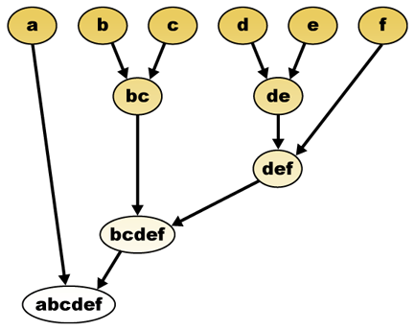
Figure 1: Hierarchical Agglomerative Clustering (Wikipedia)
In figure 1 above the hierarchical agglomerative clustering algorithm works as follows:
- Begin by placing each individual element into its own cluster.
- Compute the distance between all clusters.
- Based on the Link Type, group the two most similar clusters together.
- Continue until only 1 cluster remains.
Implementation Details
In this study the hierarchical agglomerative method was implemented with both single-link and complete-link characteristics. Several key classes were used in the implementation of the Hierarchical Agglomerative clustering algorithm.
Class | Description
DataPoint | Used to represent an N-Dimensional Point.
Dendogram | Used to represent a tree-diagram of clusters.
Similarity | Used to store the similarity between two DataPoints.
HierarchicalSimilarityMatrix | Used to store a n x n matrix of similarity measure between all pairs of data points, excluding the identity row since it is not necessary to calculate the similarity of a point to itself.
SimilarityComparator | Used when comparing two similarity objects.
Geometry | Used to perform DataPoint calculations such as Euclidean distance.
PointGenerator | Used to generate a List of Random points, or input a data file of existing points.
Challenges
The study specifically implemented the Average-Link Hierarchical agglomerative method. This java implementation of the hierarchical method required some adjustments because of challenges during implementation. Although the worst case run-time O(n²), the actual implementation of this algorithm in java is O(n³). This is because of the need to recompute the SimilarityMatrix storing the measure of similarity between all pairs of clusters, optimally only portions of the matrix need to be recomputed, and other portions deleted. It was also observed that the large size of the table required that the maximum heap size of the jvm be adjusted upwards to 512mb. The adjustments to the runtime will affect the runtime comparison between k-means, but it is already known that the k-means algorithm has a superior runtime. The focus of this exercise of implementing the hierarchical algorithm is to compare the clustering output of the Hierarchical algorithm to the k-means and r-tree algorithms.
Results
Clustering output
The hierarchical method unlike the k-means method generates a hierarchy of clusterings from 1 to n, where n is the number of elements to cluster. The generated hierarchy showing the gradual progression of n elements to 1 super cluster provides the flexibility to avoid choosing value k representing the number of clusters to be outputted. It is often times unclear what value of k to choose in order to properly characterize the data into clusters. In addition to having the flexibility of analyzing different values of number of clusters, the dendogram also provides a logical reasoning showing how values were chosen to be clustered together.
Sanity Check
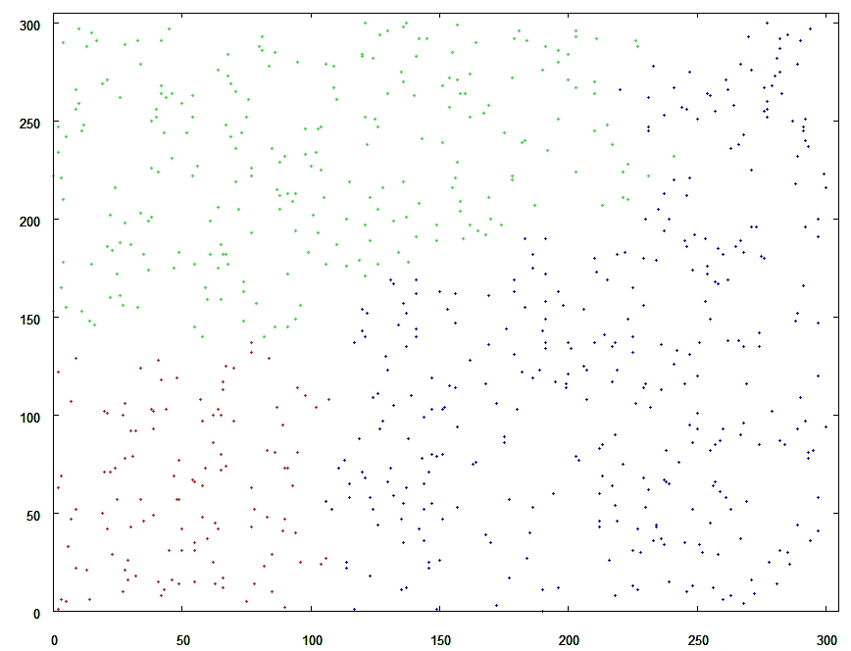
Figure 2: Hierarchical Agglomerative Average-Link Clustering
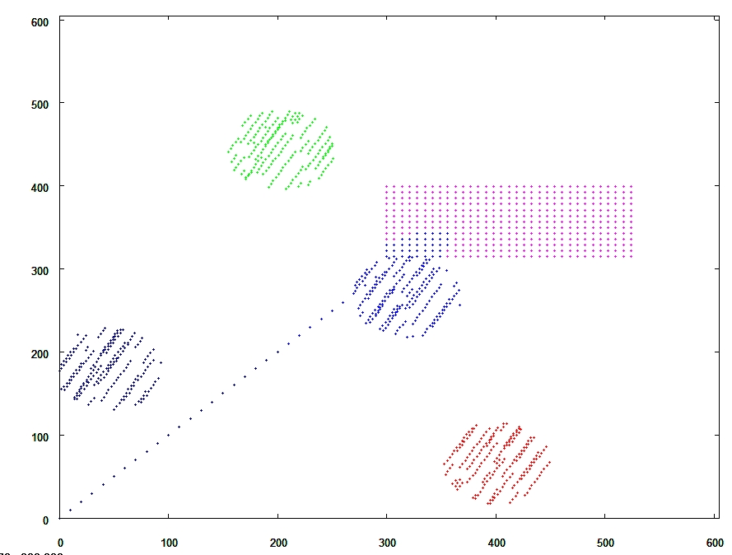
Figure 3: Hierarchical Agglomerative Average Link Clustering
Figure 2 above represents data which represents points which can be easily clustered by a human being. On inspection the points appear to represent several shapes and lines. The color of the points represents a distinct cluster. It appears that the Hierarchical clustering algorithm provides output that is fairly consistent with human expectations. However, on the intersection of the points where the circle and rectangle intersect it can be seen that the clusters appear to bleed slightly into one another.
Runtime Analysis and Space Analysis
When running hierarchical analysis on large sets of data (1000+) points it was very obvious that the algorithm performed slowly. The large sets of data also displayed the large space requirements because it was required to adjust the jvm heap space to large large sets of data. The major contributors to the slow runtime of the Hierarchical method are the requirement to calculate a n x n similarity matrix, and the convergence to a single cluster. This forces the runtime of the hierarchical method into O(n³). The algorithm also requires the storage of a n x n matrix to store the similarity matrix, so the algorithm has the space complexity O(n²).
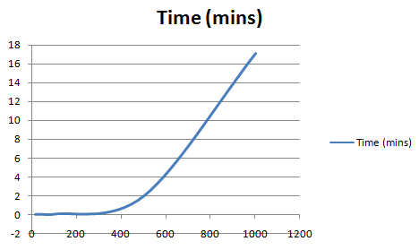
Figure 4: Runtime Average-Link Clustering
Table 1: Average-Link Runtimes
Number of Points | Time (mins)
15 | 0
50 | 0
100 | .02
500 | 2.22
1000 | 18.5
Analyzing the runtime complexity for both the Single-Link algorithms it appears that the curve generated fits that of a cubic graph. We can see that as the number of points scale the time appears to scale in a squared or cubic manner.

