Methods
Hierarchical Method
Opposed to the partitional algorithms which work by partitioning data into clusters, Hierarchical algorithms produce a dendogram (tree-diagram) representing a hierarchy of clusterings to produce a super cluster. The hierarchical algorithms work by either breaking down or building up these clusters. The characteristic of breaking down, or building up clusters determines whether the hierarchical algorithm is agglomerative or divisive. The second defining characteristic of a hierarchical algorithm is the link type which may be either single-link or complete link. When considering the minimum distance between clusters, the link type is said to be single-link. The maximum distance between clusters determines the link type as complete link.
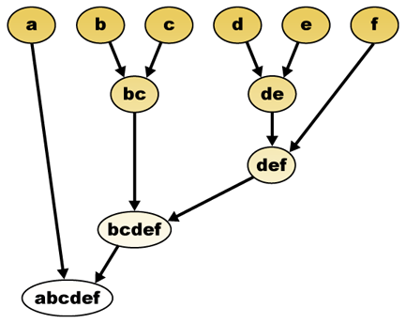
Figure 1: Hierarchical Agglomerative Clustering (Wikipedia)
In figure 1 above the hierarchical agglomerative clustering algorithm works as follows:
- Begin by placing each individual element into its own cluster.
- Compute the distance between all clusters.
- Based on the Link Type, group the two most similar clusters together.
- Continue until only 1 cluster remains.
Implementation Details
In this study the hierarchical agglomerative method was implemented with both single-link and complete-link characteristics. Several key classes were used in the implementation of the Hierarchical Agglomerative clustering algorithm.
Class | Description
DataPoint | Used to represent an N-Dimensional Point.
Dendogram | Used to represent a tree-diagram of clusters.
Similarity | Used to store the similarity between two DataPoints.
HierarchicalSimilarityMatrix | Used to store a n x n matrix of similarity measure between all pairs of data points, excluding the identity row since it is not necessary to calculate the similarity of a point to itself.
SingleLinkComparator | Used when comparing DataPoints to determine the minimum Euclidean distance.
CompleteLinkComparator | Used when comparing dataPoints to determine the maximum Euclidean distance.
Geometry | Used to perform DataPoint calculations such as Euclidean distance.
PointGenerator | Used to generate a List of Random points, or input a data file of existing points.
Challenges
This java implementation of the hierarchical method required some adjustments because of challenges during implementation. Although the worst case run-time O(n²), the actual implementation of this algorithm in java is O(n³). This is because of the need to recompute the SimilarityMatrix storing the measure of similarity between all pairs of clusters, optimally only portions of the matrix need to be recomputed, and other portions deleted. It was also observed that the large size of the table required that the maximum heap size of the jvm be adjusted upwards to 512mb. The adjustments to the runtime will affect the runtime comparison between k-means, but it is already known that the k-means algorithm has a superior runtime. The focus of this exercise of implementing the hierarchical algorithm is to compare the clustering output of the Hierarchical algorithm to the k-means and r-tree algorithms.
Results
Clustering output
The hierarchical method unlike the k-means method generates a hierarchy of clusterings from 1 to n, where n is the number of elements to cluster. The generated hierarchy showing the gradual progression of n elements to 1 super cluster provides the flexibility to avoid choosing value k representing the number of clusters to be outputted. It is often times unclear what value of k to choose in order to properly characterize the data into clusters. In addition to having the flexibility of analyzing different values of number of clusters, the dendogram also provides a logical reasoning showing how values were chosen to be clustered together.
Sanity Check
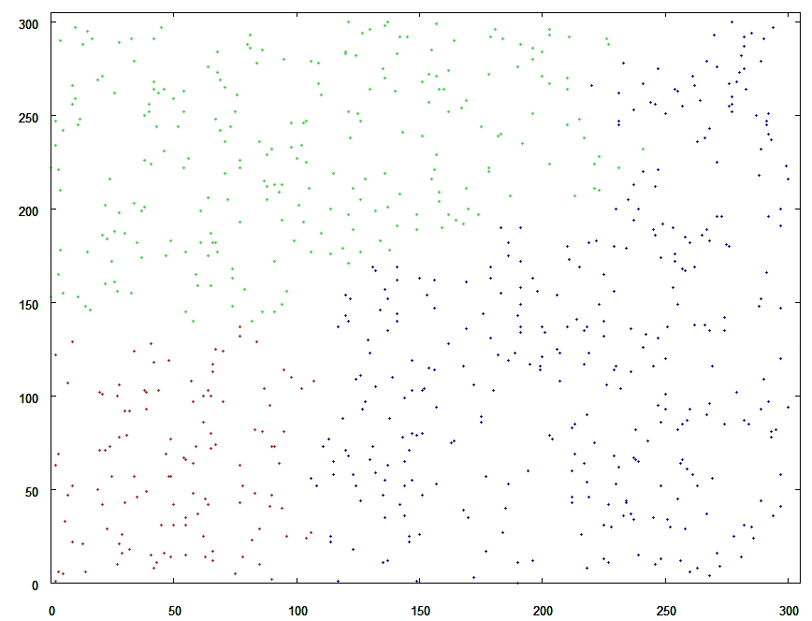
Figure 2: Hierarchical Agglomerative Single-Link Clustering
The hierarchical clustering algorithm was examined by running several runs with small input and confirming the calculation by hand and then with multiple iterations of tests. The above figure 2, illustrates an example of a graph where the points appear to be uniformly randomly generated throughout the entire space. The results from all three algorithms: k-means, hierarchical, and r-trees returned the same output.
Single-link vs. Complete-Link output
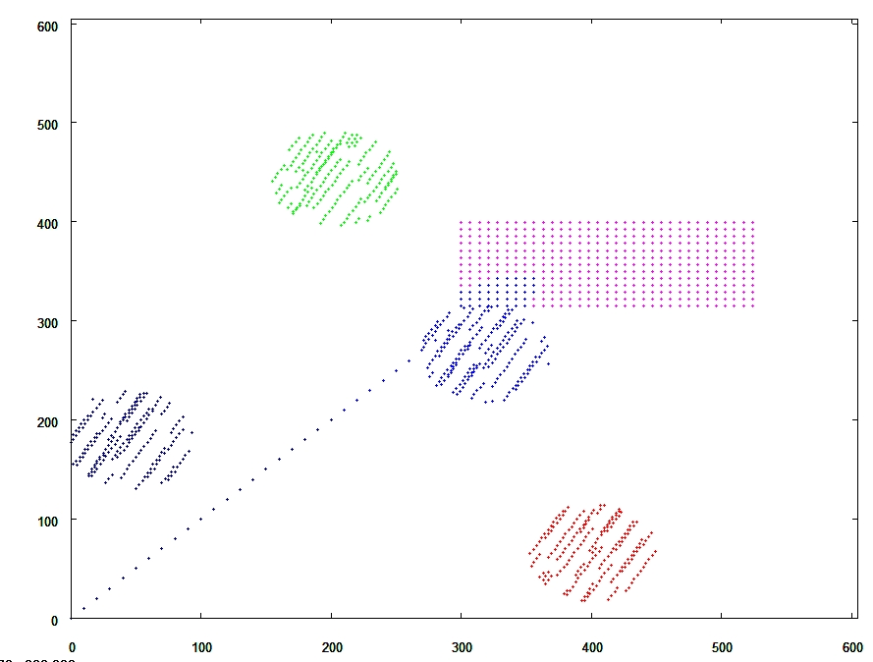
Figure 3: Hierarchical Agglomerative Single Link Clustering
Figure 2 above represents data which represents points which can be easily clustered by a human being. On inspection the points appear to represent several shapes and lines. The color of the points represents a distinct cluster. It appears that the Single-Link clustering algorithm provides output that is fairly consistent with human expectations. The Single-Link criteria requires that points be chosen based on their minimum distance.
Figure 3 below contains the same data as figure 2 above. This figure represents the clustering output by the complete-link criteria. It appears that it has clustered the points in this graph very poorly. The complete-link criterion appears to force each cluster to have equally distributed points between the natural clusters which we observe as shapes. It appears that the complete-link criteria is not appropriate for this type of data.

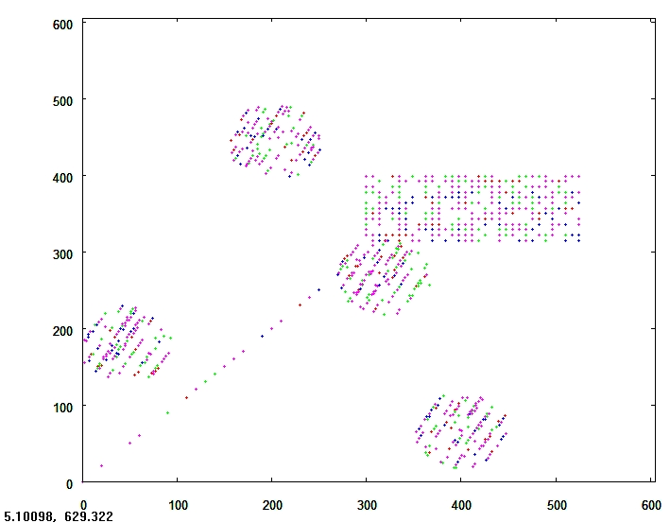
Figure 4: Hierarchical Agglomerative Complete Link clustering
Runtime Analysis and Space Analysis
When running hierarchical analysis on large sets of data (1000+) points it was very obvious that the algorithm performed slowly. The large sets of data also displayed the large space requirements because it was required to adjust the jvm heap space to large large sets of data. The major contributors to the slow runtime of the Hierarchical method are the requirement to calculate a n x n similarity matrix, and the convergence to a single cluster. This forces the runtime of the hierarchical method into O(n³). The algorithm also requires the storage of a n x n matrix to store the similarity matrix, so the algorithm has the space complexity O(n²).
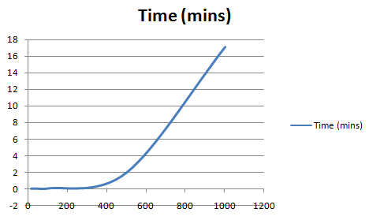
Figure 5: Runtime Single-Link Clustering
Table 1 :Complete-Link Runtimes
Number of Points | Time (mins)
15 | 0
50 | 0
100 | .02
500 | 1.95
1000 | 17.07
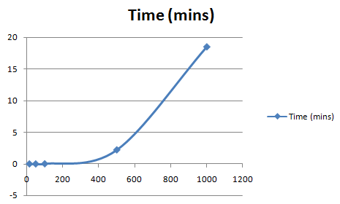
Table 2: Single-Link Runtimes
Number of Points | Time (mins)
15 | 0
50 | 0
100 | .02
500 | 2.22
1000 | 18.5
Analyzing the runtime complexity for both the Single-Link algorithms it appears that the curve generated fits that of a cubic graph. We can see that as the number of points scale the time appears to scale in a squared or cubic manner.

