Problem 2:

The Generalized Metropolis algorithm removed the step-size error by an additional acceptance/rejection step, which adds substantial overhead.

To improve on the ﬁrst-order Langevin algorithm, can you devise a second-order Langevin algorithm to reduce the step-size error dependence to (∆t)^2?

See attached for second-order derivation.

Repeat problem 2 of HW10 using this second-order Langevin algorithm.

Repeating our calculation from homework 10, we compute energy as a function of our time step:

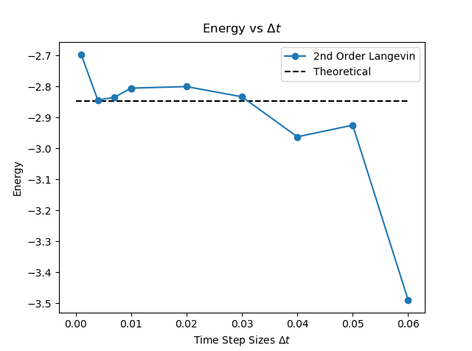
It is clear our calculation no longer has a linear dependence associated with the step size, although it tends to become slightly inaccurate as Δt increases.
Problem 3:

Solve the time-dependent Schrodinger equation using the second-order FFT method as described in the lecture note.

a) Run the program and see that at dt=0.05, the transmission coefficient is 0.518982 as compared to the exact result of 0.52001.

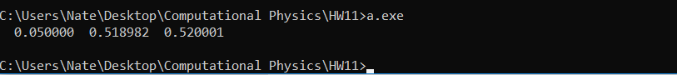
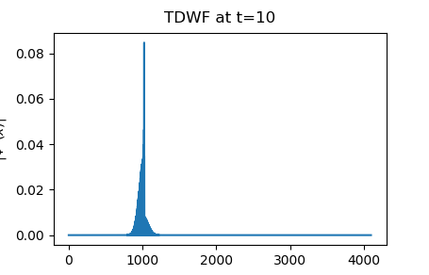
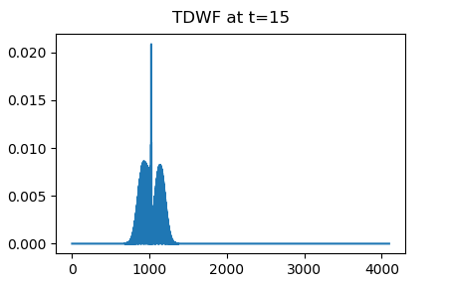
b) Out put |ψ(x)|2 at t=10, 15, 20, 25.

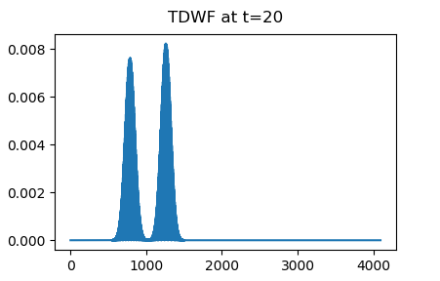
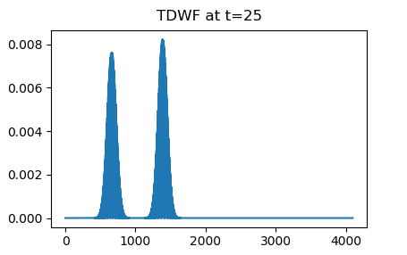
c) Compute T(E) as a function of the initial energy for dt=0.05. Repeat the calculation using the fourth-order Forest-Ruth algorithm.

Plot these two results against the exact Tex(E) as given in the lecture note.
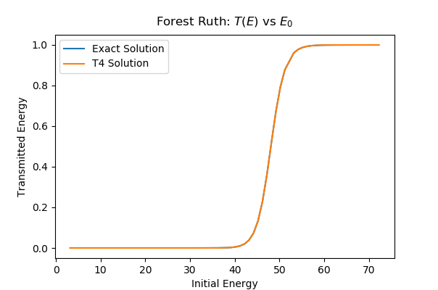
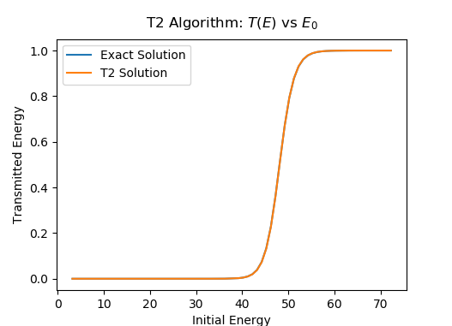
Clearly, the results are so similar that they completely overlap the theoretical solution.

Plot also T(E)−Tex(E) for these two results in the same graph.
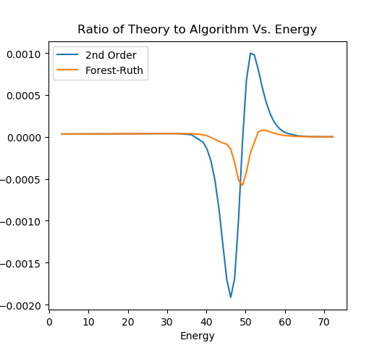
Here we see the distinctive symmetrical swing in the error accustomed to 4th order calculations.

