Problem 1:

Compute the exact ground state energy of the Helium atom by use of the Diﬀusion Monte Carlo algorithm with importance sampling. Use the trial function introduced in problem 3 of HW7.

The basic idea of DMC is to use the Langevin algorithm to iterate the configurations of the system (the two electrons’ position in the case of Helium), but ADDITIONALLY, replicated each configuration according to the exponential of the local energy as described in the lecture note. When computing the energy expectation values, average over ALL configurations (include those replicated ones)

For my algorithm, I began by initializing 500 pairs of electrons through the use of a metropolis algorithm to generate their starting positions. I then generated a test update to the electrons' positions via the Langevin algorithm and accepted or rejected the move according to the Metropolis probability as established in previous homeworks.

Finally, I computed the branching factor for each configuration:

and duplicated or deleted configurations based on this result. The trial energy was then updated, the number of walkers normalized back to 500, and this process was iterated over for several hundred time steps. As an example, see my result for Δt = .01 :
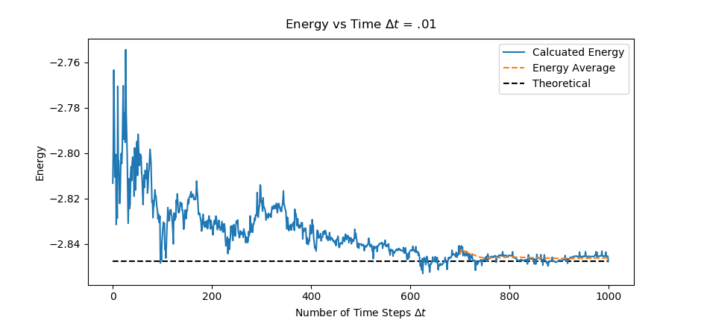
If we zoom in closer towards the end of our run:
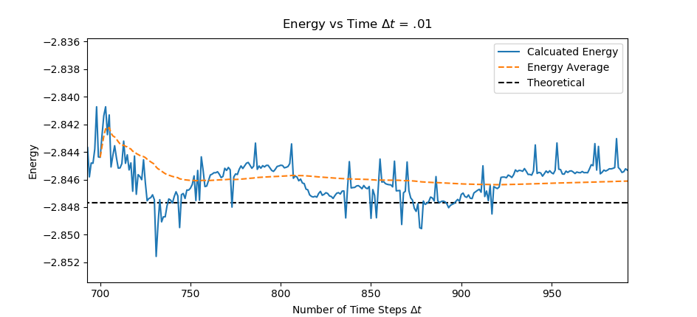
we can see that this algorithm very nicely approaches our ground state energy level for the helium atom as derived in homework 7.

As a function of step size Δt, I present the following:
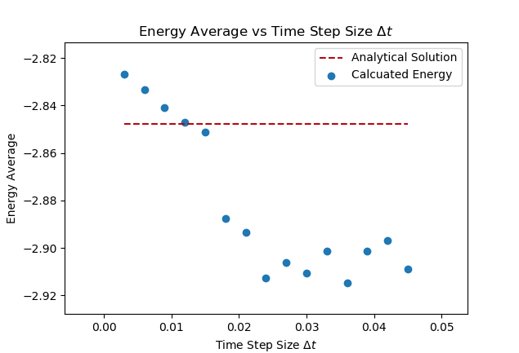
There is a clear trend that as the step size increases, the calculated average energy decreases. This trend is expected to decrease linearly, which is what is observed at small time steps. Unfortunately, my algorithm began to break down at too large a time step, and I was only able to obtain reasonable results up to ~Δt = .05 where we can see the linear trend is no longer noticeable.

