# Diets from two Arctic fishes reflect life history strategies during a seasonal resource pulse in the Canadian high Arctic

Lars J. Hammer1*†, Nathan T. Hermann1*, Nigel E. Hussey2, Marianne Marcoux3, Kevin J. Hedges3, Nathan B. Furey1

1University of New Hampshire, Department of Biological Sciences, Durham, NH, United States

2University of Windsor, Integrative Biology, Windsor, ON, Canada

3Department of Fisheries and Oceans, Winnipeg, MB, Canada

*Co-first Authors

Contact: Lars Hammer; Lars.Hammer@maine.gov

Nathan Hermann; Nathan.Hermann@unh.edu

†Current Position: Maine Department of Marine Resources, Augusta, ME, United States

Prepared for Submission to **Oecologia**

# Abstract

The dramatic seasonal changes that occur annually in the Arctic require organisms to adapt to harsh, and exploit, favorable conditions as they occur. Foremost among these changes is the sudden abundance of resources and habitats following the receding sea-ice. Many marine organisms respond behaviorally to maximally exploit this resource pulse; however, the strategy by which this is done varies among organisms. To assess the degree and means of exploitation by the fishes of a pristine coastal Arctic community, we collected stomach contents from migrant anadromous Arctic char (*Salvelinus alpinus*; n = 91) and resident sculpins (*Myoxocephalus* spp.; n = 190) in Tremblay Sound, Nunavut, Canada during the ice-free seasons of 2017-2019. Feeding intensity (as both percent of empty stomachs and relative consumption) and diet composition were compared between the two fishes to identify differences in their feeding within a shared environment. Despite eating larger prey items, the amounts Arctic char consumed were smaller relative to body weight (mean ±SD; 1.92% ±1.38%) than those of sculpin (2.88% ±2.93%). Arctic char also had fewer empty stomachs than sculpins (1.96% vs 14.7%). For diet consumption, 52.6% of identified prey categories were shared by both predators. Non-metric multidimensional scaling (NMDS) ordination and discrimination tests showed dietary distinctions were primarily driven by Arctic char’s higher consumption of fishes and copepods whereas sculpin diets were dominated by several types of amphipods. Our findings are consistent with understandings of life histories for relatively sedentary, benthic-oriented, resident sculpins intermittently consuming small, benthic prey items at very high levels whereas mobile, semi-pelagic, migratory Arctic char consume pelagic prey items at more consistent levels that do not impede aerobic activity. Ultimately, we have shown that, unsurprisingly, diets are reflective of predator physiology but also of life history traits, such as migratory behavior, that differentiate Arctic char and sculpins as common predators within a constricted Arctic food web.

**Keywords:** Arctic char, sculpins, Arctic, feeding ecology, diet analyses

# Introduction

The Arctic is a highly dynamic environment, experiencing dramatic seasonal change in environmental conditions (AMAP 2017). Winter in Arctic ecosystems is generally characterized as a resting state, exhibiting low productivity, almost complete darkness, and ice-covered landscapes for much of the year (Berge et al. 2015). At the end of this winter however, comes a rapid transition between ice-cover and open-water (AMAP 2017). This spring transition, coupled with increased daylight, causes a primary productivity bloom that provides key nutrients for Arctic consumers (Hop et al. 2011; McMeans et al. 2015). Increasing temperatures associated with climate change have altered these phenological patterns by gradually reducing the duration and extent of sea-ice cover across much of the Arctic (Johannessen et al. 2004; Stroeve et al. 2007; Dai et al. 2019). Consumers that rely on the regularity of transitions in sea-ice cover may be negatively affected by changes in ice phenology, and understanding those relationships is critical to predicting their future climate resilience.

Large resource pulses attract a wide variety of migratory animals that presumably exploit these seasonally abundant resources (Melnikov 1997), including birds (Lameris et al. 2017; Descamps et al. 2019), marine mammals (Heide-Jørgensen et al. 2002; Harwood et al. 2012), and anadromous fishes (Harwood and Babaluk 2014; Hammer et al. 2022). These species generally arrive at the start of ice melt to exploit pulses in productivity and depart before the transition back to ice cover when conditions are harshest (Edwards et al. 2022). In contrast to migratory animals, Arctic resident species remain in these habitats year-round. To live in these harsh environments continuously requires residents exhibit specific adaptations to changing conditions through the tradeoff for reduced mobility costs being a usage of physiological adaptations (Harwood and Babaluk 2014; Baumgartner and Tarrant 2017) or lipid storage (Biro et al. 2004). In Arctic systems both resident and migratory species take advantage of resource pulses to varying degrees, likely based on their life history requirements and capacity for feeding.

Migratory and resident organisms possess different anatomical features, physiological capabilities, and behavioral characteristics. Among the most visible differences between migratory species and their resident counterparts is in the standard of mobility, namely that migratory species possess a capacity for persistent, directed movements which define migration (Bauer and Hoye 2014). While residents can still exhibit high mobility within a single area (Becker et al. 2020) and some migrants are famously slow-moving (Blake et al. 2013), the anatomical features which influence an organism’s migratory behavior will similarly influence their foraging. In poikilothermic fishes, the scope of activity is influenced by water temperature, but a portion of that metabolism is dedicated to activity such as digestion (Clark et al. 2013). Therefore, the metabolic costs of digestion necessarily impede aerobic scope for other necessary functions such as mobility. Alternatively, fishes may raise their total aerobic scope during times of high consumption by seeking warmer temperatures (Armstrong et al. 2013), though conditions for this strategy are rare. From this, we can see that the feeding behaviors of fishes are linked to the broader life history elements based on adaptations of anatomy and physiology; but to understand this more fully we must understand their feeding.

Diet analysis is a common method for understanding the feeding behaviors of fishes. As most fish do not masticate and, especially in cold-water environments, digest prey slowly (Durbin et al. 1983), assessments of stomach contents can effectively reveal the recent feeding of an individual (Amundsen and Sánchez-Hernández 2019). Two major components of feeding can be determined from stomach content analysis providing a snapshot of feeding: composition and magnitude. Composition can not only describe all the prey items which a predator consumes, but also details about the generality/selectivity of their foraging (Gerking 1994) and which prey items might be most important to individuals or populations (Amundsen et al. 1996). Additionally, when the ecology of prey items is known, then deductions about a predator’s foraging habitats can be made as well, i.e., those consuming only benthic prey items likely feed at and occupy the benthos. Diet magnitude, which is commonly estimated as relative consumption or the weight of the diet relative to the weight of the fish, can provide a proxy for energetic intake and overall productivity. As mentioned previously, the magnitude of feeding will scale to the aerobic investment of feeding and inversely with mobility (Clark et al. 2013). Finally, the distribution of magnitude can provide insights into the feeding behaviors of a predator based on diet analyses being just a snapshot in time. Specifically, samples where all individuals have similar levels of relative consumption, i.e., low variance, are most likely drawn from a population which feeds consistently. In contrast, high variances, especially if samples include extreme values or frequently empty stomachs, indicate intermittent feeding (see Arrington et al. 2002; Armstrong and Schindler 2011). As such, diet analyses are a useful tool for exploring the ecology of species and to contextualize them with other inhabitants of the same ecosystem.

Arctic char (*Salvelinus alpinus*) are a relatively large and mobile pelagic migratory fish that provides an important source of protein to indigenous communities throughout the Arctic (Booth and Watts 2007). In addition to their migratory capabilities, Arctic char are known to exhibit highly diverse movements and life history patterns (Beddow et al. 1998; Jensen and Rikardsen 2008; Moore et al. 2017). In contrast, sculpins (family Cottidae) are small to moderately sized benthic fishes with those of the genus *Myoxocephalus* being cold-water, Northern temperate-polar fishes of primarily marine environments (Balakirev et al. 2020). Sculpin are sit-and-wait ambush foragers (Landry et al. 2019) and maintain small home ranges in coastal Arctic waters year-round (Barton et al. 2020; Hermann et al. 2023). The summer resource pulse occurring with ice-melt in Arctic systems provides abundant resources that both species can presumably exploit.

With both Arctic char and sculpins present within the shared ecosystem of Tremblay Sound, we sought to use diet analyses to understand their exploitation of this resource pulse. Tremblay Sound was identified as a model system to achieve this objective as it experiences an annual ice-on/ice-off cycle which produces a pulse of productivity. Included as occupants of Tremblay Sound are Arctic char which are anadromous migrants in coordination with the sea-ice (Hammer et al. 2022) and sculpins that are year-round residents exhibiting flexible behaviors across seasons (Hermann et al. 2023). Specifically, the objective of this study was to compare the feeding rates and diet composition of a resident and migrant fish through the seasonal prey pulse. We hypothesize that several metrics of diet will differ between Arctic char and sculpins reflecting their contrasting behaviors surrounding the pulse. We predict that while Arctic char will feed on energetically dense prey items at consistent rates, sculpins will intermittently gorge on a broad, benthic diet.

# Methods

Fish were captured in Tremblay Sound, Nunavut, Canada (72.357° N, 81.108° W) in the summers of 2017, 2018, and 2019. Arctic char were primarily captured using gillnets with a ~15 cm stretched mesh between 19-Jul-2017 and 4-Sep-2017, 20-Jul-2018 and 28-Aug-2018, and 8-Aug-2019 and 14-Aug-2019. Nets were carefully watched during deployment and any fish that hit were immediately removed from the net. Sculpin species were captured using a fyke net deployed between 23-July-2017 and 26-Aug-2017, 31-Jul-2018 and 11-Sep-2018, and 12-Aug-2019 and 21-Aug-2019. The fyke net was checked and fish and other organisms were collected at every low tide resulting in 85, 79, and 18 collections in 2017, 2018, and 2019, respectively.

Captured fish were euthanized and were measured for total length (TL) and weight. Additionally, a Fulton’s condition factor (𝐾 = 100*($W/{{TL}^{3}}$); where W = weight; Ricker 1975) was calculated for each fish. Measured fish were then dissected and their stomachs were removed. In 2017, stomach contents were picked at the field site without a microscope and were not weighed. In 2018, stomachs were weighed in the field, frozen, and shipped whole to the University of Windsor for storage. One 2018 char sample was not relocated after shipping. In 2019, stomach contents were removed from the stomach, weighed, frozen, and shipped to the University of New Hampshire. Empty stomachs were weighed and discarded in 2019. Fresh diet items from 2017 and thawed diet items from 2018 and 2019 were sorted to the lowest taxonomic level and each taxa present was enumerated and massed. All capture and dissection methods were approved by the University of Windsor (AUPP: #17-12) and the University of New Hampshire (IACUC:#180602). Sampling protocols also followed a quota set by the local Pond Inlet Hunters and Trappers Organization, which defined the maximum number of individuals that could be sacrificed for dissection.

Feeding intensity was expressed for both species as relative consumption, calculated as the wet mass of the diet contents divided by the wet mass of the fish (g/g). The wet mass of diet contents was calculated as the weight of the full stomach divided by the weight of the empty stomach. Diet content mass was not measured for 2017 fish, so a relative consumption could not be calculated, and they were removed from further analyses of feeding intensity.

A generalized linear model (GLM) framework was used to analyze factors contributing to relative consumption. Explanatory variables in the models included species (char, sculpin), year (2018, 2019), and month (July, August, September). The initial GLM was constructed with a binomial distribution to determine the factors contributing to empty (0) or not-empty (1) stomachs. A second GLM containing the same explanatory variables was run with a gamma distribution for only those fish that fed (i.e., relative consumption > 0). This hurdle GLM allowed the determination of variable importance to whether individuals fed (binomial model) and when they had, the magnitude of their consumption (Gamma model; Bolker et al. 2009). All subsets regression was performed using the *dredge* function from the *MuMIn* package (Bartoń 2020) in R (v4.0.2; R Core Team 2020). The model with the lowest Akaike Information Criterion with a correction for small sample size, AICc, was selected as the most parsimonious model.

Diet composition was assessed using frequency of occurrence (FOO; Garvey and Chipps 2013). FOO for each prey type (lowest taxonomic level) was calculated for each species (Arctic char and sculpins) and year as the percentage of diets that contained a specified prey item. Other common diet analysis metrics (percent numeric abundance and percent mass; Garvey and Chipps 2013) were not included in this study due to procedural variations (i.e., diet contents were not consistently counted or massed in 2017) and inconsistencies in identifiability across diets (i.e., percent numeric abundance and percent mass could not be calculated for diets with unidentifiable prey). Presence-absence data was ordinated by NMDS to assess diet composition differences between species and years. Distance matrix created using Bray-Curtis distance, 250 random starts for axes 1-6 with *metaMDS* function from the *vegan* package in R (v4.0.2; R Core Team 2020) then selecting the best based on being < 20 stress and not reducing by > 5 with an additional axis. Selected ordination is then visualized with functions from the *ggplot2* package (Wickham 2016) in R (v4.0.2; R Core Team 2020) and each point is labeled according to species (Arctic char and sculpin) and year (2017, 2018, and 2019) with convex hulls built around those points. The consistency of composition for each group (combination of taxa and year) was tested using Permutational Multivariate Analysis of Variance (PerMANOVA) with the *adonis* function from the *vegan* package in R (v4.0.2; R Core Team 2020) with any significant factors being tested pairwise with the function *pairwise.perm.manova* from the *RVAideMemoire* package in R (v4.0.2; R Core Team 2020). As PerMANOVA significance can be driven by differences in both position (centroid values in multivariate space) and dispersion (variance in individual positions within a group) a *post-hoc* estimation of both values was made for each group to compare their influence on inter-group differences as well as identify those groups which are most different. Inter-group centroid distances are calculated using the function *dist_multi_centroids* from the package *usedist* in R (v4.0.2; R Core Team 2020) resulting in a 6x6 symmetrical matrix. Dispersion is calculated by calculating the distance between each individual and its group centroid and estimating the average, in this case a median was used to mitigate the effects of outliers. As dispersion is calculated in multivariate space, units are meaningless but are restricted to values ≥ 0.

To assess how well our sampling of Arctic char and sculpins stomachs captured variability in prey items, we used prey accumulation curves. Prey accumulation curves were constructed for both species in each year, and combined across study years (2017, 2018, and 2019). The analysis was designed to calculate the expected (mean) species richness within diets using the *accumcomp* function from the *BiodiversityR* package (Kindt 2023) in R (v4.0.2; R Core Team 2020).

# Results

A total of 91 Arctic char and 190 sculpin were captured for diet analysis from 2017–2019 (Table 1). Char samples were distributed relatively evenly across the three years (n2017-2019:37, 23, 31), while sculpin samples were mostly collected in 2017 and 2018 (n2017-2019:114, 59, 17; Table 1). Sampled Arctic char had an average TL of 62.1 cm and an average mass of 2,609.2 g (Table 1). Sculpin were smaller than char at an average of 18.5 cm and 78.9 g (Table 1). Char had an average Fulton’s K of 914.1 (±176.5), with sculpin being slightly better conditioned (mean = 1,062.1; SD = 572.3; Table 1).

A total of 51 char and 75 sculpin from 2018–2019 were available for analysis of feeding intensity. The initial GLM examining factors related to whether a fish consumed prey or had an empty stomach only retained the species variable (Table 3). Eleven sculpin (14.67%) had empty stomachs, while only a single char (1.96%) was found with an empty stomach. The second model investigating factors relating to feeding intensity retained the species and year variables (Table 3). In general, sculpin (mean = 2.88%; max = 10.5%) fed more intensely than char (mean = 1.92%; max = 4.63%). Both predators fed more intensely in 2019 (meansculpin = 3.19%; meanchar = 2.42%) than in 2018 (meansculpin = 2.79%; meanchar = 1.16%).

Between the two predators there were 15 identifiable prey types among all stomachs and 19 total categories. Both char and sculpin each consumed 12 distinct prey types with 10 common between the two predators (52.6%; Figure 1). Of the prey items consumed, frequencies ranged from <1% to 93.3% for a taxon in a given year. The most commonly consumed prey items were Amphipods (n = 109, 41.4%) with the most common among those identified more specifically being *Onisimus* sp. that were found in 81 stomachs (30.7%). The prevalence of amphipods as a top prey item was consistent across years for sculpins (2017: Amphipod, FOO = 61.2%; 2018: *Onisimus* sp., FOO = 46.9%; 2019: Amphipod, FOO = 50.0%) and for Arctic char (2017: Amphipod, FOO = 68.5%; 2018: *Onisimus* sp., FOO = 68.1%; 2019: *Themisto* sp., FOO = 93.3%; Figure 1). The largest difference of the total FOO for a prey item between the two predator taxa was for *Themisto* sp. as they were never found in the diets of sculpins (Sculpin 0% FOO vs Arctic char 32.1% FOO). For those taxa consumed by both predators the largest difference was for Copepods (Sculpin 10.7% FOO vs Arctic char 35.6% FOO) and Fish (Sculpin 21.0% FOO vs Arctic char 42.5% FOO; Figure 1).

Diets were successfully ordinated on three axes through NMDS with a stress of 9.04 (Figure 2). The majority of the ordination space for a predator taxon in a sampling year was overlapping across taxa and years with differences being driven by the inclusion of variably abundant prey items, e.g., *Themisto* sp. by Arctic char in 2019 (Figure 2). ISA revealed stronger associations between Arctic char and their prey than those by sculpins. Arctic char possessed 6 significant prey types (Arctic cod, Sand lance, Fish, *Onisimus* sp., *Themisto* sp., and Copepods) whereas sculpins had just two (Amphipods and Mysids) as well as an association with Digested materials (Table 2). All groups (combination of predator taxa and year) were significantly different via PerMANOVA (p = 0.0015 – 0.0310) with centroid distances ranging between 0.220 and 0.664. Typically, centroid distances between the predator taxa within the same year were smaller (mean = 0.364, range = 0.220 – 0.571) than for the same predator taxa across years (mean = 0.456, range = 0.228 – 0.638; Figure 5a). Dispersion values for individuals ranged from 0 – 0.879 (a Sculpin from 2018) with groups showing variation in their averages (Figure 5b) but no consistent effect of predator taxa nor of year was observed.

# Discussion

Both sculpin and char exploited the brief prey pulse, with few individuals exhibiting empty stomachs, and many feeding intensely. The percentage of empty stomachs (char = 1.96%; sculpin = 14.67%) was lower than the average for fishes analyzed worldwide (16.2%), but was within the range of other fish populations, particularly in North America (Arrington et al. 2002). Levels of consumption were high on average for both Arctic char (1.92% ± 0.19%) and sculpins (2.88% ± 0.33%) with individuals reaching 4.63% for Arctic char and 10.50% for sculpins. Previously, definitions of binge-feeding have been made for fishes based on their capacity for digestion and assimilation based on detailed bioenergetics models (Hanson et al. 1997; Furey et al. 2016). Unfortunately, neither Arctic char nor for any *Myoxocephalus* sculpins do bioenergetics models exist to be able to specifically define binge feeding. Therefore, our best comparison is using close relatives for which bioenergetics models exist: Bull trout (*Salvelinus confluentus*) and Prickly sculpin (*Cottus asper*). Using methods from Furey et al. (2016), a threshold for binge-feeding was defined based on temperature- and mass-dependent models parameterized by (Mesa et al. 2013) and (Moss 2001) for Bull trout and Prickly sculpin, respectively. These models were fed a maximum temperature observed from haphazard surface water temperatures taken near the campsite (11°C) and the mean body weight from fish sampled in this study (2609 g for Arctic char; 78.9 g for sculpins). From these proximal models, Arctic char are estimated to experience maximal consumption at 3.52% body weight and sculpins may have maximal consumption at just 1.46%. Compared to these estimates, excessive consumption occurred in both predator groups, perhaps more than 1/3 of individuals across all sampled (15.4% of Arctic char; 52.0% of sculpins). Both the regular and intense feeding observed here has been found as characteristic fish responses to other large resource pulses (Furey et al. 2016; Hermann et al. 2020). Regardless of our inability to define specific metrics for binge-feeding for Arctic char and *Myoxocephalus* spp. sculpins, the relatively intense feeding by both predators during the ice-off season is likely to be important to their year-round energy budgets and success.

Though both Arctic char and sculpins fed intensively, their diets differ in ways which may reflect differences in their mobility and migratory behavior. Mobility may explain the higher presence of more mobile or pelagic prey items in the diets of Arctic char such as fish and copepods. Conversely, sculpins are primarily benthic predators with prey items being dominated by small benthic invertebrates (Moore and Moore 1974), consistent with our observations across years. Similarly, the higher percentage of empty stomachs by sculpins may suggest they are less capable of seeking consistent feeding opportunities and, as such, when they do feed do so at rates that are generally higher. This would be accurately reflective of their lie-in-wait foraging style and general sedentary lifestyle (Moore and Moore 1974; Breen et al. 2009). These two observations help contrast the foraging strategies of Arctic char and sculpins, the former moving quickly (Hammer et al. 2022) between patches of productivity within Tremblay Sound to feed consistently whereas sculpins occupy one area and consume the resources opportunistically available and only being able to slowly move between patches (Hermann et al. 2023). Perhaps, these differences position the two predators within the two categories of predatory responses to resource pulses defined by Yang et al. (2008): mobile specialists (Arctic char) and opportunistic residents (sculpins). However, it is possible that Arctic predators require additional plasticity (e.g., digestive capacity flexibility in Dolly Varden (*Salvelinus malma*); Armstrong and Bond 2013) and, as such, may not fit neatly into categories defined primarily from temperate environments (Yang et al. 2008). Future studies should investigate whether there is a limit to diet plasticity to further inform how Arctic predators will respond to continued and more severe impacts of climate change. Additional adaptations include the migration behavior which is in addition to the marine mobility of Arctic char.

The migratory behavior of Arctic char presents a significant undertaking which their summer feeding must be capable of supporting. The energetic expense of migration is well understood for many taxa (birds, McWilliams and Karasov 2014; mammals, Harwood et al. 2012; and fishes, Wilson et al. 2013) including for Arctic char specifically (Harwood and Babaluk 2014). For some migrants, the expense of the extended movement is exacerbated by the minimal or absent feeding throughout migration (Harwood and Babaluk 2014). As such, migrants largely rely on energy stores built up during other times of the year meaning this foraging must be maximized. However, the ability to consume high levels of prey by maintaining digestive machinery can be expensive in its own right (Cant et al. 1996). Alternatively, other adaptations relying on flexibility (Armstrong and Bond 2013) or binging (Furey et al. 2016) can impose high costs by absorbing the aerobic capacity that could otherwise be used for mobility (Clark et al. 2013). While this can clearly contribute to the observation of limited feeding during migrations (Clark et al. 2013), it can additionally influence how fishes exploit resources during a period when foraging is the primary focus such as the Arctic summer (Harwood and Babaluk 2014; Landry et al. 2018). While having an anatomical ability for mobility can enable foraging behaviors by Arctic char such as the mobile specialist categorization discussed earlier, maintaining that level of mobility can put an upper limit on the magnitude of feeding they can undertake. In this sense, for fishes the choice to be mobile and to feed comes as a trade-off wherein the two capacities must be balanced for each species based on the internal characteristics of that species and the external features of their environment, both biotic and abiotic (see Armstrong et al. 2013). Our observations comparing the diets of sculpins and Arctic char support such a trade-off among fishes experiencing the same resource pulse but experiencing distinct anatomical and life history characteristics.

Another important contributing factor behind dietary differences is the average and maximum body size between Arctic char that > 3x larger than sculpins from our sample. The prey consumed by Arctic char included more fish than did the diets of sculpin likely due to gape limitation common among fishes (Urban 2007). In fact, the incorporation of larger prey items while still consuming small items follows the same pattern of many fishes (Scharf et al. 2000) resulting in many larger fishes having more prey options than smaller fishes which can result in rapid growth (Urban 2007). Though larger fish can consume larger prey, the trade-off with large diets is large aerobic investments that can limit mobility (Norin and Clark 2017). Both predators must balance these impacts of consumption and metabolism, but the high rates of relative consumption observed in sculpins may suggest that they are less constrained by needing to maintain excess aerobic scope in favor of increasing growth rates (Norin and Clark 2017). Also contributing to impacts of body size on feeding is the scaling of space use wherein larger organisms rely on larger areas to acquire sufficient resources (Tamburello et al. 2015). As such, the obvious differences in body size between the predators sampled within this shared environment may contribute further to subtle differences in feeding magnitude and composition.

Though the difference between sculpins and Arctic char can be observed and attributed to life history differences between the taxa, there was also observed differences between sampling years. Indicator species analysis was able to identify prey items that were significantly associated with certain sampling years, most notably different taxa of amphipods for each year: *Gammaracanthus* sp. in 2017, *Onisimus* sp. in 2018, and *Themisto* sp. in 2019. Changes in the composition of macrofauna are known to be linked to environmental conditions as they vary throughout the Arctic, especially for dominant amphipods (David et al. 2015). Environmental features such as ice-cover and temperature were observed to vary in Tremblay Sound anecdotally (N. Hussey, *pers. obs*) and could contribute to the available prey taxa to both Arctic char and sculpins. Specifically, amphipods vary in the strength of association with the sea-ice with those strongly sympagic species declining in abundance quickly as ice melts (Hop et al. 2011). Though sampling in all years occurred after the entire Sound had cleared, the presence of drifting ice varied from one berg for the whole 2019 sampling season to regular fast ice in 2018. Variability in the faunal community between years could be confirmed by future research which collects both the diets of major predators and the sympatric prey base. Both predators are limited to the prey that are available; however, based on centroid distance between years Arctic char (mean distance = 0.55) may be more sensitive to the changing prey base than sculpins (mean distance = 0.36). Sculpins, that are known to be opportunistic predators, may not reflect dominant taxa inter-annually as their mobility may impede their ability to select prey items. Ultimately, more intensive sampling of prey availability, especially in the dominant habitats which these predators utilize, is required to identify selectivity of feeding as it may contribute to inter-annual variability in diet composition.

Though these results are valuable, it is important to acknowledge the limits of diet analyses in representing broader feeding behavior and the generalizability of observations from one system during a rapidly varying seasonal pulse. Though our study was successful at generating samples in different years, the time of year contained some variation with 2017 and 2018 being collected over a longer time than 2019. Additionally, all years began well after complete ice-melt when the resource pulse begins (Ji et al. 2013) with successive changes as the season progresses (Hop et al. 2011). Much of this feeding period was missed by our samples (Søreide et al. 2010) and may present a different story on the foraging of these predators. Beyond the timing of sampling, the methods for collecting fish may have resulted in a narrow understanding of the feeding behaviors of Arctic char and sculpins. Individual specialization was observed within our sample (Bolnick et al. 2002), but we believe that a sufficient number of diets was collected to fully encapsulate the prey consumed (via prey accumulation curves) even if some responses may be less well represented. Specifically, collection occurred at just one site which, for sculpins especially, may result in a biased sample of the population due to limited mixing. Telemetry studies have identified that both predators can access the entirety of Tremblay Sound (Hammer et al. 2022; Hermann et al. 2023), but differences may exist between subpopulations or reflecting variable resources within different regions of the system (see Armstrong et al. 2013). Finally, we acknowledge the limitations of visual gut content analysis to misidentification, underrepresenting soft-tissued prey items, and providing information on only the recent feeding history (Amundsen and Sánchez-Hernández 2019). The improvement of gut content analyses with metabarcoding or integration of stable isotope or fatty acid analyses could provide a deeper understanding on the history of feeding by individuals and populations (Giraldo et al. 2016), albeit at increased cost to researchers.

Despite the caveats above, our analyses have documented differences between two important predators feeding on a resource pulse in the same system. Predator responses to the resource pulse and differences in feeding are directly reflective of their life history traits (e.g., migratory vs resident) and broader ecology (e.g., mobile vs sedentary, small vs large). Regardless of differences in life history and ecology, both predators were able to exploit the dynamic summer prey pulse in Tremblay Sound. However, primary productivity in high Arctic systems is at risk from shifts in sea-ice phenology due to climate change. A completely ice-free summer is a likely possibility in the near future (Overland and Wang 2013, Wang and Overland 2012), with implications for prey pulses and the consumers that exploit them. Both predators in this study demonstrated diet plasticity and the ability to feed at high rates, which could indicate resilience to climate related shifts in prey availability and abundance. Despite consistencies in the two predator types here in being capable of exploiting the Arctic resource pulse, the patterns observed differed in a manner reflecting the life history patterns of the predators themselves.

# Tables

Table 1. Summary of Arctic char and sculpins from which stomachs were collected with subsets across sampling years. Metrics of condition are hepatosomatic index (HSI), gonadosomatic index (GSI), and Fulton’s K. Values shown are mean (±SD).

|  |  |  |  |  |  |  |
| --- | --- | --- | --- | --- | --- | --- |
| **Species --Year** | **n** | **Mass**  **(g)** | **TL**  **(cm)** | **Fulton’s K** | **% Empty** | **Relative Consumption** |
| Arctic char | 91 | 2609.2 (±1494.4) | 62.1  (±15.7) | 914.1 (±176.5) | 3.33 | 1.92  (±1.38) |
| --2017 | 37 | 1956.4 (±1397.8) | 55.4  (±17.2) | 855.7 (±175.8) | 5.40 | --- |
| --2018 | 23 | 3194.3 (±1781.1) | 70.0  (±16.7) | 793.6 (±123.8) | 0 | 1.16  (±1.07) |
| --2019 | 31 | 2970.9 (±1093.5) | 64.2  (±9.3) | 1061.5 (±86.1) | 3.22 | 2.42  (±1.35) |
| Sculpins | 190 | 78.9  (±69.3) | 18.5  (±5.4) | 1062.1 (±572.3) | 7.36 | 2.88  (±2.93) |
| --2017 | 114 | 76.5 (±69.7) | 17.8  (±5.2) | 1176.5 (±686.9) | 2.63 | --- |
| --2018 | 59 | 100.1 (±69.0) | 21.1  (±5.3) | 923.4 (±266.4) | 13.55 | 2.79  (±2.88) |
| --2019 | 17 | 22.4 (±4.7) | 14.2  (±1.2) | 774.9 (±150.2) | 17.64 | 3.19  (±3.15) |

Table 2. Results from indicator species analysis indicating associations between diet items and the species (Arctic char or Sculpin) or year (2017, 2018, or 2019) of consumption. Significant associations for the prey species (row) with the predator species or year (column) are denoted in bold. Missing values indicate that diet item was not consumed by that species or during that year.

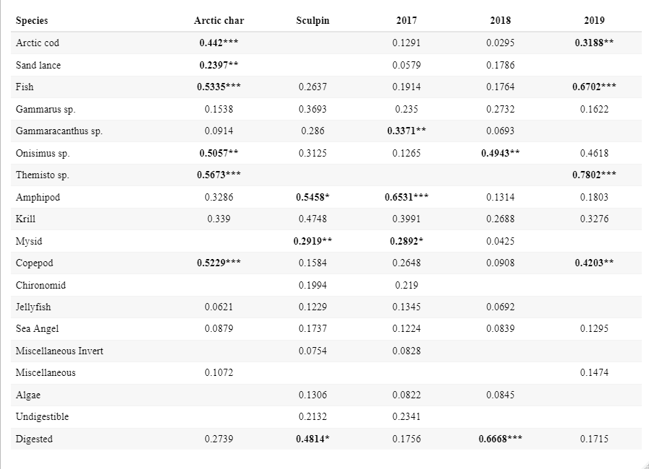

***p<0.001 **0.001<p<0.01 *0.01<p<0.05

**Table 3.** Generalized linear model (GLM) with model weight > 0.10 determined via all subsets regression. AICc: Akaike’s information criterion adjusted for small sample size; Wi: Akaike weight. The response variables and best-fit models are presented in **bold**. Additional models for a given response variable fall below the best-fit model, and the response variable is not shown.

|  |  |  |  |  |
| --- | --- | --- | --- | --- |
| Response | Model | loglik | AICc | Wi |
| Food in Stomach (0 or 1) | Species | -36.188 | 76.5 | 0.473 |
| Species + Year | -35.982 | 78.2 | 0.203 |
| Species + Month | -35.132 | 78.6 | 0.164 |
| Relative Consumption | Species + Year | -222.535 | 453.4 | 0.582 |
| Species | -224.346 | 454.9 | 0.279 |

# Figure Legends

Figure 1. Frequency of Occurrence for diet categories for both Arctic char (blue) and sculpins (yellow). Silhouettes indicate the general appearance of the diet item, note that all amphipod categories are covered under the same silhouette despite differences in genera. Dotted vertical lines separate rough groupings of diet items (from left to right): Fish, Amphipods, Zooplankton/Invertebrates, Miscellaneous.

Figure 2. Non-metric multidimensional scaling ordination of predator diet compositions simplifying a 3-dimensional ordination to 2-dimensions. Points, which represent an individual, and convex hulls are group by species (Arctic char in blue; Sculpin in yellow) and year (2017 circle points and solid line; 2018 square points and dashed line; 2019 diamond points and dotted line). The group (species and year) centroids are indicated with a red point color and shape coded in the same manner. Black lines and prey items indicate the impact of that item on diet ordination position.

Figure 3. Boxplots of relative consumption (percent body weight consumed) between years for Arctic char and sculpin. Each dot represents an individual stomach, with open circles marking empty stomachs. Midlines indicate median values, hinges indicate the first and third (25th and 75th) percentiles, and whiskers extend to 1.5-times the interquartile range from each hinge.

Figure 4. Yearly prey accumulation curves for Arctic char and sculpin. The dashed line indicates a cumulative curve without discriminating between years. Circles mark random samples along the curve.

Figure 5. Distance (a) between centroids of different groups and (b) between individuals to the centroid within a group. Groups are a combination of predator taxa (Arctic char and Sculpins) and year (2017, 2018, and 2019). In (a), cells include both the distance value and are color coded according to that value. Fully black cells are those between the same groups and represent a distance of 0. Black outlines highlight cells which are between the same predator taxa across years, red outlines highlight cells comparing predator taxa within the same year.

# Figures

Figure 1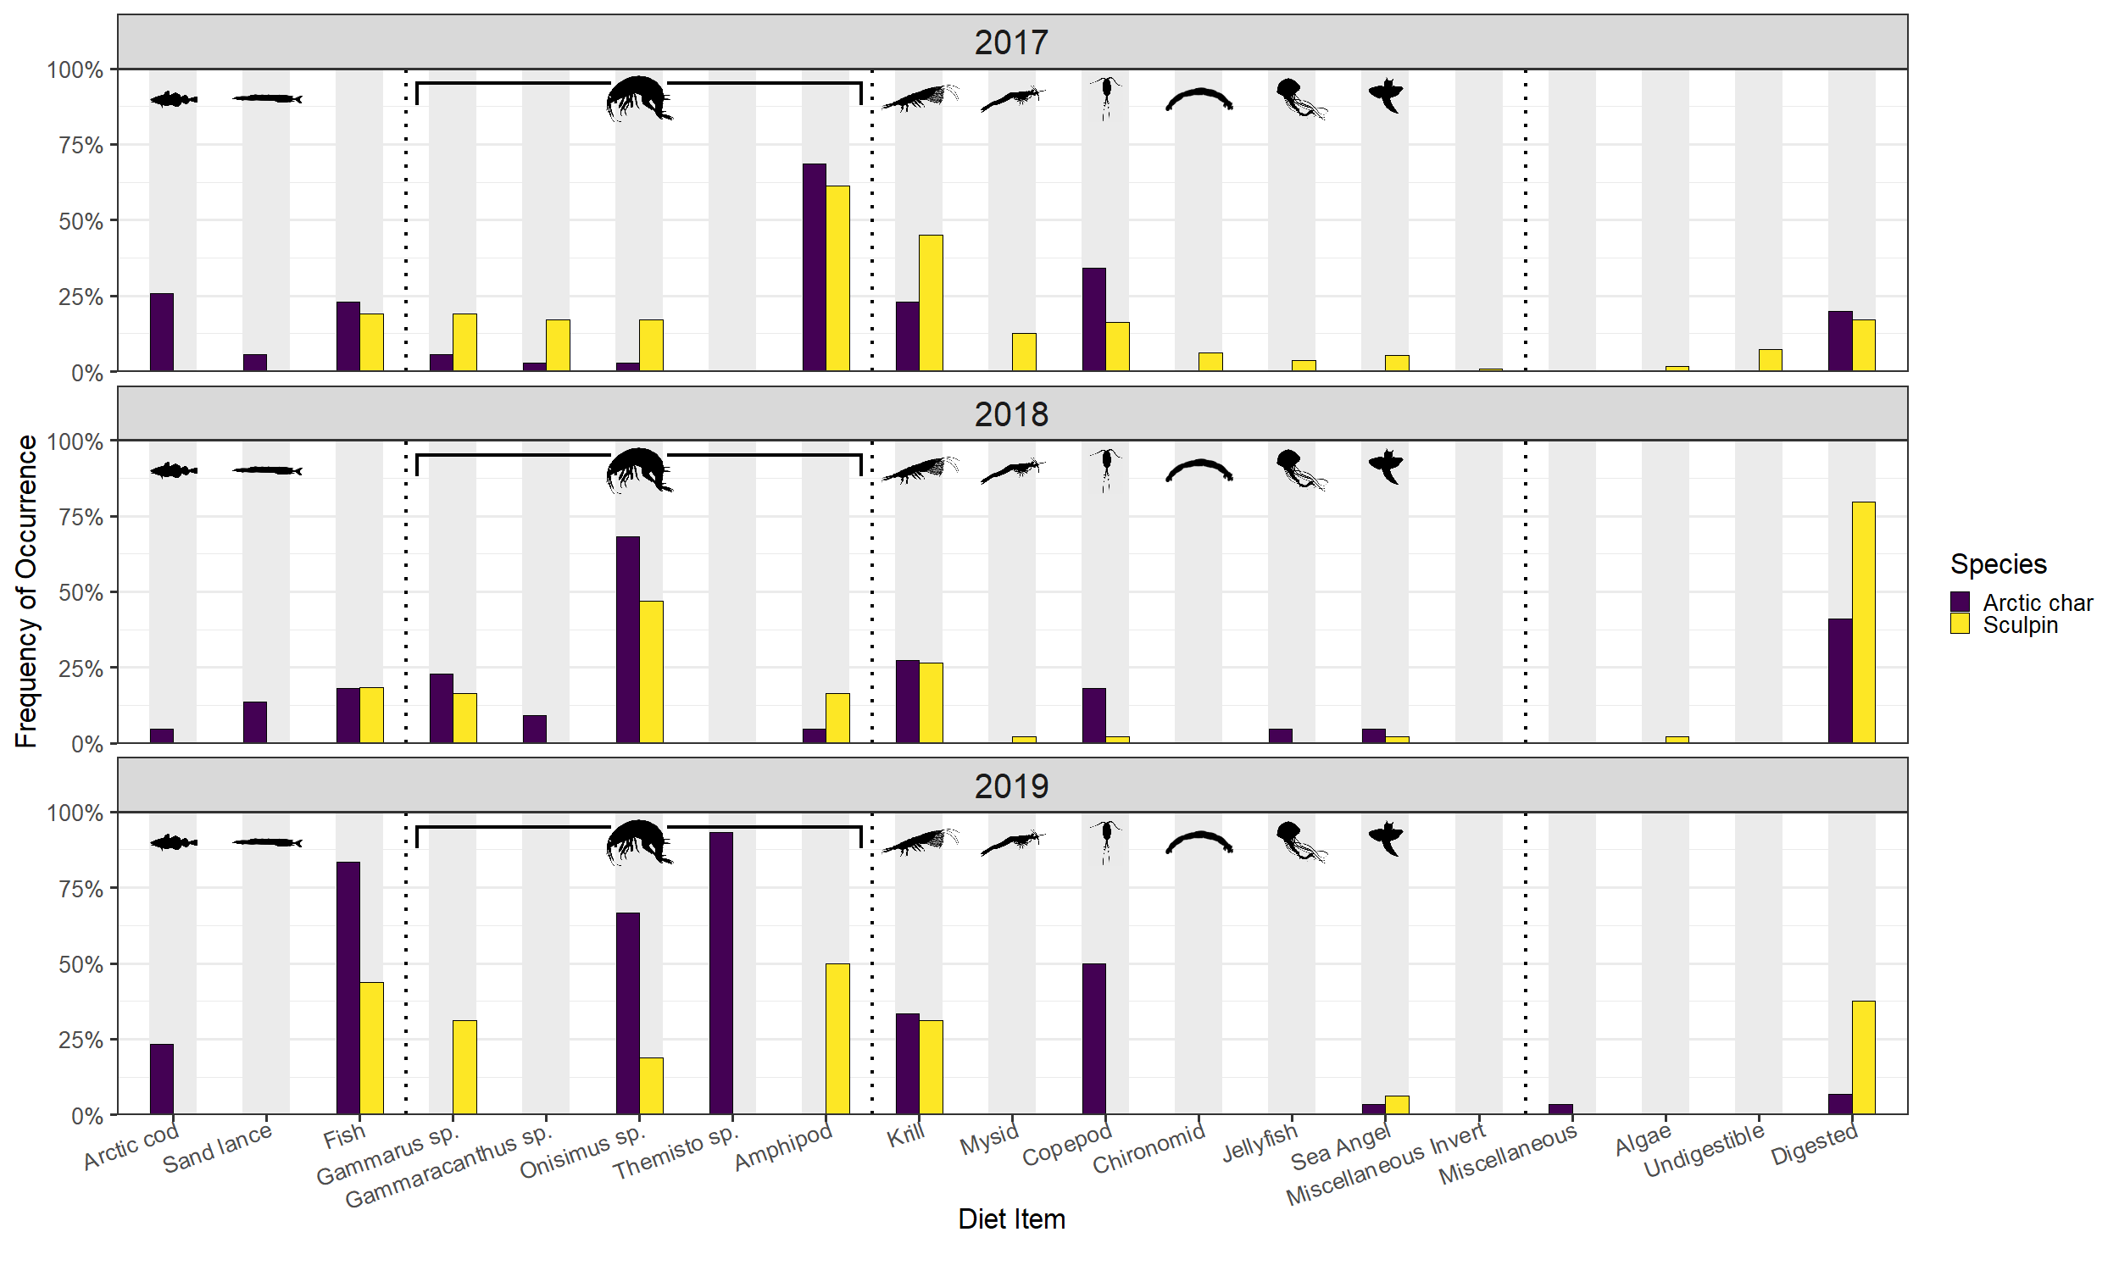

Figure 2

Figure 3



Figure 4



Figure 5

a

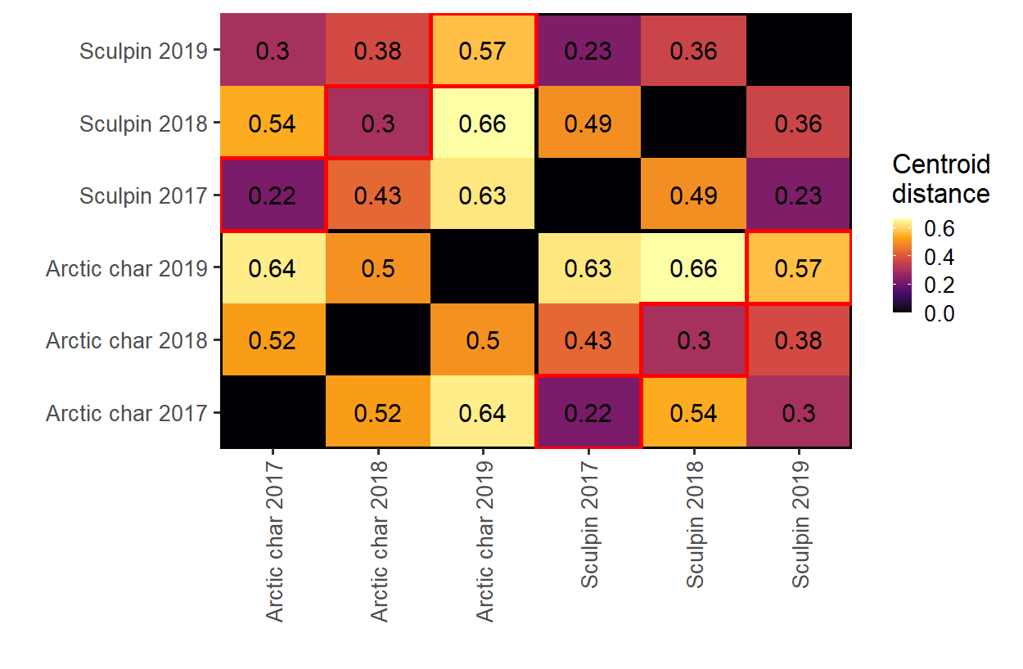

b

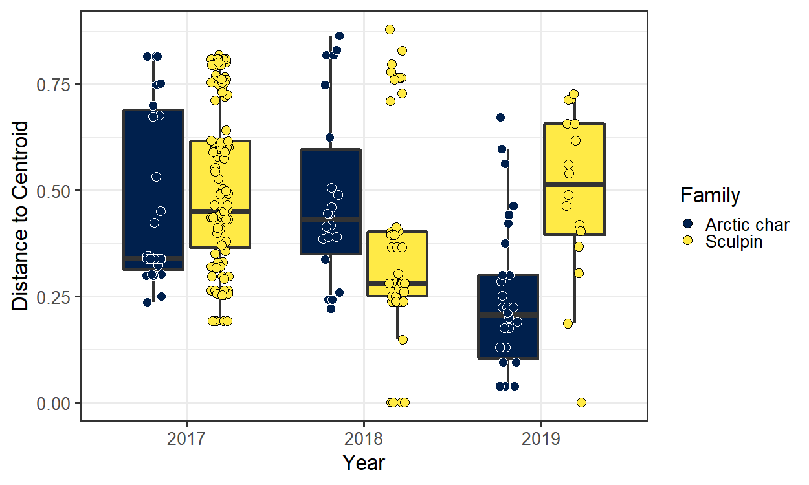

# Declarations

**Funding:** This study was funded by the Department of Fisheries and Oceans Canada and the University of New Hampshire.

**Conflict of Interest:** The authors declare that they have no conflict of interest.

**Ethical Approval:** All applicable institutional and national guidelines for the care and use of animals were followed as approved by the University of Windsor (AUPP:#17-12), University of New Hampshire (IACUC:#180602), and the local Mittimatalik Hunters and Trappers Organization.

**Availability of data and material:** The datasets used and analyzed during the current study are availability from the corresponding author on reasonable request.

**Code availability:** All code used for data analysis was completed in R and is available at: <https://github.com/nhermann1/Hammer_Hermann>

**Author Contributions:** NEH, MM, and KJH contributed project design for the initial field program. Field work was completed by NEH, LJH, and NTH. Analyses were completed by LJH and NTH with advisement by NBF and NEH. LJH and NTH equally contributed to the writing of the manuscript with all other authors providing editorial advice.

# References

AMAP (2017) Snow, Water, Ice and Permafrost in the Arctic (SWIPA) 2017. Oslo, Norway

Amundsen PA, Gabler HM, Staldvik FJ (1996) A new approach to graphical analysis of feeding strategy from stomach contents data—modification of the Costello (1990) method. J Fish Biol 48:607–614. https://doi.org/10.1006/jfbi.1996.0060

Amundsen PA, Sánchez-Hernández J (2019) Feeding studies take guts – critical review and recommendations of methods for stomach contents analysis in fish. J Fish Biol 1364–1373. https://doi.org/10.1111/jfb.14151

Armstrong JB, Bond MH (2013) Phenotype flexibility in wild fish: Dolly Varden regulate assimilative capacity to capitalize on annual pulsed subsidies. J Anim Ecol 82:966–975. https://doi.org/10.1111/1365-2656.12066

Armstrong JB, Schindler DE (2011) Excess digestive capacity in predators reflects a life of feast and famine. Nature 476:84–88. https://doi.org/10.1038/nature10240

Armstrong JB, Schindler DE, Ruff CP, et al (2013) Diel horizontal migration in streams: Juvenile fish exploit spatial heterogeneity in thermal and trophic resources. Ecology 94:2066–2075. https://doi.org/10.1890/12-1200.1

Arrington DA, Winemiller KO, Loftus WF, Akin S (2002) How Often Do Fishes “Run on Empty”? Ecology 83:2145–2151. https://doi.org/10.2307/3072046

Balakirev ES, Kravchenko AYu, Semenchenko AA (2020) Genetic Evidence for a Mixed Composition of the Genus Myoxocephalus (Cottoidei: Cottidae) Necessitates Generic Realignment. Genes 11:1071–1085

Bartoń K (2020) MuMIn: Multi-Model Inference

Barton MB, Vollenweider JJ, Heintz RA, et al (2020) Spatiotemporal variation of environmental conditions and prey availability that drive Arctic nearshore fish community structure in the Point Barrow, Alaska, region. Can J Fish Aquat Sci 77:1612–1624. https://doi.org/dx.doi.org/10.1139/cjfas-2019-0068

Bauer S, Hoye BJ (2014) Migratory Animals Couple Biodiversity and Ecosystem Functioning Worldwide. Science 344:1242552. https://doi.org/10.1126/science.1242552

Baumgartner MF, Tarrant AM (2017) The Physiology and Ecology of Diapause in Marine Copepods. Annu Rev Mar Sci 9:387–411. https://doi.org/10.1146/annurev-marine-010816-060505

Becker SL, Finn JT, Novak AJ, et al (2020) Coarse- and fine-scale acoustic telemetry elucidates movement patterns and temporal variability in individual territories for a key coastal mesopredator. Environ Biol Fishes 103:13–29. https://doi.org/10.1007/s10641-019-00930-2

Beddow TA, Deary C, McKinley RS (1998) Migratory and reproductive activity of radio-tagged Arctic char (*Salvelinus alpinus* L.) in northern Labrador. In: Lagardère J-P, Anras M-LB, Claireaux G (eds) Advances in Invertebrates and Fish Telemetry. Springer Netherlands, Dordrecht, pp 249–262

Berge J, Renaud PE, Darnis G, et al (2015) In the dark: A review of ecosystem processes during the Arctic polar night. Prog Oceanogr 139:258–271. https://doi.org/10.1016/j.pocean.2015.08.005

Biro PA, Morton AE, Post JR, Parkinson EA (2004) Over-winter lipid depletion and mortality of age-0 rainbow trout (*Oncorhynchus mykiss*). Can J Fish Aquat Sci 61:1513–1519. https://doi.org/10.1139/F04-083

Blake S, Yackulic CB, Cabrera F, et al (2013) Vegetation dynamics drive segregation by body size in Galapagos tortoises migrating across altitudinal gradients. J Anim Ecol 82:310–321. https://doi.org/10.1111/1365-2656.12020

Bolker BM, Brooks ME, Clark CJ, et al (2009) Generalized linear mixed models: a practical guide for ecology and evolution. Trends Ecol Evol 24:127–135. https://doi.org/10.1016/j.tree.2008.10.008

Bolnick DI, Yang LH, Fordyce JA, et al (2002) Measuring Individual-Level Resource Specialization. Ecology 83:2936–2941. https://doi.org/10.1890/0012-9658(2002)083[2936:MILRS]2.0.CO;2

Booth S, Watts P (2007) Canada’s Arctic Marine Fish Catches. In: Zeller D, Pauly D (eds) Reconstruction of marine fisheries catches for key countries and regions (1950-2005)., 2nd edn. Fisheries Centre, University of British Columbia, pp 3–15

Breen MJ, Ruetz CR, Thompson KJ, Kohler SL (2009) Movements of mottled sculpins (*Cottus bairdii*) in a Michigan stream: How restricted are they? Can J Fish Aquat Sci 66:31–41. https://doi.org/10.1139/F08-189

Cant JP, McBride BW, Croom WJ (1996) The Regulation of Intestinal Metabolism and Its Impact on Whole Animal Energetics. J Anim Sci 74:2541–2553. https://doi.org/10.2527/1996.74102541x

Clark TD, Sandblom E, Jutfelt F (2013) Aerobic scope measurements of fishes in an era of climate change: Respirometry, relevance and recommendations. J Exp Biol 216:2771–2782. https://doi.org/10.1242/jeb.084251

Dai A, Luo D, Song M, Liu J (2019) Arctic amplification is caused by sea-ice loss under increasing CO2. Nat Commun 10:121. https://doi.org/10.1038/s41467-018-07954-9

David C, Lange B, Rabe B, Flores H (2015) Community structure of under-ice fauna in the Eurasian central Arctic Ocean in relation to environmental properties of sea-ice habitats. Mar Ecol Prog Ser 522:15–32. https://doi.org/10.3354/meps11156

Descamps S, Ramírez F, Benjaminsen S, et al (2019) Diverging phenological responses of Arctic seabirds to an earlier spring. Glob Change Biol 25:4081–4091. https://doi.org/10.1111/gcb.14780

Durbin EG, Durbin AG, Langton RW, Bowman AE (1983) Stomach contents of Silver hake, *Merluccius bilinearis*, and Atlantic cod, *Gadus morhua*, and estimation of their daily rations. Fish Bull 81:437–454

Edwards JE, Hedges KJ, Kessel ST, Hussey NE (2022) Multi-year acoustic tracking reveals transient movements, recurring hotspots, and apparent seasonality in the coastal-offshore presence of Greenland sharks (Somniosus microcephalus). Front Mar Sci 9:902854. https://doi.org/10.3389/fmars.2022.902854

Furey NB, Hinch SG, Mesa MG, Beauchamp DA (2016) Piscivorous fish exhibit temperature-influenced binge feeding during an annual prey pulse. J Anim Ecol 85:1307–1317. https://doi.org/10.1111/1365-2656.12565

Garvey JE, Chipps SR (2013) Diets and Energy Flow. In: Zale AV, Parrish DL, Sutton TM (eds) Fisheries Techniques, 3rd edn. American Fisheries Society, Bethesda, USA, pp 1–48

Gerking SD (1994) Feeding Ecology of Fish. Academic Press, Inc.

Giraldo C, Stasko A, Choy ES, et al (2016) Trophic variability of Arctic fishes in the Canadian Beaufort Sea: a fatty acids and stable isotopes approach. Polar Biol 39:1267–1282. https://doi.org/10.1007/s00300-015-1851-4

Hammer L, Hussey N, Marcoux M, et al (2022) Arctic char (Salvelinus alpinus) movement dynamics relative to ice breakup in a high Arctic embayment. Mar Ecol Prog Ser 682:221–236. https://doi.org/10.3354/meps13939

Hanson P, Johnson TB, Schindler DE, Kitchell JF (1997) Fish Bioenergetics 3.0. Madison, WI

Harwood LA, Babaluk JA (2014) Spawning, overwintering and summer feeding habitats used by anadromous Arctic char (*Salvelinus alpinus*) of the Hornaday River, Northwest Territories, Canada. Arctic 67:449–461. https://doi.org/10.14430/arctic4422

Harwood LA, Smith TG, Auld JC (2012) Fall Migration of Ringed Seals (*Phoca hispida*) through the Beaufort and Chukchi Seas, 2001–02. ARCTIC 65:35-44-35–44. https://doi.org/10.14430/arctic4163

Heide-Jørgensen MM, Dietz RR, Laidre KK, Richard PP (2002) Autumn movements, home ranges, and winter density of narwhals (*Monodon monoceros*) tagged in Tremblay Sound, Baffin Island. Polar Biol 25:331–341. http://dx.doi.org.unh.idm.oclc.org/10.1007/s00300-001-0347-6

Hermann NT, Chaloner DT, Gerig BS, Lamberti GA (2020) Ecological consequences of Great Lakes salmon subsidies for stream-resident brook and brown trout. Can J Fish Aquat Sci 77:1758–1771. https://doi.org/10.1139/cjfas-2020-0086

Hermann NT, Hammer LJ, Hussey NE, et al (2023) Year-round monitoring of Arctic species of sculpin to identify residency and seasonality of movement behavior. Can J Fish Aquat Sci cjfas-2023-0042. https://doi.org/10.1139/cjfas-2023-0042

Hop H, Mundy CJ, Gosselin M, et al (2011) Zooplankton boom and ice amphipod bust below melting sea ice in the Amundsen Gulf, Arctic Canada. Polar Biol 34:1947–1958. https://doi.org/10.1007/s00300-011-0991-4

Jensen JLA, Rikardsen AH (2008) Do northern riverine anadromous Arctic charr Salvelinus alpinus and sea trout Salmo trutta overwinter in estuarine and marine waters? J Fish Biol 73:1810–1818. https://doi.org/10.1111/j.1095-8649.2008.02042.x

Ji R, Jin M, Varpe Ø (2013) Sea ice phenology and timing of primary production pulses in the Arctic Ocean. Glob Change Biol 19:734–741. https://doi.org/10.1111/gcb.12074

Johannessen OM, Bengtsson L, Miles MW, et al (2004) Arctic climate change: observed and modelled temperature and sea-ice variability. Tellus A 56:328–341. https://doi.org/10.1111/j.1600-0870.2004.00060.x

Kindt R (2023) BiodiversityR: Package for Community Ecology and Suitability Analysis

Lameris TK, Scholten I, Bauer S, et al (2017) Potential for an Arctic-breeding migratory bird to adjust spring migration phenology to Arctic amplification. Glob Change Biol 23:4058–4067. https://doi.org/10.1111/gcb.13684

Landry JJ, Fisk AT, Yurkowski DJ, et al (2018) Feeding ecology of a common benthic fish, shorthorn sculpin (*Myoxocephalus scorpius*) in the high arctic. Polar Biol 41:2091–2102. https://doi.org/10.1007/s00300-018-2348-8

Landry JJ, Kessel ST, McLean MF, et al (2019) Movement types of an arctic benthic fish, shorthorn sculpin (*Myoxocephalus scorpius*), during open-water periods in response to biotic and abiotic factors. Can J Fish Aquat Sci 76:626–635. https://doi.org/10.1139/cjfas-2017-0389

McMeans BC, McCann KS, Humphries M, et al (2015) Food Web Structure in Temporally-Forced Ecosystems. Trends Ecol Evol 30:662–672. https://doi.org/10.1016/j.tree.2015.09.001

McWilliams SR, Karasov WH (2014) Spare capacity and phenotypic flexibility in the digestive system of a migratory bird: Defining the limits of animal design. Proc R Soc B Biol Sci 281:1–9. https://doi.org/10.1098/rspb.2014.0308

Melnikov A (1997) Arctic Sea Ice Ecosystem. Gordon and Breach, Amsterdam

Mesa MG, Weiland LK, Christiansen HE, et al (2013) Development and evaluation of a bioenergetics model for Bull Trout. Trans Am Fish Soc 142:41–49. https://doi.org/10.1080/00028487.2012.720628

Moore IA, Moore JW (1974) Food of Shorthorn Sculpin, *Myoxocephalus scorpius*, in the Cumberland Sound Area of Baffin Island. J Fish Res Board Can 31:355–359

Moore J-S, Harris LN, Le Luyer J, et al (2017) Genomics and telemetry suggest a role for migration harshness in determining overwintering habitat choice, but not gene flow, in anadromous Arctic Char. Mol Ecol 26:6784–6800. https://doi.org/10.1111/mec.14393

Moss JHH (2001) Development and Application of a Bioenergetics Model for Lake Washington Prickly Sculpin (Cottus asper). Master of Science, University of Washington

Norin T, Clark TD (2017) Fish face a trade-off between ‘eating big’ for growth efficiency and ‘eating small’ to retain aerobic capacity. Biol Lett 13:3–6. https://doi.org/10.1098/rsbl.2017.0298

R Core Team (2020) R: A Language and Environment for Statistical Computing. R Foundation for Statistical Computing, Vienna, Austria

Ricker WE (1975) Computation and Interpretation of Biological Statistics of Fish Populations. Environment Canada

Scharf F, Juanes F, Rountree R (2000) Predator size-prey size relationships of marine fish predators: interspecific variation and effects of ontogeny and body size on trophic-niche breadth. Mar Ecol Prog Ser 208:229–248. https://doi.org/10.3354/meps208229

Søreide JE, Leu E, Berge J, et al (2010) Timing of blooms, algal food quality and *Calanus glacialis* reproduction and growth in a changing Arctic. Glob Change Biol 16:3154–3163. https://doi.org/10.1111/j.1365-2486.2010.02175.x

Stroeve J, Holland MM, Meier W, et al (2007) Arctic sea ice decline: Faster than forecast. Geophys Res Lett 34:. https://doi.org/10.1029/2007GL029703

Tamburello N, Côté IM, Dulvy NK (2015) Energy and the Scaling of Animal Space Use. Am Nat 186:196–211. https://doi.org/10.1086/682070

Urban MC (2007) The Growth-Predation Risk Trade-Off under a Growing Gape-Limited Predation Threat. Ecology 88:2587–2597

Wickham H (2016) ggplot2: Elegant Graphics for Data Analysis. Springer-Verlag New York

Wilson SM, Hinch SG, Eliason EJ, et al (2013) Calibrating acoustic acceleration transmitters for estimating energy use by wild adult Pacific salmon. Comp Biochem Physiol A Mol Integr Physiol 164:491–498. https://doi.org/10.1016/j.cbpa.2012.12.002

Yang LH, Bastow JL, Spence KO, Wright AN (2008) What Can We Learn from Resource Pulses? Ecology 89:621–634