# Diets from two Arctic fishes reflect life history strategies during a seasonal resource pulse in the Canadian high Arctic

Lars J. Hammer1*, Nathan T. Hermann2*, Nigel E. Hussey3, Marianne Marcoux4, Kevin J. Hedges4, Nathan B. Furey2

1Maine Department of Marine Resources, Augusta, ME, United States

2University of New Hampshire, Department of Biological Sciences, Durham, NH, United States

3University of Windsor, Integrative Biology, Windsor, ON, Canada

4Department of Fisheries and Oceans, Winnipeg, MB, Canada

*Co-first Authors

Contact: Lars Hammer; Lars.Hammer@maine.gov

Nathan Hermann; Nathan.Hermann@unh.edu

Prepared for Submission to **Oecologia**

# Abstract

The dramatic seasonal changes that occur annually in the Arctic require occupants to be able to adapt to and exploit favorable conditions when they are available. Foremost among these changes is the sudden abundance of resources and habitats following the receding sea-ice. Many marine organisms coordinate behaviors to be appropriately positioned to maximally exploit this resource pulse; however, the manner in which this is done varies as much as the life histories of those organisms. To try to assess the degree and means of exploitation by the fishes of a pristine coastal Arctic community, we collected stomach contents from Arctic char (*Salvelinus alpinus*) and sculpins (*Myoxocephalus* spp.) in Tremblay Sound during the ice-free seasons of 2017-2019. Composition and magnitude of diets were compared between the two fishes to identify differences in their feeding despite occupying the same environment. Simple assessments of frequency of occurrence for different prey items and multivariate compositions analysis through non-metric multidimensional scaling showed significant overlap in diets with distinctions being observed among fishes and copepods which were consumed more often by Arctic char whereas sculpins had diets dominated by amphipods. Despite having larger prey items, Arctic char diets were smaller relative to body weight than those of sculpin; both predators fed at high rates regularly. Our findings are consistent with understandings of life histories for relatively sedentary, benthic-oriented, resident sculpins consuming small, benthic prey items at very high levels whereas mobile, semi-pelagic, migratory Arctic char consume pelagic prey items at more consistent levels that do not impede aerobic activity. Ultimately, we have shown that, unsurprisingly, diets are reflective of life history and other physiological traits of fishes, but also that Arctic char and sculpins do overlap but also partition resources as common predators within a constricted Arctic food web.

**Keywords:** Arctic char, sculpins, Arctic, life history, foraging ecology, comparative ecology, diet analyses

# Introduction

The Arctic is a highly dynamic environment, experiencing dramatic seasonal change in environmental conditions (AMAP 2017). Winter in Arctic ecosystems is generally characterized as a resting state, exhibiting low productivity, almost complete darkness, and ice-covered landscapes for much of the year (Berge et al. 2015). At the end of this winter however, comes a rapid transition between ice-cover and open-water (AMAP 2017). This spring transition, coupled with increased daylight, causes a primary productivity bloom that provides key nutrients for Arctic consumers (Hop et al. 2011; McMeans et al. 2015). Increasing temperatures associated with climate change have altered these phenological patterns by gradually reducing the duration and extent of sea-ice cover across much of the Arctic (Johannessen et al. 2004; Stroeve et al. 2007; Dai et al. 2019). Consumers that rely on the regularity of transitions in sea-ice cover may be negatively affected by changes in ice phenology, and understanding those relationships is critical to predicting their future climate resilience.

Large resource pulses attract a wide variety of migratory animals that presumably exploit these seasonally abundant resources (Melnikov 1997), including (Lameris et al. 2017; Descamps et al. 2019), marine mammals (Heide-Jørgensen et al. 2002; Harwood et al. 2012), and anadromous fishes (Harwood and Babaluk 2014; Hammer et al. 2022). These species generally arrive at the start of ice melt and depart before the transition back to ice cover (Edwards et al. 2022). In contrast to migratory animals, Arctic resident species remain in these habitats year-round. To live in these harsh environments continuously requires specific adaptations to changing conditions. Avian or terrestrial species often respond to environmental change through plumage or pelage plasticity (Piersma and van Gils 2011), but aquatic species must rely on physiological adaptations (Harwood and Babaluk 2014; Baumgartner and Tarrant 2017) or lipid storage (Biro et al. 2004). In Arctic systems both resident and migratory species take advantage of resource pulses to varying degrees, likely based on their life history requirements and capacity for feeding.

Migratory and resident organisms possess different anatomical features, physiological capabilities, and behavioral characteristics reflecting their life histories. Among the most visible differences between migratory species and their resident counterparts is in the standard of mobility, namely that migratory species possess a higher capacity for regular, consistent movement which enables that very migration. While a resident can still be highly mobile in rare circumstances and some migrants are slow-moving and might be otherwise considered sedentary, the anatomical features which organisms possess that influence their status as migrant or resident will similarly influence their foraging. In poikilothermic fishes, the scope of activity is influenced by water temperature, but a portion of that metabolism is dedicated to activity such as digestion (Clark et al. 2013). Therefore, the metabolic costs of digestion necessarily impede aerobic scope for other necessary functions such as mobility. This partially explains why many migratory fishes fast during their migration. For this reason, it is expected that migratory fishes, which are more mobile, may pace out consumption more than sedentary fishes that can dedicate large portions of their metabolic scope to digestion. Alternatively, fishes may raise their total aerobic scope during times of high consumption by seeking warmer temperatures (Armstrong et al. 2013), though conditions for this strategy are rare. From this, we can see that the feeding behaviors of fishes are linked to the broader life history elements based on adaptations of anatomy and physiology; but to understand this more fully we must understand their feeding.

Diet analysis is a common method for understanding the feeding behaviors of fishes. As most fish do not masticate and, especially in cold-water environments, digest prey slowly (Durbin et al. 1983), assessments of stomach contents can effectively reveal the recent feeding of an individual (Amundsen and Sánchez-Hernández 2019). Two major components of feeding can be determined from stomach content analysis providing a snapshot of feeding: composition and magnitude. Composition can not only describe all the prey items which a predator consumes, but also details about the generality/selectivity of their foraging (Gerking 1994) and which prey items might be most important to individuals or populations (Amundsen et al. 1996). Additionally, when the ecology of prey items is known, then deductions about a predator’s foraging habitats can be made as well, i.e., those consuming only benthic prey items likely feed at and occupy the benthos. Diet magnitude, which is commonly estimated as relative consumption or the weight of the diet relative to the weight of the fish, can provide a proxy for energetic intake and overall productivity. As mentioned previously, the magnitude of feeding will scale to the aerobic investment of feeding and inversely with mobility (Clark et al. 2013). Finally, the distribution of magnitude can provide insights into the feeding behaviors of a predator based on diet analyses being just a snapshot in time. Specifically, samples where all individuals have similar levels of relative consumption, i.e., low variance, are most likely drawn from a population which feeds consistently. In contrast, high variances, especially if samples include extreme values or frequently empty stomachs, indicate intermittent feeding (see Arrington et al. 2002; Armstrong and Schindler 2011). As such, diet analyses are a useful tool for exploring the ecology of species and to contextualize them with other inhabitants of the same ecosystem.

Arctic char (*Salvelinus alpinus*) are a relatively large and mobile pelagic migratory fish that provides an important source of protein to indigenous communities throughout the Arctic (Booth and Watts 2007). In addition to their migratory capabilities, Arctic char are known to exhibit highly diverse movements and life history patterns (Beddow et al. 1998; Jensen and Rikardsen 2008; Moore et al. 2017). In contrast, sculpins (family Cottidae) are small to moderately sized benthic fishes with those of the genus *Myoxocephalus* being cold-water, Northern temperate-polar fishes of primarily marine environments (Balakirev et al. 2020). Sculpin are sit-and-wait ambush foragers (Landry et al. 2019) and maintain small home ranges in coastal Arctic waters year-round (Barton et al. 2020; Hermann 2021). The summer resource pulse occurring with ice-melt in Arctic systems provides abundant resources that both species can presumably exploit. With both Arctic char and sculpins present within the shared ecosystem of Tremblay Sound, we sought to use diet analyses to understand their exploitation of this resource pulse. Specifically, the objective of this study was to compare the feeding rates and diet composition of a resident and migrant fish through the seasonal prey pulse. We hypothesize that our diet observations will reflect the life history characteristics known about both fish taxa. We predict that while Arctic char will feed on energetically dense prey items at consistent rates, sculpins will intermittently gorge on a broad, benthic diet.

# Methods

Fish were captured in Tremblay Sound, Nunavut, Canada (72.357° N, 81.108° W) in the summers of 2017, 2018, and 2019. Arctic char were primarily captured using gillnets with a ~15 cm stretched mesh between 19 July and 4 September in 2017, 20 July and 28 August 2018, and 8 August and 14 August 2019. Nets were carefully watched during deployment and any fish that hit were immediately removed from the net. Sculpin species were captured using a fyke net deployed between 23 July and 26 August 2017, 31 July and 6 September 2018, and 12 August and 21 August 2019. The fyke net was checked at every low tide.

Captured fish were euthanized and were measured for total length (TL) and mass. Additionally, a Fulton’s condition factor (𝐾 = 100*(); where W = weight and L = length; Ricker 1975) was calculated for each fish. Measured fish were then dissected and their stomachs were removed. Multiple other masses (e.g., liver mass, heart mass, gonad mass) were taken to calculate biological indices (i.e., hepatosomatic index and gonadosomatic index) and for use in other projects. In 2017, stomach contents were picked at the field site without a microscope and were not weighed. In 2018, stomachs were weighed in the field, frozen, and shipped whole to the University of Windsor for storage. One 2018 char sample was not relocated after shipping. In 2019, stomach contents were removed from the stomach, weighed, frozen, and were eventually shipped to the University of New Hampshire. Empty stomachs were weighed and discarded in 2019. All capture and dissection methods were approved by the University of Windsor (AUPP: #17-12) and the University of New Hampshire (IACUC:#180602). Sampling protocols also followed a quota set by the local Pond Inlet Hunters and Trappers Organization, which defined the maximum number of individuals that could be sacrificed for dissection.

After the 2018 and 2019 field seasons, stomach contents were thawed in the lab for further investigation. Except for three char (empty stomach disposed of in the field), all emptied stomachs from 2018 fish were weighed in the lab. A collective stomach content mass was then measured for each fish. Diet items were then sorted to the lowest taxonomic level using a dissecting microscope, and each taxa present was enumerated and massed. Stomach contents from 2017 were sorted in the field without a microscope, and the counts and masses of diet items were taken opportunistically.

Diet composition was assessed using the frequency of occurrence (FOO) metric (Garvey and Chipps 2013). FOO for each prey type (lowest taxonomic level) was calculated for each year as the percentage of diets that contained a specified prey item. Other common diet analysis metrics (percent numeric abundance and percent mass; Garvey and Chipps 2013) were not included in this study due to procedural variations (i.e., diet contents were not consistently counted or massed in 2017) and inconsistencies in identifiability across diets (i.e., percent numeric abundance and percent mass could not be calculated for diets with unidentifiable prey). Diet composition was assessed statistically using the method of non-metric multidimensional scaling (NMDS). Distance matrix created using Bray-Curtis distance, 250 random starts for axes 1-6 with *metaMDS* function then selecting the best based on being <20 stress and not dropping >5 to have an additional axis. Selected ordination is then visualized with *ggplot2* (Wickham 2016) and each point is labeled according to species (Arctic char and Sculpin) and year (2017, 2018, and 2019) with convex hulls built around those points. The consistency of composition for each group (combination of taxa and year) was tested using PerMANOVA with the *adonis* function from the *vegan* package with any significant factors being tested pairwise with *pairwise.perm.manova* from *RVAideMemoire*. As PerMANOVA significance can be driven by differences in positions (centroid values in multivariate space) and dispersion (variance in individual positions) a *post-hoc* estimation of both values was made for each group to compare their influence on inter-group differences as well as identify those groups which are most different. Inter-group centroid distances are calculated using *dist_multi_centroids* from the package *usedist* resulting in a 6x6 symmetrical matrix. Dispersion is calculated by calculating the distance between each individual and its group centroid and estimating the average, in this case a median was used to mitigate the effects of outliers. As dispersion is calculated in multivariate space, units are meaningless but are restricted to values ≥0.

Prey accumulation curves were constructed for both species in each year, and combined across study years (2017, 2018, and 2019). The analysis was designed to calculate the expected (mean) species richness within diets using the *accumcomp* function from the *BiodiversityR* package (Kindt 2023) in R (v4.0.2; R Core Team 2020).

Feeding intensity was expressed for both species as relative consumption, calculated as the wet mass of the diet contents divided by the wet mass of the fish (g/g). The wet mass of diet contents was calculated as the weight of the full stomach divided by the weight of the empty stomach. Diet content mass was not measured for 2017 fish, so a relative consumption could not be calculated, and they have been removed from further analyses of feeding intensity.

A generalized linear model (GLM) framework was used to analyze factors contributing to relative consumption. Explanatory variables in the models included species (char, sculpin), year (2018, 2019), and month (July, August, September). The initial GLM was constructed with a binomial distribution to determine the factors contributing to empty (0) or not empty (1) stomachs. A second GLM containing the same explanatory variables was run with a gamma distribution for only those fish that fed. This hurdle GLM allowed the determination of variable importance to whether individuals fed (binomial model) and when they had, the magnitude of their consumption (Gamma model; Bolker et al. 2009). All subsets regression was performed using the *dredge* function from the *MuMIn* package (Bartoń 2020) in R (v4.0.2; R Core Team 2020). The model with the lowest AICc was selected as the most parsimonious model.

# Results

A total of 91 Arctic char and 190 sculpin were captured for diet analysis from 2017–2019 (Table 1). Char samples were distributed relatively evenly across the three years (n2017-2019:37, 23, 31), while sculpin samples were mostly collected in 2017 and 2018 (n2017-2019:114, 59, 17). Arctic char had an average TL of 62.18 cm and an average mass of 2,609.25 g (Table 1). Sculpin were smaller than char at an average of 18.54 cm and 78.91 g (Table 1). Char had an average Fulton’s K of 914.1, with sculpin being slightly better conditioned (mean = 1,062.18; Table 1).

Due to a lost sample (2018 char) only 90 char were available for diet composition analyses. There were 15 identifiable prey types among all stomachs, with char and sculpin each consuming 12 unique prey types (Figure 1). Four additional categories were established for undigestible or unidentifiable prey items (Figure 1). Of the prey items consumed, frequencies ranged from <1% to 93.3% for a taxa in a given year. The most commonly consumed prey items were Amphipods (n = 109, 41.4%) with the most common among those identified more specifically being *Onisimus* sp. that were found in 81 stomachs (30.7%). The prevalence of amphipods as a top prey item was consistent across years for sculpins (2017: Amphipod, FOO = 61.2%; 2018: *Onisimus* sp., FOO = 46.9%; 2019: Amphipod, FOO = 50.0%) and for Arctic char (2017: Amphipod, FOO = 68.5%; 2018: *Onisimus* sp., FOO = 68.1%; 2019: *Themisto* sp., FOO = 93.3%; Figure 1). The largest difference of the total FOO for a prey item between the two predator taxa was for *Themisto* sp. as they were never found in the diets of sculpins (0% vs 32.1%). For those taxa consumed by both predators the largest difference was for Copepods (Sculpin 10.7% vs Arctic char 35.6%) and Fish (Sculpin 21.0% vs Arctic char 42.5%; Figure 1).

Diets were successfully ordinated on three axes through NMDS with a stress of 9.04 (Figure 2). The majority of the ordination space for a predator taxa in a sampling year was overlapping across taxa and years with differences being driven by the inclusion of variably abundant prey items, e.g., *Themisto* sp. by Arctic char in 2019 (Figure 2). ISA revealed stronger associations between Arctic char and their prey than those by sculpins. Arctic char possessed 6 significant species (Arctic cod, Sand lance, Fish, *Onisimus* sp., *Themisto* sp., and Copepods) whereas sculpins had just two (Amphipods and Mysids) as well as an association with Digested materials (Table 2). All groups (combination of predator taxa and year) were significantly different by PerMANOVA (p = 0.0015 – 0.0310) with centroid distances ranging between 0.220 and 0.664. Typically, centroid distances between the predator taxa within the same year were smaller (mean = 0.364, range = 0.220 – 0.571) than for the same predator taxa across years (mean = 0.456, range = 0.228 – 0.638; Figure 5a). Dispersion values for individuals ranged from 0 – 0.879 (a Sculpin from 2018) with groups showing variation in their averages (Figure 5b) but no consistent effect of predator taxa nor of year was observed.

A total of 51 char and 75 sculpin from 2018–2019 were available for analysis of feeding intensity. The initial GLM examining factors related to whether a fish consumed prey or had an empty stomach only retained the species variable (Table 3). Eleven sculpin (14.67%) had empty stomachs, while only a single char (1.96%) was found with an empty stomach. The second model investigating factors relating to feeding intensity retained the species and year variables (Table 3). In general, sculpin (mean = 2.88%; max = 10.5%) fed more intensely than char (mean = 1.92%; max = 4.63%). Both predators fed more intensely in 2019 (meansculpin = 3.19%; meanchar = 2.42%) than in 2018 (meansculpin = 2.79%; meanchar = 1.16%).

# Discussion

Both sculpin and char exploited the brief prey pulse, with few individuals exhibiting empty stomachs, and many feeding intensely. The percentage of empty stomachs (char = 1.96%; sculpin = 14.67%) was lower than the average for fishes analyzed worldwide (16.2%), but was within the range of other fish populations, particularly in North America (Arrington et al. 2002). Levels of consumption were high on average for both Arctic char (1.92% ± 0.19%) and sculpins (2.88% ± 0.33%) with individuals reaching 4.63% for Arctic char and 10.50% for sculpins. Previously, definitions of binge-feeding have been made for fishes based on their capacity for digestion and assimilation based on detailed bioenergetics models (Hanson et al. 1997; Furey et al. 2016). Unfortunately, neither Arctic char nor for any *Myoxocephalus* sculpins do bioenergetics models exist to be able to specifically define binge feeding. Therefore, our best comparison is using close relatives for which bioenergetics models exist: Bull trout (*Salvelinus confluentus*) and Prickly sculpin (*Cottus asper*). Using methods from Furey et al. (2016), a threshold for binge-feeding was defined based on temperature- and mass-dependent models parameterized by (Mesa et al. 2013) and (Moss 2001) for Bull trout and Prickly sculpin, respectively. These models were fed a maximum temperature observed from haphazard surface water temperatures taken near the campsite (11°C) and the mean body weight from fish sampled in this study (2609 g for Arctic char; 78.9 g for sculpins). From these proximal models, Arctic char are estimated to experience maximal consumption at 3.52% body weight and sculpins may have maximal consumption at just 1.46%. Compared to these estimates, excessive consumption occurred in both predator groups, perhaps more than 1/3 of individuals across all sampled (15.4% of Arctic char; 52.0% of sculpins). Both the regular and intense feeding observed here has been found as characteristic fish responses to other large resource pulses (Furey et al. 2016; Hermann et al. 2020). Therefore, though the energetics of prey items was not estimated, this feeding by both predators at this time of year is likely to be important to their success year-round.

Though apparent in both predators, prey exploitation by Artic char and sculpin differs in ways which likely reflect differences in their mobility. The most visible influence of mobility on the feeding of these two predators is seen in the diet contents which differ, most notably the higher presence of more mobile or pelagic prey items in the diets of Arctic char such as fish and copepods. Sculpins are primarily benthic predators with prey items being dominated by small benthic invertebrates (Moore and Moore 1974), an observation we made in this study with those compositions being similar across years. Similarly, the higher percentage of empty stomachs by sculpins may suggest they are less capable of seeking consistent feeding opportunities. This would be accurately reflective of their lie-in-wait foraging style and general sedentary lifestyle (Moore and Moore 1974; Breen et al. 2009). These two observations help contrast the foraging strategies of Arctic char and sculpins, the former moving quickly (Hammer et al. 2022) between patches of productivity within Tremblay Sound to feed consistently whereas sculpins occupy one area and consume the resources opportunistically available and only being able to slowly move between patches (Hermann 2021). Perhaps, these differences position the two predators within the two categories of predatory responses to resource pulses defined by Yang et al. (2008): mobile specialists and opportunistic residents. However, another species of char in Arctic ecosystems, Dolly Varden (*Salvelinus malma*), has been categorized within a third category of ‘specialist resident’ reflecting their sedentary behavior which uses phenotypic flexibility to enable their pulsed consumption on a single prey type (Armstrong and Bond 2013). This predator exists in a similar Arctic context which includes significant variations in the availability of resources (Berge et al. 2015). As such, it is possible that both predators here incorporate some level of plasticity in digestive capacity and may not fit neatly into these previously defined categories from primarily temperate environments (Yang et al. 2008). Future studies should investigate whether there is a limit to diet plasticity to further inform how Arctic predators will respond to continued and more severe impacts of climate change. Additional adaptations include the migration behavior which is in addition to the marine mobility of Arctic char.

The migratory behavior of Arctic char presents a significant undertaking which their summer feeding must be capable of supporting. The energetic expense of migration is well understood for many taxa (birds, McWilliams and Karasov 2014; mammals, Harwood et al. 2012; and fishes, Wilson et al. 2013) including for Arctic char specifically (Harwood and Babaluk 2014). For some migrants, the expense of the extended movement is exacerbated by the minimal or absent feeding throughout migration (Harwood and Babaluk 2014). As such, migrants largely rely on energy stores built up during other times of the year meaning this foraging must be maximized. However, the ability to consume high levels of prey by maintaining digestive machinery can be expensive in its own right (Cant et al. 1996). Alternatively, other adaptations relying on flexibility (Armstrong and Bond 2013) or binging (Furey et al. 2016) can impose high costs by absorbing the aerobic capacity that could otherwise be used for mobility (Clark et al. 2013). While this can clearly contribute to the observation of limited feeding during migrations (Clark et al. 2013), it can additionally influence how fishes exploit resources during a period when foraging is the primary focus such as the Arctic summer (Harwood and Babaluk 2014; Landry et al. 2018). While having an anatomical ability for mobility can enable foraging behaviors by Arctic char such as the mobile specialist categorization discussed earlier, maintaining that level of mobility can put an upper limit on the magnitude of feeding they can undertake. In this sense, for fishes the choice to be mobile and to feed comes as a trade-off wherein the two capacities must be balanced for each species based on the internal characteristics of that species and the external features of their environment, both biotic and abiotic (see Armstrong et al. 2013). Our observations comparing the diets of sculpins and Arctic char support such a trade-off among fishes experiencing the same resource pulse but experiencing distinct anatomical and life history characteristics.

Another important anatomical difference between Arctic char and sculpins is in their average and maximum body size. Apparent in our sample, Arctic char are orders of magnitude larger in weight and over three times longer than sculpins resulting in absolute differences in diet magnitude that even out, on average, on a relative scale. The prey consumed by Arctic char included more fish than did the diets of sculpin likely due to gape limitation common among fishes (Urban 2007). In fact, the incorporation of larger prey items while still consuming small items follows the same pattern of many fishes (Scharf et al. 2000) resulting in many larger fishes having more prey options than smaller fishes which can result in rapid growth (Urban 2007). Though larger fish can consume larger prey, the trade-off with large diets is large aerobic investments that can limit mobility (Norin and Clark 2017). Both predators must balance these impacts of consumption and metabolism, but the high rates of relative consumption observed in sculpins may suggest that they are less constrained by needing to maintain excess aerobic scope in favor of increasing growth rates (Norin and Clark 2017). Also contributing to impacts of body size on feeding is the scaling of space use wherein larger organisms rely on larger areas to acquire sufficient resources (Tamburello et al. 2015). As such, the obvious differences in body size between the predators sampled within this shared environment may contribute further to subtle differences in feeding magnitude and composition.

Though the difference between sculpins and Arctic char can be observed and attributed to life history differences between the taxa, there was also observed differences between sampling years. Indicator species analysis was able to identify prey items that were significantly associated with certain sampling years, most notably different taxa of amphipods for each year: *Gammaracanthus* sp. in 2017, *Onisimus* sp. in 2018, and *Themisto* sp. in 2019. Changes in the composition of macrofauna are known to be linked to environmental conditions as they vary throughout the Arctic, especially for dominant amphipods (David et al. 2015). Environmental features such as ice-cover and temperature were observed to vary in Tremblay Sound anecdotally (N. Hussey, *pers. obs*) and could contribute to the available prey taxa to both Arctic char and sculpins. Specifically, amphipods vary in the strength of association with the sea-ice with those strongly sympagic species declining in abundance quickly as ice melts (Hop et al. 2011). Though sampling in all years occurred after the entire Sound had cleared, the presence of drifting ice varied from one berg for the whole 2019 sampling season to regular fast ice in 2018. Variability in the faunal community between years could be confirmed by future research which collects both the diets of major predators and the sympatric prey base. Both predators are limited to the prey that are available; however, based on centroid distance between years Arctic char (mean distance = 0.55) may be more sensitive to the changing prey base than sculpins (mean distance = 0.36). Sculpins, that are known to be opportunistic predators, may not reflect dominant taxa inter-annually as their mobility may impede their ability to select prey items. Ultimately, more intensive sampling of prey availability, especially in the dominant habitats which these predators utilize, is required to identify selectivity of feeding as it may contribute to inter-annual variability in diet composition.

Important caveats to the research presented here and their implications include the quality of dietary analyses, their generalizability, and the time period in which they are collected. Though our study was successful at generating samples in different years, the time of year contained some variation with 2017 and 2018 being collected over a longer time than 2019. Additionally, all years began well behind even the complete ice-melt when the resource pulse begins (Ji et al. 2013) with successive changes as the season progresses (Hop et al. 2011). Much of this feeding period was missed by our samples (Søreide et al. 2010) and may present a different story on the foraging of these predators. Beyond when individuals were collected, the methods for collecting fish may have resulted in a narrow understanding of the whole population feeding behavior. Individual specialization was observed within our sample (Bolnick et al. 2002), but we believe that a sufficient number of diets was collected to fully encapsulate the prey consumed even if some responses may be less well represented. Specifically, collection occurred at just one site which, for sculpins especially, may result in a biased sample of the population due to limited mixing. Movement analyses have identified that both predators can access the entirety of Tremblay Sound (Hammer et al. 2022; Hermann et al. *in review*), but differences may exist between subpopulations or reflecting variable resources within different regions of the system (see Armstrong et al. 2013). Finally, we acknowledge the limitations of visual gut content analysis to misidentification, underrepresenting soft-tissued prey items, and providing information on only the recent feeding history (Amundsen and Sánchez-Hernández 2019). The pairing of gut content analyses with other methods, such as stable isotope or fatty acid analysis, can provide a deeper understanding on the history of feeding by individuals and populations (Giraldo et al. 2016). However, the sample sizes we were able to achieve here can be difficult to process through these more intensive analyses.

Despite the caveats above, our analyses have documented differences between two important predators feeding on a resource pulse in the same system. Predator responses to the resource pulse and differences in feeding are directly reflective of their life history traits (e.g., migratory vs resident) and broader ecology (e.g., mobile vs sedentary, small vs large). Regardless of differences in life history and ecology, both predators were able to exploit the dynamic summer prey pulse in Tremblay Sound. However, primary productivity in high Arctic systems is at risk from shifts in sea-ice phenology due to climate change. A completely ice-free summer is a likely possibility in the near future (Overland and Wang 2013, Wang and Overland 2012), with implications for prey pulses and the consumers that exploit them. Both predators in this study demonstrated diet plasticity and the ability to feed at high rates, which could indicate resilience to climate related shifts in prey availability and abundance. Despite consistencies in the two predator types here in being capable of exploiting the Arctic resource pulse, the patterns observed differed in a manner reflecting the life history patterns of the predators themselves.

# Tables

Table 1. Summary of Arctic char and Sculpin from which stomachs were collected. Metrics of condition are hepatosomatic index (HSI), gonadosomatic index (GSI), and Fulton’s K. Values shown are mean (±SD).

|  |  |  |  |  |  |  |
| --- | --- | --- | --- | --- | --- | --- |
| **Species** | **N** | **Mass**  **(g)** | **TL**  **(cm)** | **HSI** | **GSI** | **Fulton’s K** |
| **Arctic char** | 91 | 2609.25 (±1494.4) | 62.18  (±15.7) | 2.07 (±0.41) | 0.42 (±0.03) | 914.1 (±176.5) |
| **Sculpin** | 190 | 78.91  (±69.3) | 18.54 (±5.4) | 3.63 (±2.07) | 3.75 (±2.83) | 1062.18 (±572.3) |

Table 2. Results from indicator species analysis indicating associations between diet items and the species (Arctic char or Sculpin) or year (2017, 2018, or 2019) of consumption. Significant associations for the prey species (row) with the predator species or year (column) are denoted in bold. Missing values indicate that diet item was not consumed by that species or during that year.

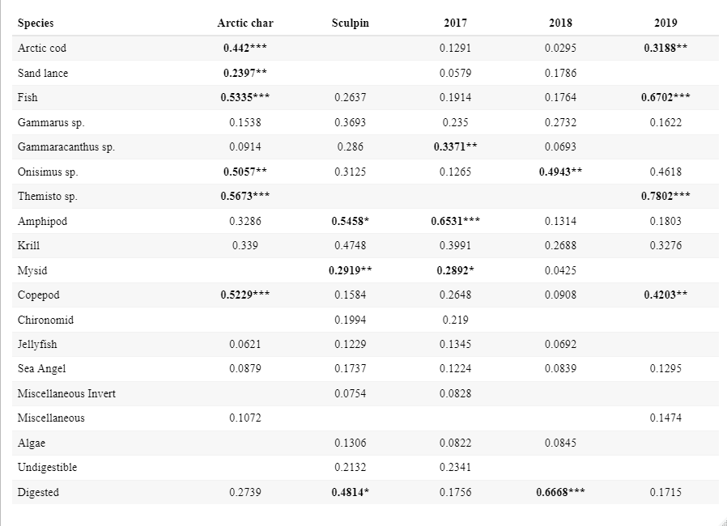

***p<0.001 **0.001<p<0.01 *0.01<p<0.05

**Table 3.** Generalized linear model (GLM) with model weight > 0.10 determined via all subsets regression. AICc: Akaike’s information criterion adjusted for small sample size; Wi: Akaike weight. The response variables and best-fit models are presented in **bold**. Additional models for a given response variable fall below the best-fit model, and the response variable is not shown.

|  |  |  |  |  |
| --- | --- | --- | --- | --- |
| Response | Model | loglik | AICc | Wi |
| **Food in Stomach (0 or 1)** | **Species** | **-36.188** | **76.5** | **0.473** |
| Species + Year | -35.982 | 78.2 | 0.203 |
| Species + Month | -35.132 | 78.6 | 0.164 |
| **Relative Consumption** | **Species + Year** | **-222.535** | **453.4** | **0.582** |
| Species | -224.346 | 454.9 | 0.279 |

# Figure Legends

Figure 1. Frequency of Occurrence for diet categories for both Arctic char (blue) and Sculpin (yellow). Silhouettes indicate the general appearance of the diet item, note that all amphipod categories are covered under the same silhouette despite differences in genera. Dotted vertical lines separate rough groupings of diet items (from left to right): Fish, Amphipods, Zooplankton/Invertebrates, Miscellaneous.

Figure 2. Non-metric multidimensional scaling (NMDS) ordination of predator diet compositions simplifying a 3-dimensional ordination to 2-dimensions. Points, which represent an individual, and convex hulls are group by species (Arctic char in blue; Sculpin in yellow) and year (2017 circle points and solid line; 2018 square points and dashed line; 2019 diamond points and dotted line). The group (species and year) centroids are indicated with a red point color and shape coded in the same manner. Black lines and prey items indicate the impact of that item on diet ordination position.

Figure 3. Boxplots of relative consumption (percent body weight consumed) between years for Arctic char and sculpin. Each dot represents an individual stomach, with open circles marking empty stomachs. Midlines indicate median values, hinges indicate the first and third (25th and 75th) percentiles, and whiskers extend to 1.5-times the interquartile range from each hinge.

Figure 4. Yearly prey accumulation curves for Arctic char and sculpin. The dashed line indicates a cumulative curve without discriminating between years. Circles mark random samples along the curve.

Figure 5. Distance (a) between centroids of different groups and (b) between individuals to the centroid within a group. Groups are a combination of predator taxa (Arctic char and Sculpins) and year (2017, 2018, and 2019). In (a), cells include both the distance value and are color coded according to that value. Fully black cells are those between the same groups and represent a distance of 0. Black outlines highlight cells which are between the same predator taxa across years, red outlines highlight cells comparing predator taxa within the same year.

# Figures

Figure 1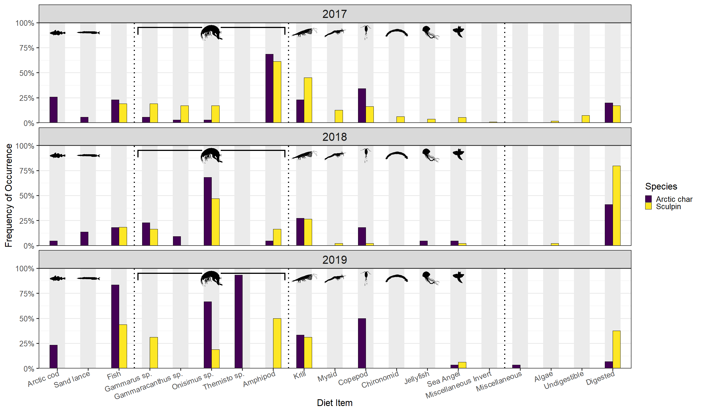

Figure 2

Figure 3



Figure 4



Figure 5

a

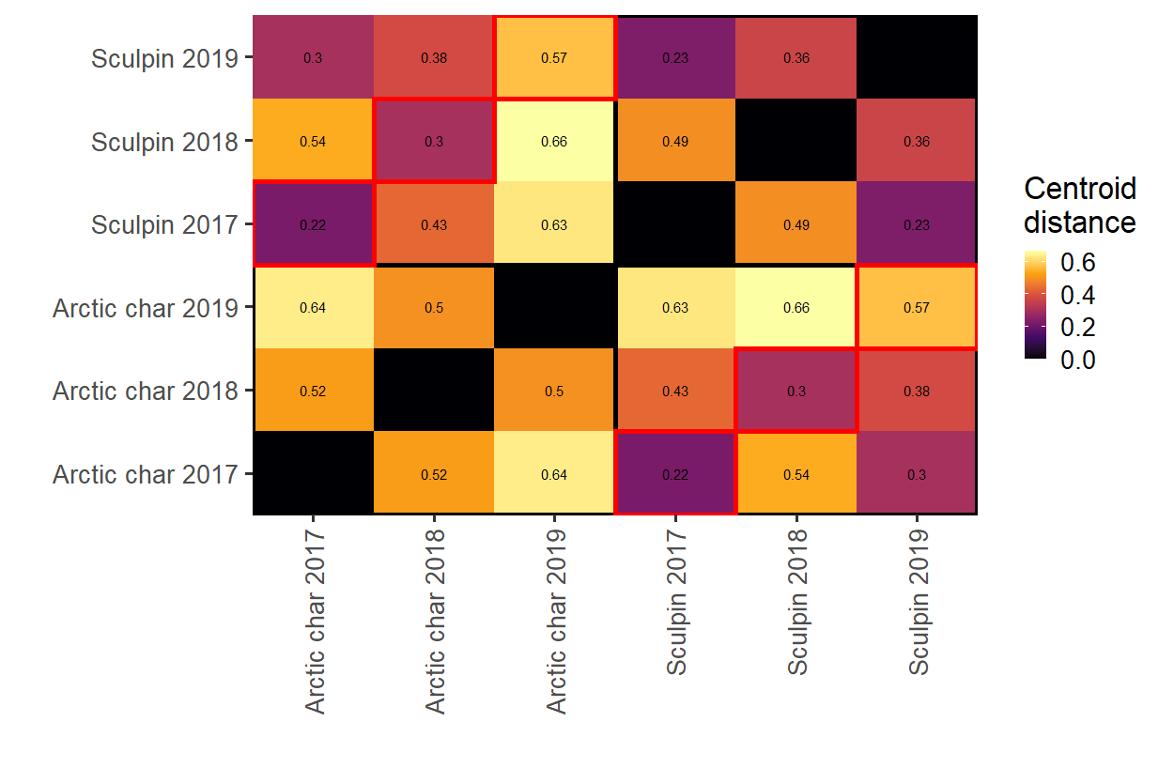

b

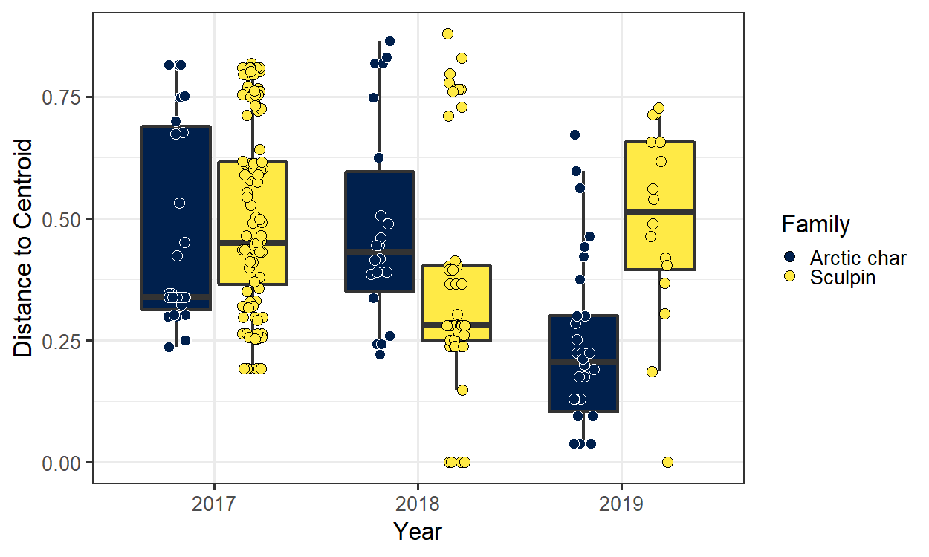

# References

AMAP. 2017. Snow, Water, Ice and Permafrost in the Arctic (SWIPA) 2017. *In* Arctic Monitoring and Assessment Programme (AMAP). Oslo, Norway. doi:10.1029/2002WR001512.

Amundsen, P.A., Gabler, H.M., and Staldvik, F.J. 1996. A new approach to graphical analysis of feeding strategy from stomach contents data—modification of the Costello (1990) method. J. Fish Biol. **48**(4): 607–614. doi:10.1006/jfbi.1996.0060.

Amundsen, P.A., and Sánchez-Hernández, J. 2019. Feeding studies take guts – critical review and recommendations of methods for stomach contents analysis in fish. J. Fish Biol. (95): 1364–1373. doi:10.1111/jfb.14151.

Armstrong, J.B., and Bond, M.H. 2013. Phenotype flexibility in wild fish: Dolly Varden regulate assimilative capacity to capitalize on annual pulsed subsidies. J. Anim. Ecol. **82**(5): 966–975. doi:10.1111/1365-2656.12066.

Armstrong, J.B., and Schindler, D.E. 2011. Excess digestive capacity in predators reflects a life of feast and famine. Nature **476**: 84–88. doi:10.1038/nature10240.

Armstrong, J.B., Schindler, D.E., Ruff, C.P., Brooks, G.T., Bentley, K.E., and Torgersen, C.E. 2013. Diel horizontal migration in streams: Juvenile fish exploit spatial heterogeneity in thermal and trophic resources. Ecology **94**(9): 2066–2075. doi:10.1890/12-1200.1.

Arrington, D.A., Winemiller, K.O., Loftus, W.F., and Akin, S. 2002. How Often Do Fishes “Run on Empty”? Ecology **83**(8): 2145–2151. Ecological Society of America. doi:10.2307/3072046.

Balakirev, E.S., Kravchenko, A.Yu., and Semenchenko, A.A. 2020. Genetic Evidence for a Mixed Composition of the Genus Myoxocephalus (Cottoidei: Cottidae) Necessitates Generic Realignment. Genes **11**(9): 1071–1085.

Bartoń, K. 2020. MuMIn: Multi-Model Inference. Available from https://cran.r-project.org/web/packages/MuMIn/MuMIn.pdf.

Barton, M.B., Vollenweider, J.J., Heintz, R.A., Norcross, B.L., and Boswell, K.M. 2020. Spatiotemporal variation of environmental conditions and prey availability that drive Arctic nearshore fish community structure in the Point Barrow, Alaska, region. Can. J. Fish. Aquat. Sci. **77**: 1612–1624. doi:dx.doi.org/10.1139/cjfas-2019-0068.

Baumgartner, M.F., and Tarrant, A.M. 2017. The Physiology and Ecology of Diapause in Marine Copepods. Annu. Rev. Mar. Sci. **9**(1): 387–411. doi:10.1146/annurev-marine-010816-060505.

Beddow, T.A., Deary, C., and McKinley, R.S. 1998. Migratory and reproductive activity of radio-tagged Arctic char (*Salvelinus alpinus* L.) in northern Labrador. *In* Advances in Invertebrates and Fish Telemetry. *Edited by* J.-P. Lagardère, M.-L.B. Anras, and G. Claireaux. Springer Netherlands, Dordrecht. pp. 249–262. doi:10.1007/978-94-011-5090-3_29.

Berge, J., Renaud, P.E., Darnis, G., Cottier, F., Last, K., Gabrielsen, T.M., Johnsen, G., Seuthe, L., Weslawski, J.M., Leu, E., Moline, M., Nahrgang, J., Søreide, J.E., Varpe, Ø., Lønne, O.J., Daase, M., and Falk-Petersen, S. 2015. In the dark: A review of ecosystem processes during the Arctic polar night. Prog. Oceanogr. **139**: 258–271. doi:10.1016/j.pocean.2015.08.005.

Biro, P.A., Morton, A.E., Post, J.R., and Parkinson, E.A. 2004. Over-winter lipid depletion and mortality of age-0 rainbow trout (*Oncorhynchus mykiss*). Can. J. Fish. Aquat. Sci. **61**(8): 1513–1519. doi:10.1139/F04-083.

Bolker, B.M., Brooks, M.E., Clark, C.J., Geange, S.W., Poulsen, J.R., Stevens, M.H.H., and White, J.S.S. 2009. Generalized linear mixed models: a practical guide for ecology and evolution. Trends Ecol. Evol. **24**(3): 127–135. doi:10.1016/j.tree.2008.10.008.

Bolnick, D.I., Yang, L.H., Fordyce, J.A., Davis, J.M., and Svanbäck, R. 2002. Measuring Individual-Level Resource Specialization. Ecology **83**(10): 2936–2941. doi:10.1890/0012-9658(2002)083[2936:MILRS]2.0.CO;2.

Booth, S., and Watts, P. 2007. Canada’s Arctic Marine Fish Catches. *In* Reconstruction of marine fisheries catches for key countries and regions (1950-2005)., 2nd edition. *Edited by* D. Zeller and D. Pauly. Fisheries Centre, University of British Columbia. pp. 3–15.

Breen, M.J., Ruetz, C.R., Thompson, K.J., and Kohler, S.L. 2009. Movements of mottled sculpins (*Cottus bairdii*) in a Michigan stream: How restricted are they? Can. J. Fish. Aquat. Sci. **66**(1): 31–41. doi:10.1139/F08-189.

Cant, J.P., McBride, B.W., and Croom, W.J. 1996. The Regulation of Intestinal Metabolism and Its Impact on Whole Animal Energetics. J. Anim. Sci. **74**(10): 2541–2553. doi:10.2527/1996.74102541x.

Clark, T.D., Sandblom, E., and Jutfelt, F. 2013. Aerobic scope measurements of fishes in an era of climate change: Respirometry, relevance and recommendations. J. Exp. Biol. **216**(15): 2771–2782. doi:10.1242/jeb.084251.

Dai, A., Luo, D., Song, M., and Liu, J. 2019. Arctic amplification is caused by sea-ice loss under increasing CO2. Nat. Commun. **10**(1): 121. doi:10.1038/s41467-018-07954-9.

David, C., Lange, B., Rabe, B., and Flores, H. 2015. Community structure of under-ice fauna in the Eurasian central Arctic Ocean in relation to environmental properties of sea-ice habitats. Mar. Ecol. Prog. Ser. **522**: 15–32. doi:10.3354/meps11156.

Descamps, S., Ramírez, F., Benjaminsen, S., Anker‐Nilssen, T., Barrett, R.T., Burr, Z., Christensen‐Dalsgaard, S., Erikstad, K., Irons, D.B., Lorentsen, S., Mallory, M.L., Robertson, G.J., Reiertsen, T.K., Strøm, H., Varpe, Ø., and Lavergne, S. 2019. Diverging phenological responses of Arctic seabirds to an earlier spring. Glob. Change Biol. **25**(12): 4081–4091. doi:10.1111/gcb.14780.

Durbin, E.G., Durbin, A.G., Langton, R.W., and Bowman, A.E. 1983. Stomach contents of Silver hake, *Merluccius bilinearis*, and Atlantic cod, *Gadus morhua*, and estimation of their daily rations. Fish. Bull. **81**(3): 437–454.

Edwards, J.E., Hedges, K.J., Kessel, S.T., and Hussey, N.E. 2022. Multi-year acoustic tracking reveals transient movements, recurring hotspots, and apparent seasonality in the coastal-offshore presence of Greenland sharks (Somniosus microcephalus). Front. Mar. Sci. **9**: 902854. doi:10.3389/fmars.2022.902854.

Furey, N.B., Hinch, S.G., Mesa, M.G., and Beauchamp, D.A. 2016. Piscivorous fish exhibit temperature-influenced binge feeding during an annual prey pulse. J. Anim. Ecol. **85**(5): 1307–1317. doi:10.1111/1365-2656.12565.

Garvey, J.E., and Chipps, S.R. 2013. Diets and Energy Flow. *In* Fisheries Techniques, 3rd edition. *Edited by* A.V. Zale, D.L. Parrish, and T.M. Sutton. American Fisheries Society, Bethesda, USA. pp. 1–48.

Gerking, S.D. 1994. Feeding Ecology of Fish. Academic Press, Inc.

Giraldo, C., Stasko, A., Choy, E.S., Rosenberg, B., Majewski, A., Power, M., Swanson, H., Loseto, L., and Reist, J.D. 2016. Trophic variability of Arctic fishes in the Canadian Beaufort Sea: a fatty acids and stable isotopes approach. Polar Biol. **39**(7): 1267–1282. Springer Berlin Heidelberg. doi:10.1007/s00300-015-1851-4.

Hammer, L., Hussey, N., Marcoux, M., Pettitt-Wade, H., Hedges, K., Tallman, R., and Furey, N. 2022. Arctic char (Salvelinus alpinus) movement dynamics relative to ice breakup in a high Arctic embayment. Mar. Ecol. Prog. Ser. **682**: 221–236. doi:10.3354/meps13939.

Hanson, P., Johnson, T.B., Schindler, D.E., and Kitchell, J.F. 1997. Fish Bioenergetics 3.0. *In* University of Wisconsin-Madison Center for Limnology and and University of Wisconsin, Sea Grant Institute. Madison, WI.

Harwood, L.A., and Babaluk, J.A. 2014. Spawning, overwintering and summer feeding habitats used by anadromous Arctic char (*Salvelinus alpinus*) of the Hornaday River, Northwest Territories, Canada. Arctic **67**(4): 449–461. Arctic Institute of North America. doi:10.14430/arctic4422.

Harwood, L.A., Smith, T.G., and Auld, J.C. 2012. Fall Migration of Ringed Seals (*Phoca hispida*) through the Beaufort and Chukchi Seas, 2001–02. ARCTIC **65**(1): 35-44-35–44. doi:10.14430/arctic4163.

Heide-Jørgensen, M.M., Dietz, R.R., Laidre, K.K., and Richard, P.P. 2002. Autumn movements, home ranges, and winter density of narwhals (*Monodon monoceros*) tagged in Tremblay Sound, Baffin Island. Polar Biol. **25**(5): 331–341. doi:http://dx.doi.org.unh.idm.oclc.org/10.1007/s00300-001-0347-6.

Hermann, N.T. 2021. Seasonal feeding and movement responses of resident sculpin in the Canadian Arctic. University of New Hampshire.

Hermann, N.T., Chaloner, D.T., Gerig, B.S., and Lamberti, G.A. 2020. Ecological consequences of Great Lakes salmon subsidies for stream-resident brook and brown trout. Can. J. Fish. Aquat. Sci. **77**(11): 1758–1771. doi:10.1139/cjfas-2020-0086.

Hop, H., Mundy, C.J., Gosselin, M., Rossnagel, A.L., and Barber, D.G. 2011. Zooplankton boom and ice amphipod bust below melting sea ice in the Amundsen Gulf, Arctic Canada. Polar Biol. **34**(12): 1947–1958. doi:10.1007/s00300-011-0991-4.

Jensen, J.L.A., and Rikardsen, A.H. 2008. Do northern riverine anadromous Arctic charr Salvelinus alpinus and sea trout Salmo trutta overwinter in estuarine and marine waters? J. Fish Biol. **73**(7): 1810–1818. doi:10.1111/j.1095-8649.2008.02042.x.

Ji, R., Jin, M., and Varpe, Ø. 2013. Sea ice phenology and timing of primary production pulses in the Arctic Ocean. Glob. Change Biol. **19**(3): 734–741. doi:https://doi.org/10.1111/gcb.12074.

Johannessen, O.M., Bengtsson, L., Miles, M.W., Kuzmina, S.I., Semenov, V.A., Alekseev, G.V., Nagurnyi, A.P., Zakharov, V.F., Bobylev, L.P., Pettersson, L.H., Hasselmann, K., and Cattle, H.P. 2004. Arctic climate change: observed and modelled temperature and sea-ice variability. Tellus A **56**(4): 328–341. doi:10.1111/j.1600-0870.2004.00060.x.

Kindt, R. 2023. BiodiversityR: Package for Community Ecology and Suitability Analysis. Available from https://cran.r-project.org/web/packages/BiodiversityR/BiodiversityR.pdf [accessed 5 July 2023].

Lameris, T.K., Scholten, I., Bauer, S., Cobben, M.M.P., Ens, B.J., and Nolet, B.A. 2017. Potential for an Arctic-breeding migratory bird to adjust spring migration phenology to Arctic amplification. Glob. Change Biol. **23**(10): 4058–4067. doi:10.1111/gcb.13684.

Landry, J.J., Fisk, A.T., Yurkowski, D.J., Hussey, N.E., Dick, T., Crawford, R.E., and Kessel, S.T. 2018. Feeding ecology of a common benthic fish, shorthorn sculpin (*Myoxocephalus scorpius*) in the high arctic. Polar Biol. **41**(10): 2091–2102. doi:10.1007/s00300-018-2348-8.

Landry, J.J., Kessel, S.T., McLean, M.F., Ivanova, S.V., Hussey, N.E., O’neill, C., Vagle, S., Dick, T.A., and Fisk, A.T. 2019. Movement types of an arctic benthic fish, shorthorn sculpin (*Myoxocephalus scorpius*), during open-water periods in response to biotic and abiotic factors. Can. J. Fish. Aquat. Sci. **76**(4): 626–635. doi:10.1139/cjfas-2017-0389.

McMeans, B.C., McCann, K.S., Humphries, M., Rooney, N., and Fisk, A.T. 2015. Food Web Structure in Temporally-Forced Ecosystems. Trends Ecol. Evol. **30**(11): 662–672. Elsevier Ltd. doi:10.1016/j.tree.2015.09.001.

McWilliams, S.R., and Karasov, W.H. 2014. Spare capacity and phenotypic flexibility in the digestive system of a migratory bird: Defining the limits of animal design. Proc. R. Soc. B Biol. Sci. **281**(1783): 1–9. doi:10.1098/rspb.2014.0308.

Melnikov, A. 1997. Arctic Sea Ice Ecosystem. Gordon and Breach, Amsterdam.

Mesa, M.G., Weiland, L.K., Christiansen, H.E., Sauter, S.T., and Beauchamp, D.A. 2013. Development and evaluation of a bioenergetics model for Bull Trout. Trans. Am. Fish. Soc. **142**(1): 41–49. doi:10.1080/00028487.2012.720628.

Moore, I.A., and Moore, J.W. 1974. Food of Shorthorn Sculpin, *Myoxocephalus scorpius*, in the Cumberland Sound Area of Baffin Island. J. Fish. Res. Board Can. **31**(3): 355–359.

Moore, J.-S., Harris, L.N., Le Luyer, J., Sutherland, B.J.G., Rougemont, Q., Tallman, R.F., Fisk, A.T., and Bernatchez, L. 2017. Genomics and telemetry suggest a role for migration harshness in determining overwintering habitat choice, but not gene flow, in anadromous Arctic Char. Mol. Ecol. **26**(24): 6784–6800. doi:10.1111/mec.14393.

Moss, J.H.H. 2001. Development and Application of a Bioenergetics Model for Lake Washington Prickly Sculpin (Cottus asper). Master of Science, University of Washington.

Norin, T., and Clark, T.D. 2017. Fish face a trade-off between ‘eating big’ for growth efficiency and ‘eating small’ to retain aerobic capacity. Biol. Lett. **13**(9): 3–6. doi:10.1098/rsbl.2017.0298.

Piersma, T., and van Gils, J.A. 2011. The Flexible Phenotype: A Body-Centered Integration of Ecology, Physiology, and Behavior. Oxford University Press, Oxford, UK.

R Core Team. 2020. R: A Language and Environment for Statistical Computing. R Foundation for Statistical Computing, Vienna, Austria. Available from https://www.R-project.org.

Ricker, W.E. 1975. Computation and Interpretation of Biological Statistics of Fish Populations. Environment Canada.

Scharf, F., Juanes, F., and Rountree, R. 2000. Predator size-prey size relationships of marine fish predators: interspecific variation and effects of ontogeny and body size on trophic-niche breadth. Mar. Ecol. Prog. Ser. **208**: 229–248. doi:10.3354/meps208229.

Søreide, J.E., Leu, E., Berge, J., Graeve, M., and Falk‐Petersen, S. 2010. Timing of blooms, algal food quality and *Calanus glacialis* reproduction and growth in a changing Arctic. Glob. Change Biol. **16**(11): 3154–3163. doi:10.1111/j.1365-2486.2010.02175.x.

Stroeve, J., Holland, M.M., Meier, W., Scambos, T., and Serreze, M. 2007. Arctic sea ice decline: Faster than forecast. Geophys. Res. Lett. **34**(9). doi:10.1029/2007GL029703.

Tamburello, N., Côté, I.M., and Dulvy, N.K. 2015. Energy and the Scaling of Animal Space Use. Am. Nat. **186**(2): 196–211. doi:10.1086/682070.

Urban, M.C. 2007. The Growth-Predation Risk Trade-Off under a Growing Gape-Limited Predation Threat. Ecology **88**(10): 2587–2597. Ecological Society of America.

Wickham, H. 2016. ggplot2: Elegant Graphics for Data Analysis. Springer-Verlag New York. Available from https://ggplot2.tidyverse.org.

Wilson, S.M., Hinch, S.G., Eliason, E.J., Farrell, A.P., and Cooke, S.J. 2013. Calibrating acoustic acceleration transmitters for estimating energy use by wild adult Pacific salmon. Comp. Biochem. Physiol. A. Mol. Integr. Physiol. **164**(3): 491–498. doi:10.1016/j.cbpa.2012.12.002.

Yang, L.H., Bastow, J.L., Spence, K.O., and Wright, A.N. 2008. What Can We Learn from Resource Pulses? Ecology **89**(3): 621–634.