**Title Lars: Comparing the feeding strategies of two divergent(?) Arctic fish**

**Title Nate: Diets from two Arctic fishes reflect life history strategies**

**Introduction: Nate**

* The Arctic is a highly seasonal environment, so organisms have adapted to the strong contrast between summer (light, warm, no-ice, productive) and winter (dark, cold, ice, unproductive)
* Migratory species arrive to exploit the pulse of productivity that comes in the summer, resident species are present in those environments always and also exploit the pulse
* Pelagic fishes are mobile and must maintain aerobic capacity for mobility. Migration requires substantial mobility but also energy reserves. Benthic fishes are less mobile and can often lie-and-wait for feeding opportunities. Residents require energy reserves to endure winter, but do not burn them with much activity
* Diet analyses can reveal a snapshot of the recent activity of an individual. The magnitude of feeding, best estimated with relative consumption, can be a proxy for both how much energy gain the fish will experience (thanks to bioenergetics where G is whatever is left from C-M-Ex-Eg) and the aerobic investment to digestion that individual is undertaking. Diet composition shows what a species CAN eat and what they DO eat.
* Arctic char are mobile, demersal, “big,” migratory fish. Sculpin are immobile, benthic, “small,” resident fish. They live in the same area, but they are very different. RQ: Are the diets of fishes with contrasting life histories also very different?
* Hypotheses: Sculpin will eat more (higher relative consumption) than char. Char will consume more types of prey items, but be more “selective” than sculpin.

**Methods**

* **Sampling at Tremblay**: Fyke net deployed from (dates) in 2017, 2018, and 2019 checked at each low tide. Gillnet deployed (dates) and any fish that hit were immediately removed from the net. Diets were collected after euthanasia, then frozen and picked under a dissecting scope at a later date in 2018 and 2019 or picked without a scope at the site in 2017
* **Data processing**: Diet items were categorized as well as possible to be consistent across years. WAS THERE ANY FILTERING??
* **Frequency of Occurrence**: The number of diets with a prey item/number of diets analyzed
* **Prey Accumulation Curve**: Constructed for each species in each year (a sampling event) as well as combining each of the three years together. Used the *accumcomp* function to do many orders of diet collections to get mean number of diet items for each number of diets that were collected.
* **GLM Analyses**: Hurdle model, binomial for empty/not empty and then Gamma for the not empty to see differences in magnitude of relative consumption. Covariates are species (Arctic char and Sculpin) and year (2017, 2018, and 2019)
* **NMDS and Indicator Species Analysis**: Distance matrix created using Bray-Curtis distance, 250 random starts for axes 1-6 with *metaMDS* function then selecting the best based on being <20 stress and not dropping >5 to have an additional axis. Selected ordination is then visualized with *ggplot2* and each point is labeled according to species (Arctic char and Sculpin) and year (2017, 2018, and 2019) with convex hulls built around those points
* **Results/Figures**

Table 1. Summary of Arctic char and Sculpin from which stomachs were collected. Metrics of condition are hepatosomatic index (HSI), gonadosomatic index (GSI), and Fulton’s K. Values shown are mean (±SE).

|  |  |  |  |  |  |  |
| --- | --- | --- | --- | --- | --- | --- |
| **Species** | **N** | **Mass**  **(g)** | **TL**  **(cm)** | **HSI** | **GSI** | **Fulton’s K** |
| **Arctic char** | 91 | 2609.25 (±156.6) | 62.18 (±1.6) | 2.07 (±0.04) | 0.42 (±0.04) | 914.1 (±18.5) |
| **Sculpin** | 190 | 78.91 (±5.0) | 18.54 (±0.39) | 3.63 (±0.15) | 3.75 (±0.2) | 1062.18 (±41.5) |

Table 2. Results from indicator species analysis indicating associations between diet items and the species (Arctic char or Sculpin) or year (2017, 2018, or 2019) consuming. Significant associations for the prey species (row) with the predator species or year (column) are denoted in bold. Missing values indicate that diet item was not consumed by/during that species/year.

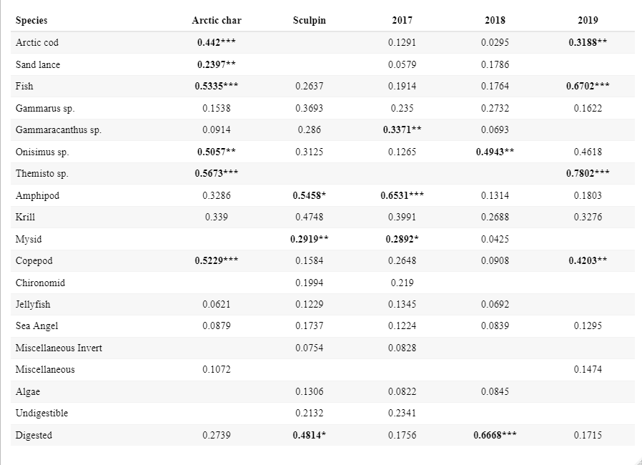

***p<0.001 **0.001<p<0.01 *0.01<p<0.05

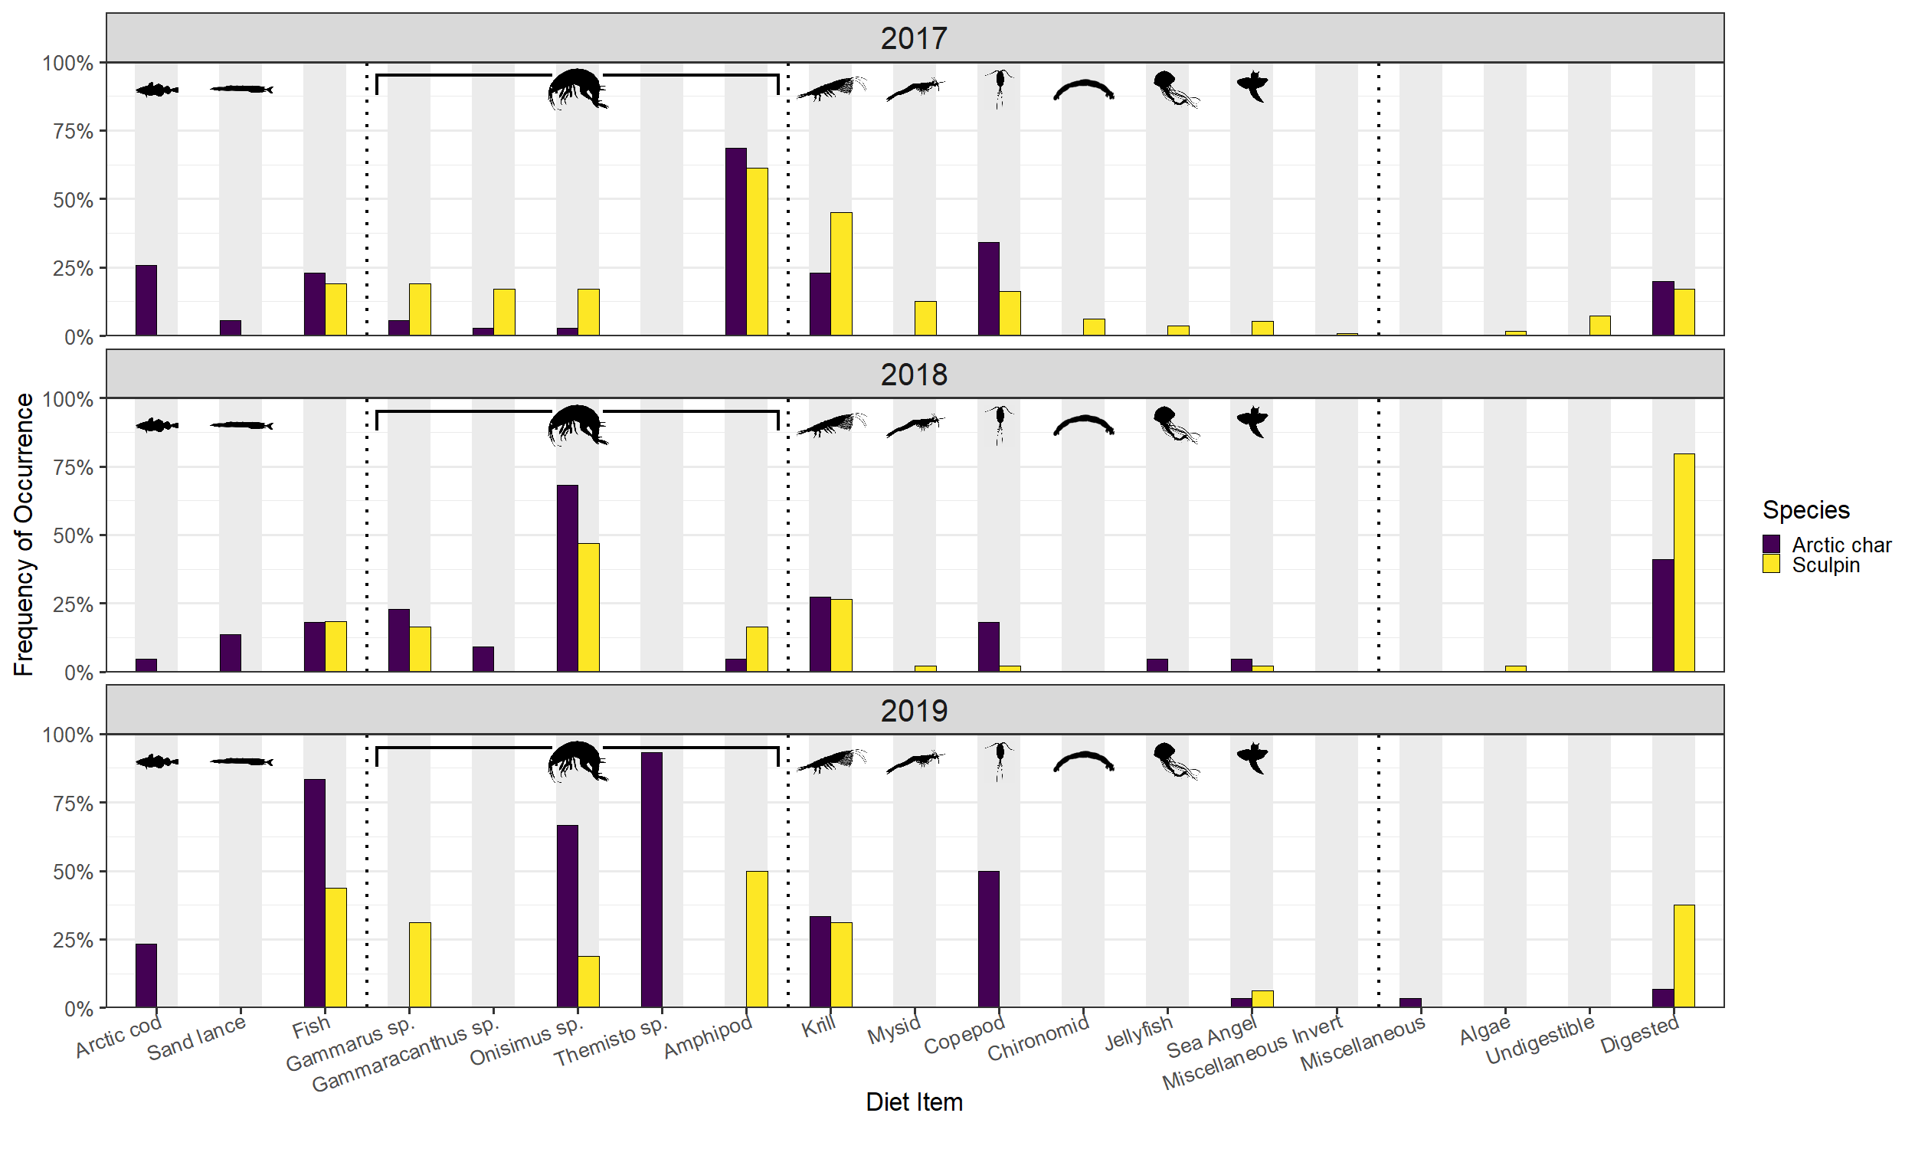Figure 1. Frequency of Occurrence for diet categories for both Arctic char (blue) and Sculpin (yellow). Silhouettes represent characteristic of the diet item, note that all amphipod categories are covered under the same silhouette. Dotted vertical lines separate rough groupings of diet items (from left to right): Fish, Amphipod, Zooplankton/Invertebrates, Miscellaneous.

Figure 2. Non-metric multidimensional scaling (NMDS) ordination of predator diet compositions simplifying a 3-dimensional ordination to 2-dimensions. Points, which represent an individual, and convex hulls are group by species (Arctic char in blue; Sculpin in yellow) and year (2017 circle points and solid line; 2018 square points and dashed line; 2019 diamond points and dotted line). The group (species and year) centroids are indicated with a red point color and shape coded in the same manner. Black lines and prey items indicate the impact of that item on diet ordination position.

* Both species are exploiting the resource pulse at high rates compared to available literature
* Sculpin eat relatively more than char
* Char exhibit more interannual variability



Figure 3. Boxplots of relative consumption (percent body weight consumed) between years for Arctic char and sculpin. Each dot represents an individual stomach. Midlines indicate median values, hinges indicate the first and third (25th and 75th) percentiles, and whiskers extend to 1.5-times the interquartile range from each hinge.

* Both species seem to be settling around 15 prey items
* We probably did a decent job sampling describing the prey items that both species eat (particularly sculpin in 2017)



Figure 4. Yearly prey accumulation curves for Arctic char and sculpin. The dashed line indicates a cumulative curve without discriminating between years. Circles mark random samples along the curve.

**Discussion: Lars**

* Importance of prey pulse/ice melt to both char and sculpin (high feeding rates/lack of empty stomachs/similar diet items (in general)
* Differences in mobility impact feeding rates and diet items – char are able to move to different areas/actively chase prey, while sculpin are lie in wait predators
* Migrant vs resident (could be intertwined with above or separate) - char need to be able to return to fresh water in the fall and must remain “athletic” so they can’t consume relatively as much as sculpin
* Body size impacts diet items – char are able to eat larger fish prey items
* Interannual variability (the main focus of this paper should be on char vs sculpin not yearly differences, so I’m not sure if a full discussion paragraph is warranted
* Anything else?