**HW3:**

**The Hiring Problem**

We want to know the expected cost of our hiring algorithm in terms of how many times we hire an applicant elementary event s is a sequence of the n applicants

Assume uniform distribution so each sequence is equally likely ie. Has probability n!

Random variable x(s) is the number of applicants that get hired given input sequence arr[size],

What Expectation should we get?

So we break down the problem using indicator random variables, dummy and properties of expectation in probability.

Change viewpoint: instead of one random variable that counts how many applicants are hired consider n random variables each one keeping track if a particular applicant is hired. Particular applicants is hired indicator random variable is 1 , if not then 0.

In our logic, we assume that each interview hypothetically lets say costs 0.001NTD and each hiring 5 NTD.

Therefore we distribute the number of cases as such:

100， 1000 interviewee:

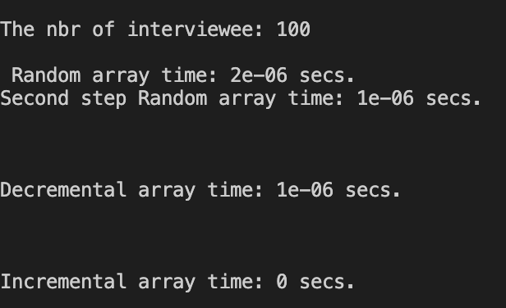

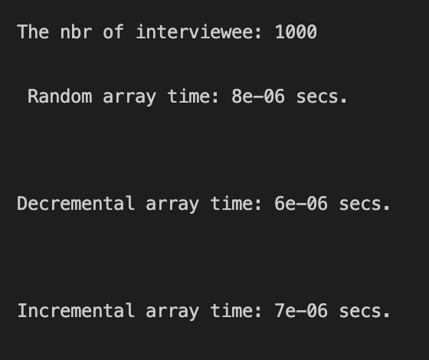

10000 interviewee:

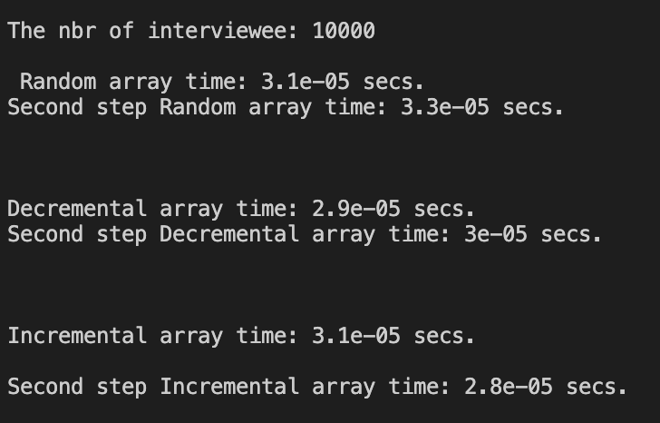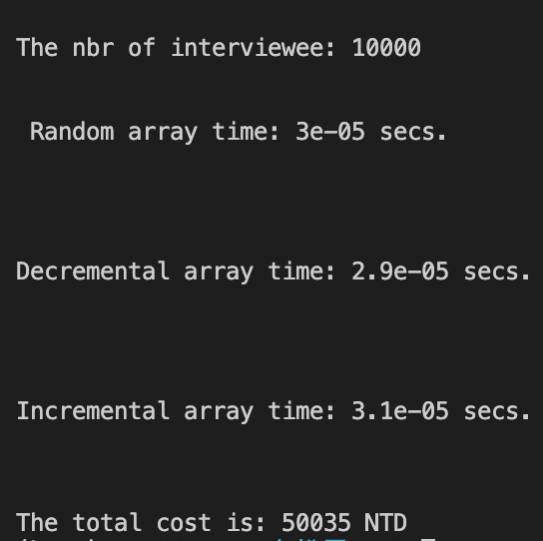

100000 interviewee：

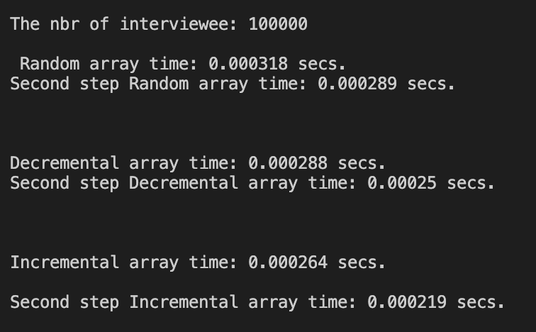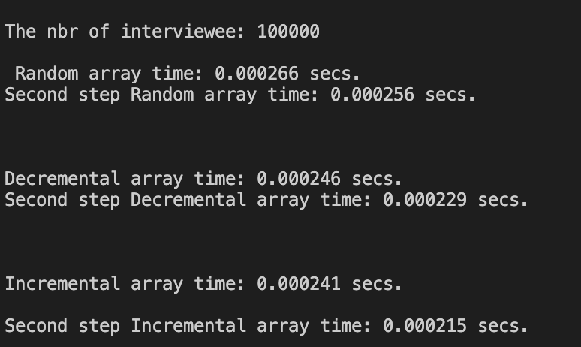:

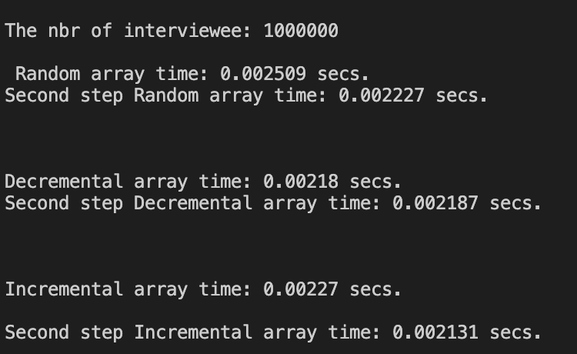1000000 interviewee:

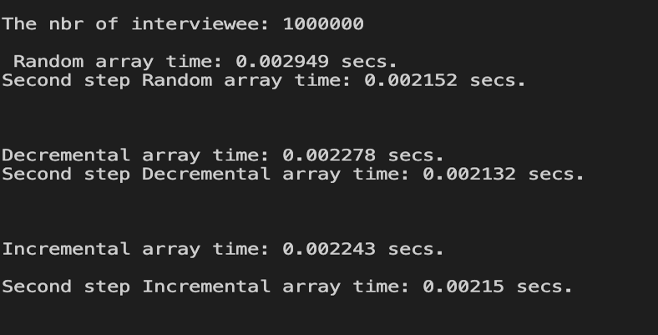

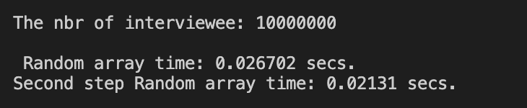One million

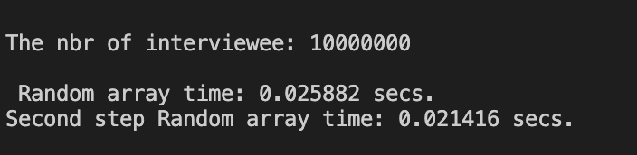

* For the detail of the problem statement we refer to the textbook.

The following procedure specifies the hiring strategy:

**HIRE_ ASSISTANT(n)**

1. Best=0
2. For i=1 to n
3. Interview candidate i
4. If candidate i is better than the candidate best
5. Best=1
6. Hire candidate i

The hiring cost is determined by the number of execution of line 6.

The worst occurs if the candidate come in strictly increasing order of duality

The best occurs if candidate I is the best.

But for the average cost:

If the candidate comes in random order, then by checking all possible n! permutations, we can obtain the average-cost. However we are not sure whether those candidates (from the agency)

Are presented to us in a random order. Therefore prefer to randomly permute these candidates before we apply the hiring Assistant(n) procedure.

With the hiring problem as a motivating example, we wish to convey the following two concepts in Algorithms.

* By enforcing a random permutation, we take control of the process the averaged cost obtained in this way is called the expected cost, which equals the average case cost, which equals the average-case cost.
* The random permutation can be done with a random number generation An algorithm whose behavior is determined in part by a random number generator is called a randomized algorithm.
* To analyze the average-case cost, especially when n is large the notion of indicator random variable is very helpful.

5.2 Indicator Random Variable

For a given probability space with an event A, we define

I(A)={1if a occurs0if a does not occurs

Indicator random variable is often used when computing the expected value at a random variable.

**SUMMARY:**

The hiring cost algorithm is a very important and popular algorithm which helps us to later deeper merge into the probably theories of all sort whose solution also strongly requires algorithms. For this assignment we also attached our cop file codes for further experiments by Tas.