
Commerce & Business Administration
Computing Studies and Information Systems
CSIS 2300 001 Winter 2023

Database I

ASSIGNMENT 4

Due Monday April 10, 2023 at 11:59 pm via Blackboard. Worth 5% of the course total and marked out of 10% in this assignment.

This assignment is based on the lecture and resources focused on Data Visualization.

Part 1:

Acquire an interesting statistical publication about COVID-19. It can be anything related to COVID-19 e.g. vaccinations, mental health cases, businesses affected by lockdowns, etc. Provide a link to, or a copy of, the statistical report. Please cite the source of the report in your submission. [2%]
Alternate topic and why you chose this topic. Write it in this box. Include link to, copy of, citation of report.

My topic of choice is ethnic diversity in Vancouver. I was inspired to choose this topic due to my personal experience upon arriving in Canada, particularly Vancouver. The level of diversity I encountered here surpassed what I had experienced in Los Angeles, and I believe that studying this topic could offer valuable insights into the social and cultural fabric of this city (and helped me answered my question who my neighbors are).

Vancouver's ethnic diversity is not only an important aspect of its identity but also a crucial factor in its economic and social growth. Understanding the population composition, and how various ethnic groups contribute to and interact within the community, can provide a better understanding of the challenges and opportunities that come with maintaining a harmonious and inclusive society.

By examining the ethnic diversity in Vancouver, we can also identify areas where policies and initiatives might be needed to ensure that all residents have equal access to resources, opportunities, and representation. This topic is relevant not only to Vancouver but also to cities worldwide, as they continue to grapple with the impacts of globalization and migration.

I am confident that exploring the ethnic diversity in Vancouver will yield valuable insights and contribute to our understanding of multiculturalism in urban centers. For example, from the statistics, I discovered that 51% of visible minorities population has Chinese origin. With this sizable portion of the population, the Chinese-origin community can contribute significantly to Vancouver's economy. Understanding their needs, preferences, and business activities can help drive targeted economic development and foster innovation. In learning this fact, I am also more motivated to continue learning Chinese again to widen my worldview and create more connections.

Citation: Statistics Canada. Table 98-10-0337-01 Visible minority by ethnic or cultural origin: Canada, provinces and territories, census metropolitan areas and census agglomerations with parts. https://www150.statcan.gc.ca/t1/tbl1/en/tv.action?pid=9810033701

Part 2:

State clearly in the box below,
- Who are your target audience?
- What is the message that you want your audience to walk away with? [3%]
For example, younger people below thirty in the community need to be incentivized to get vaccinated as the rate of vaccination in this community is very low. Your audience would be their parents, relatives, teachers, and their health care providers.

Suggestion. The more focused and concise you are with your message, the clearer your message will be.
Target audience and the message that you want to get across to your audience. Write it here.

Target audience: Vancouver residents

Message: The city's multiculturalism adds colorful richness to its cultural, social, and economic fabric, making it a vibrant and exciting place to live. Residents can be proud of this diversity and celebrate the unique qualities that each community brings to the city.

More succinct message: Diversity is beautiful.

My process: I obtained the data from statcan and then used python to scale the dataset to 100 to make it easier for my audience to digest the data. In my visualization, I used a Tree map chart instead of the typical commonly used pie chart so that even the 1% population is represented. I used free stock graphic elements from Canva to decorate my chart, making it look more lively and culturally interesting.

Part 3:

Using real objects (e.g. lego bricks), or a hand-drawing, or computer drawing software create a visual that captures the essence of your message. Paste a digitalized copy of the image on this page below (see deliverables next page). [5%]

Please see the pdf or png file included in my folder for bigger resolution.
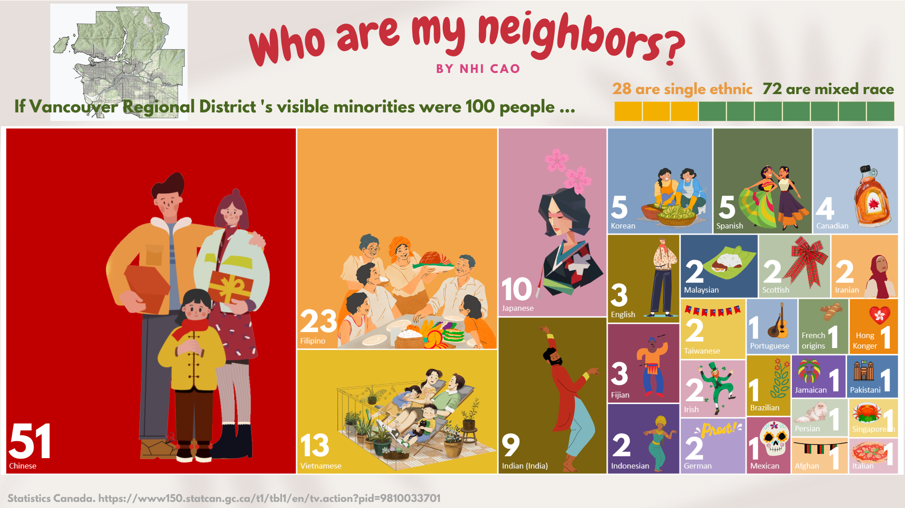

Part 1 Deliverables

- Provide a link to, or a copy of, the statistical report in the box above.
- Cite the source of your report.

Part 2 Deliverables

- State the target audience that you are delivering your message to.
- State the message you want to get across.
- Use the box provided above.

Part 3 Deliverables

- Paste a digital copy of your visual on page 3 above.
- Please remember to cite the sources of digital images you might obtain from the Internet even if used partially in your visual.
- If you use real world objects, please take a photo of your visual but please remember to place your student card somewhere obvious beside your objects but not where it might obstruct the view.

Overall Deliverables
- Submit a Microsoft WORD file together with a copy of your statistical report if you have one. No other format will be graded.
- Files without your name in the filename will have 1% deducted from your grade.
- Using my template WORD file (this file) is HIGHLY recommended.

Submit your file to Blackboard by due date and time with your name in the filename.
The chances of two students having similar reports are very low. You, I, and the other student will be taking a stroll to the Associate Dean’s office if your reports look similar. It’s the twelfth week. It’s not worth it. Advice: Don’t even look at your friend’s report.

Good luck!

End of document

