System Title: IoT-Based Smart Predictive Maintenance and Monitoring System for Air
Conditioning Units
Group Members: Eunice G. Lorenzo
Anthony Charles S. Monoy
Josephus Jay Pogoy
Rationale: Why This System Is Needed
Air conditioning units are essential in educational institutions like Caraga State University Cabadbaran Campus (CSUCC), especially in a tropical country like the Philippines where high temperatures and humidity persist year-round. These units operate continuously in classrooms, laboratories, and offices, making them critical to maintaining a comfortable and healthy learning environment.
However, the current maintenance approach at CSUCC—and in many Philippine educational institutions—relies on fixed, schedule-based cleaning (typically every few months), regardless of the actual condition of each unit. This creates several problems:
- Inefficient Maintenance Scheduling — Heavily used units in high-traffic areas may accumulate dust faster than less frequently used units, yet all units are cleaned on the same fixed schedule. This means some units receive unnecessary maintenance while others may already be overdue for cleaning.
- No Real-Time Visibility — Maintenance personnel must physically inspect each unit one by one to determine if cleaning is needed. There is no centralized system to monitor dust conditions across multiple units simultaneously.
- Delayed Problem Detection — Without continuous monitoring, serious dust accumulation is often discovered only after noticeable performance issues occur—such as reduced cooling efficiency, increased energy consumption, or even equipment damage.
- Manual Record-Keeping — Maintenance activities and inspection records are documented manually, making it difficult to track the maintenance history and condition of each unit over time.
The Problem It Solves
Research shows that excessive dust buildup inside HVAC systems restricts airflow, reduces cooling performance, and increases energy consumption. If left unmonitored, clogged filters can lead to overheating, poor indoor air quality, and unexpected equipment failure.
AirSense solves this by replacing time-based maintenance scheduling with condition-responsive, data-driven monitoring. Instead of cleaning units based on a calendar, maintenance personnel are alerted when dust levels actually reach critical thresholds—allowing them to respond precisely when and where maintenance is needed.
Who Benefits
- Maintenance Personnel — Gain real-time visibility of all monitored AC units, receive automated alerts when cleaning is needed, and have access to historical monitoring records for better decision-making. This reduces unnecessary physical inspections and allows them to prioritize units that genuinely need attention.
- CSUCC Administration and Facility Managers — Benefit from more efficient maintenance operations, reduced energy costs due to improved airflow efficiency, extended equipment lifespan, and centralized maintenance tracking that supports budgeting and planning.
- Students, Faculty, and Staff — Enjoy a more comfortable and healthier indoor environment, as properly maintained AC units provide better cooling and improved indoor air quality.
- The Broader Institution — The system demonstrates how IoT technology can be adopted within the university to modernize facility management, aligning with the growing trend of smart buildings and data-driven operations.

System Description
The AirSense system works as an integrated pipeline that moves data from a physical sensor near the AC unit all the way to a web-based dashboard that maintenance personnel can access remotely. Here's how it works, step by step:
1. Data Sensing (Hardware Layer)
A PMS5003 laser dust sensor is physically mounted near the air filter compartment of an air conditioning unit. This sensor continuously measures airborne particulate matter concentrations—specifically PM1.0, PM2.5, and PM10—in micrograms per cubic meter (μg/m³). It operates using laser light scattering: airborne particles pass through a chamber where they scatter light from an internal laser diode, and a photodiode analyzes the scattered light to determine particle concentration. The sensor is positioned so that its optical sensing path aligns with the airflow direction to ensure accurate detection of dust accumulation.
2. Data Processing (Processing Layer)
The ESP32 microcontroller receives the raw sensor data through UART (Universal Asynchronous Receiver-Transmitter) serial communication. The ESP32 then processes this data in several steps:
- Normalization — The raw PM2.5 concentration value is converted into a standardized dust level percentage (0% to 100%) using a linear mapping formula. This makes the data easier to interpret and classify.
- Noise Reduction — Minor fluctuations caused by environmental disturbances or signal noise are minimized using moving average filtering techniques to improve data stability.
- Classification — The dust level percentage is categorized into three operational levels:
  - Low (0–39%) — Normal operation; no action needed.
  - Moderate (40–79%) — Cautionary monitoring; dust is accumulating but not yet critical.
  - High (80–100%) — Critical alert triggered; cleaning or maintenance is required.
- Alert Decision Logic — A Boolean threshold function checks if the dust level meets or exceeds 80%. If yes, the system sets an alert flag to 1 (Alert ON); if below 80%, the flag remains 0 (Alert OFF).
3. Data Transmission and Cloud Storage (Cloud Layer)
Once processed, the ESP32 transmits the dust concentration readings, classification status, and alert flags to the Firebase Realtime Database through its built-in Wi-Fi module using HTTPS communication. Firebase serves as the centralized cloud storage, automatically synchronizing data across all connected devices in real time. This means:
- Every sensor reading is stored with a timestamp for historical tracking.
- Alert records are logged when dust levels reach critical thresholds.
- Maintenance logs (cleaning activities, service dates, technician notes) are also stored and linked to specific units.
4. Data Retrieval and Visualization (Presentation Layer)
The AirSense web dashboard—developed using HTML5, CSS3, and JavaScript—retrieves the stored data from Firebase using the Firebase JavaScript SDK. The dashboard displays:
- Real-Time Dust Level — Current dust percentage and classification status (Low / Moderate / High) for each monitored AC unit.
- Historical Analytics — Trend charts and graphs generated using Chart.js, showing dust accumulation patterns over time. This helps maintenance personnel identify units that are accumulating dust faster than others.
- Automated Alerts — When the dust level reaches or exceeds 80%, a red warning popup appears on the dashboard, notifying maintenance personnel that the unit requires immediate cleaning or servicing.
- Maintenance Logs — A centralized record of all maintenance activities, allowing staff to track when each unit was last cleaned and what was observed.
5. User Interaction and Response
Maintenance personnel can access the dashboard through any modern web browser (Google Chrome or Microsoft Edge) on university computers or devices—no specialized software installation is required. From the dashboard, they can:
- View real-time dust levels across all monitored units.
- Receive and acknowledge alert notifications.
- Review historical data and analytics to identify trends.
- Log maintenance activities (e.g., cleaning performed, date, unit identifier, dust level at time of service).
- Track the maintenance history of each AC unit over time.
6. Deployment and Accessibility
The entire system is deployed through Firebase Hosting, making the dashboard accessible online. Authorized users log in through Firebase Authentication (email and password) to ensure only maintenance personnel can access monitoring data and controls. The system is designed to operate continuously, with the ESP32 transmitting data at regular intervals, Firebase syncing in real time, and the dashboard updating automatically without requiring manual page refreshes.

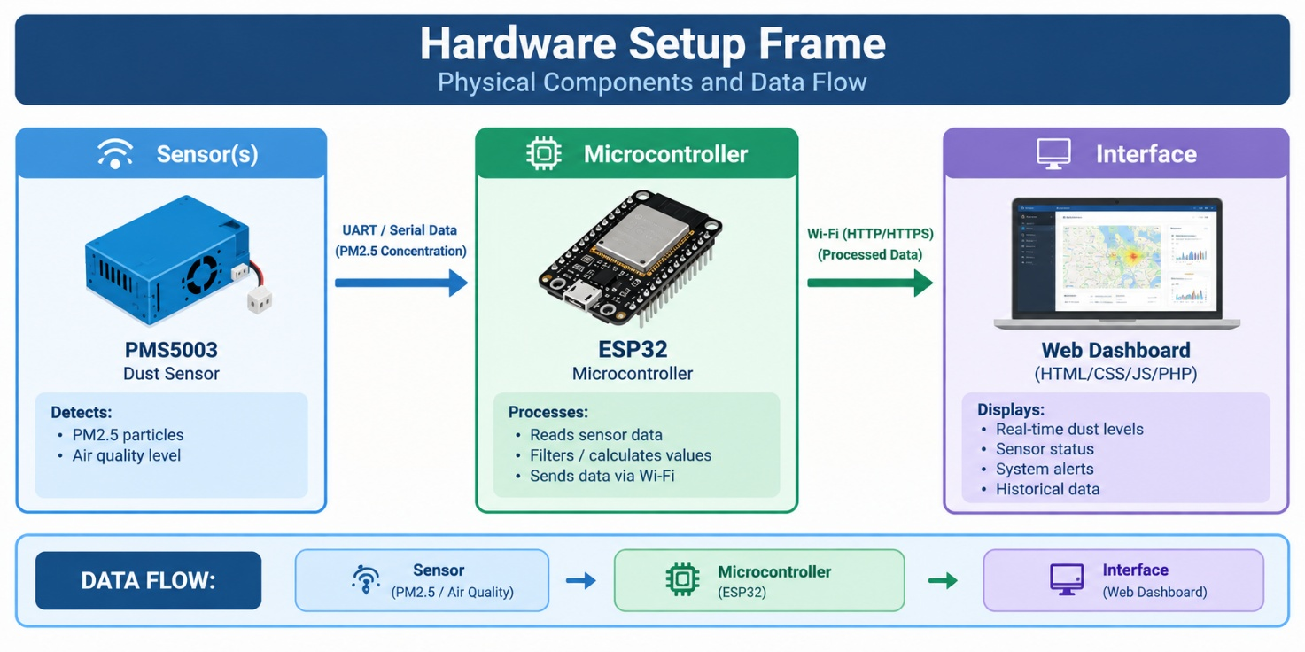
Hardware Components Used

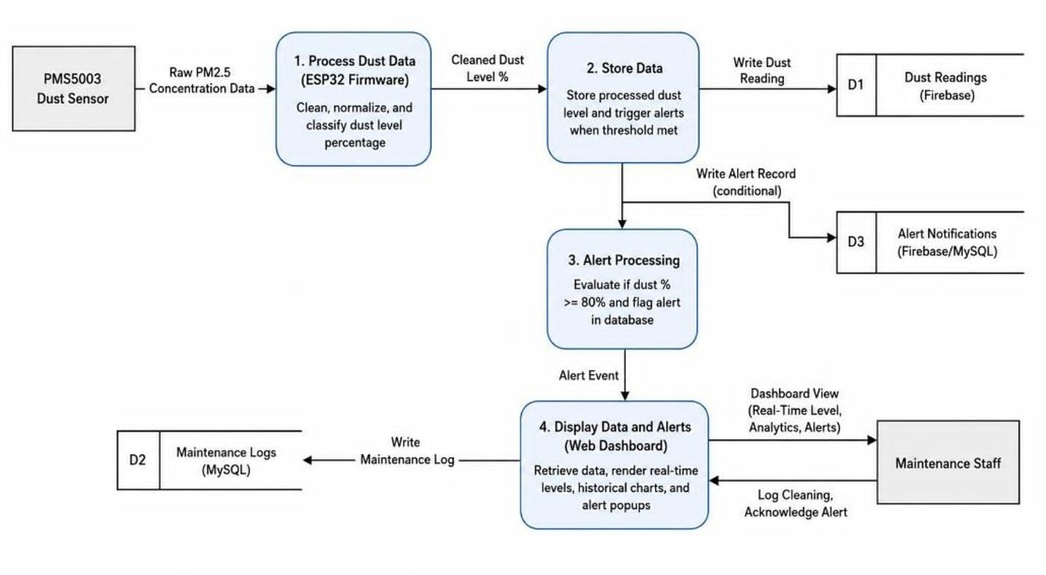

Component | Type | Specific Role
ESP32 Microcontroller | Microcontroller | Serves as the primary processing and communication unit. It receives dust concentration data from the PMS5003 sensor via UART, performs data preprocessing (normalization, noise reduction, classification), applies threshold-based alert logic, and transmits the processed data to the Firebase Realtime Database through its built-in Wi-Fi module. The ESP32 was selected over traditional microcontrollers like Arduino Uno because it includes native wireless communication features, reducing additional hardware requirements.
PMS5003 Dust Sensor | Sensor | A laser-based particulate matter sensor that detects PM1.0, PM2.5, and PM10 concentrations in the air. It operates using laser light scattering—airborne particles pass
Landing Page
