**1. Little Italy - Ẩm Thực Ý**

[10 Nguyễn Thái Học, P. Phú Hội,](https://www.foody.vn/hue/little-italy-am-thuc-y/nearBy) [Tp. Huế](https://www.foody.vn/hue/khu-vuc-tp-hue), Huế

**Đang mở cửa**  08:00 - 23:00

50.000đ - 200.000đ

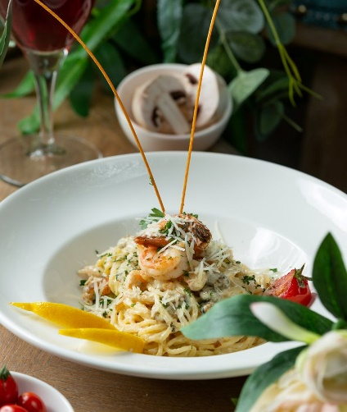

# 2. Kyodai Japanese Restaurant - Sushi & BBQ

[Số 1 Kiệt 66 Lê Lợi, P. Phú Hội,](https://www.foody.vn/hue/kyodai-japanese-restaurant-sushi-bbq/nearBy) [Tp. Huế](https://www.foody.vn/hue/khu-vuc-tp-hue), Huế

**Đang mở cửa**  09:00 - 13:30 | 16:00 - 22:00

10.000đ - 250.000đ

# 3. Liên Hoa Thư Quán - Món Chay

[3 Lê Quý Đôn ,](https://www.foody.vn/hue/lien-hoa-thu-quan-mon-chay/nearBy) [Tp. Huế](https://www.foody.vn/hue/khu-vuc-tp-hue), Huế

**Đang mở cửa**  07:00 - 22:00

15.000đ - 55.000đ

# 4. Seoul Restaurant

[1 Nguyễn Hữu Thọ, P. Xuân Phú,](https://www.foody.vn/hue/seoul-restaurant/nearBy) [Tp. Huế](https://www.foody.vn/hue/khu-vuc-tp-hue), Huế

**Đang mở cửa**  09:00 - 22:00

50.000đ - 200.000đ

# 5. Nhà Hàng Cơm Niêu Chạn

[01 Nguyễn Thái Học ,](https://www.foody.vn/hue/nha-hang-chan/nearBy) [Tp. Huế](https://www.foody.vn/hue/khu-vuc-tp-hue), Huế

**Đang mở cửa**  09:00 - 22:00

50.000đ - 250.000đ

# 6. Pao Lóu Restaurant - Ẩm Thực Hong Kong

[37 Nguyễn Thái Học,](https://www.foody.vn/hue/pao-lou-restaurant-am-thuc-hong-kong/nearBy) [Tp. Huế](https://www.foody.vn/hue/khu-vuc-tp-hue), Huế

**Đang mở cửa**  10:00 - 22:30

45.000đ - 270.000đ