LUONG HOANG HUONG

**MENTOR**

HUYNH THI NHIEN CE140122

HUYNH BA DAT CE140320

TRAN CHAN DUONG CE140484

**DND GROUP**

**Website Clothes**

**Sell**

Chapter 1: Introduction

* 1. Problem definition

Most clothes shops in Vietnam manage sales via by traditional ways and save sales history using traditional methods by notesbooks. This may cause some problems:

* Must be in the shop at all times
* Easy to lose notesbooks
* Difficulty in calculating with too many data, easily confused causing damage to the shop
* Must calculate by handheld calculator
* Difficulties in making reports at the end of the month
* Continuous monitoring of import and export goods
* Difficulties in management
* Marketing costs a lot of money
* Many costs include: space, electricity, water, ..
* Limited sales time

To solve this problems, we provide stores to apply technology to their store management by doing business online.

The benefits compared to traditional management when business online:

* Accurate calculation of complex interest rates, avoiding errors in the manual calculation process.
* Can manage many transactions to avoid unnecessary errors
* Save a lot of time to solve the job
* Easily store transaction information, store in many places to avoid data loss, ensure absolute safety data
* Can access on multiple devices
* Easily make reports at the end of each month
* Saves marketing time and costs less than traditional methods ways
* Sales with 24/7 time and efficient customer service
* Saving a lot of costs as space, water, electricity
* Creating convenience for customers when not having to buy directly
* The product price is cheaper because it does not have to pay a lot of fixed costs
* Easily compare product prices with each other
* Easy selection of items suitable
* Avoid jostling customers when they arrive at the store during peak times and problems that arise.
* Fast and easy order processing process
  1. Customer Requirement Specification

• Provides a good graphical interface and user-friendly program.

• Easy in report the revenue and profit of the day. These reports when calculated using management software need to be accurate and secure and need to have the ability to decentralize access to information at each level of management.

• Might find and change information as name, price of product, image, description

• Might add new product into menu.

• Filter products by condition "Or"

• Filter products by condition "And"

• Add delete edit news articles

• Record customer orders

• Website management updates order status

• Search orders by customer phone number / email client / application number

• Software needs to have features that help employees save service time and minimize errors in the process of ordering and paying.

• Shopping cart allows multiple products at once

• Live chat

• Optimized mobile interface

1.3 Hardware and Software Requirement

Chapter 2: Theory

2.1 Introduction to JSP

2.2 Introduction to MVC in JSP

2.3 Introcution to …

Chapter 3: Architecture System

3.1 Architecture system

3.2 Use-case Diagram

3.3 Activity Diagram

3.4 DFD

3.4.1 Contextual Level

3.4.2 Level 0

* + 1. Level 1

# IV. Architecture System

## Architecture system

## Use-case Diagram

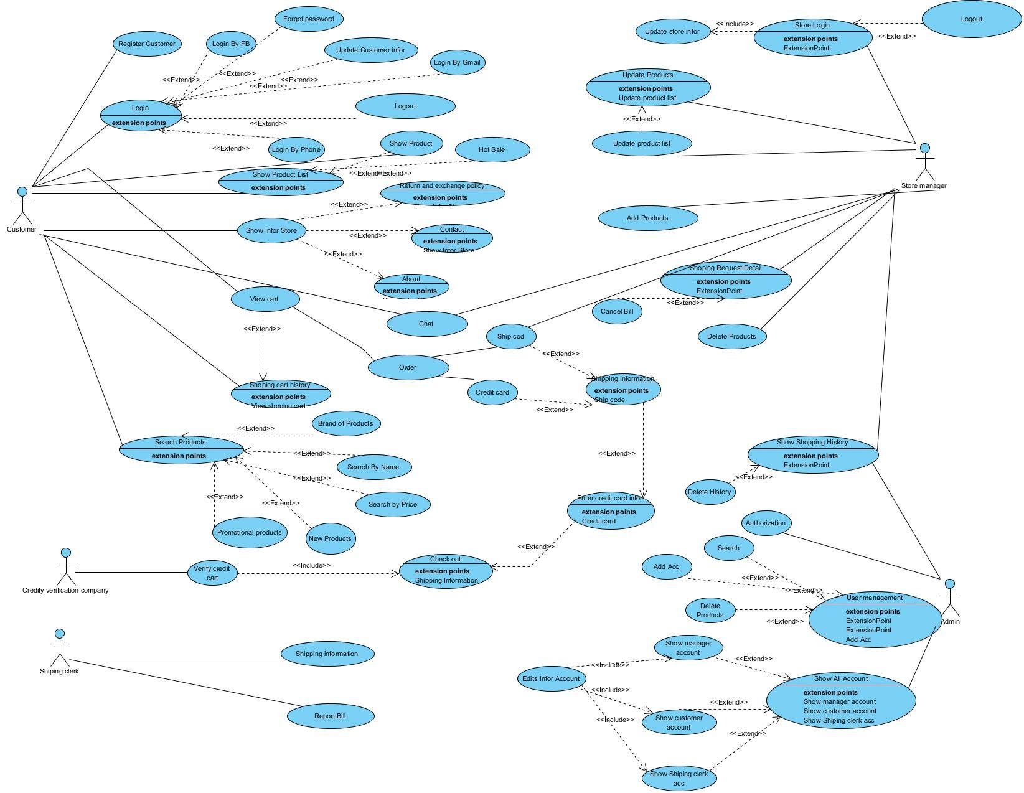

## Activity Diagram

### User

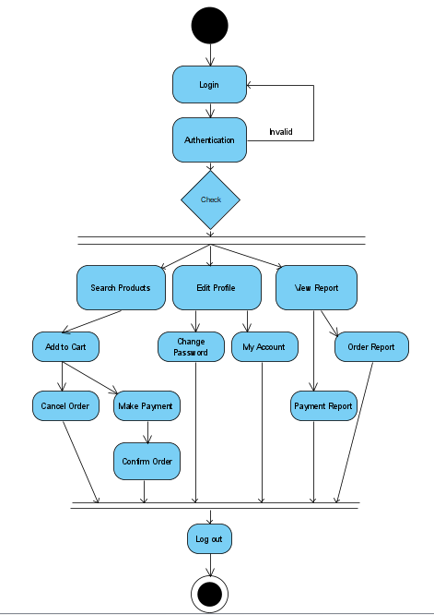

### Admin

## DFD

|  |  |
| --- | --- |
| Symbol | Description |
|  | **Data Flow:** Data flow are pipelines through the packets of information flow. |
|  | **Process:** A Process or task performed by the system. |
|  | **Entity:** Entity are object of the system. A source or destination data of a system. |
|  | **Data Store:** A place where data to be stored. |

### Level 0

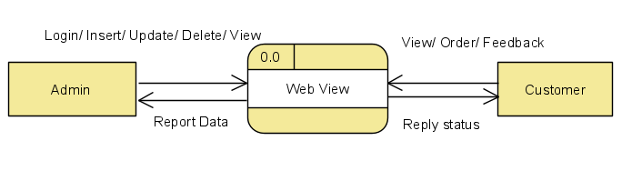

### Level 1

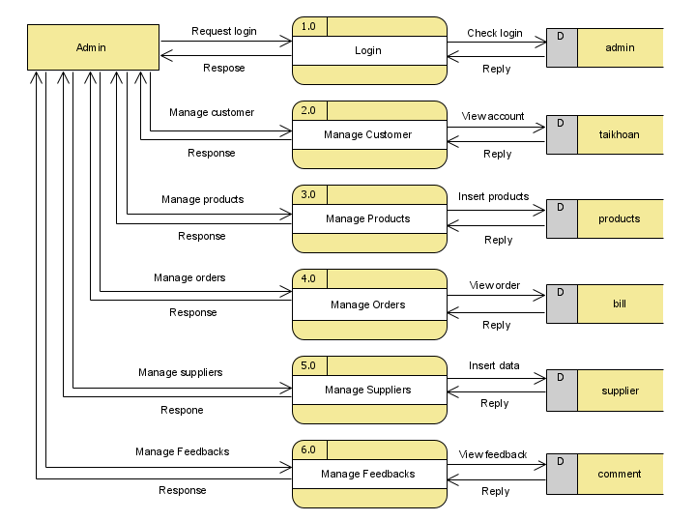

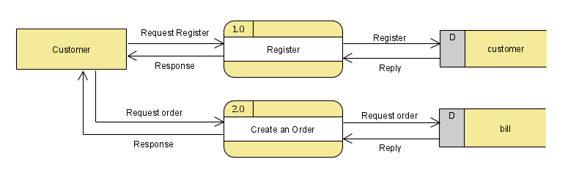

### Level 2

1. Level 3

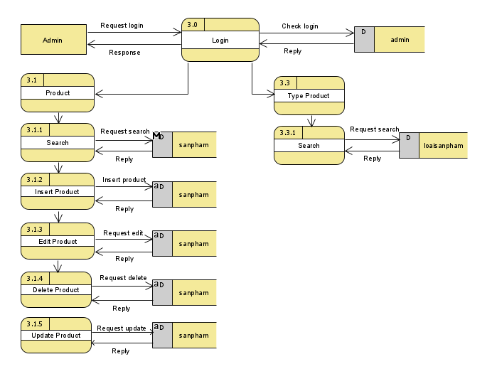

### Level 4

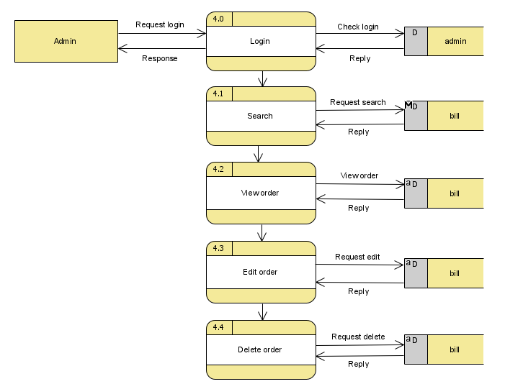

# Conclusion

Website selling clothes online brings great benefits to the owner as well as customers.

Using the Website makes it easier for us not to go outside on hot days, it is quite easy to choose and buy products.

In addition, it helps store owners more easily manage in many aspects such as: invoices, customers, products sold. Easily record and calculate sales of goods instead of calculating and managing by traditional methods

Over time, online sales have been increasingly used in many provinces and cities around the world, so the change from traditional methods to websites is very reasonable and brings many benefits. Useful for many parties

In summary, the sale through the website is extremely reasonable and suitable for the present time, in addition, the sales through the website it affects information technology and e-commerce. If you do not absorb and innovate with the trend of the online market, you will quickly lag behind other stores.