Course: CSE 204 – Computer Networks
LAB 1 – Introduction to Computer Networks
Due date: October 25th, 2025

Student name | Phan Ngoc Hanh Nhi
Student ID | 2131209002

Objectives
- Understanding TCP/IP configuration on Windows.
- Understanding commands used to configure network.
- Using Wireshark software to monitor the network traffic.

Assignment List

II.1 Understanding Network configuration on Windows
- Run the command ipconfig /all to see the TCP/IP configuration.
- How many network adapters does your computer have?
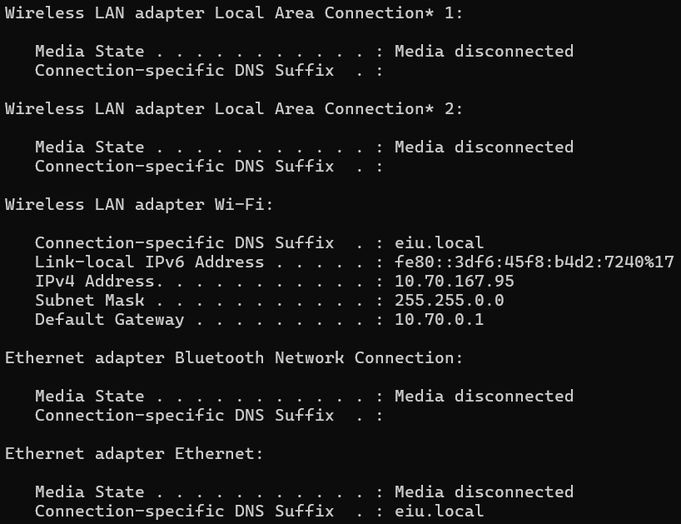
Answer: My computer has 5 network adapters in total, but only 1 active adapter (the Wi-Fi adapter) is currently connected to a network.
- Wireless LAN adapter Local Area Connection 1* — Media disconnected
- Wireless LAN adapter Local Area Connection 2* — Media disconnected
- Wireless LAN adapter Wi-Fi — Connected (IPv4: 10.70.167.95)
- Ethernet adapter Bluetooth Network Connection — Media disconnected
- Ethernet adapter Ethernet — Media disconnected
- List the detail information of each network adapter.
  - Type of network adapter
  - IP address
  - Subnet mask
  - Default gateway
  - DNS server
Answer:
- Wireless LAN adapter Local Area Connection 1*
  - Type: Wireless (virtual adapter)
  - IP Address: None (Media disconnected)
  - Subnet Mask: None
  - Default Gateway: None
  - DNS Server: None (not active)
- Wireless LAN adapter Local Area Connection 2*
  - Type: Wireless (virtual adapter)
  - IP Address: None (Media disconnected)
  - Subnet Mask: None
  - Default Gateway: None
  - DNS Server: None (not active)
- Wireless LAN adapter Wi-Fi
  - Type: Wireless
  - IPv6 Address: fe80::3df6:45f8:b4d2:7240%17
  - IPv4 Address: 10.70.167.95
  - Subnet Mask: 255.255.0.0
  - Default Gateway: 10.70.0.1
  - DNS Server: eiu.local
- Ethernet adapter Bluetooth Network Connection:
  - Type: Ethernet (Bluetooth PAN)
  - IP Address: None (Media disconnected)
  - Subnet Mask: None
  - Default Gateway: None
  - DNS Server: None (not active)
- Ethernet adapter Ethernet
  - Type: Ethernet (wired)
  - IP Address: None (Media disconnected)
  - Subnet Mask: None
  - Default Gateway: None
  - DNS Server: None (not active)
- Take the screenshot of each adapter information and show the results below.
Result:
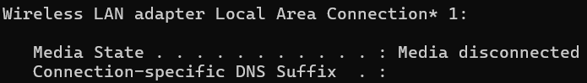
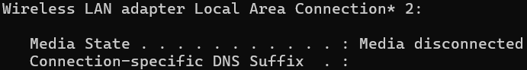
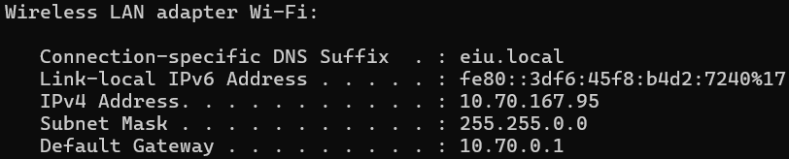
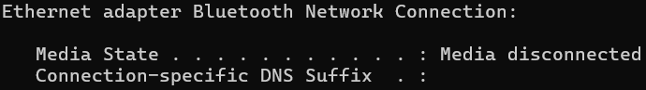
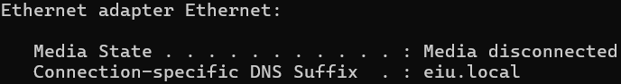

II.2 Understanding basic commands for Network information

ipconfig command
- What does this command do?
Answer: Displays all current TCP/IP network configuration values and refreshes Dynamic Host Configuration Protocol (DHCP) and Domain Name System (DNS) settings. Used without parameters, ipconfig displays Internet Protocol version 4 (IPv4) and IPv6 addresses, subnet mask, and default gateway for all adapters.
- What is the result of the command?
Result:
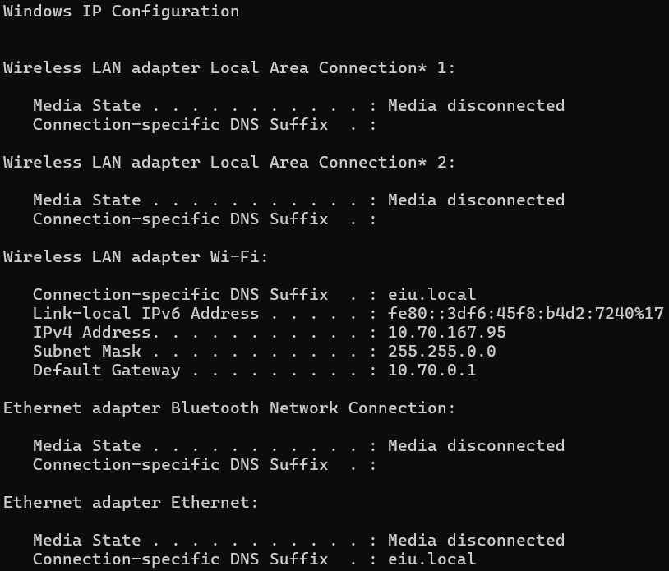
- Explain the result of this command.
Answer: The output shows the network status and configuration for each adapter:
  - Wireless LAN adapter Wi-Fi:
My computer is connected to a wireless network named eiu.local with IP 10.70.167.95.
The subnet mask (255.255.0.0) defines which IP range is local, and the default gateway (10.70.0.1) is the router providing internet access.
  - Other adapters (Ethernet, Bluetooth, etc.):
These show “Media disconnected”, meaning they are currently not in use. Overall, this result helps users or network administrators:
  - Diagnose network connectivity issues
  - Verify if the computer has a valid IP address
  - Identify the gateway and DNS used for internet access

netstat command
- What does this command do?
Answer: Displays active TCP connections, ports on which the computer is listening, Ethernet statistics, the IP routing table, IPv4 statistics (for the IP, ICMP, TCP, and UDP protocols), and IPv6 statistics (for the IPv6, ICMPv6, TCP over IPv6, and UDP over IPv6 protocols). Used without parameters, this command displays active TCP connections.
- What is the result of the command?
Result:
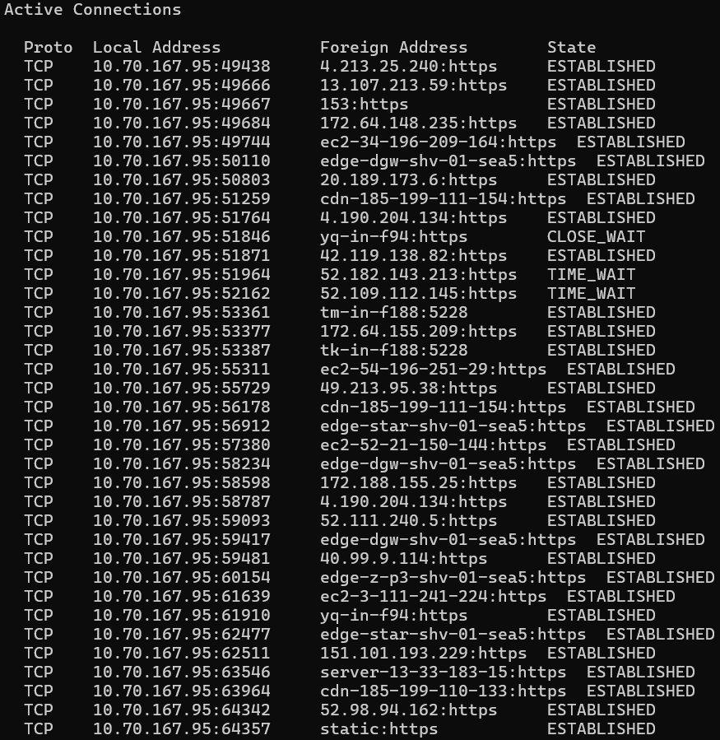
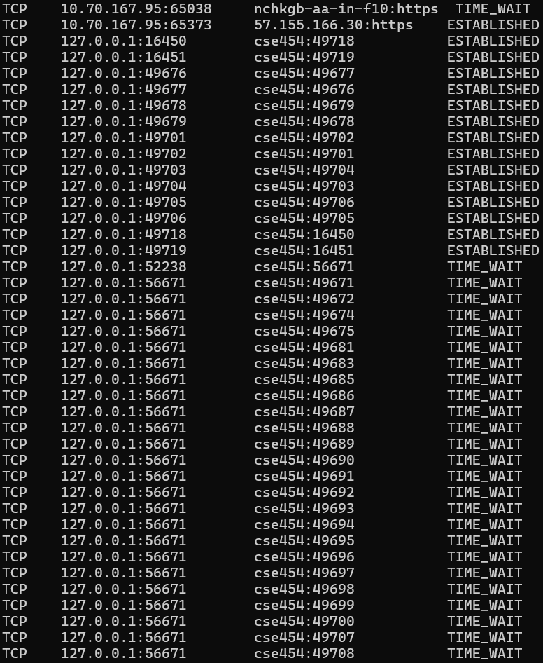

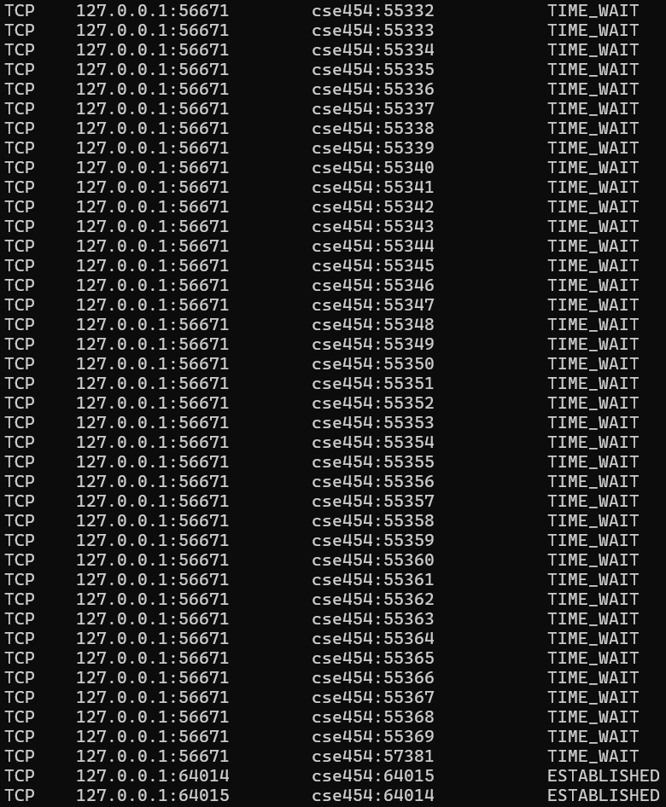
- Explain the result of this command.
Answer: The netstat result shows that your computer is currently connected to multiple remote servers (mostly through secure HTTPS connections) and also has some local connections used by background applications or system services. This confirms that your computer is actively communicating on the network and the internet.

tracert command
- What does this command do?
Answer:
- The tracert (short for Trace Route) command is used in Windows to trace the path that data packets take from your computer to a destination host (for example, a website like google.com).
- It shows the list of all routers (or network devices) that your data passes through before reaching the final destination.
Each router along the path is called a hop.
- What is the result of the command “tracert www.google.com”?
Result:
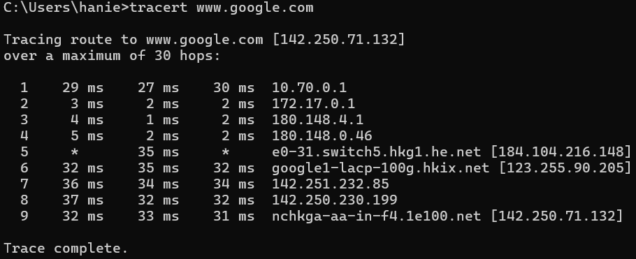
- Explain the result of this command.
Answer: The tracert result confirms that your computer successfully reached Google’s server after passing through multiple routers across your local network, your ISP, and Google’s global backbone.
It demonstrates how data travels step-by-step through the internet from your device to the destination website.

route command
- What does this command do?
Answer: Displays and modifies the entries in the local IP routing table. If used without parameters, route displays help at the command prompt.
- What is the result of the command “route PRINT”?
Result:
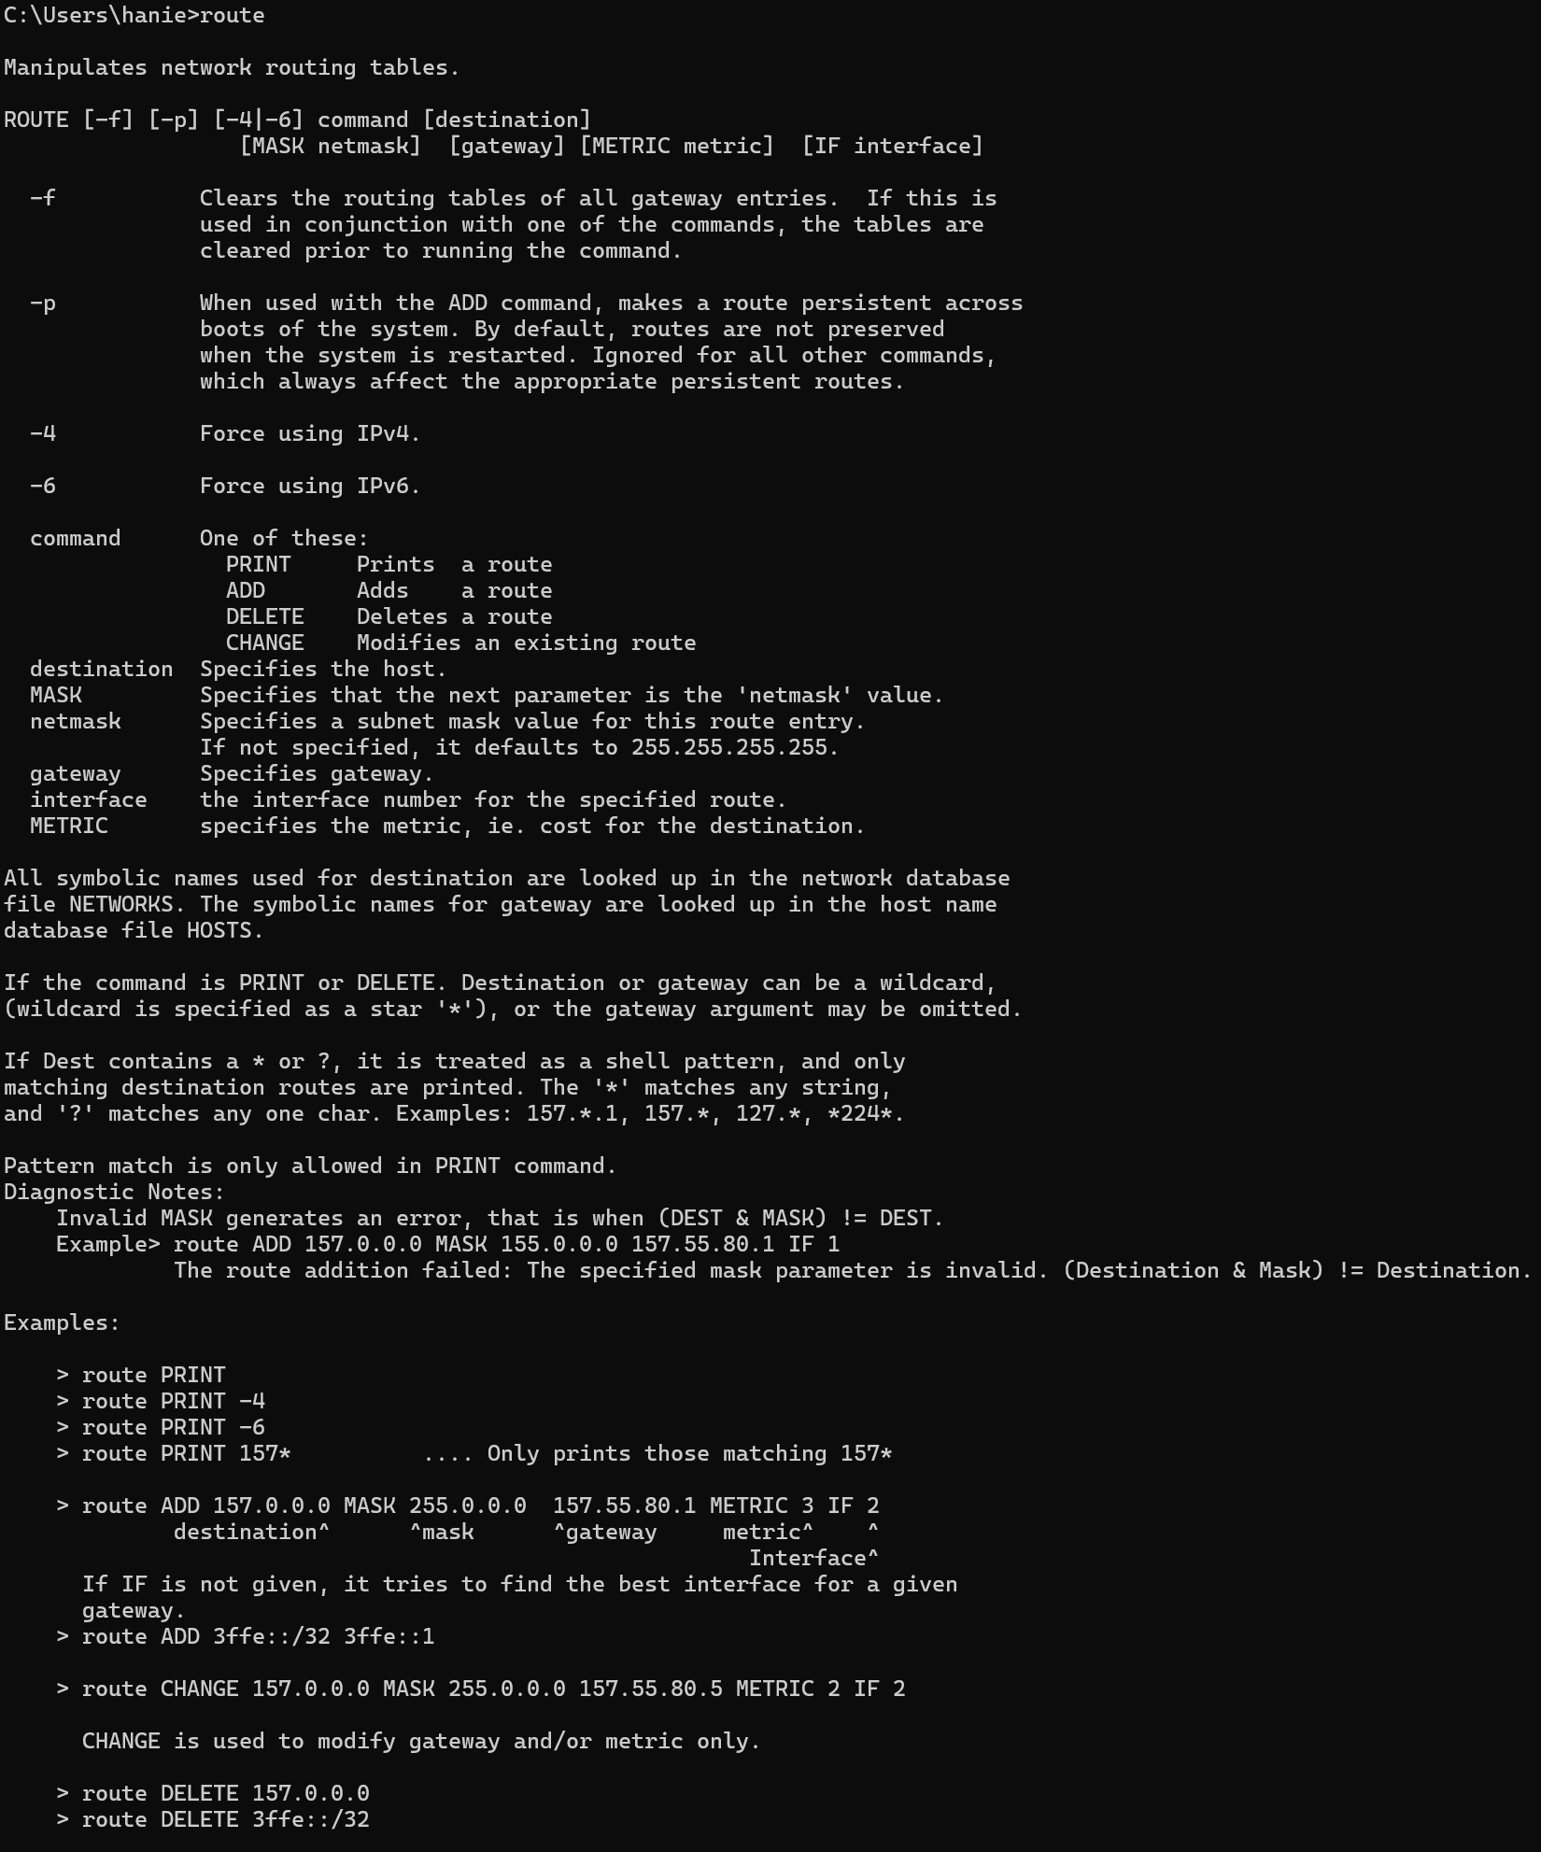
- Explain the result of this command.
Answer: The result of the route PRINT command shows the computer’s current routing table, listing all possible network paths. Each entry explains how data packets are sent: the Network Destination and Netmask define the target network, the Gateway shows the next hop or router, the Interface indicates which network adapter is used, and the Metric represents the route’s priority. This table helps the system decide where to send data for each destination.

ping command
  - What does this command do?
Answer: The ping command is used to test the connectivity between your computer and another device (host) on a network. It sends small packets of data (ICMP Echo Requests) to the target IP address or domain and waits for a reply to check if the destination is reachable and how long the response takes.
  - What is the result of the following commands:
    - ping www.google.com
Result:
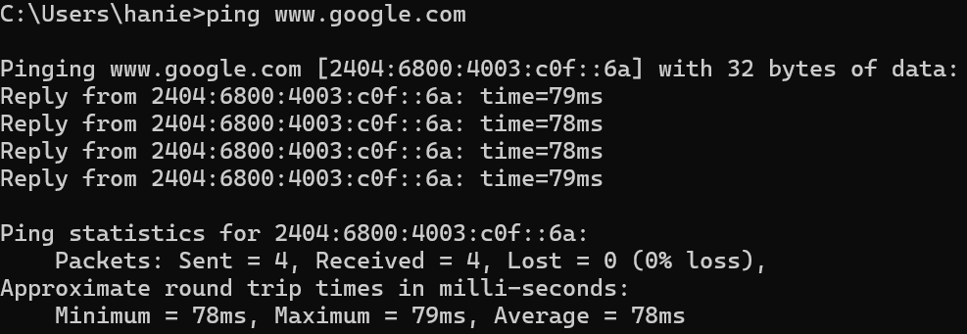
    - ping www.eiu.edu.vn
Result:
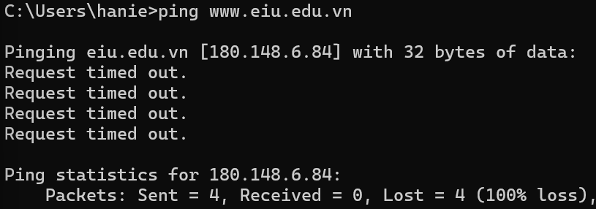
- Explain the result of this command.
Answer: The result shows two ping tests with different outcomes.
When pinging www.google.com, all four packets were successfully sent and received with no packet loss (0%). The response times ranged from 78 ms to 79 ms, indicating a stable and active Internet connection. This means Google’s server is online, reachable, and allows ICMP (ping) requests, confirming proper network connectivity. When pinging www.eiu.edu.vn, all requests timed out, resulting in 100% packet loss. This indicates that the computer could not receive any reply from the target server. Possible reasons include the server being offline, a temporary network or routing issue, or the destination server blocking ICMP echo requests for security reasons.

nslookup command
- What does this command do?
Answer: The nslookup command is used to obtain information about a domain name or IP address by querying the Domain Name System (DNS). It helps find the IP address associated with a domain name or the domain name associated with an IP address, useful for diagnosing DNS or network issues.
- What is the result of the command “nslookup www.eiu.edu.vn”?
Result:
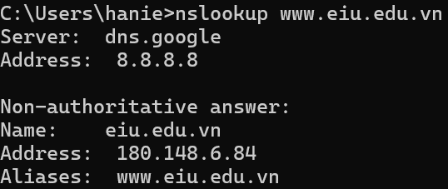
- Explain the result of this command.
Answer: The result shows that the nslookup command successfully queried the Google public DNS server (8.8.8.8) to resolve the domain www.eiu.edu.vn. The DNS server responded with a non-authoritative answer, meaning the information came from a cache rather than the main DNS source. It shows that the domain eiu.edu.vn corresponds to the IP address 180.148.6.84, and that www.eiu.edu.vn is an alias for the same domain. This confirms that the DNS resolution for the EIU website is working correctly.
II.3 Configure IP address on Windows clients
Requirements: 2 Windows virtual machines in VMWare Workstation

Configure IP address on Windows
- Instruction: Do the following steps
  - Open Start menu.
  - Search and open Control Panel.
  - Open Network and Internet.
  - Open Network and Sharing Center.
  - On the left panel, choose Change adapter settings.
  - Right click on the adapter you want to configure and choose Properties.
  - In the first tab, click on Internet Protocol Version 4 (TCP/IPv4) and then click Properties.
  - Click on Use the following IP address. Then, fill in the information as follows:
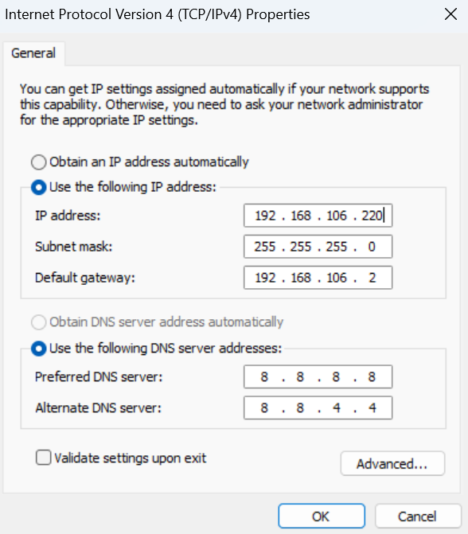
- After that, open Command Prompt and run the command “ipconfig” to check the result. Result:
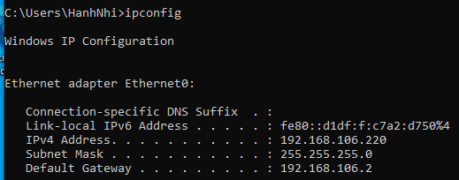
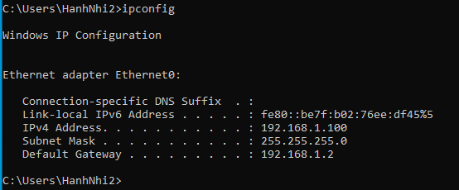

Test connectivity between 2 Windows Clients
- Case 1:
- Configure IP address of two clients:
  - Client #1: 192.168.1.x (Subnet Mask: 255.255.255.0)
  - Client #2: 192.168.1.y (Subnet Mask: 255.255.255.0)
  - Note: x and y MUST be different and in range 2-200
- Run the ping command in two clients. Results:
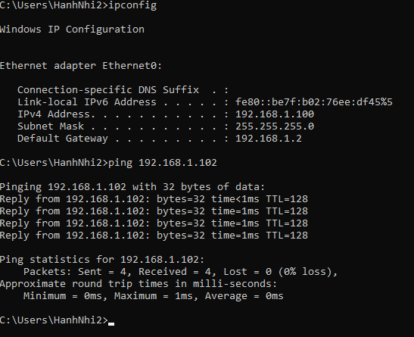
- Case 2
- Configure IP address of two clients:
  - Client #1: 192.168.1.x (Subnet Mask: 255.255.255.0)
  - Client #2: 10.10.114.y (Subnet Mask: 255.255.255.0)
  - Note: x and y MUST be different and in range 2-200
- Run the Ping command in two clients. Results:
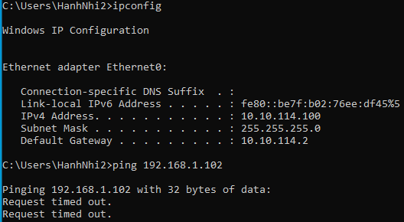
- Explain why.
Case 1: Same Network (192.168.1.x and 192.168.1.y)
Both clients are configured with IP addresses in the same network (192.168.1.0/24). Because they share the same network ID and subnet mask (255.255.255.0), they belong to the same local network. Therefore, the two computers can communicate directly with each other without needing a router. When using the ping command, the result is successful because the packets are sent and received within the same subnet.
Case 2: Different Networks (192.168.1.x and 10.10.114.y)
In this case, the two clients are in different networks. Client #1 belongs to the 192.168.1.0/24 network, while Client #2 belongs to the 10.10.114.0/24 network. Since their network IDs are different and no router or gateway connects these two networks, the computers cannot reach each other directly. As a result, the ping command fails because there is no route for packets to travel from one subnet to another.

II.4 Understanding Wireshark

Wireshark Installation
- Follow the instructions to install Wireshark at: https://www.wireshark.org/

Using Wireshark
- To start to capture packets: At the main window, double-click on the Interface you want to capture the network traffic.

Wireshark Practice
- Start up the Wireshark packet sniffer
- Enter the following URL into your browser:
http://gaia.cs.umass.edu/wireshark-labs/protected_pages/HTTP-wireshark-file5.html
- Type the requested user name and password into the pop up box. Then, click Sign in.
- Stop Wireshark packet capture, and enter “http” in the display-filter-specification window, so that only captured HTTP messages will be displayed later in the packet-listing window.
- Questions
  - Question 1: Find the credential (user name, password) in the HTTP message.
Result:

  - Question 2: What is the server’s response (status code and phrase) in response to the initial HTTP GET message from your browser?
Result:

II.5 Understanding Ethernet

Capturing and analyzing Ethernet frames
- First, make sure your browser’s cache of previously downloaded documents is empty.
- Start up Wireshark and enter the following URL into your browser: http://gaia.cs.umass.edu/wireshark-labs/HTTP-wireshark-file3.html. Your browser should display the rather lengthy US Bill of Rights.
- Stop Wireshark packet capture.
- Expand the Ethernet II information in the packet details window.
- Questions:
  - Question 1: What is the 48-bit Ethernet address of your computer?
Result:

  - Question 2: What is the 48-bit destination address in the Ethernet frame?
Result:

Address Resolution Protocol
- Display the contents of the ARP cache on your computer using the command “arp –d –a”. What is the result of this command?

- Clear your ARP cache using the command “arp –d *” (make sure to open Command prompt using Administration privillege) and make sure your browser’s cache is cleared of previously downloaded documents. What is the result?

- Start up the Wireshark packet sniffer.
- Enter the following URL into your browser: http://gaia.cs.umass.edu/wireshark-labs/HTTP-wireshark-lab-file3.html
- Your browser should again display the rather lengthy US Bill of Rights.
- Stop Wireshark packet capture
- Questions:
- Question 1: What is the hexadecimal value of the source address in the Ethernet frame containing the ARP request message sent out by your computer?
Result:

- Question 2: What is the hexadecimal value of the destination addresses in the Ethernet frame containing the ARP request message sent out by your computer?
Result:

