Course: CSE 204 – Computer Networks
LAB 5 – DHCP and Routing
Due date: November 22nd, 2025

Student name | Phan Ngoc Hanh Nhi
Student ID | 2131209002

Goal
- Students know how to configure DHCP on router.
- Students know how to connect 2 router using Serial Interface
- Students know how to configure Static routing
- Students know how to configure Dynamic routing (RIPv2)

Assignment list
Note: In the first time we open the Router CLI, if the initial configuration dialog appears, please enter “no”.
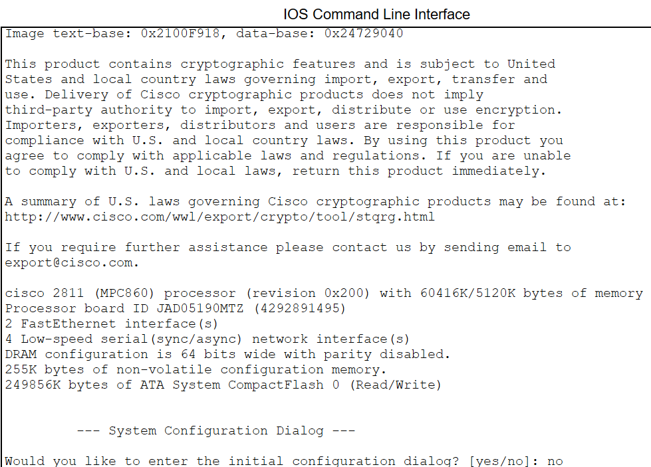
II.1 DHCP Configuration
- Open Cisco Packet Tracer and implement the network as shown below:
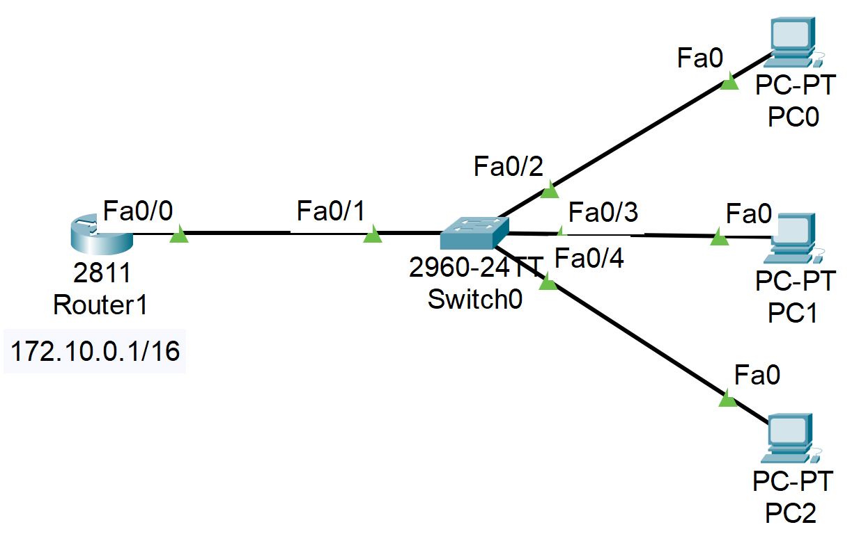
- On the Router:
Router>enable
Router#config terminal
Router(config)#ip dhcp pool net172 | //enter dhcp config mode
Router(dhcp-config)#network 172.10.0.0 255.255.0.0 | //dhcp for network 172.10.0.0/16
Router(dhcp-config)#default-router 172.10.0.1 | //default gateway for PCs client
Router(dhcp-config)#exit
Router(config)#ip dhcp excluded-address 172.10.0.1 | //do not assign 172.10.0.1 to hosts
Router(config)#interface fastEthernet 0/0
Router(config-if)#ip address 172.10.0.1 255.255.0.0 | //set ip for interface fa0/0 on Router
Router(config-if)#no shutdown
- On the PCs
On PCs, set DHCP on.
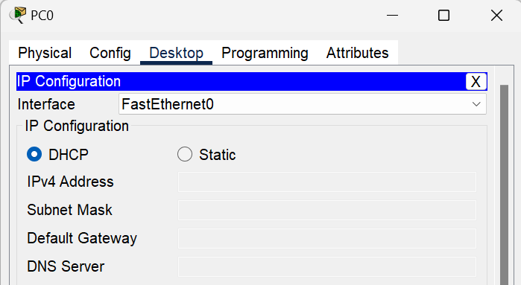
Result:
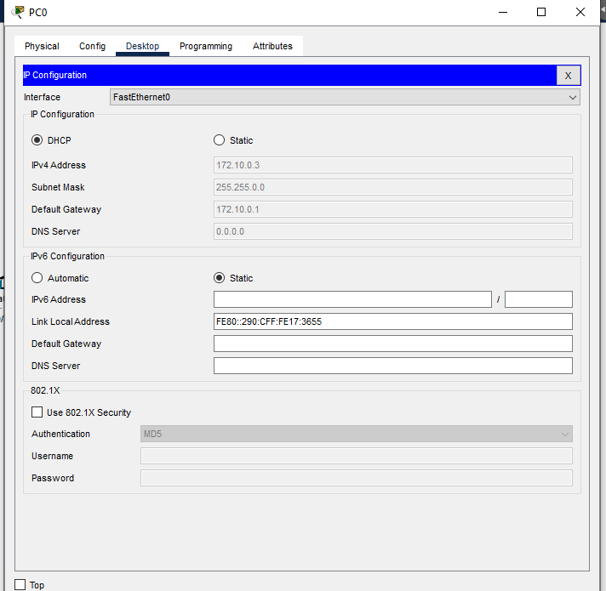
II.2 Connect 2 routers using serial interface
- Add serial interface module for router
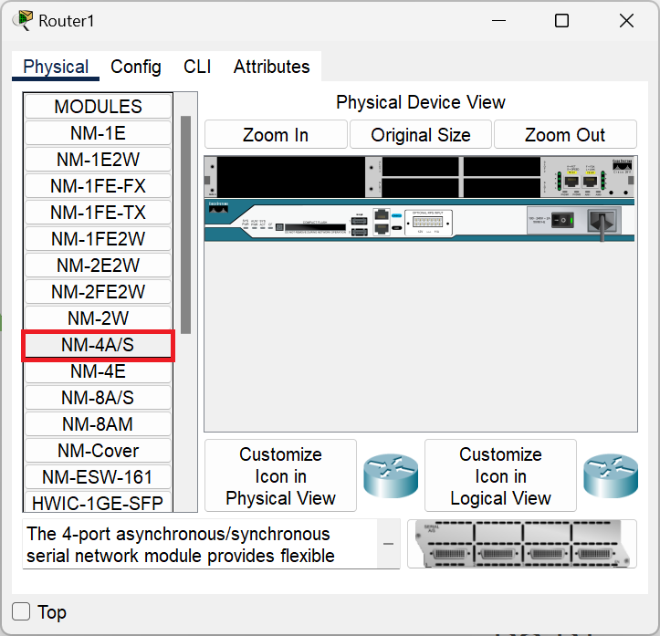
- Connect 2 routers by serial cable
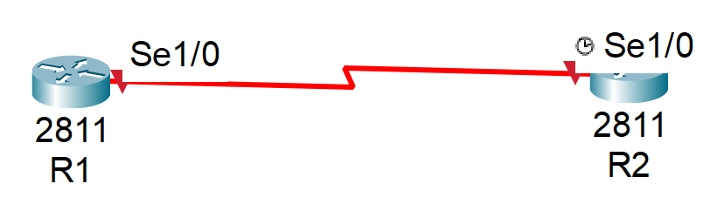
- Configure connection between 2 routers
- On Router R1
Router>enable
R1#config terminal
Router(config)#hostname R1
R1(config)#interface serial1/0
R1(config-if)#ip address 10.0.0.1 255.255.255.252
R1(config-if)#no shutdown
- On Router R2
Router>enable
R2#config terminal
Router(config)#hostname R2
R2(config)#interface serial1/0
R2(config-if)#clock rate 128000
R2(config-if)#ip address 10.0.0.2 255.255.255.252
R2(config-if)#no shutdown
- Ping 2 Routers and show the result:
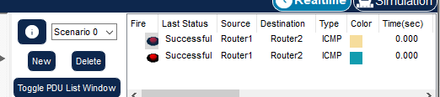
II.3 Static Routing
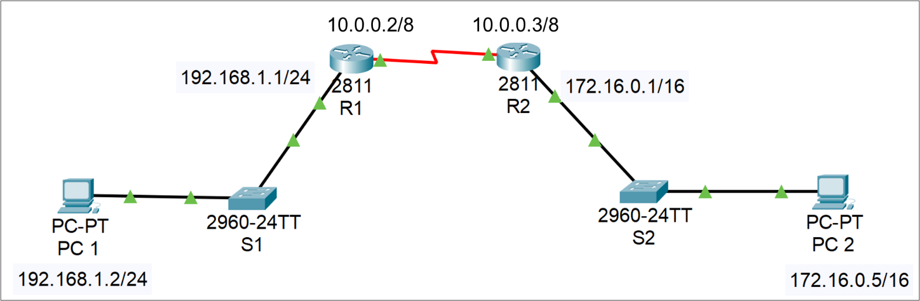
- Configure DHCP and assign IP to all Router interfaces

- On Router R1
      - R1 (config)#ip route 172.16.0.0 255.255.0.0 10.0.0.3
      - OR: R1 (config)#ip route 172.16.0.0 255.255.0.0 se1/0
- On Router R2
      - R2 (config)#ip route 192.168.1.0 255.255.255.0 10.0.0.2
      - OR: R2 (config)#ip route 192.168.1.0 255.255.255.0 se1/0
- Show routing table
      - Router#show ip route

- Result (ping between PCs):
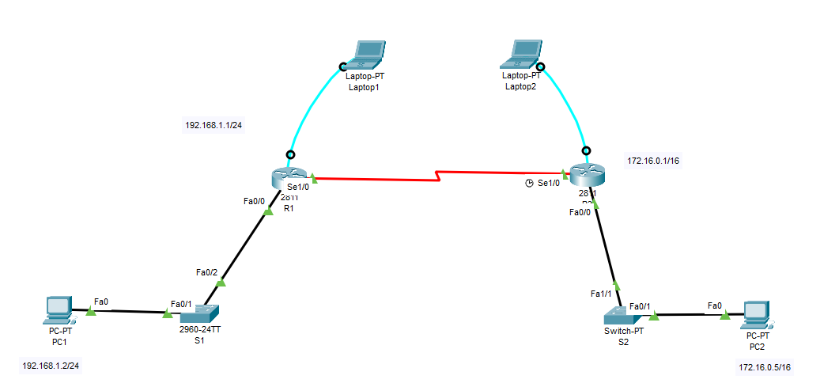
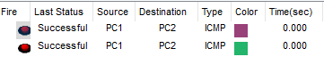
II.4 Dynamic Routing – RIPv2
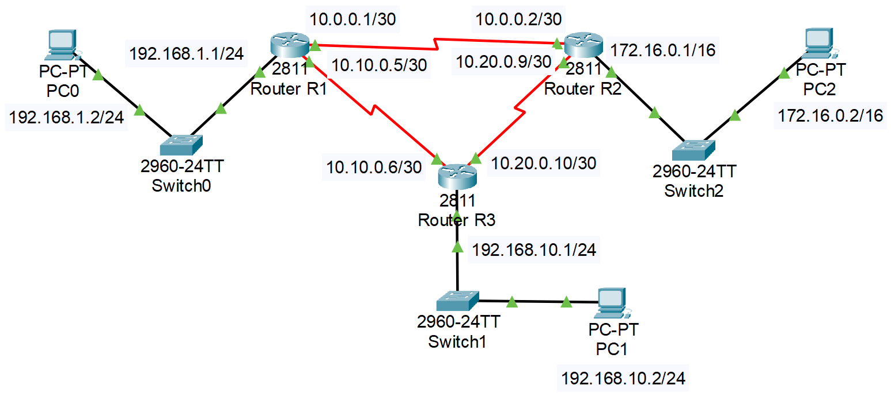
- On R1
Router(config)#router rip
Router(config-router)#version 2
Router(config-router)#network 192.168.1.0
Router(config-router)#network 10.0.0.0
Router(config-router)#network 10.10.0.0
- On R2
Repeat those steps on R1
- On R3
Repeat those steps on R1
- Results:
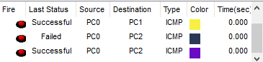
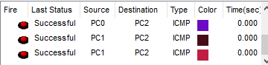

III. Extra Assignments
III.1 DHCP & Static Routing
- Configure DHCP and Static Routing using the model below
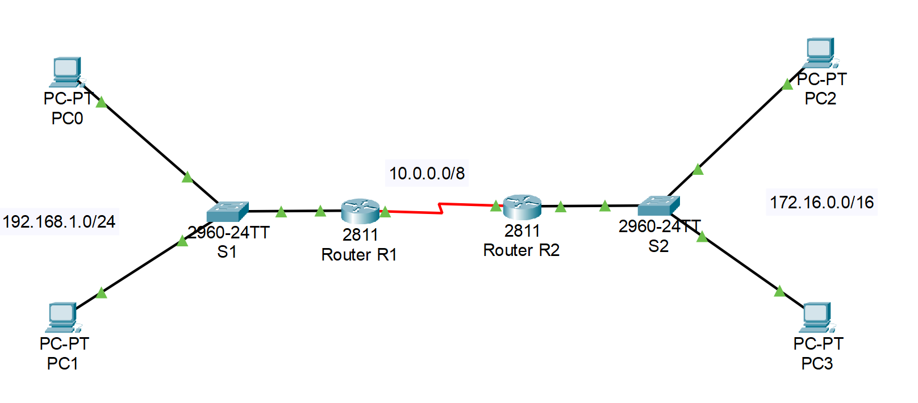
      - Show all configuration commands at each step for each device
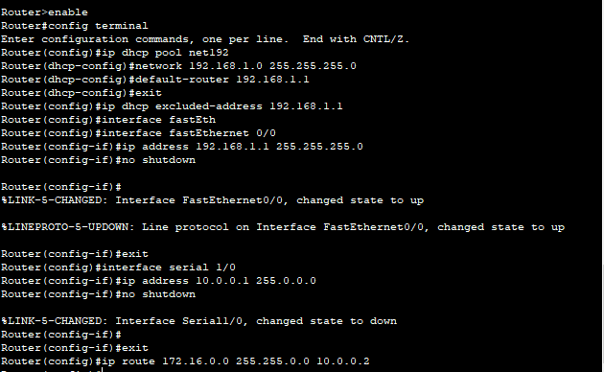
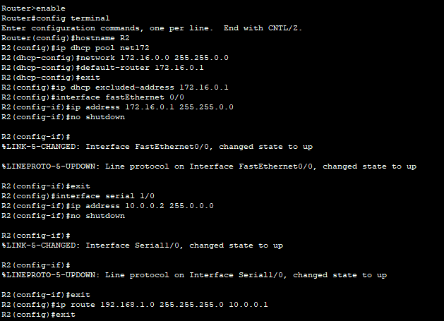
      - Show the routing table on each router and ping results between PCs
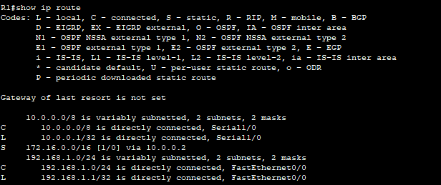
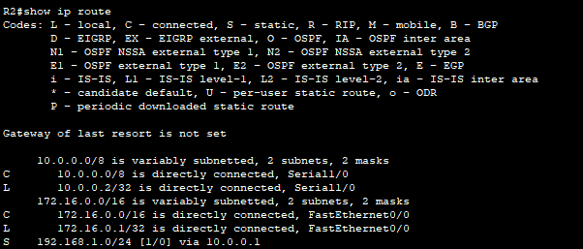
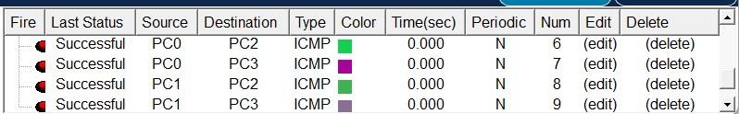
- Configure DHCP and Static Routing using the model below
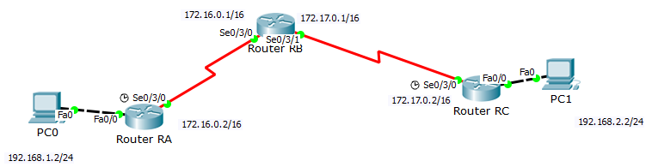
      - Show all configuration commands at each step for each device
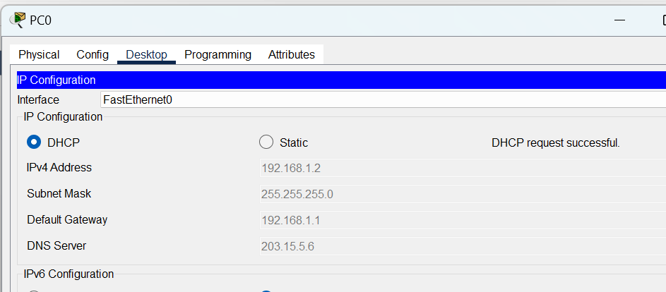
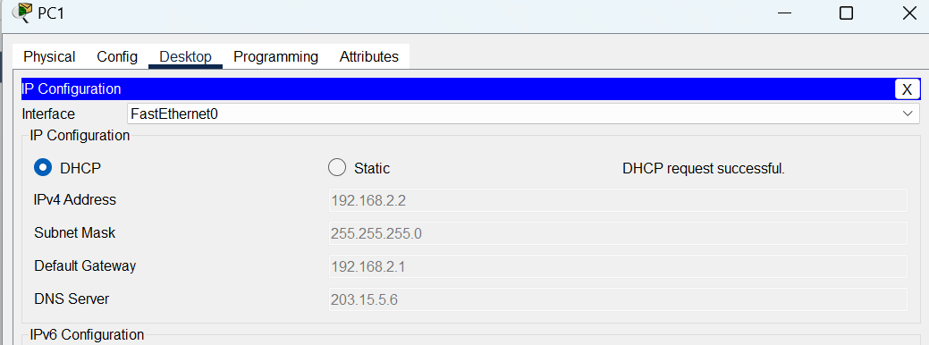
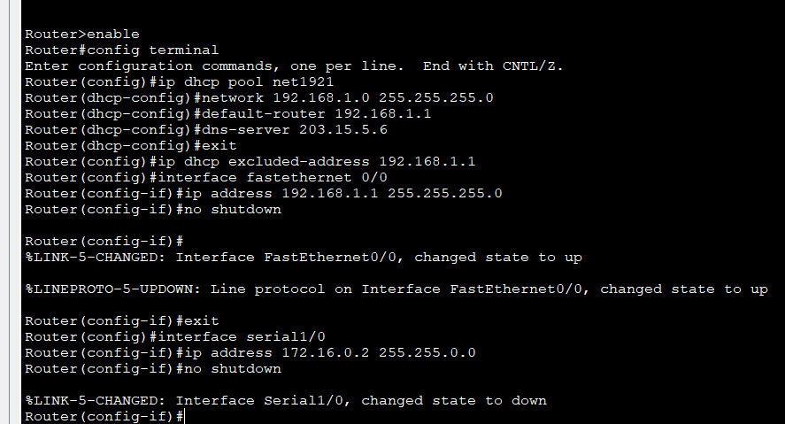
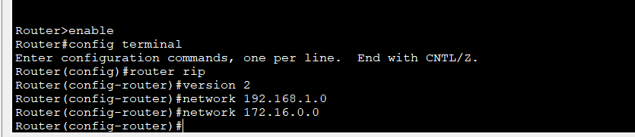
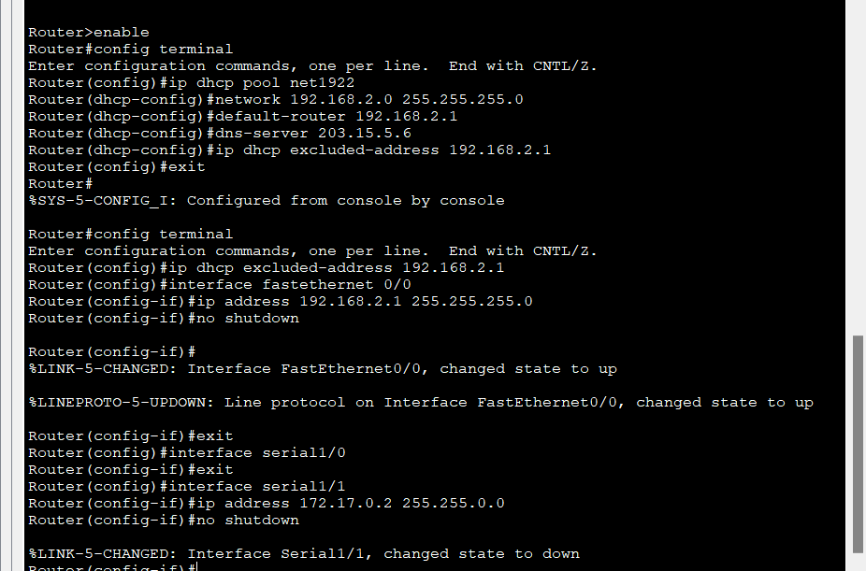
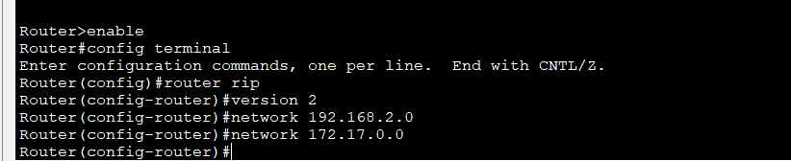
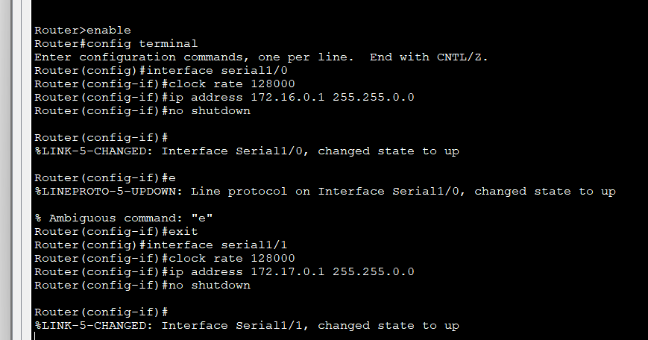
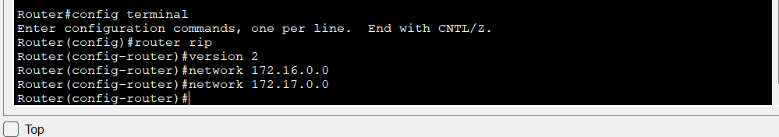
      - Show the routing table on each router and ping results between PCs
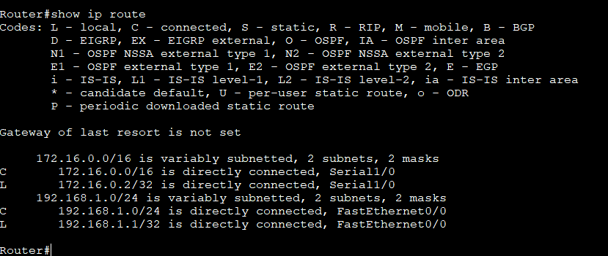
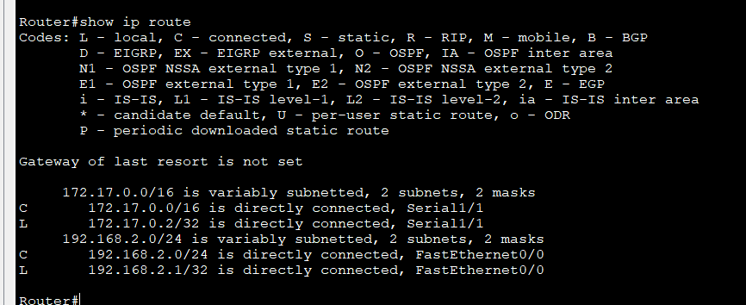
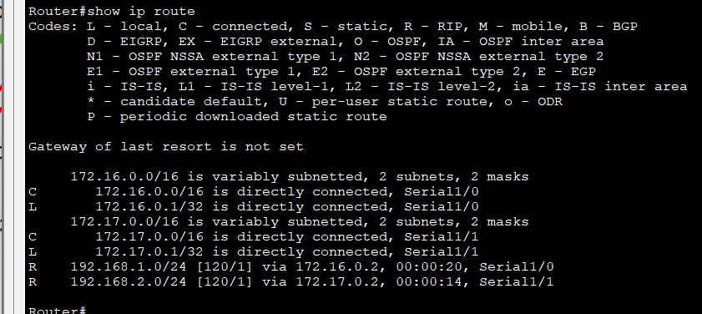
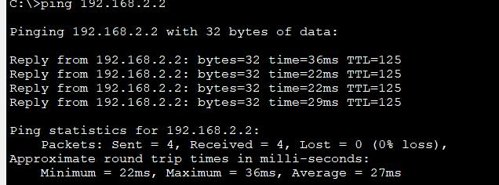
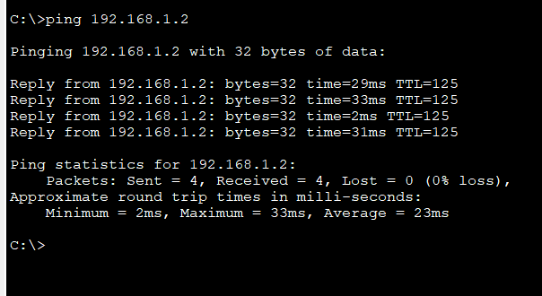
III.2 Dynamic Routing
- Configure DHCP and Dynamic Routing using the model below

      - Show all configuration commands at each step for each device
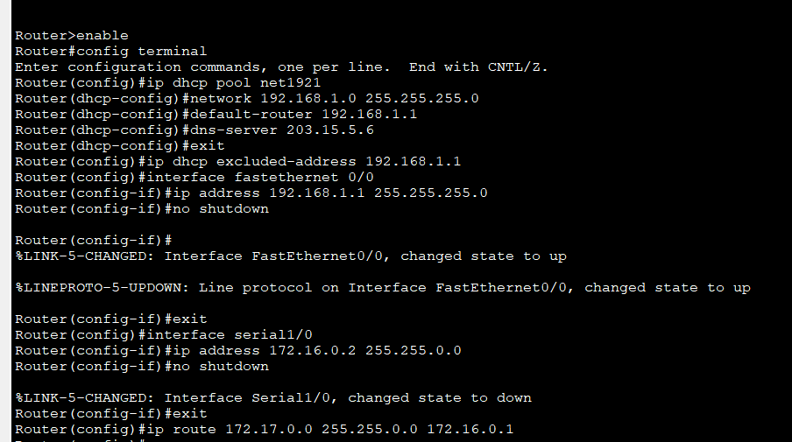
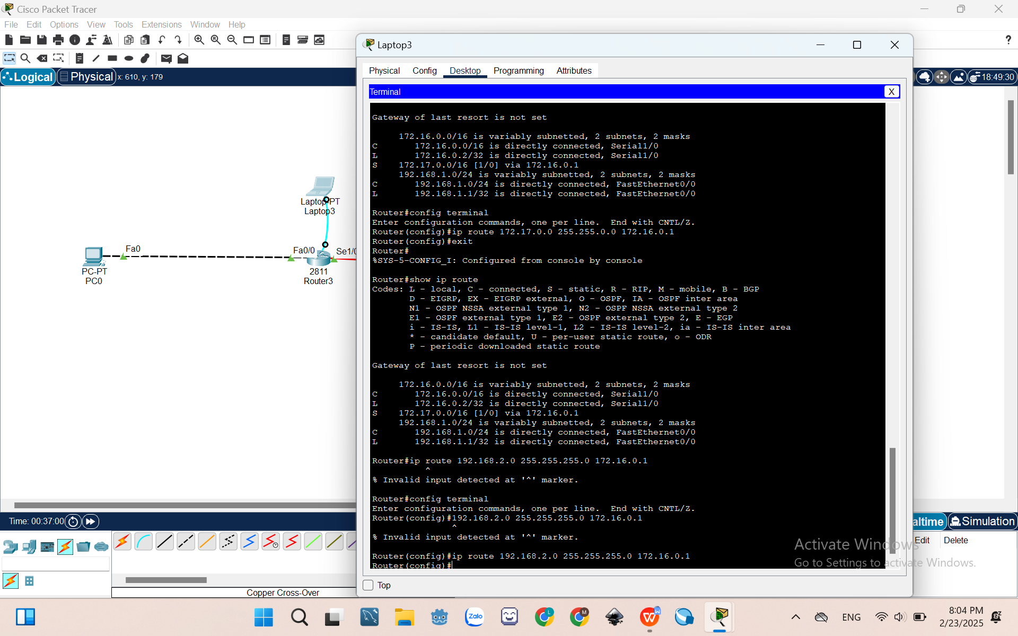
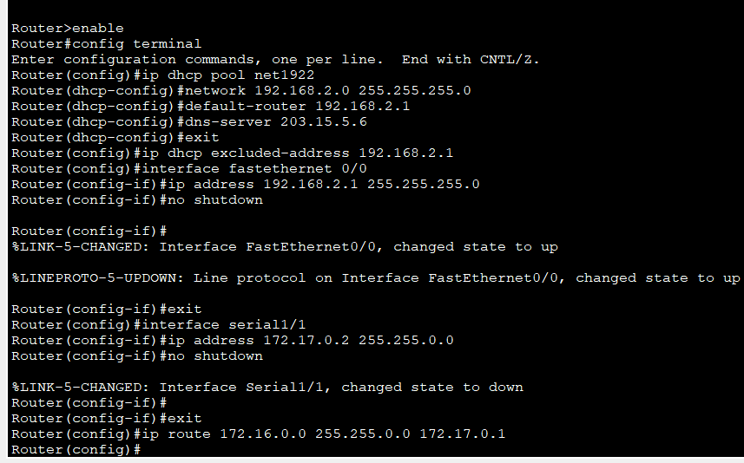
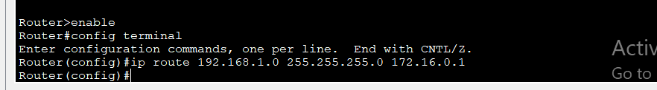
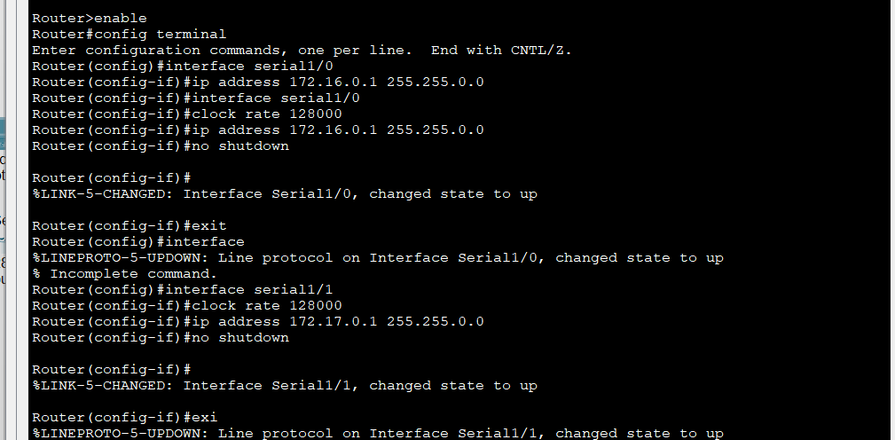
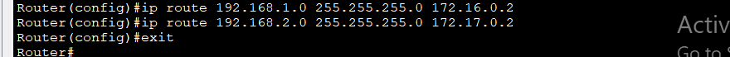
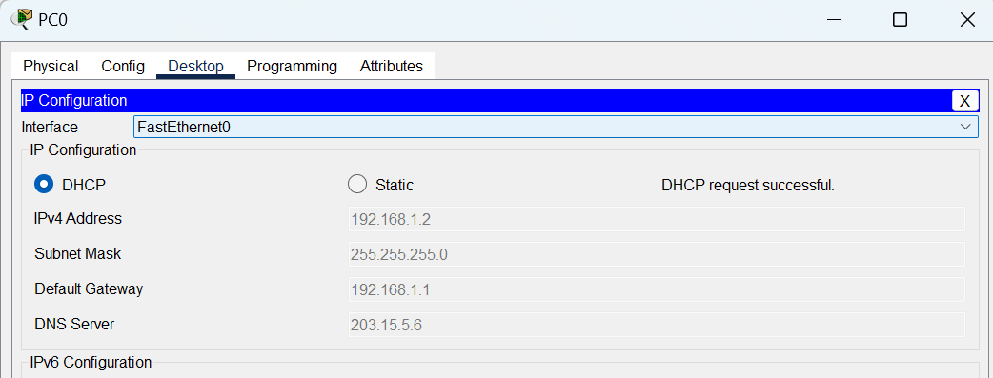
      - Show the routing table on each router and ping results between PCs
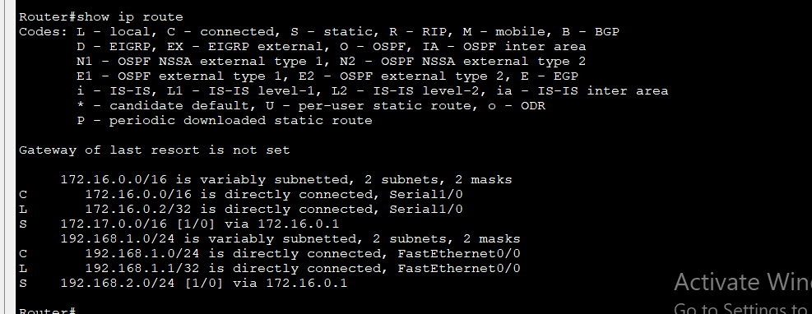
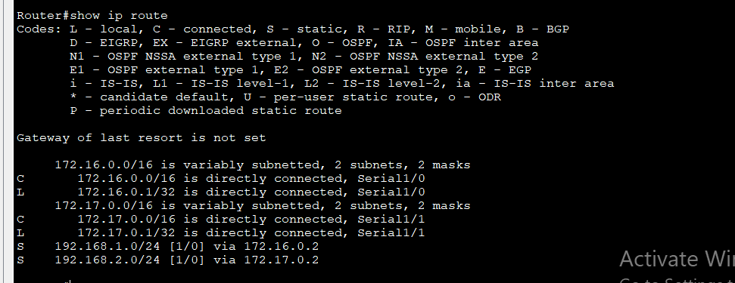
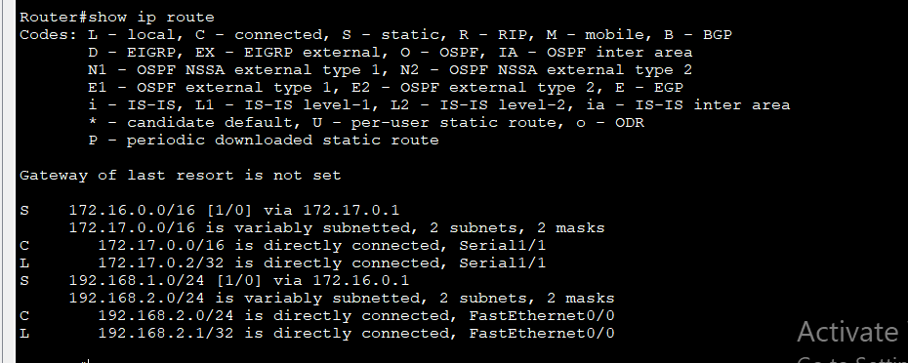
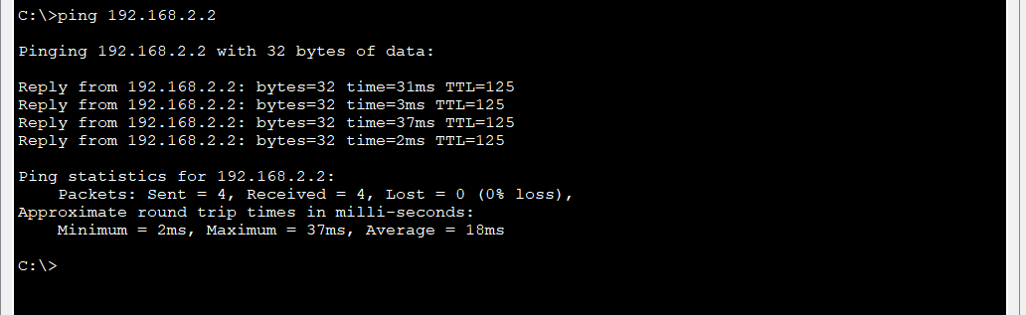
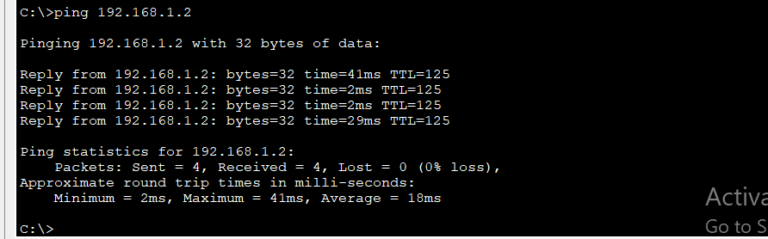
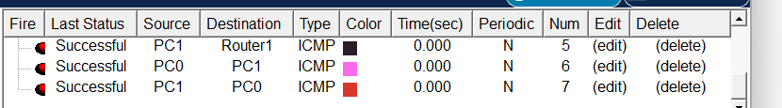
- Configure DHCP and Dynamic Routing using the model below
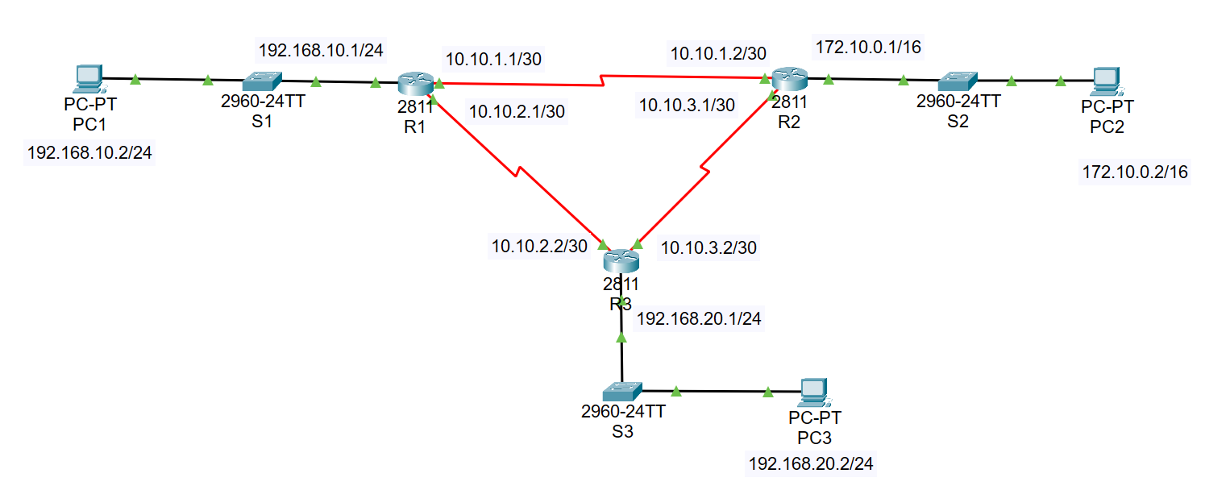
      - Show all configuration commands at each step for each device
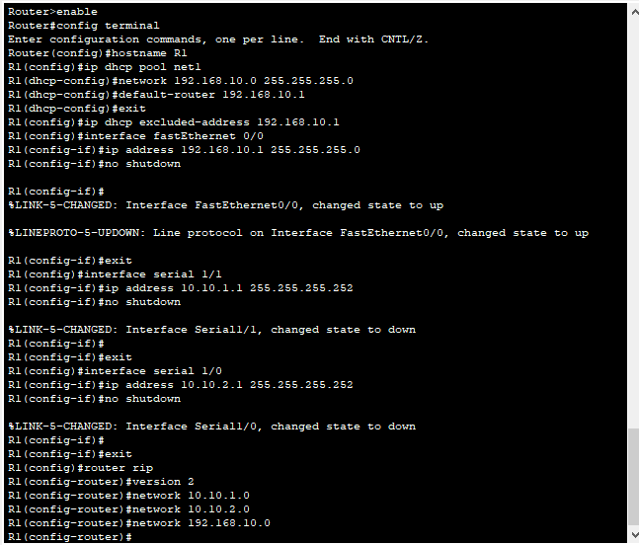
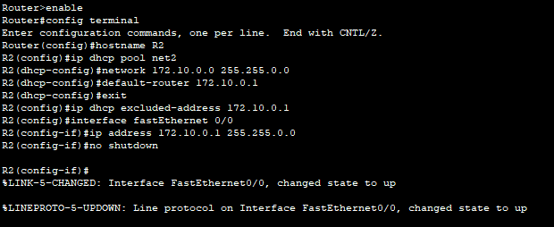
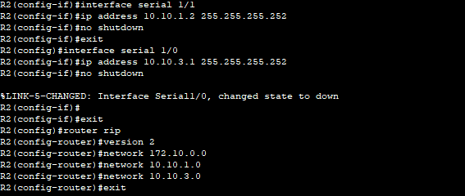
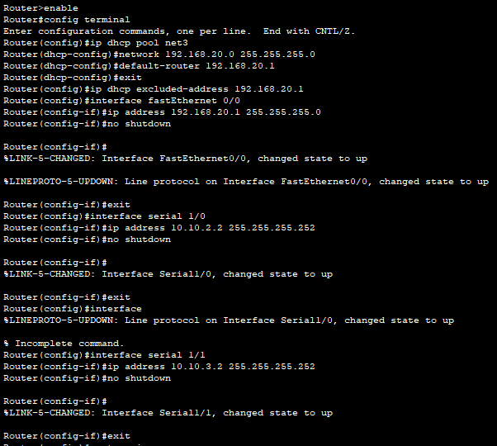
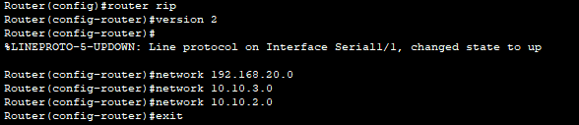
      - Show the routing table on each router and ping results between PCs
